# Relation report

Source file: 20251214-ScalesData-Combined_ver0.7-Cleaned-IncomeNormalized-NoOutliers.csv

Pairs analyzed: 117

## Emotional Support - T Score vs Age (IN YEARS)

Test: pearson/spearman; statistic: 0.42102286814144935; p-value: 0.00015235349306927018; spearman_r=0.403, spearman_p=0.000303

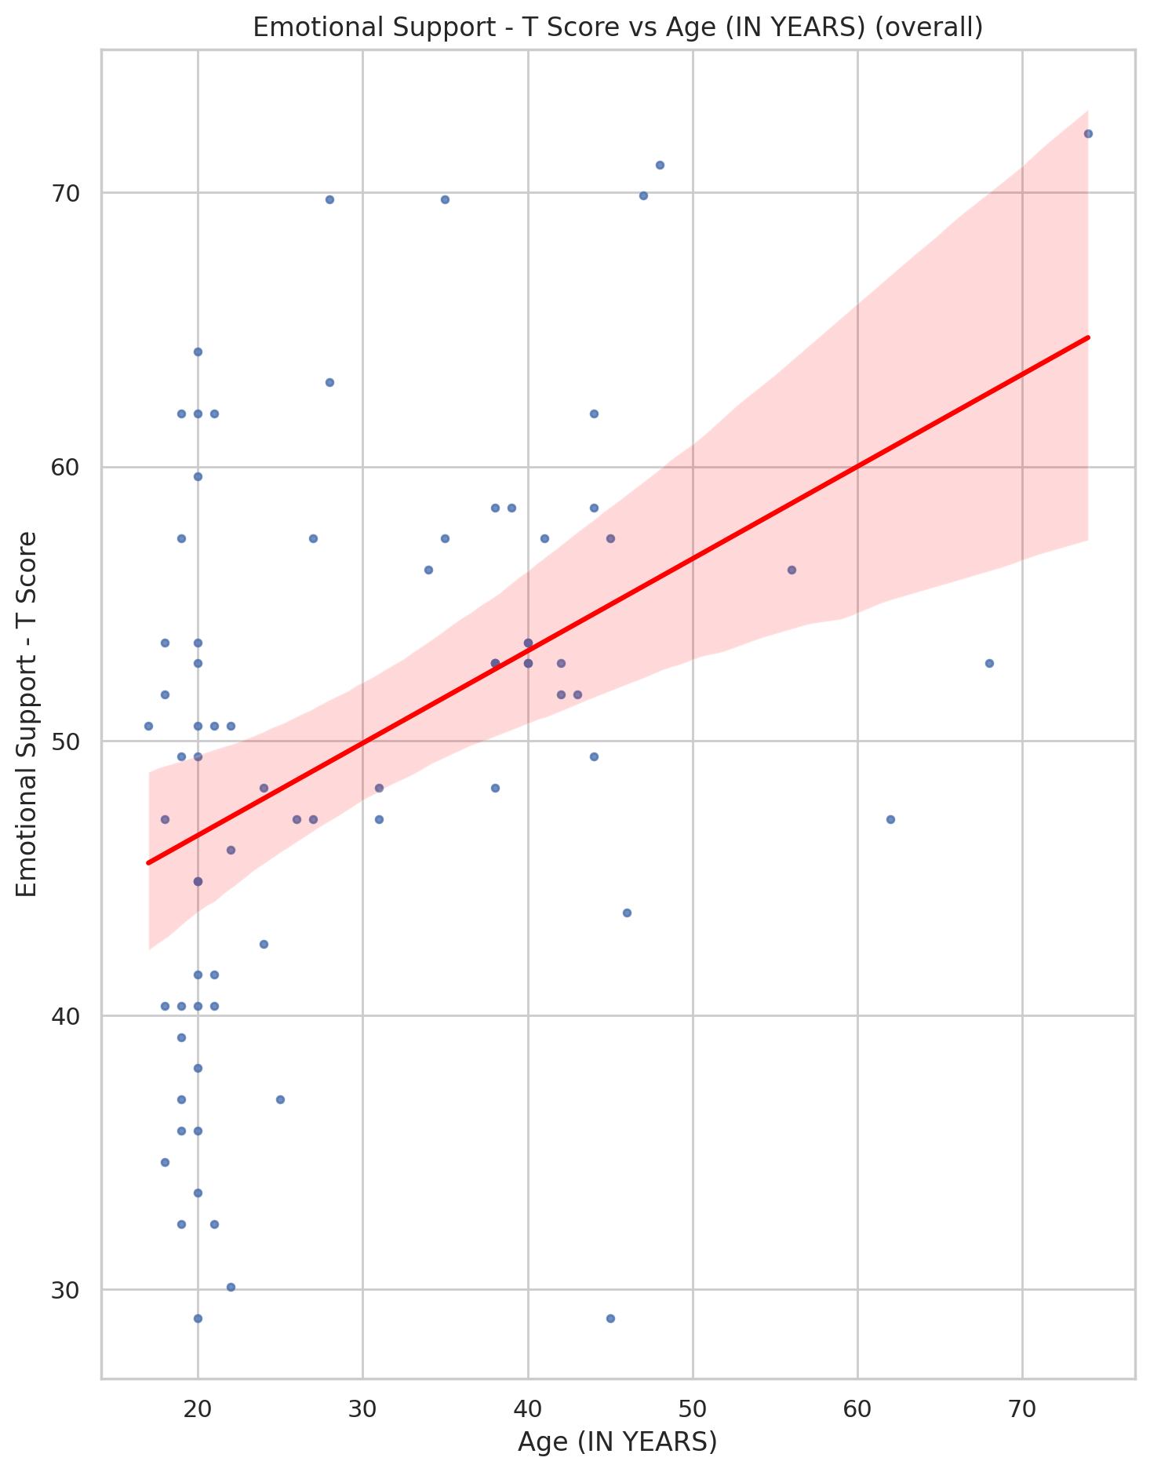

## Informational Support - T Score vs Age (IN YEARS)

Test: pearson/spearman; statistic: 0.28208988120945905; p-value: 0.013556447703175356; spearman_r=0.306, spearman_p=0.00725

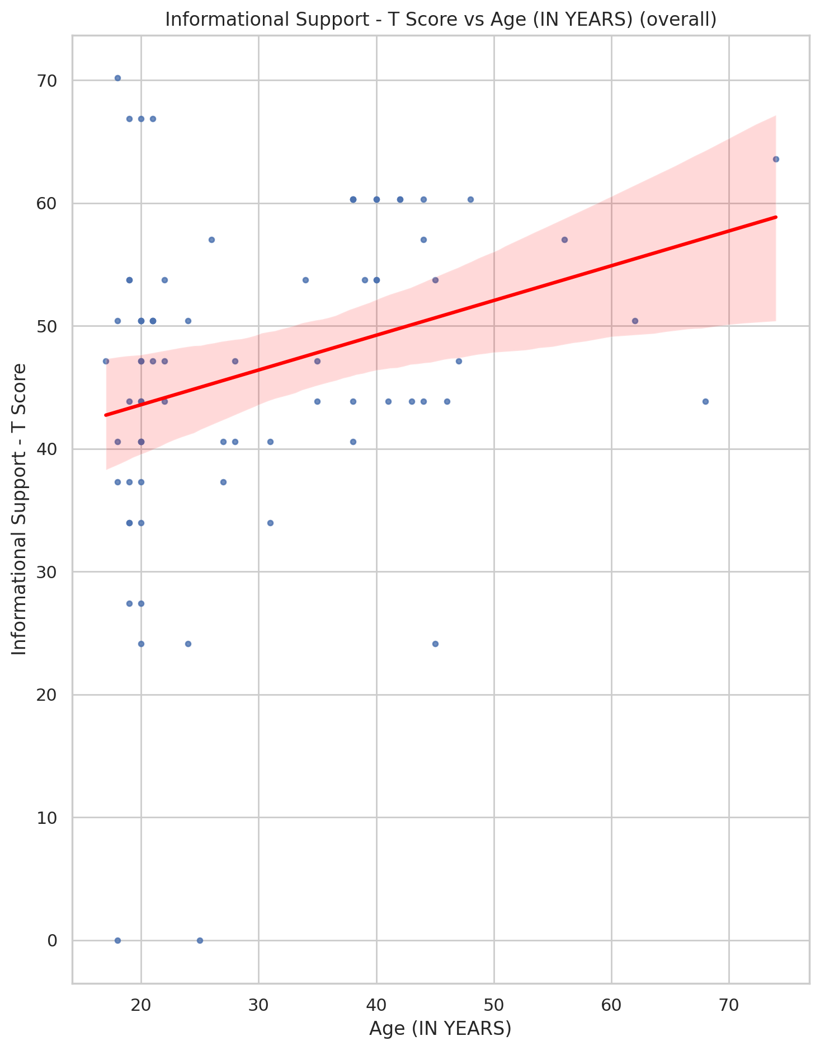

## Instrumental Support - T Score vs Age (IN YEARS)

Test: pearson/spearman; statistic: 0.2581689235060618; p-value: 0.024342358281559513; spearman_r=0.299, spearman_p=0.00859

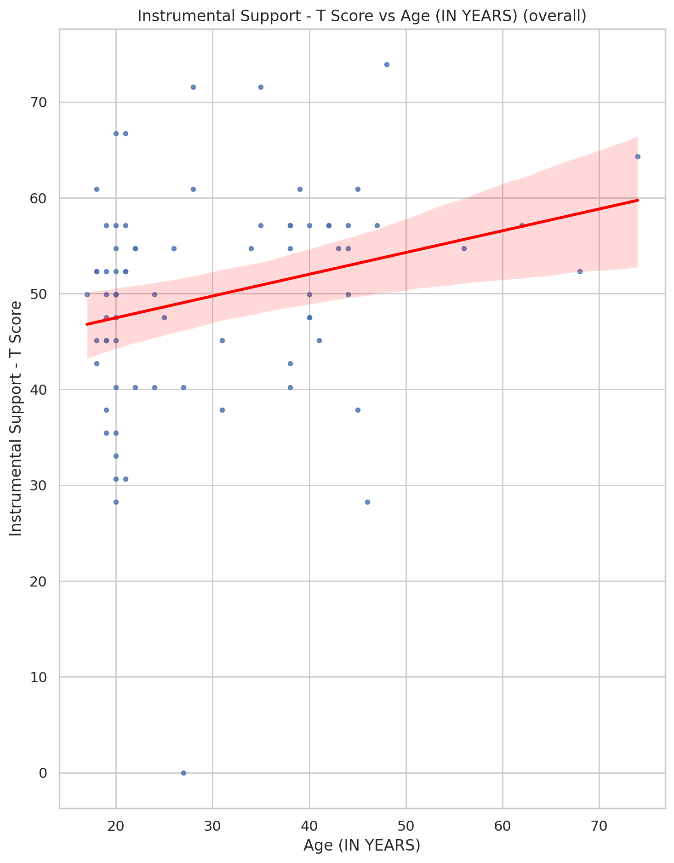

## Emotional Support - Rank vs Age (IN YEARS)

Test: ANOVA; statistic: 4.990698942305764; p-value: 0.0013305717511732425;

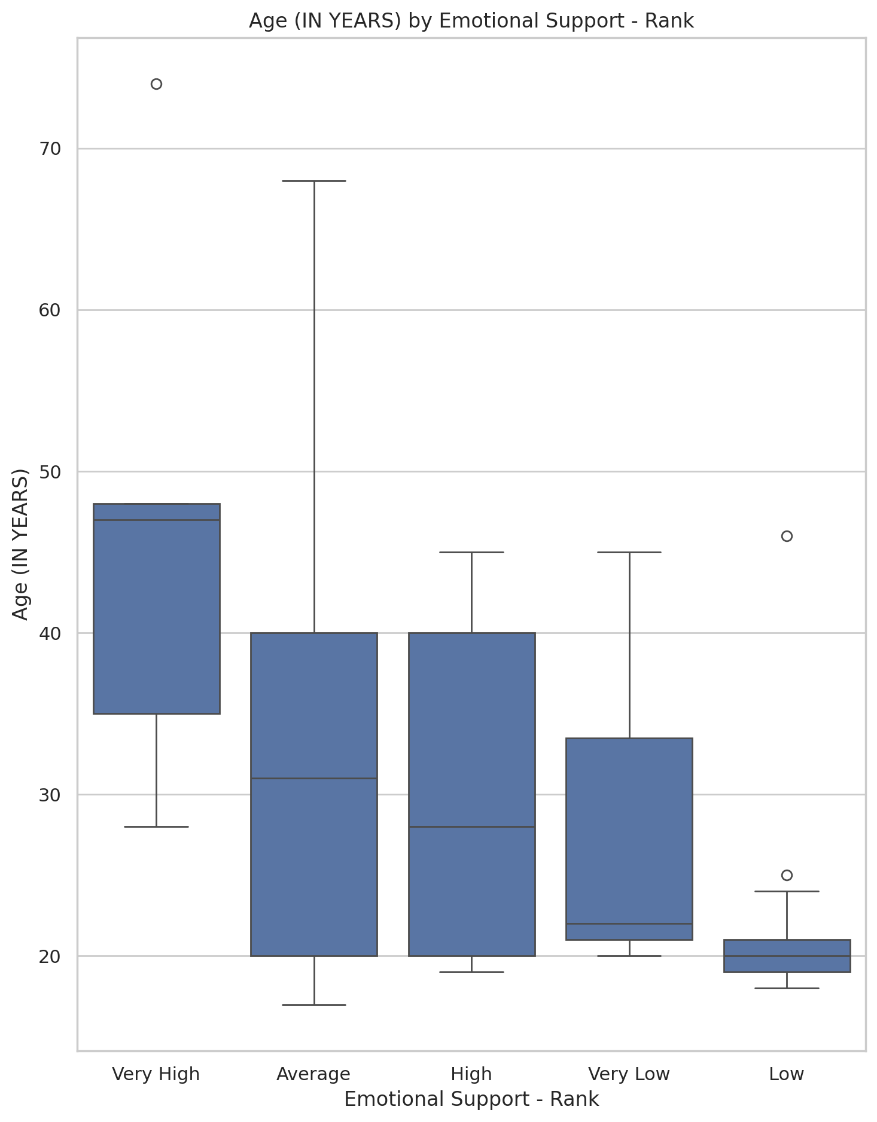

## Informational Support - Rank vs Age (IN YEARS)

Test: ANOVA; statistic: 3.2616858489813625; p-value: 0.016323370644667306;

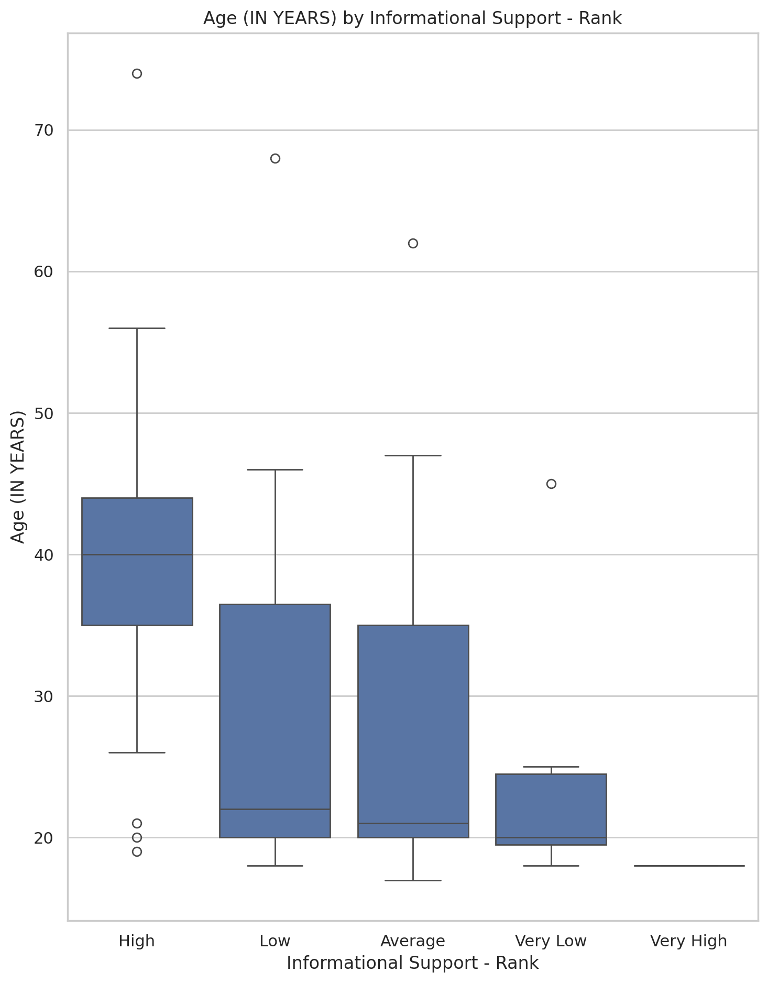

## Instrumental Support - Rank vs Age (IN YEARS)

Test: ANOVA; statistic: 2.1101023066013256; p-value: 0.08848765724930135;

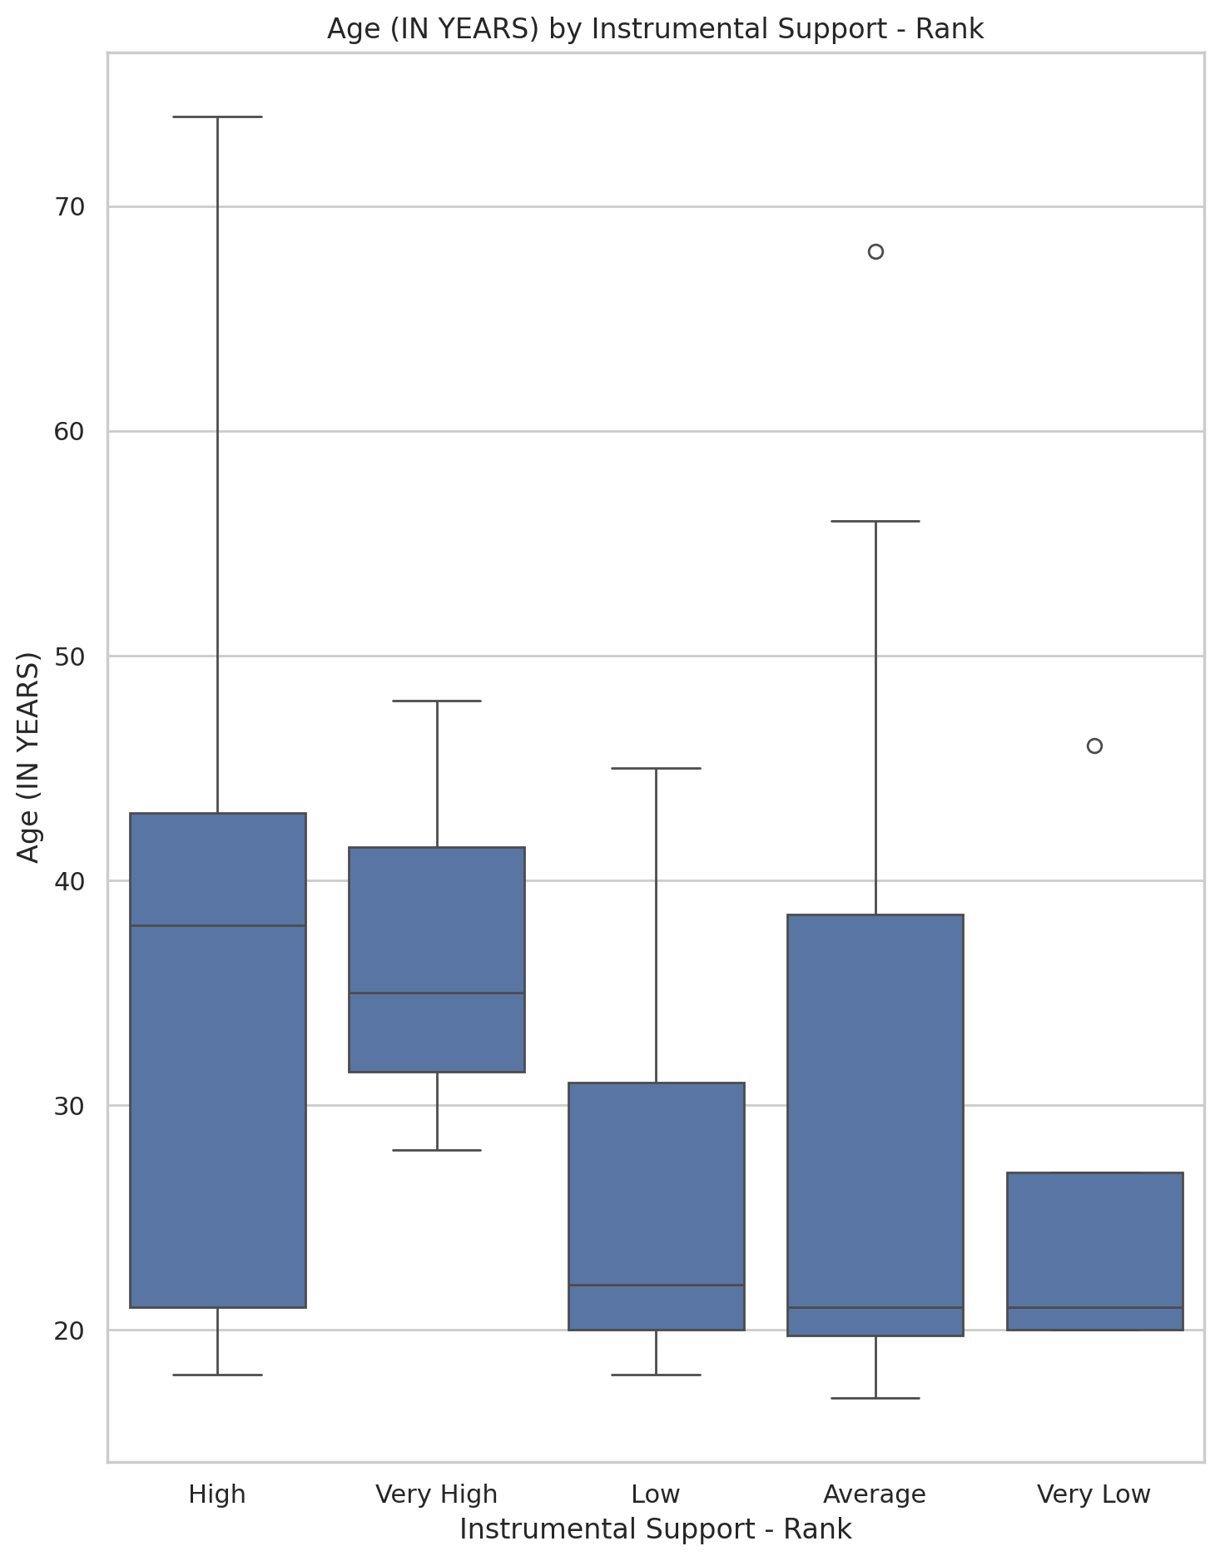

## Real Self Concept Total Category vs Age (IN YEARS)

Test: ANOVA; statistic: 6.85260985309928; p-value: 0.0018734108149392247;

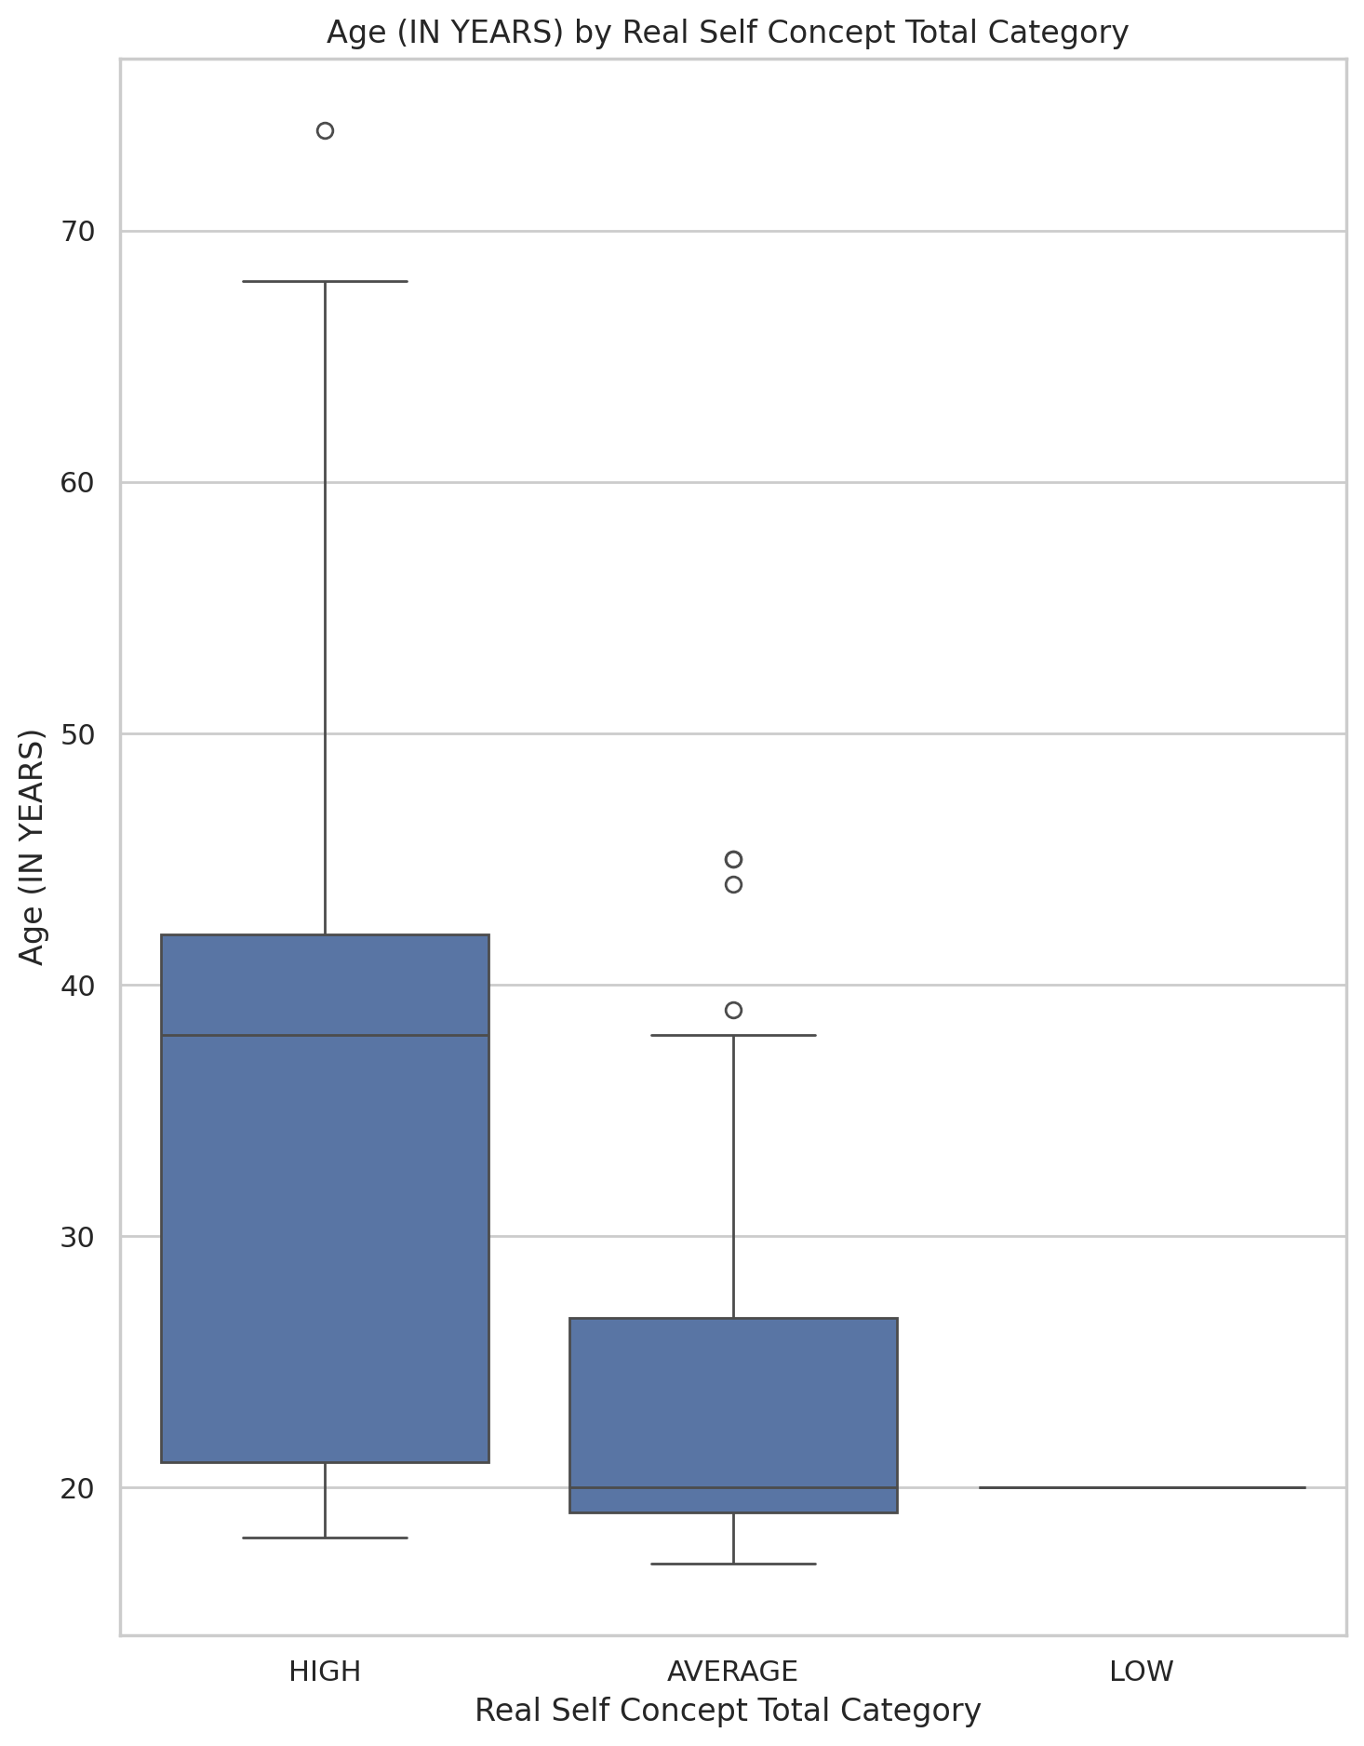

## Ideal Self Concept Total Category vs Age (IN YEARS)

Test: ANOVA; statistic: 3.997419608359945; p-value: 0.04924189830848793;

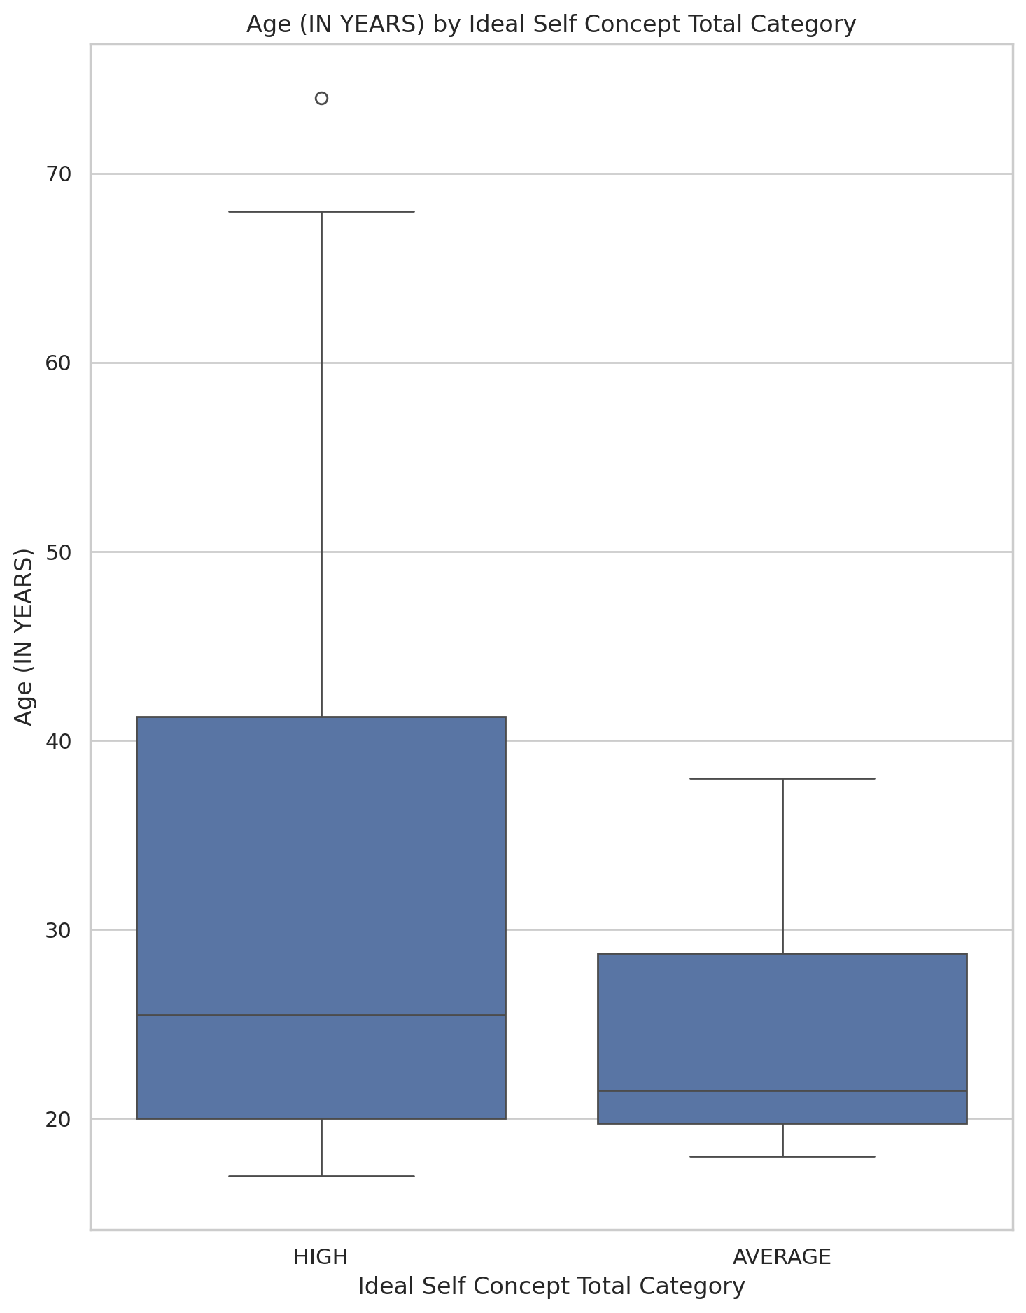

## Social Self Concept Total Category vs Age (IN YEARS)

Test: ANOVA; statistic: 7.89303867966375; p-value: 0.0007883093513310721;

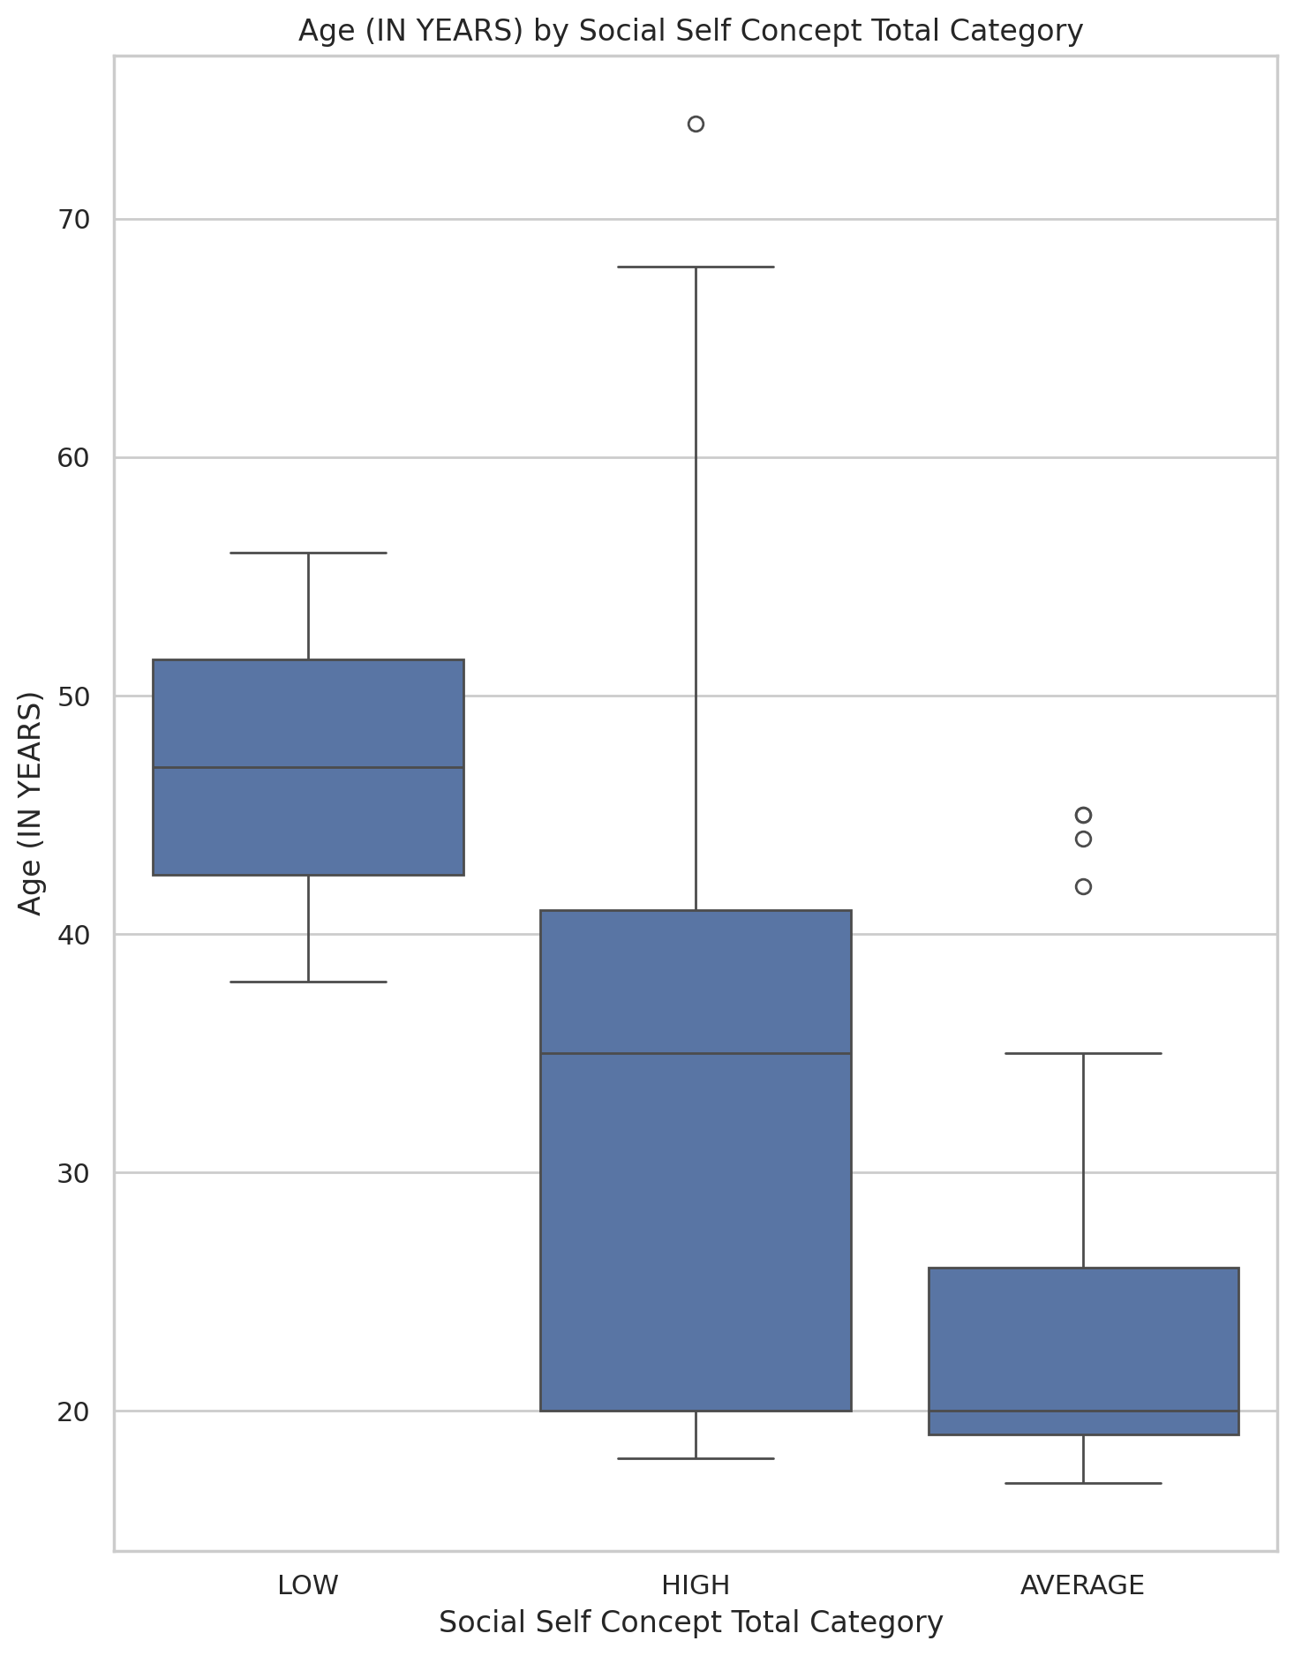

## Emotional Support - T Score vs Marital Status

Test: ANOVA; statistic: 17.43444525421392; p-value: 7.846651663551928e-05;

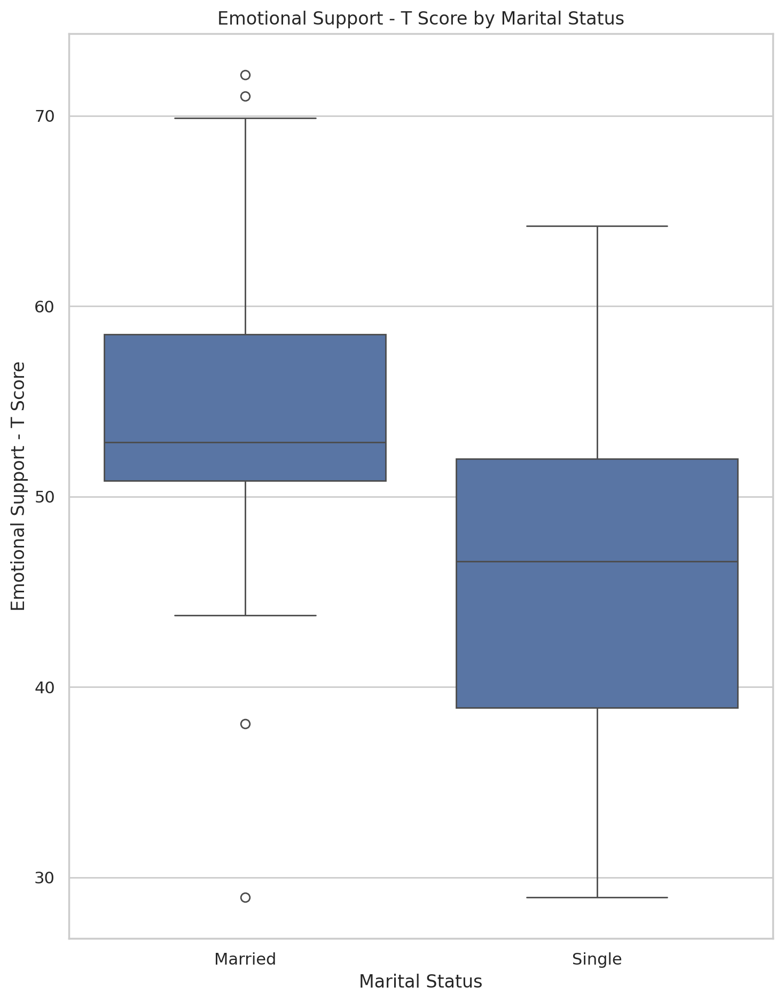

## Informational Support - T Score vs Marital Status

Test: ANOVA; statistic: 2.2122841713247925; p-value: 0.14105315940974203;

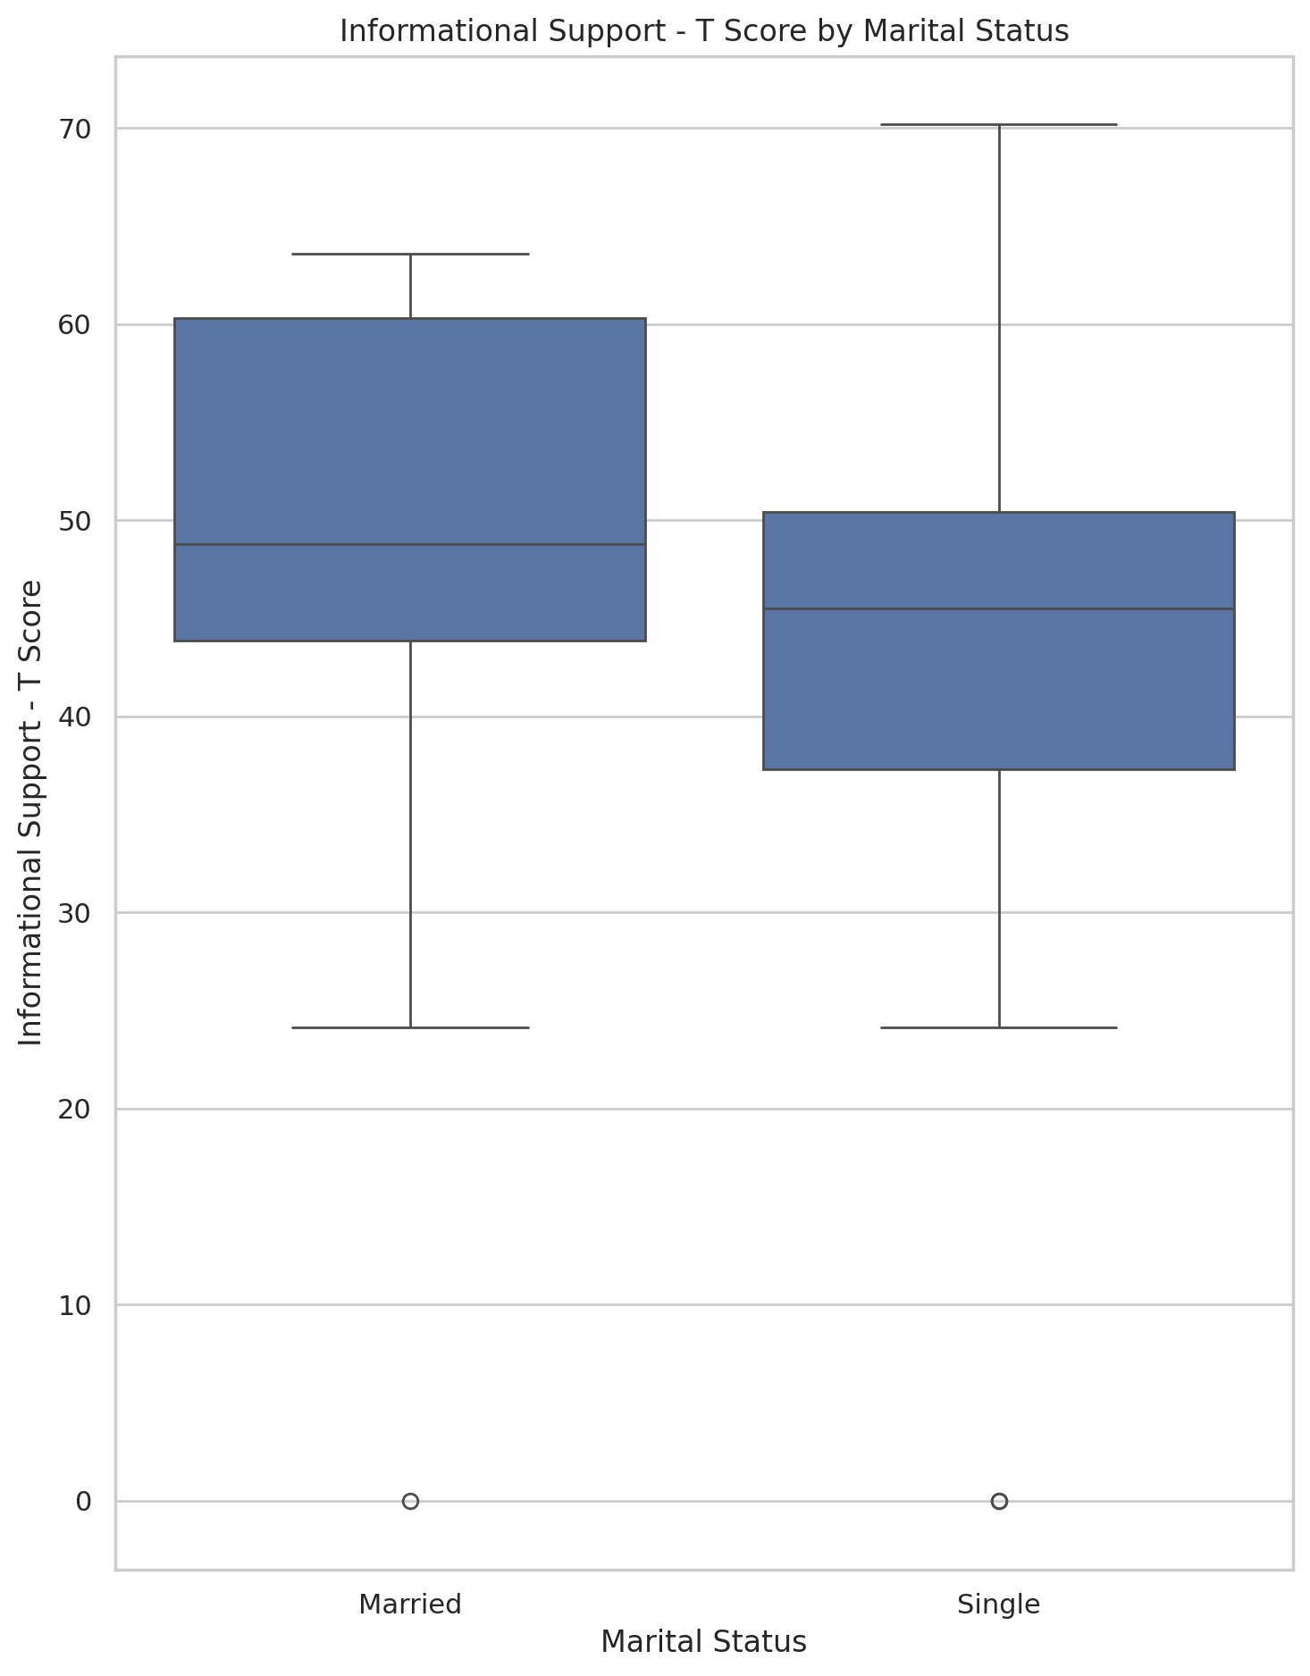

## Instrumental Support - T Score vs Marital Status

Test: ANOVA; statistic: 6.04056076612339; p-value: 0.01625902608553172;

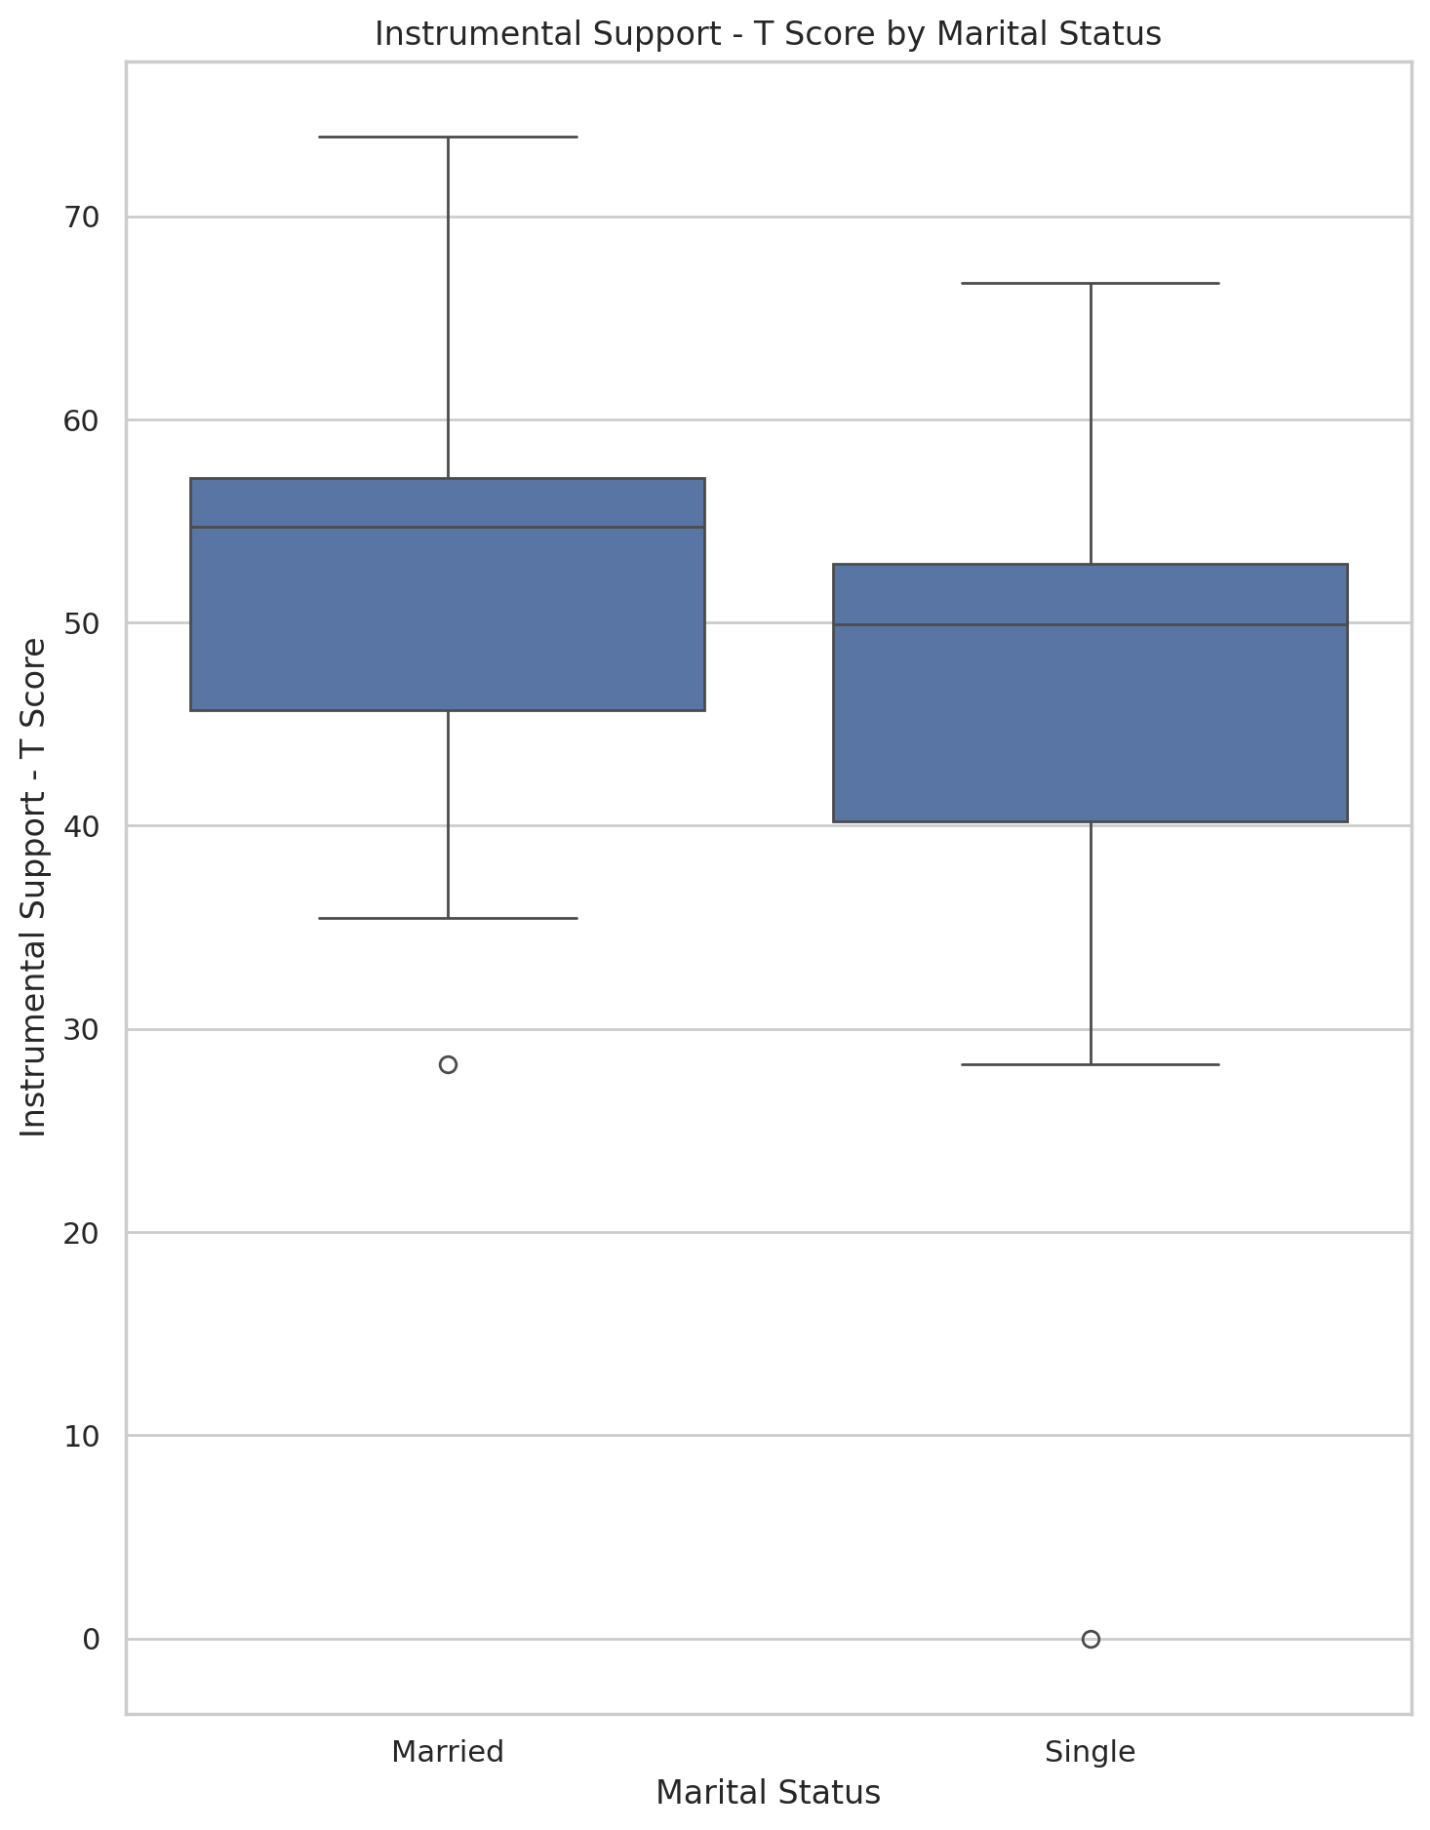

## Emotional Support - Rank vs Marital Status

Test: chi2; statistic: 16.226766113143828; p-value: 0.0027294939374630407;

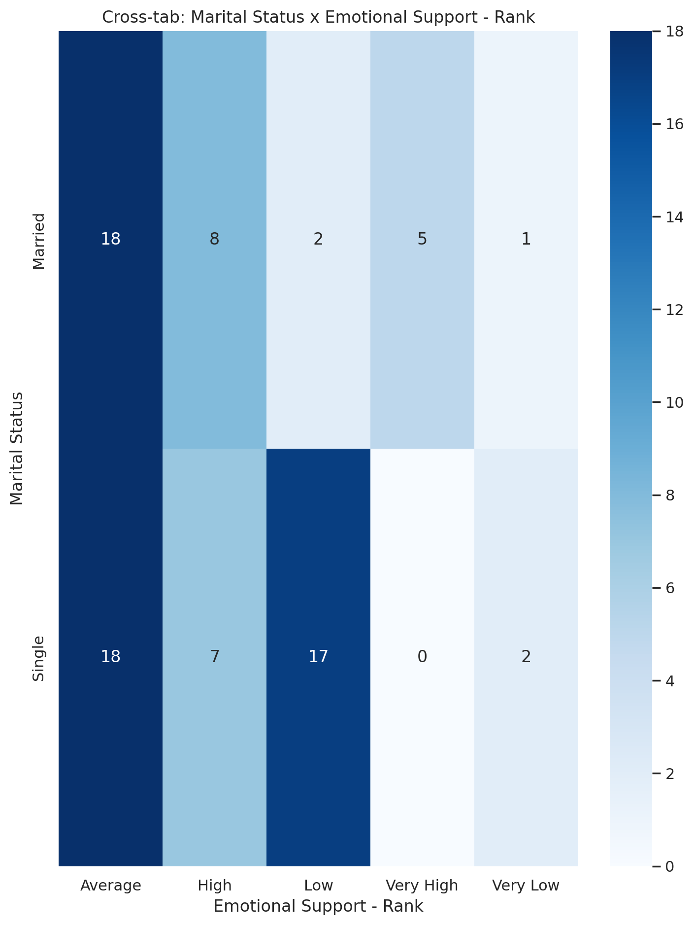

## Informational Support - Rank vs Marital Status

Test: chi2; statistic: 5.951700089126561; p-value: 0.2027844936195962;

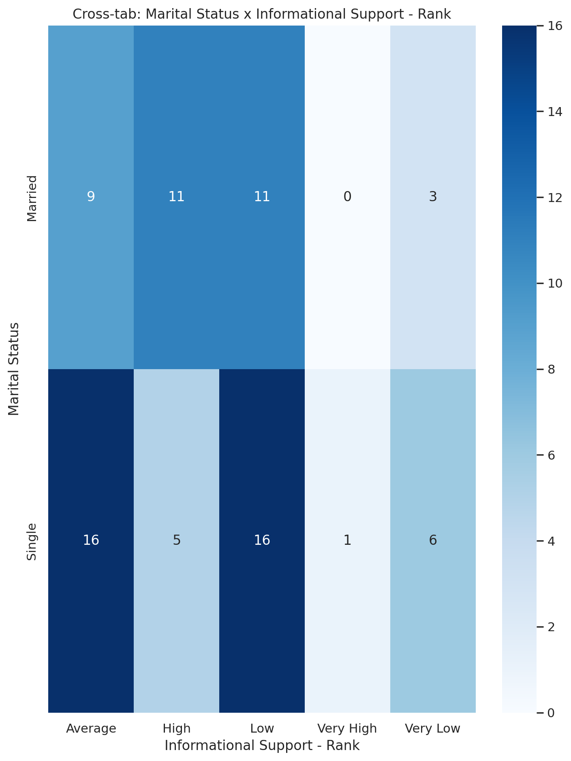

## Instrumental Support - Rank vs Marital Status

Test: chi2; statistic: 12.004635649682086; p-value: 0.01731682662745229;

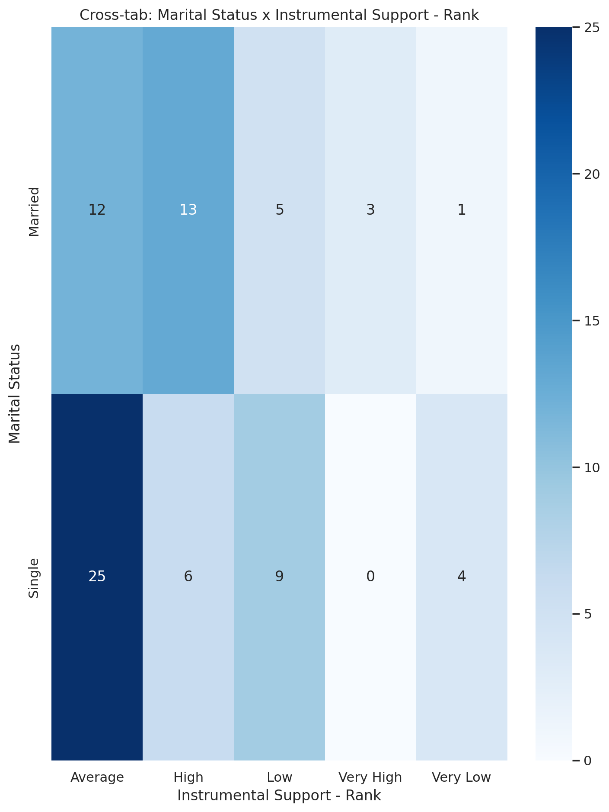

## Real Self Concept Total Category vs Marital Status

Test: chi2; statistic: 9.657639419404127; p-value: 0.007995953244661487;

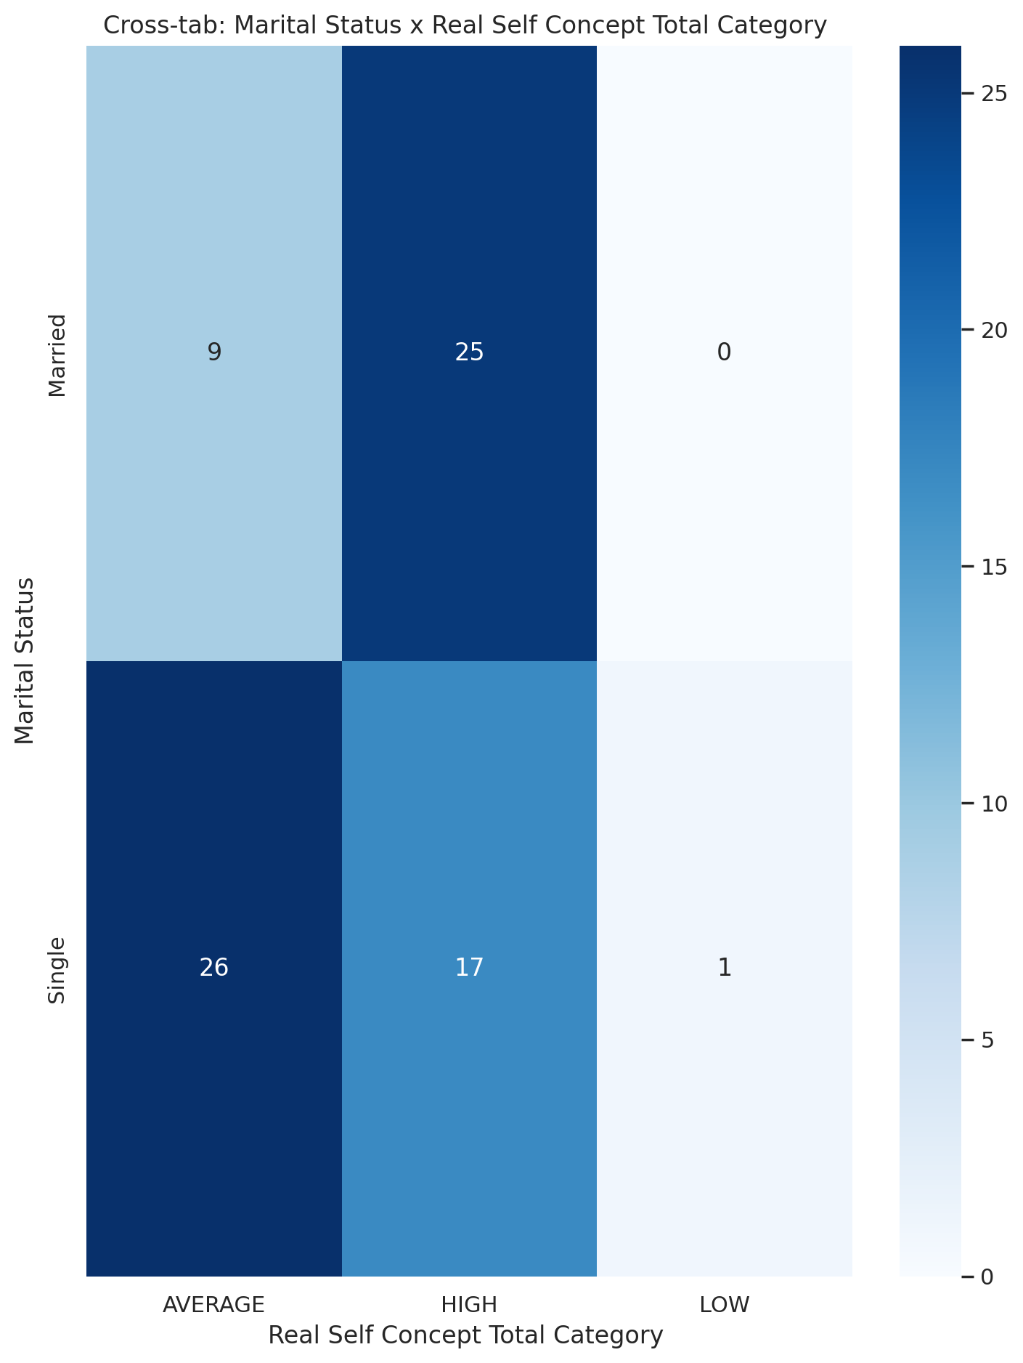

## Ideal Self Concept Total Category vs Marital Status

Test: chi2; statistic: 0.25345505082018777; p-value: 0.6146527087056158;

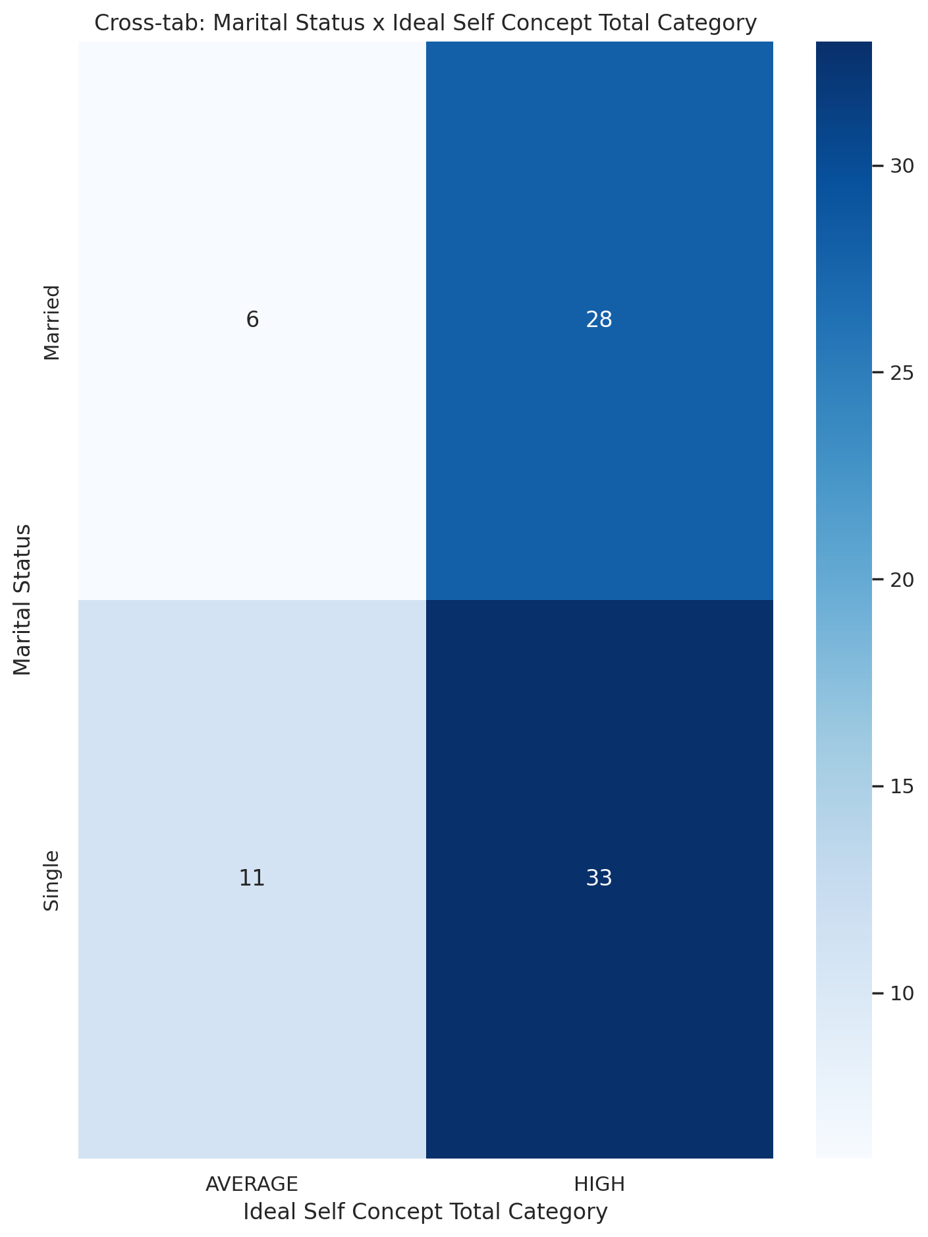

## Social Self Concept Total Category vs Marital Status

Test: chi2; statistic: 9.934458275288726; p-value: 0.006962413220528244;

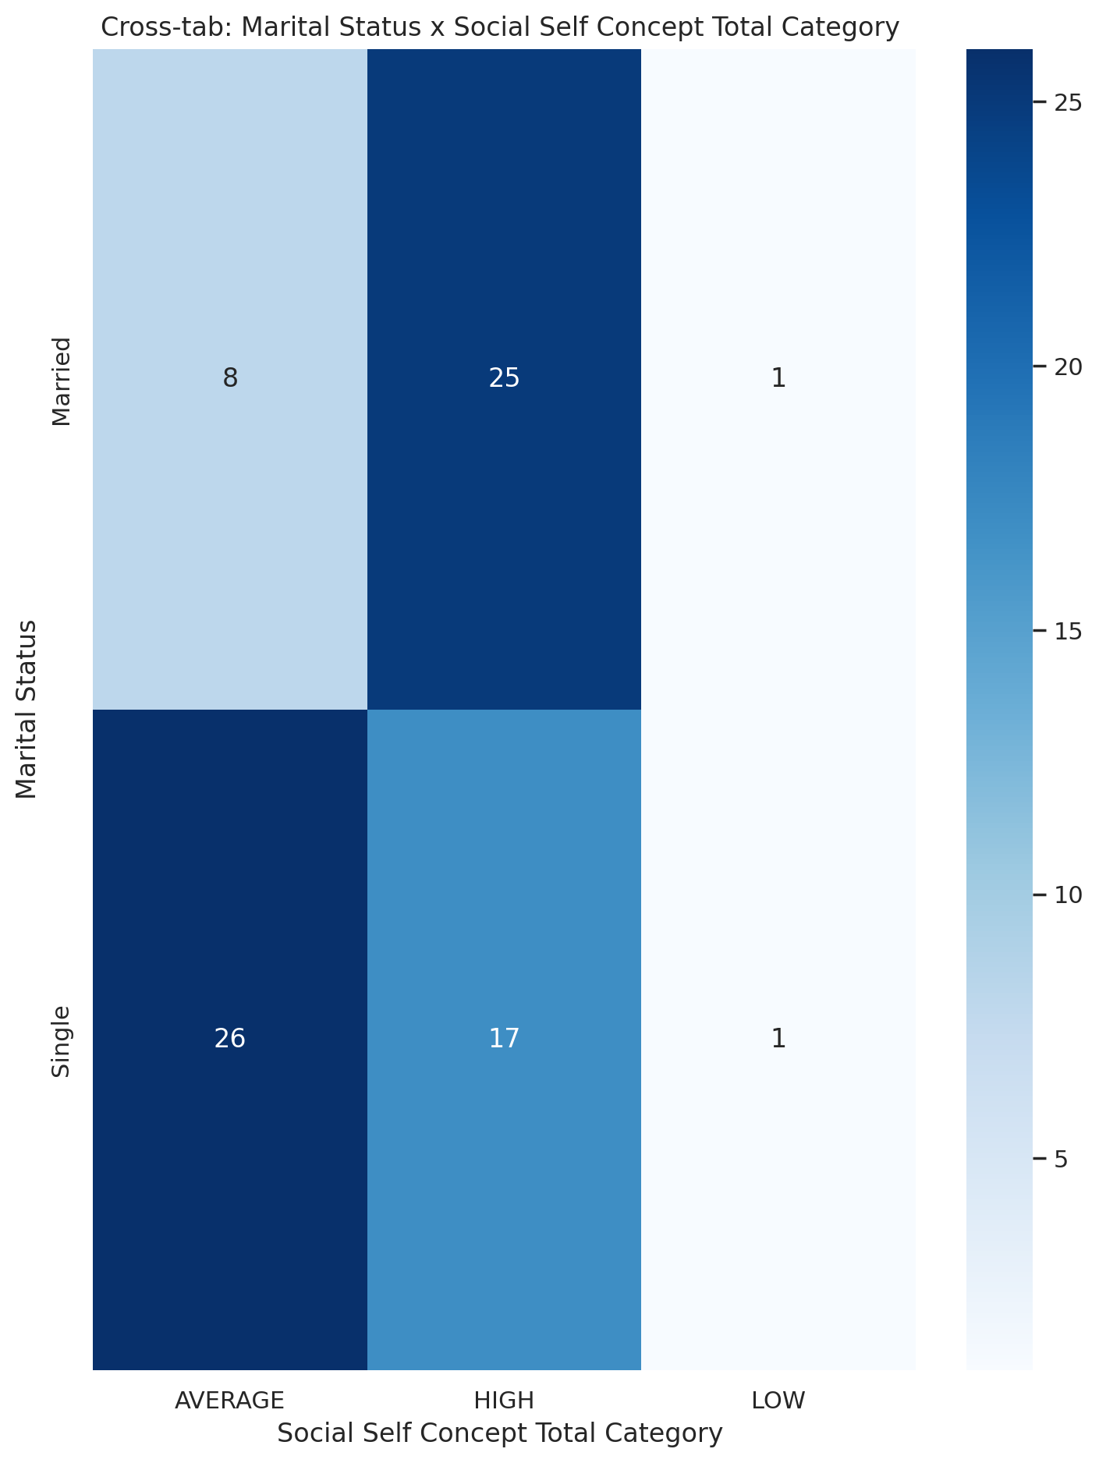

## Emotional Support - T Score vs Highest level of education completed

Test: ANOVA; statistic: 1.879647570887404; p-value: 0.10869712505228146;

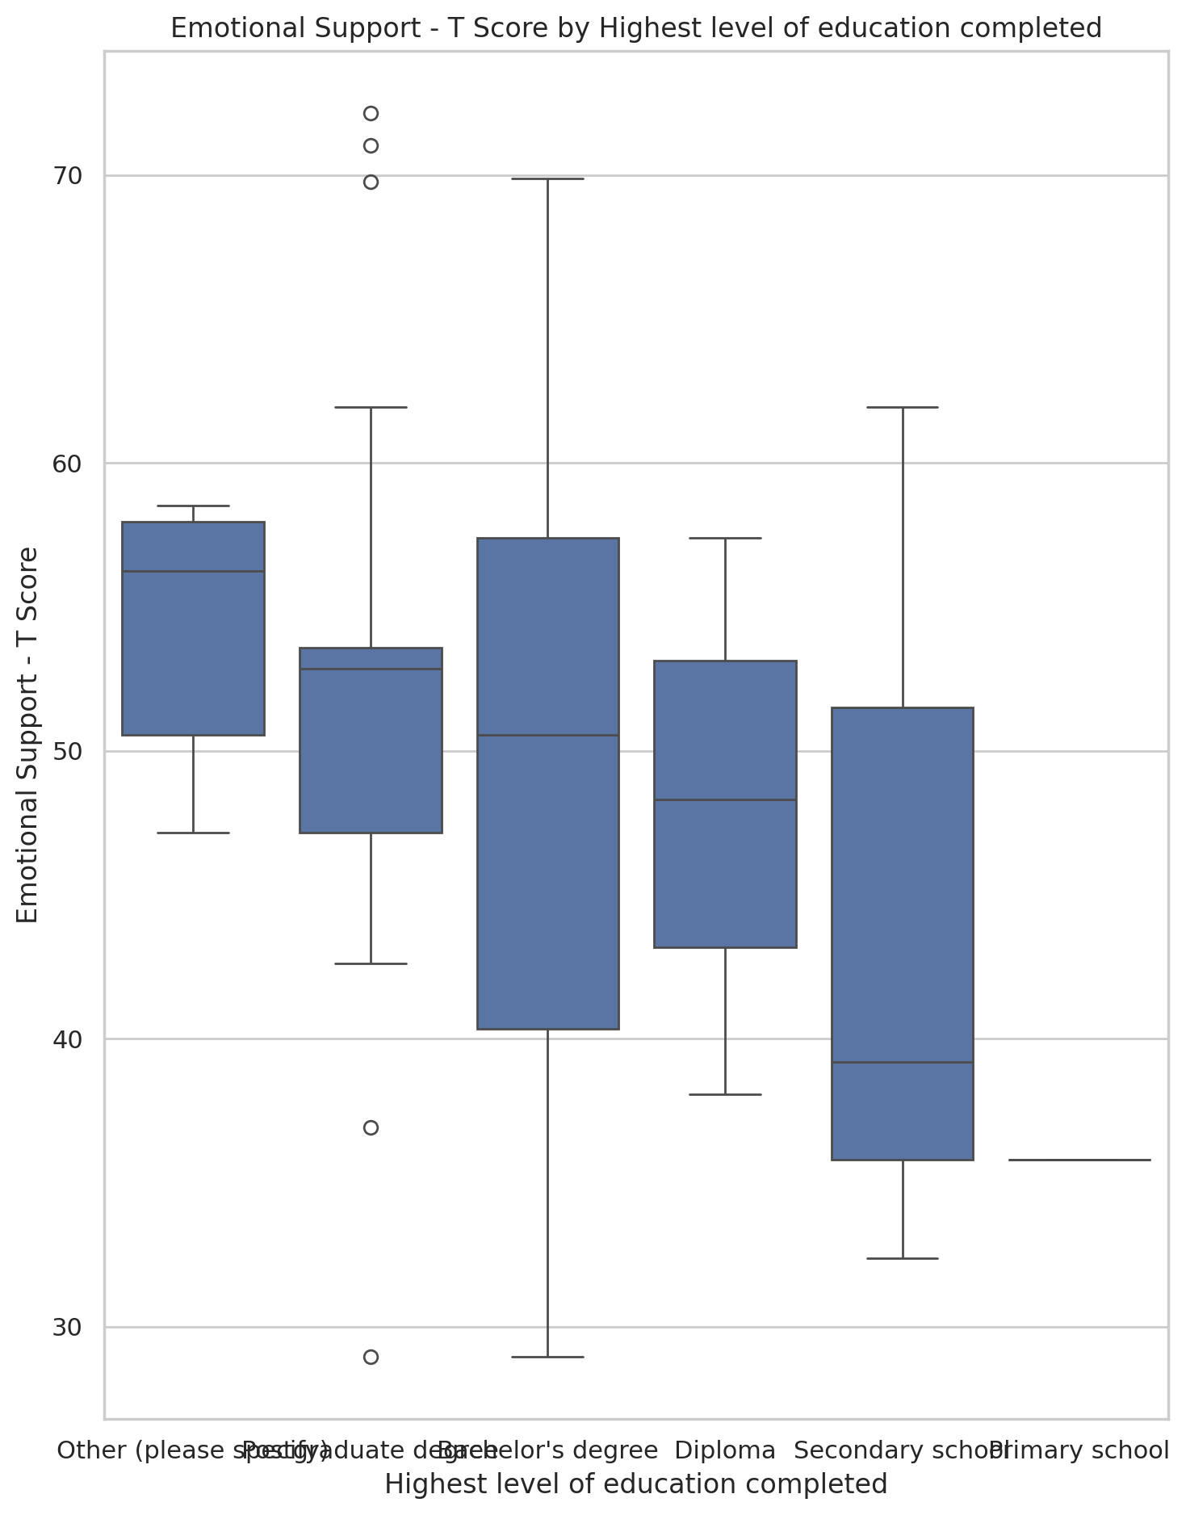

## Informational Support - T Score vs Highest level of education completed

Test: ANOVA; statistic: 1.108099285999988; p-value: 0.3638986532521197;

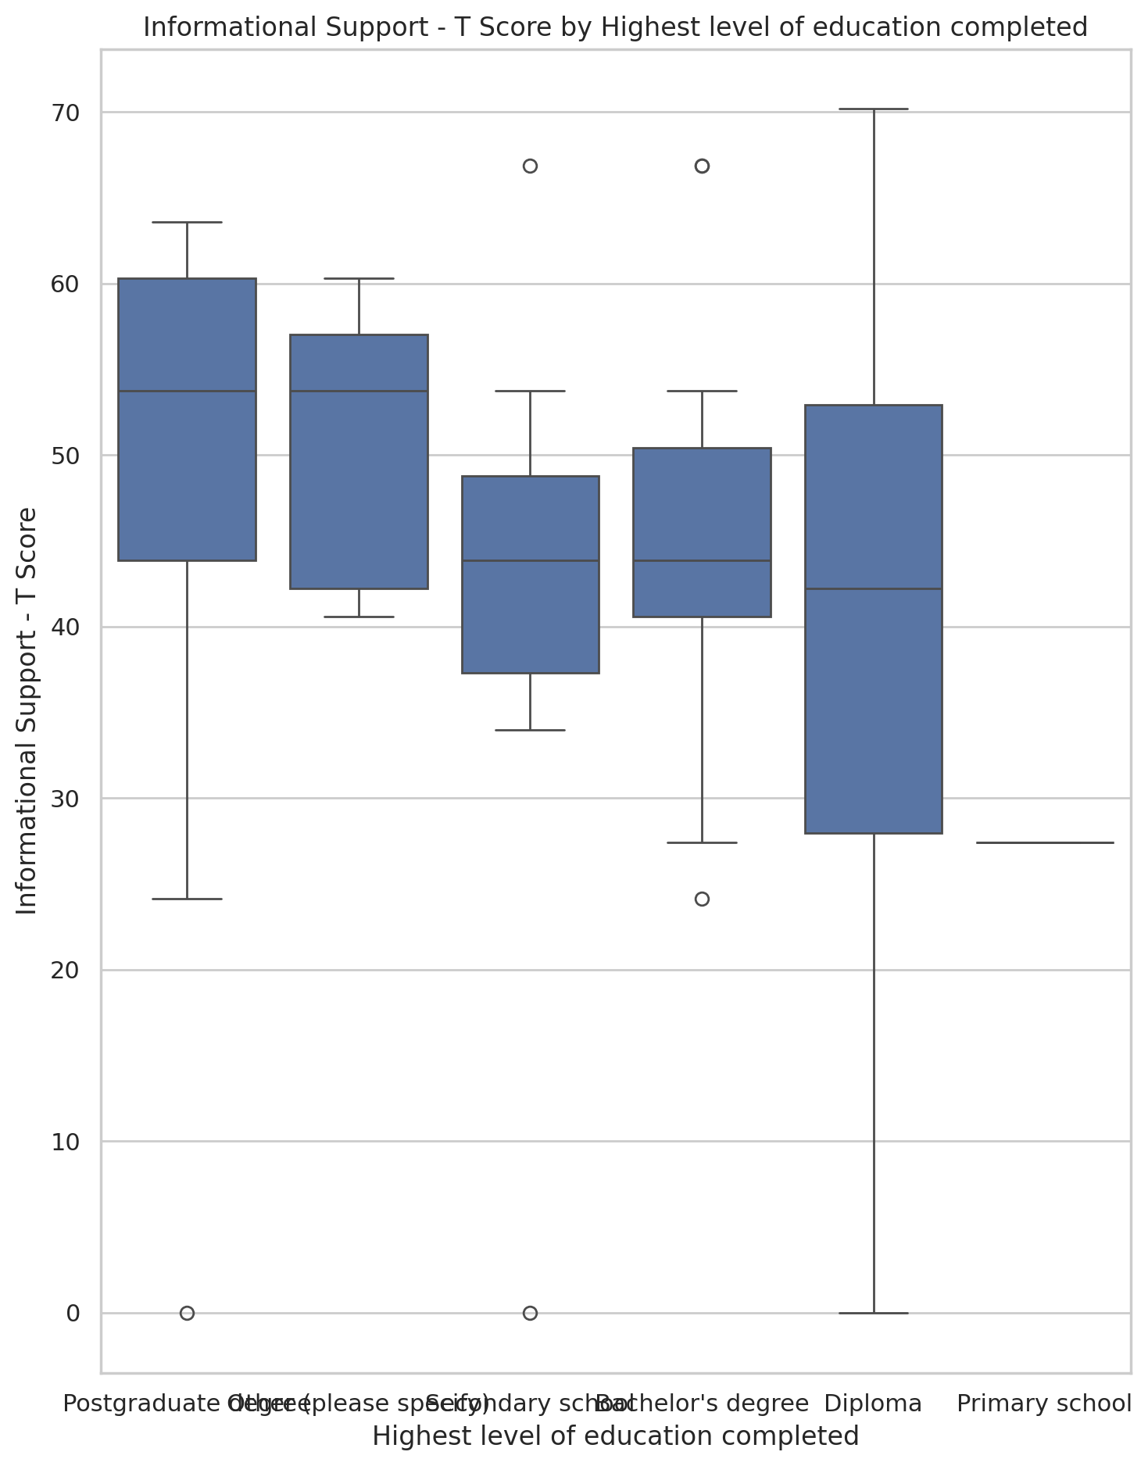

## Instrumental Support - T Score vs Highest level of education completed

Test: ANOVA; statistic: 1.5586255139863974; p-value: 0.18297083866650285;

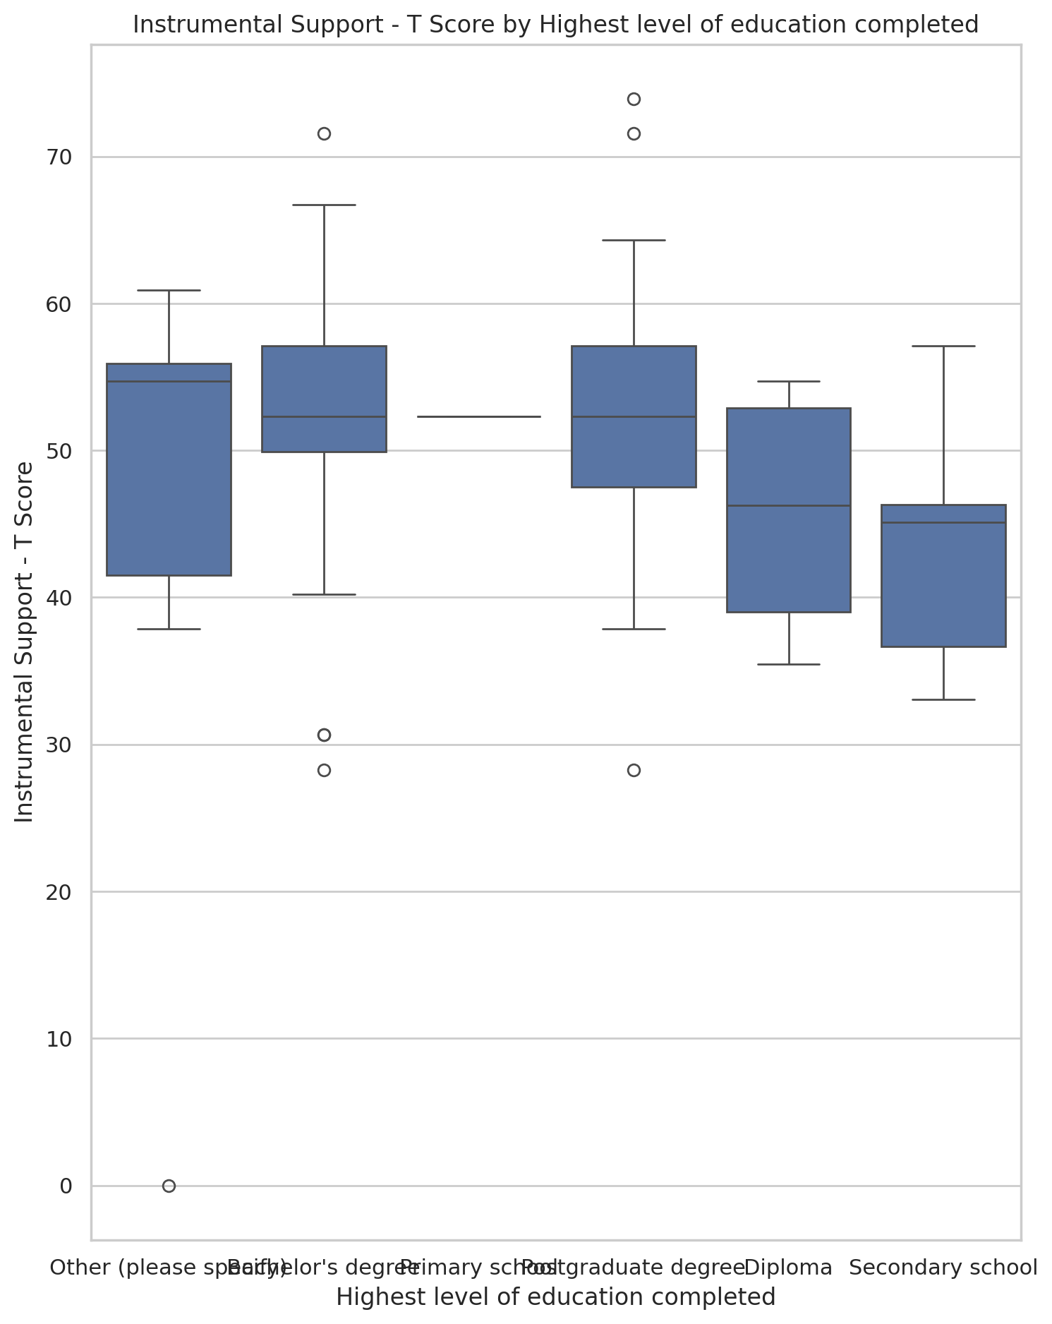

## Emotional Support - Rank vs Highest level of education completed

Test: chi2; statistic: 25.142435024342465; p-value: 0.19603613584515908;

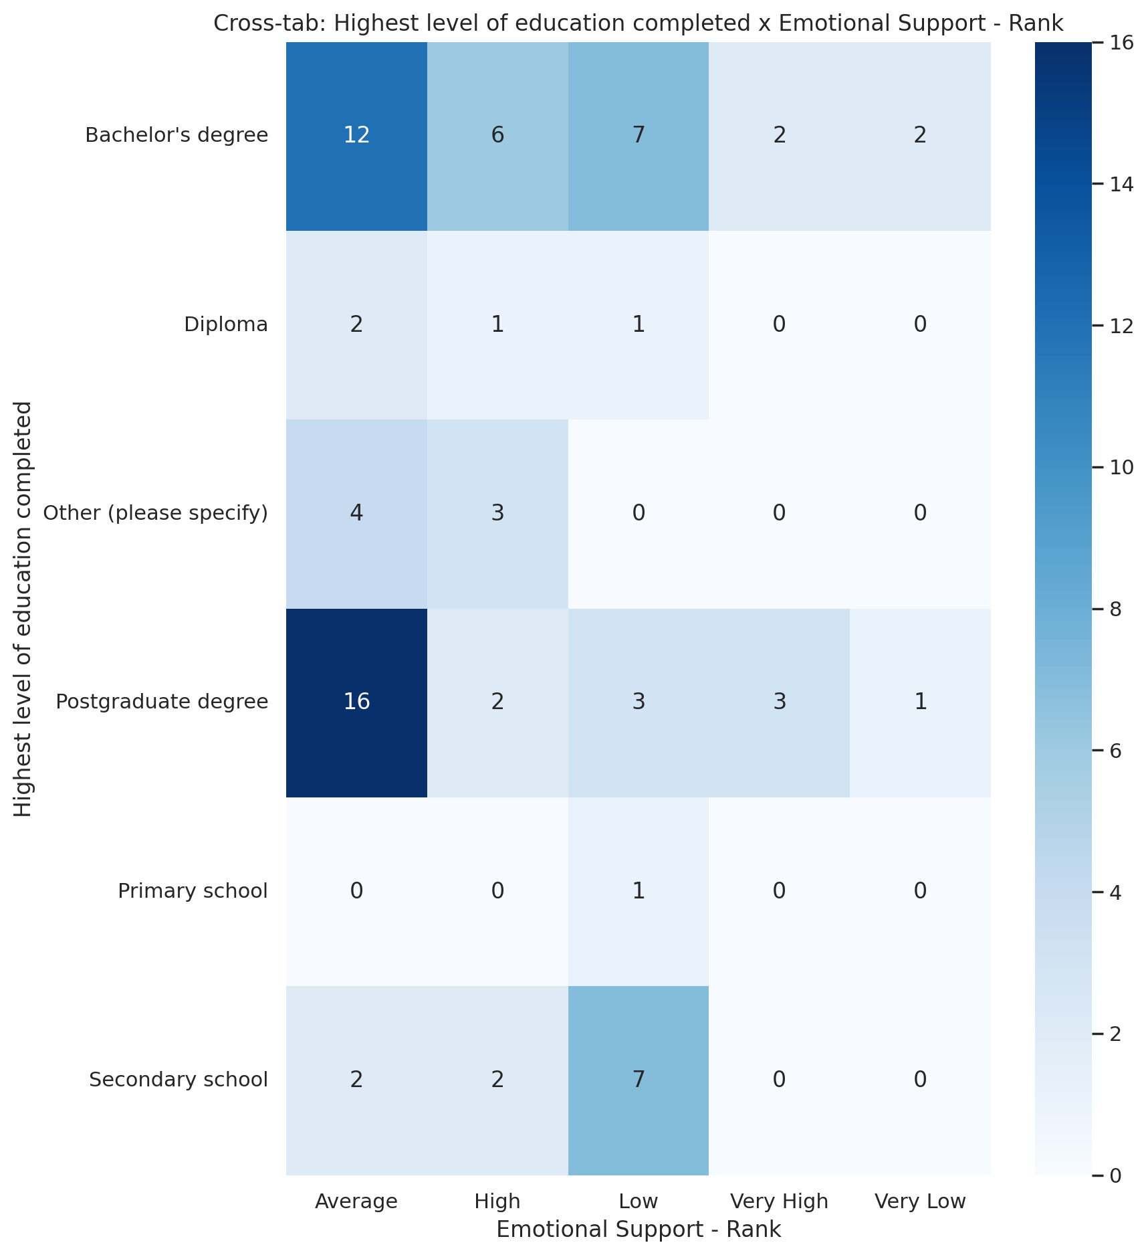

## Informational Support - Rank vs Highest level of education completed

Test: chi2; statistic: 41.96273575007368; p-value: 0.0027966697551860243;

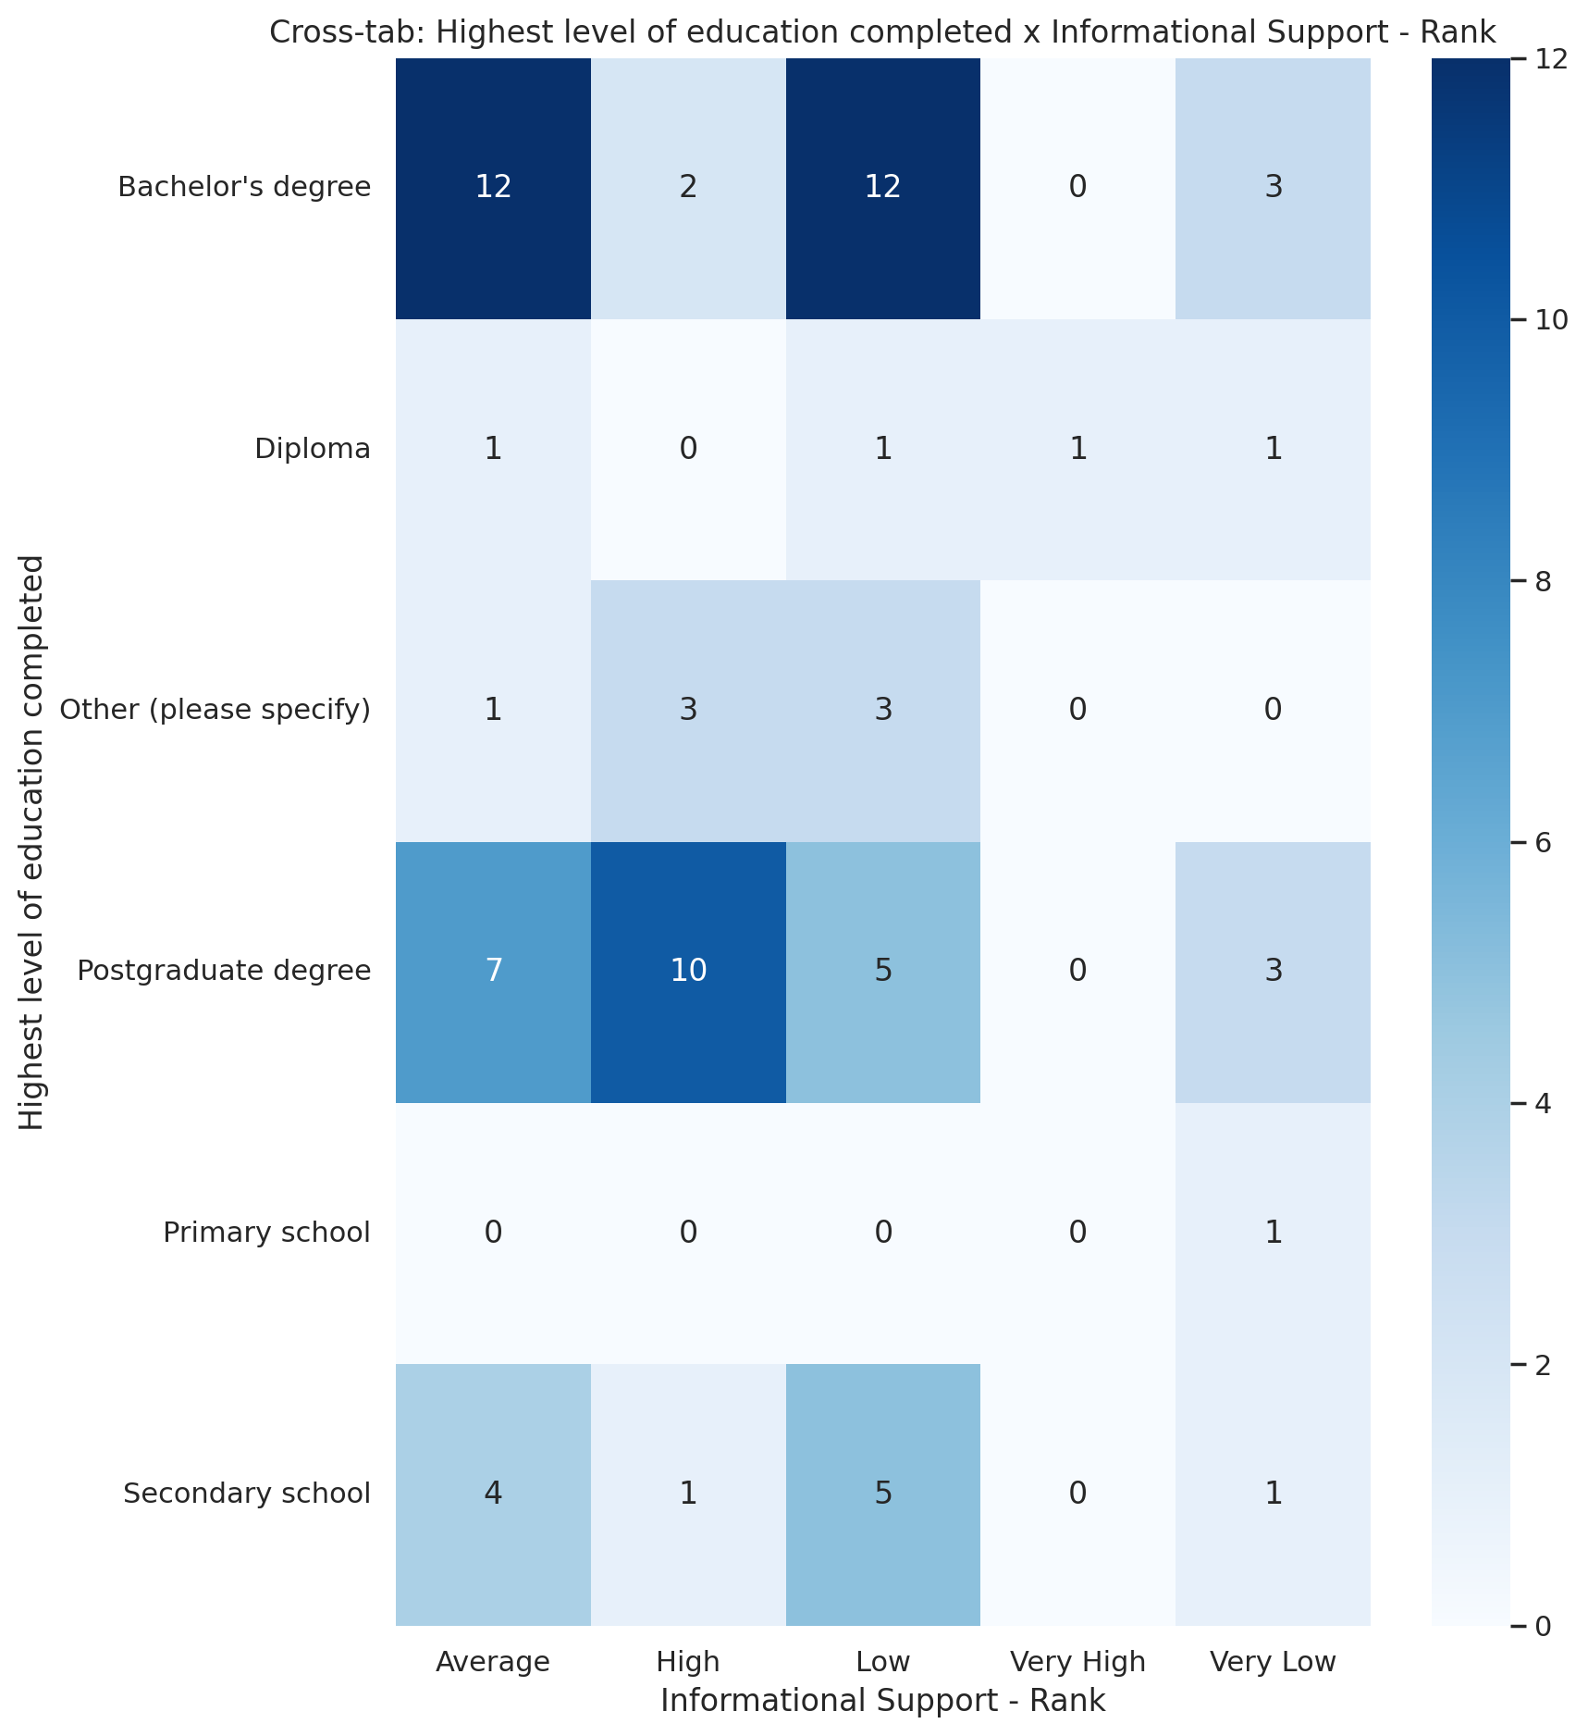

## Instrumental Support - Rank vs Highest level of education completed

Test: chi2; statistic: 17.09607899525141; p-value: 0.646726310522822;

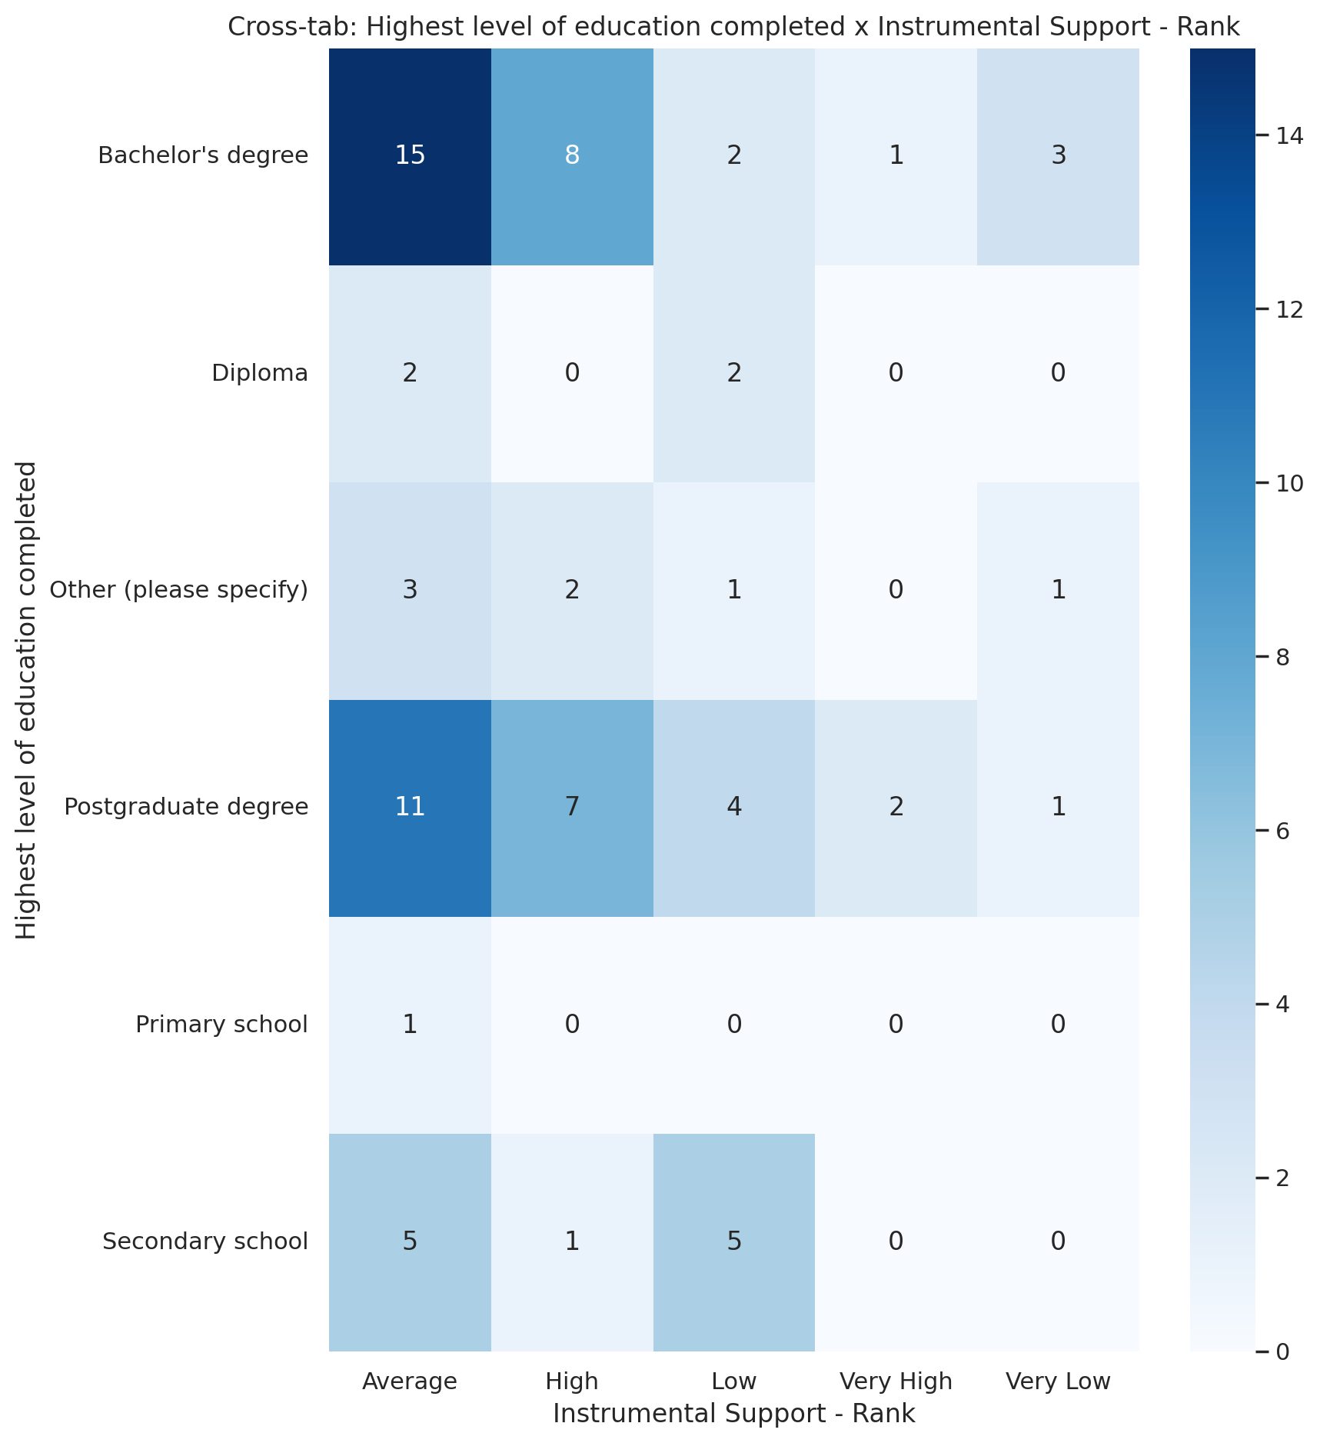

## Real Self Concept Total Category vs Highest level of education completed

Test: chi2; statistic: 7.112484400656814; p-value: 0.21240822344162913;

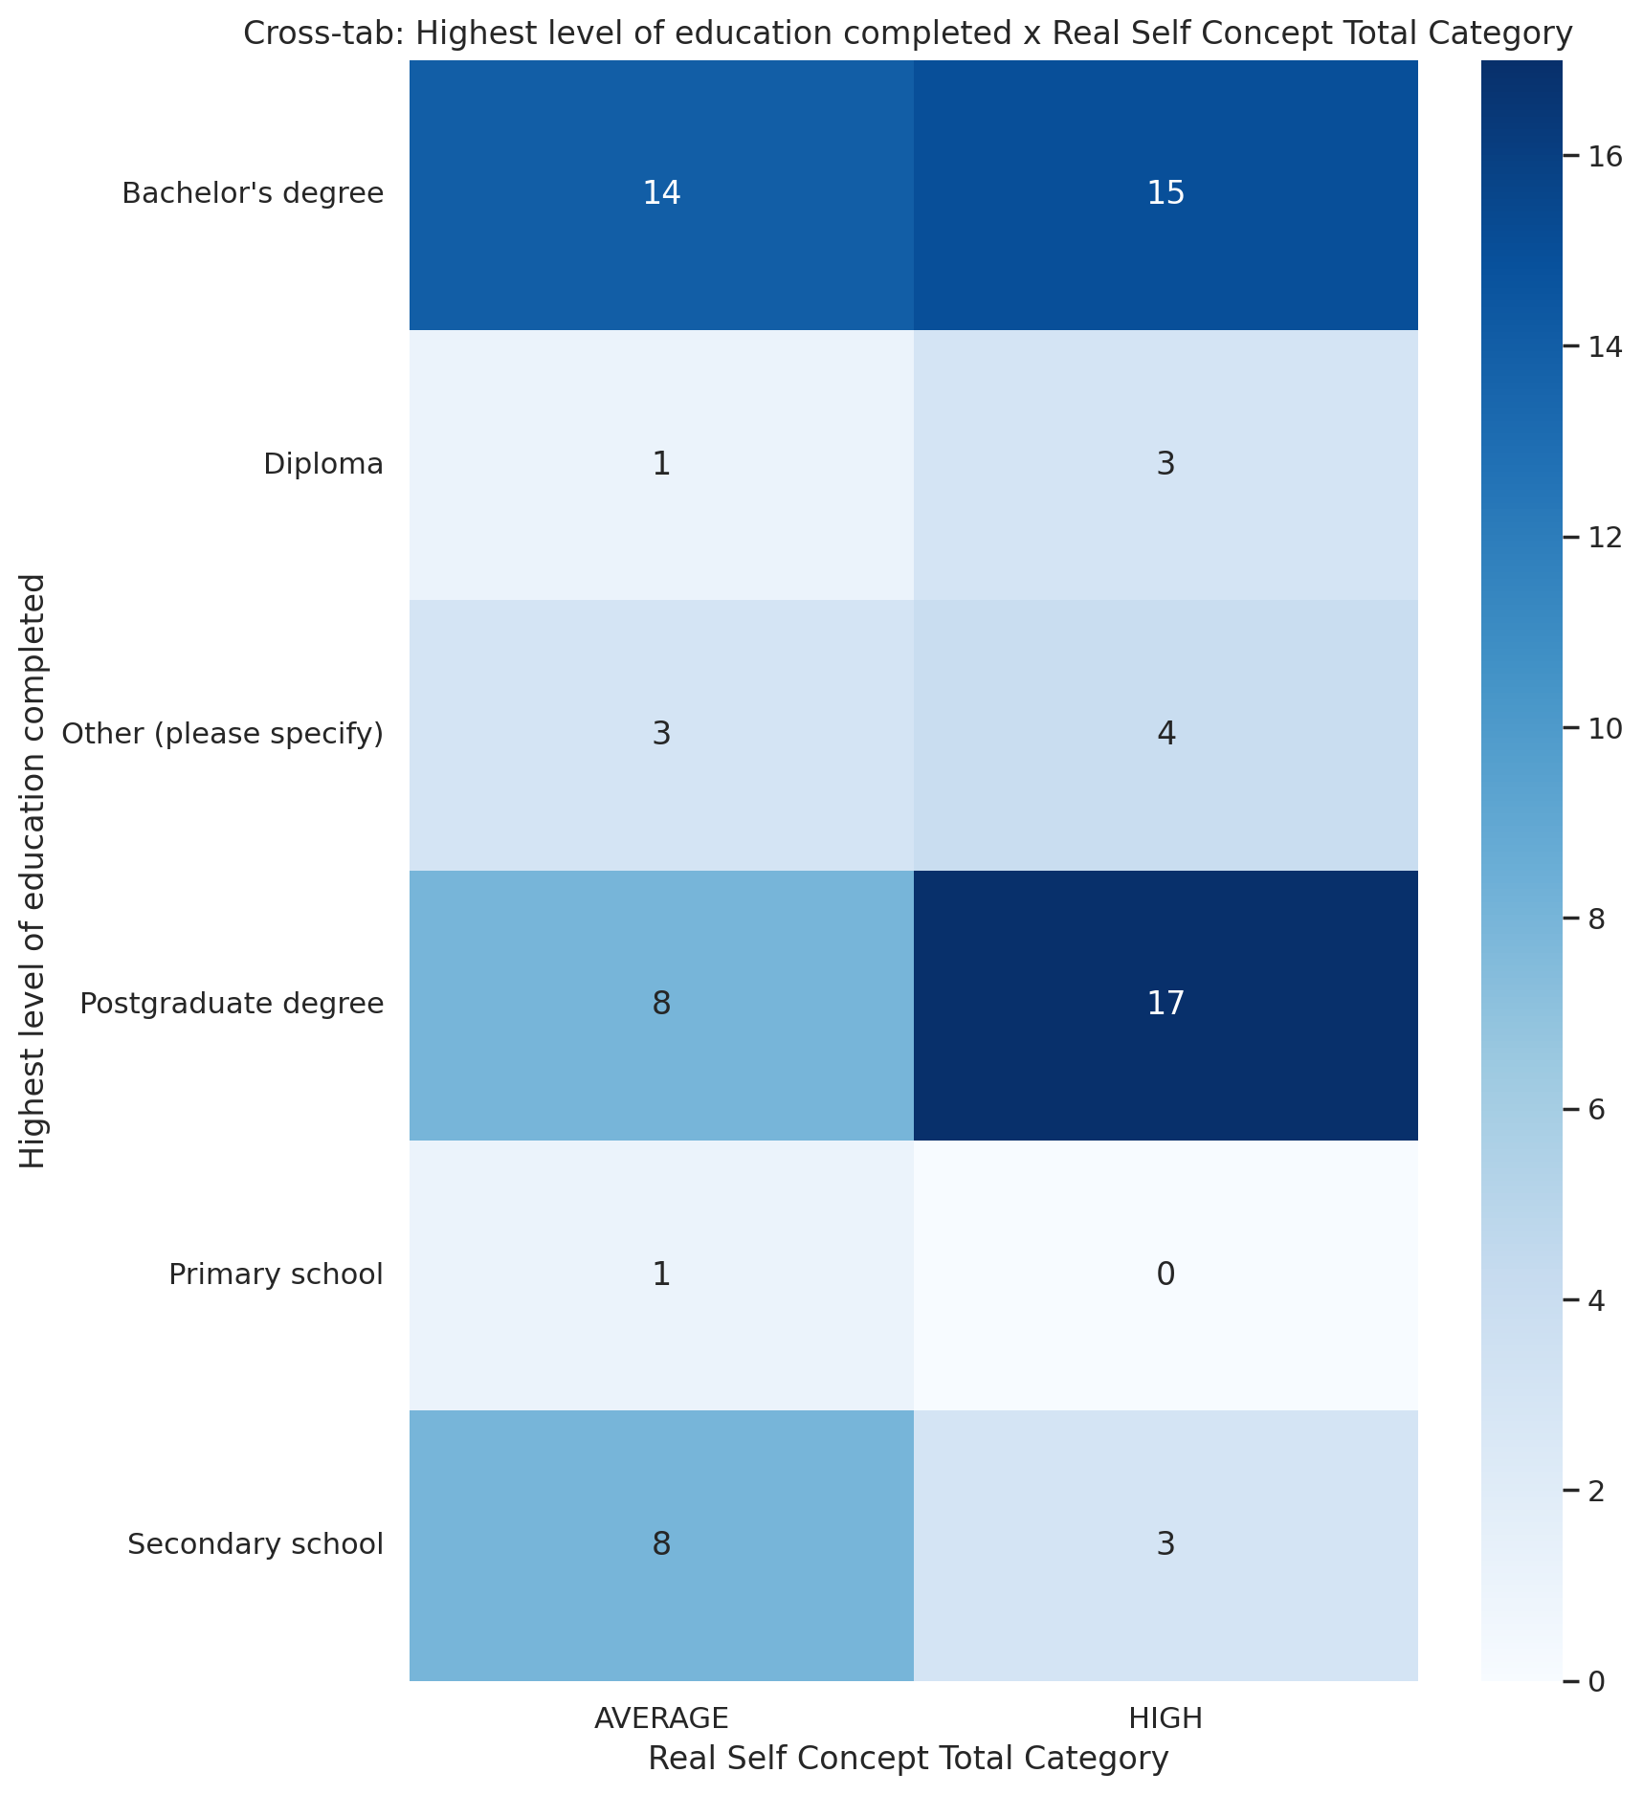

## Ideal Self Concept Total Category vs Highest level of education completed

Test: chi2; statistic: 6.757957885811192; p-value: 0.2392725479260407;

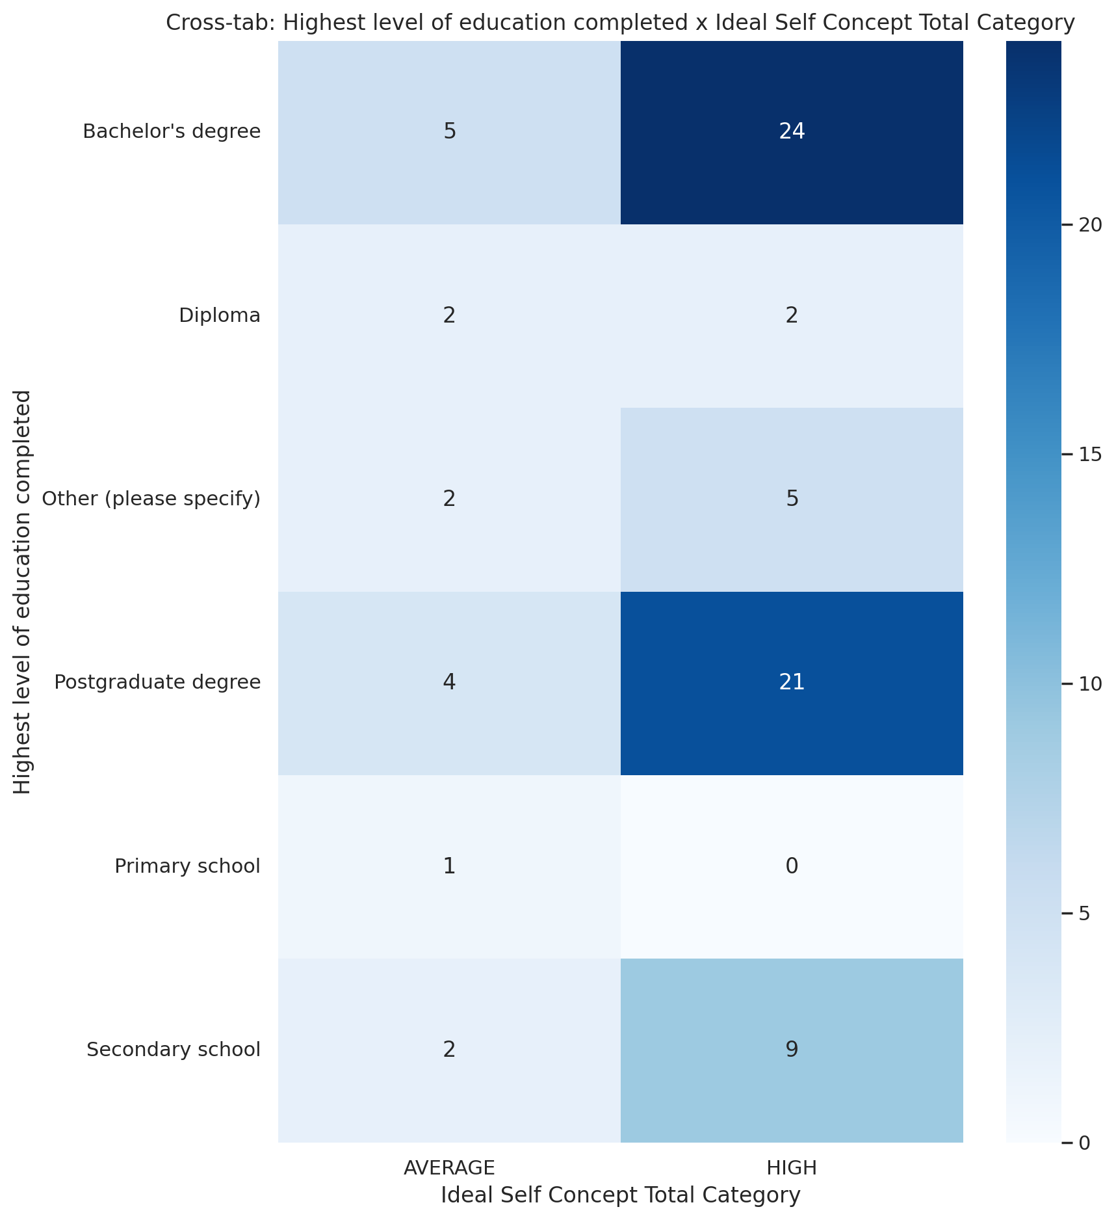

## Social Self Concept Total Category vs Highest level of education completed

Test: chi2; statistic: 11.266233766233766; p-value: 0.3371556770681682;

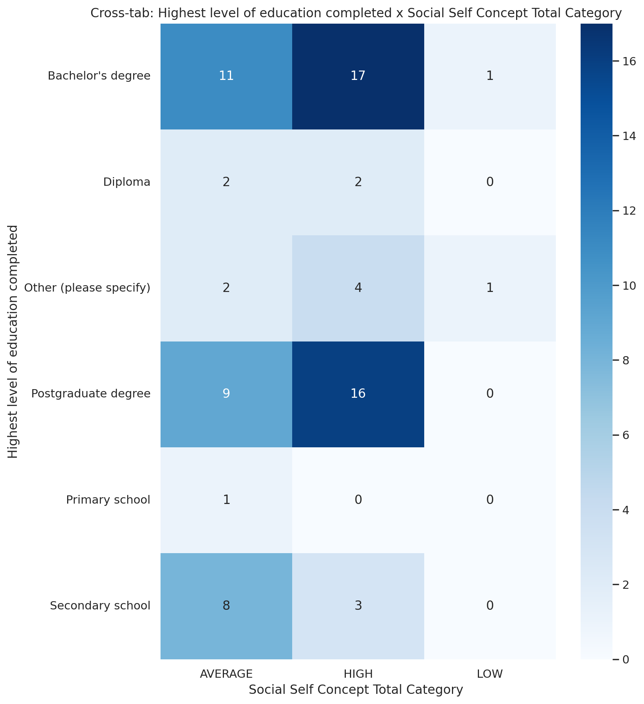

## Emotional Support - T Score vs Current Employment Status

Test: ANOVA; statistic: 2.670386759136185; p-value: 0.021628080833388498;

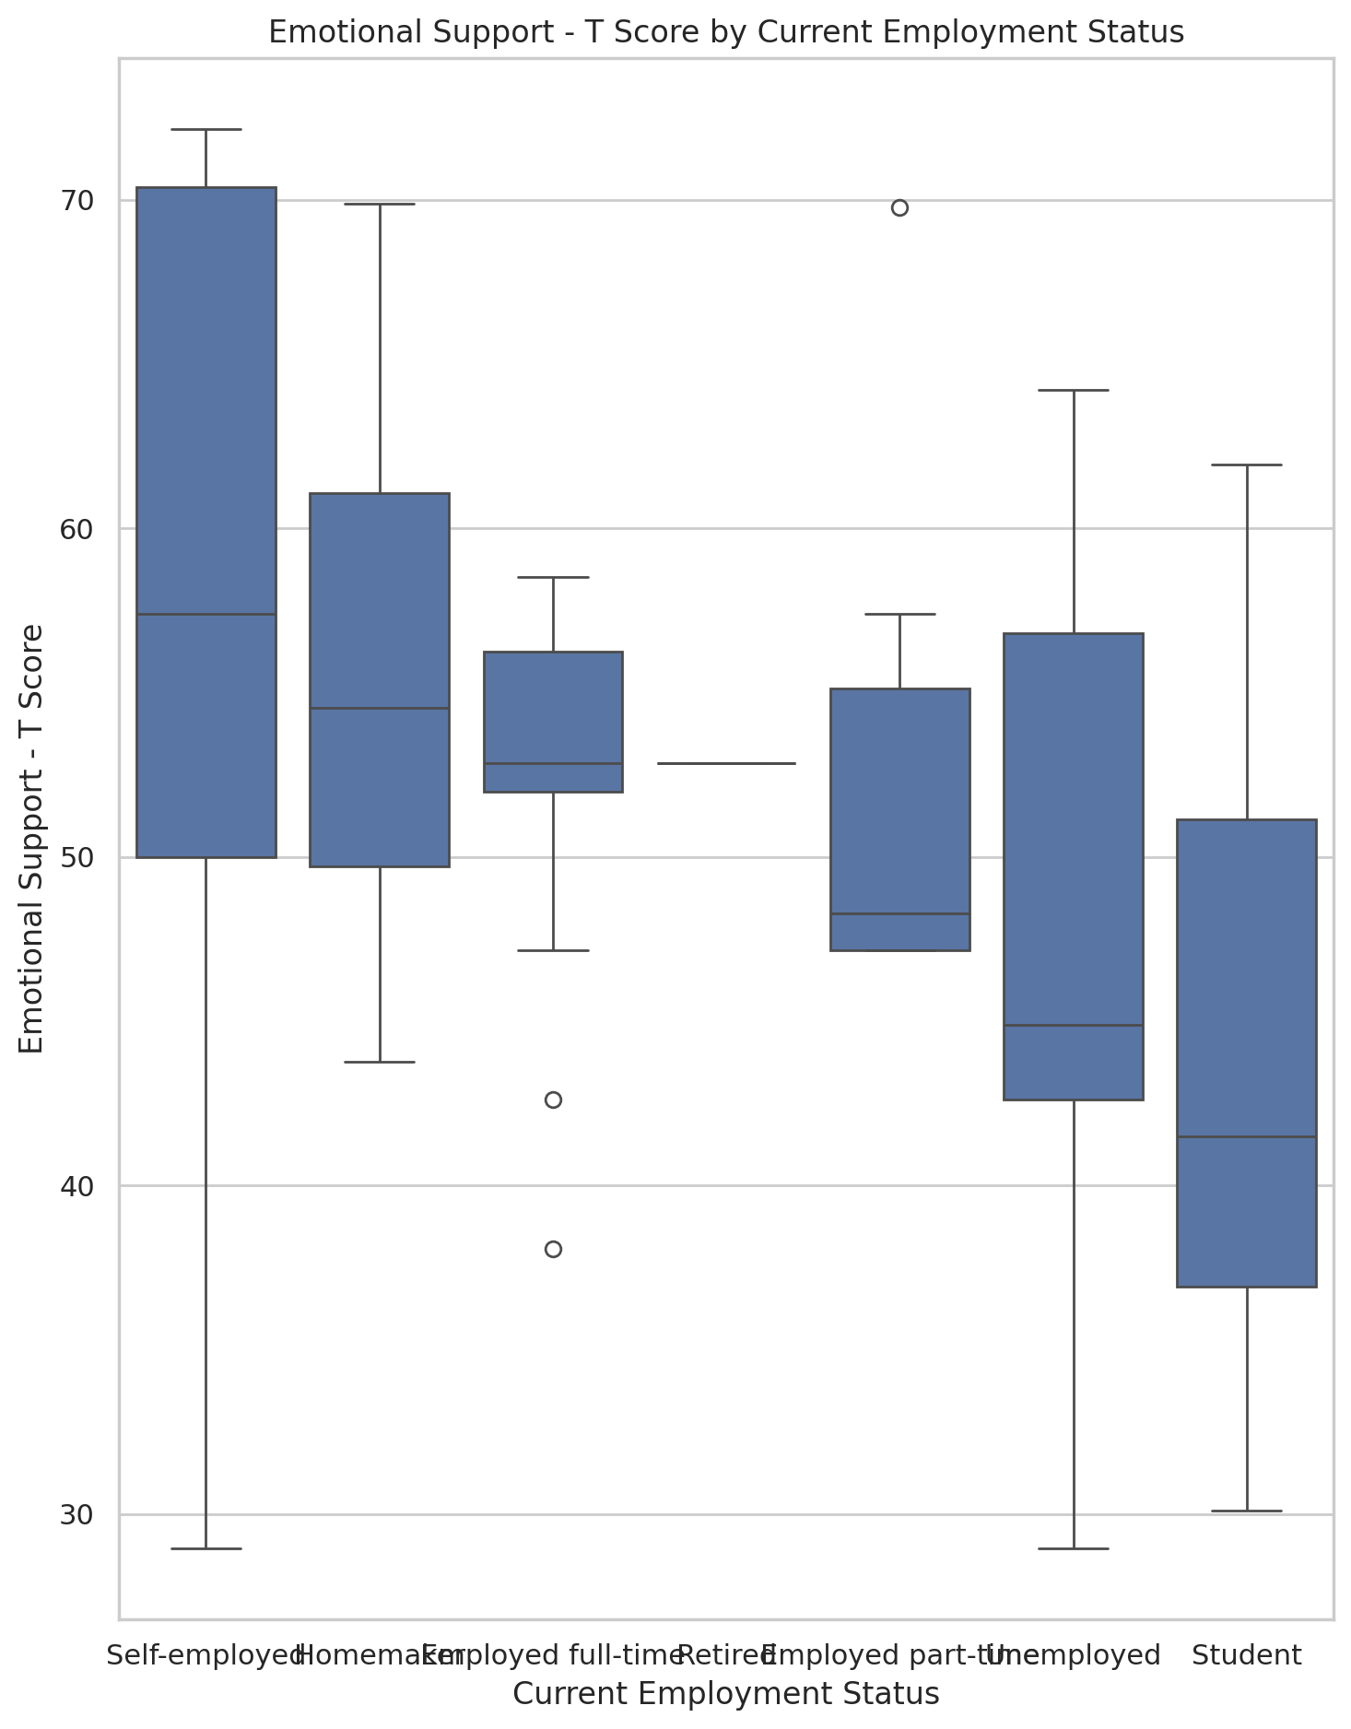

## Informational Support - T Score vs Current Employment Status

Test: ANOVA; statistic: 0.47467536025262635; p-value: 0.8249289207060988;

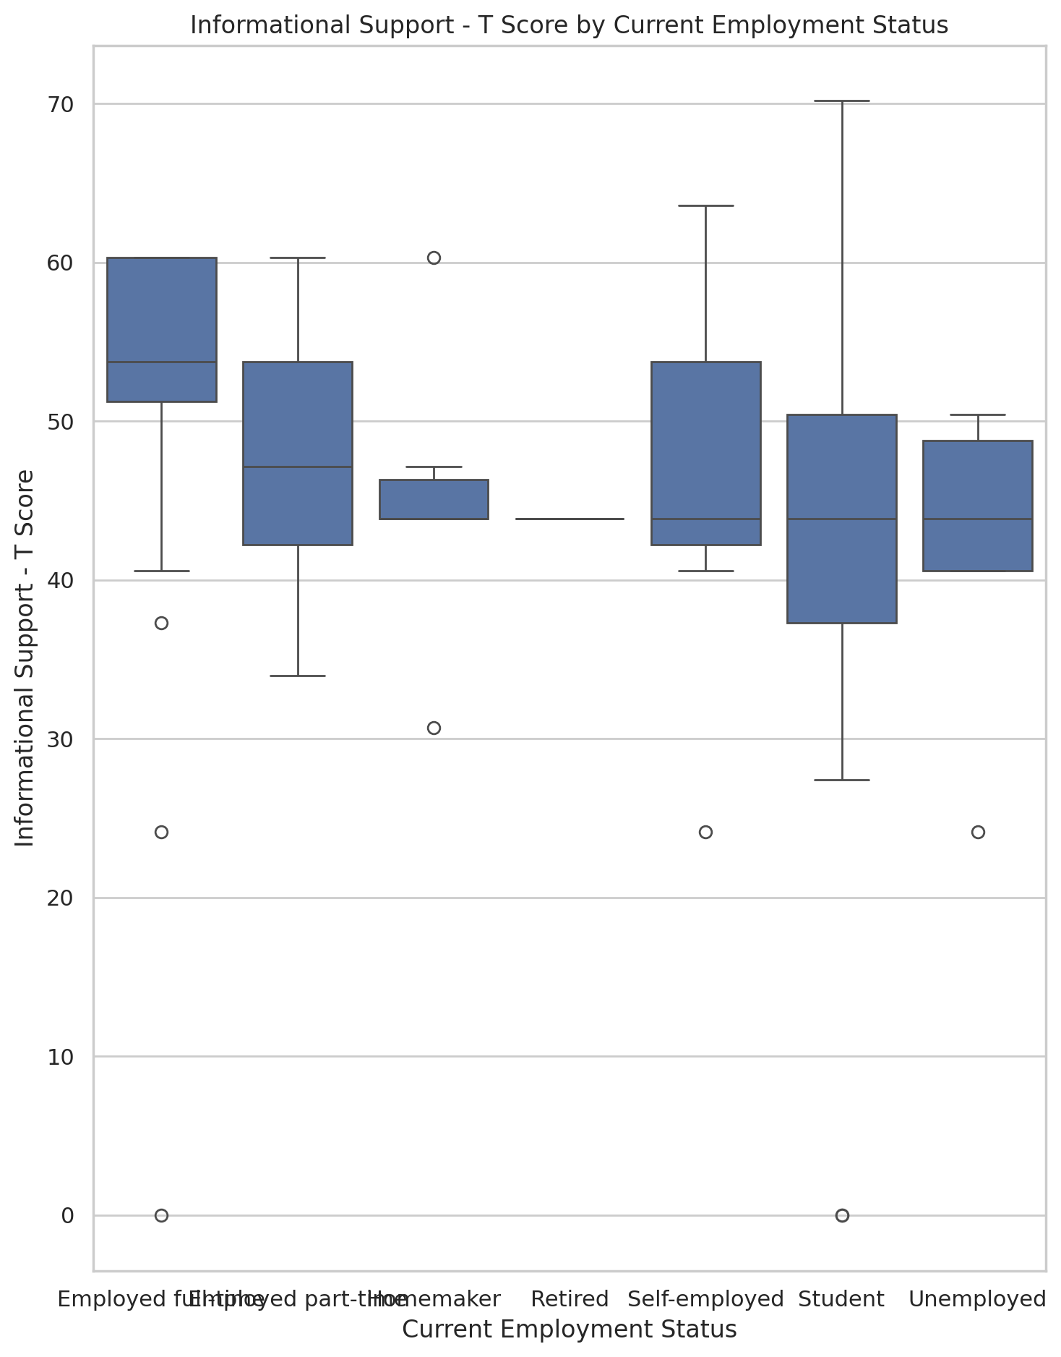

## Instrumental Support - T Score vs Current Employment Status

Test: ANOVA; statistic: 0.7528272149510892; p-value: 0.6092776555784454;

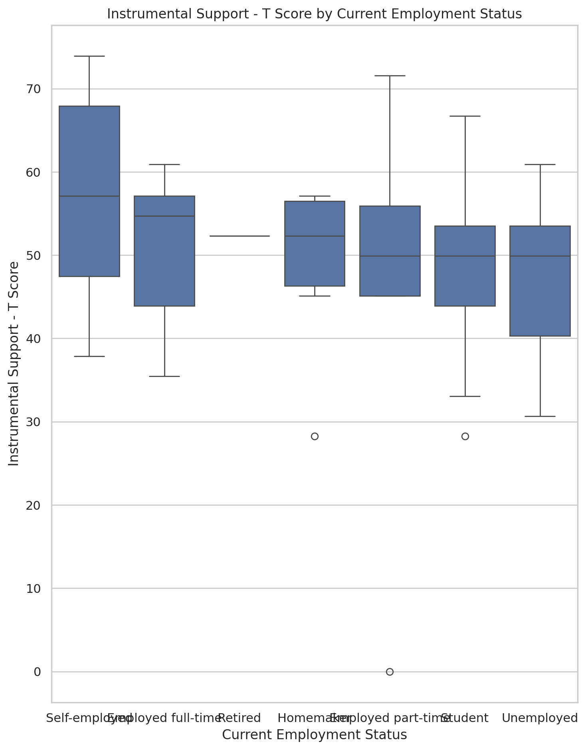

## Emotional Support - Rank vs Current Employment Status

Test: chi2; statistic: 44.12845734407704; p-value: 0.007371840176385654;

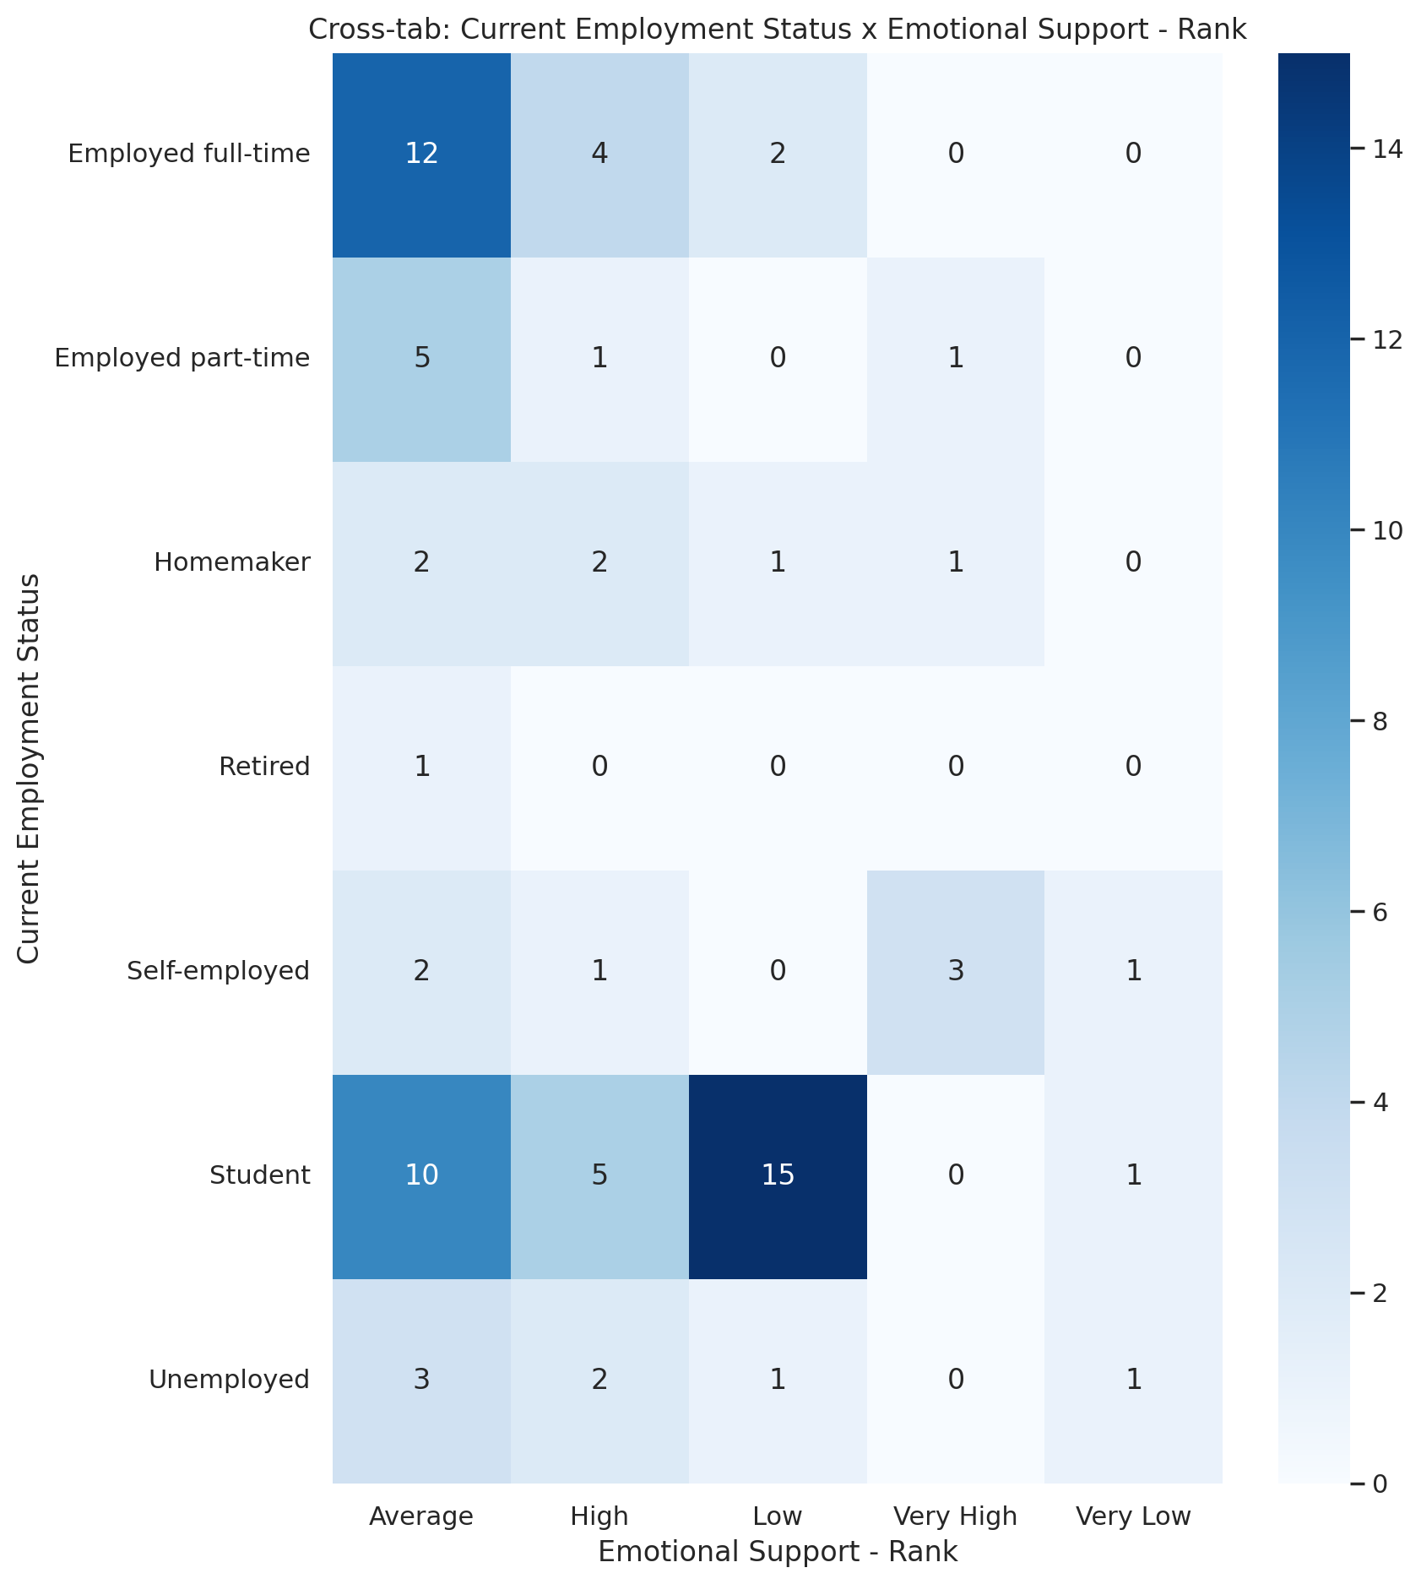

## Informational Support - Rank vs Current Employment Status

Test: chi2; statistic: 18.383209710606664; p-value: 0.7840331989731384;

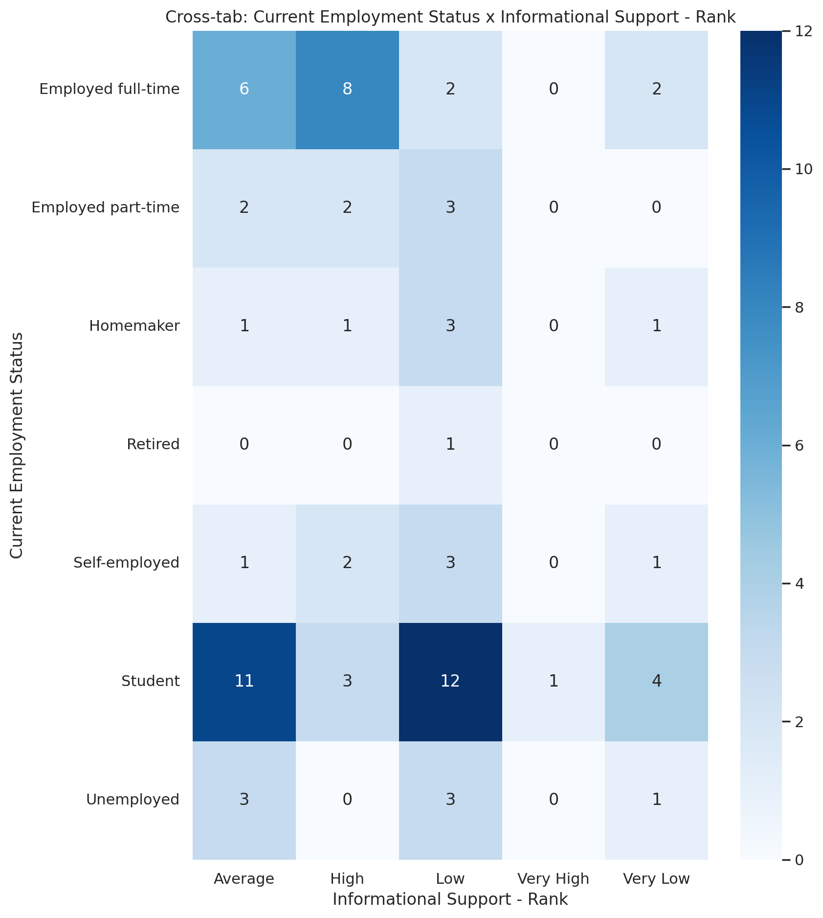

## Instrumental Support - Rank vs Current Employment Status

Test: chi2; statistic: 36.434250276228205; p-value: 0.04978317171216585;

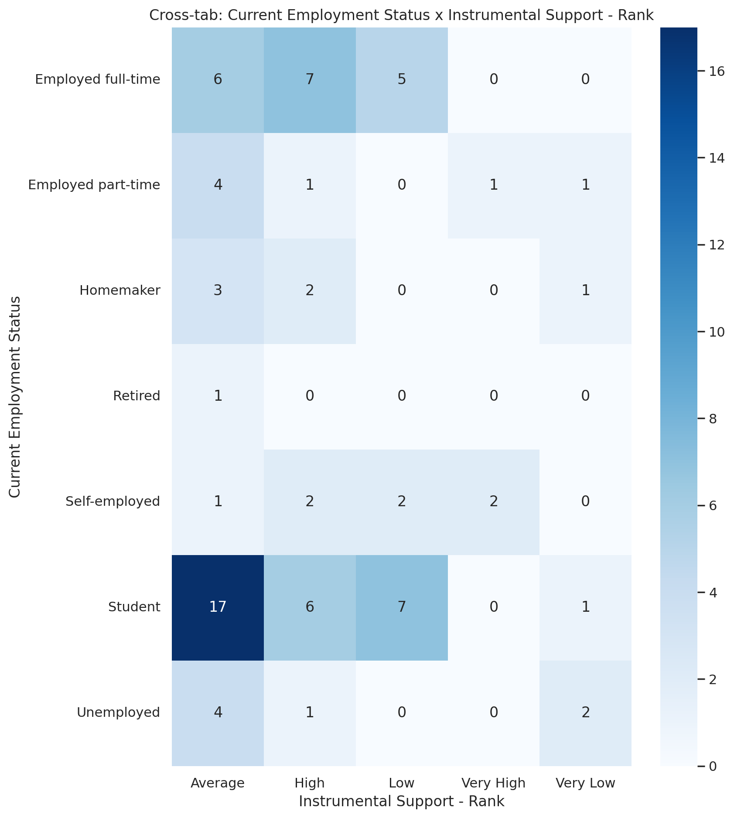

## Real Self Concept Total Category vs Current Employment Status

Test: chi2; statistic: 11.69830225997209; p-value: 0.47020345024809473;

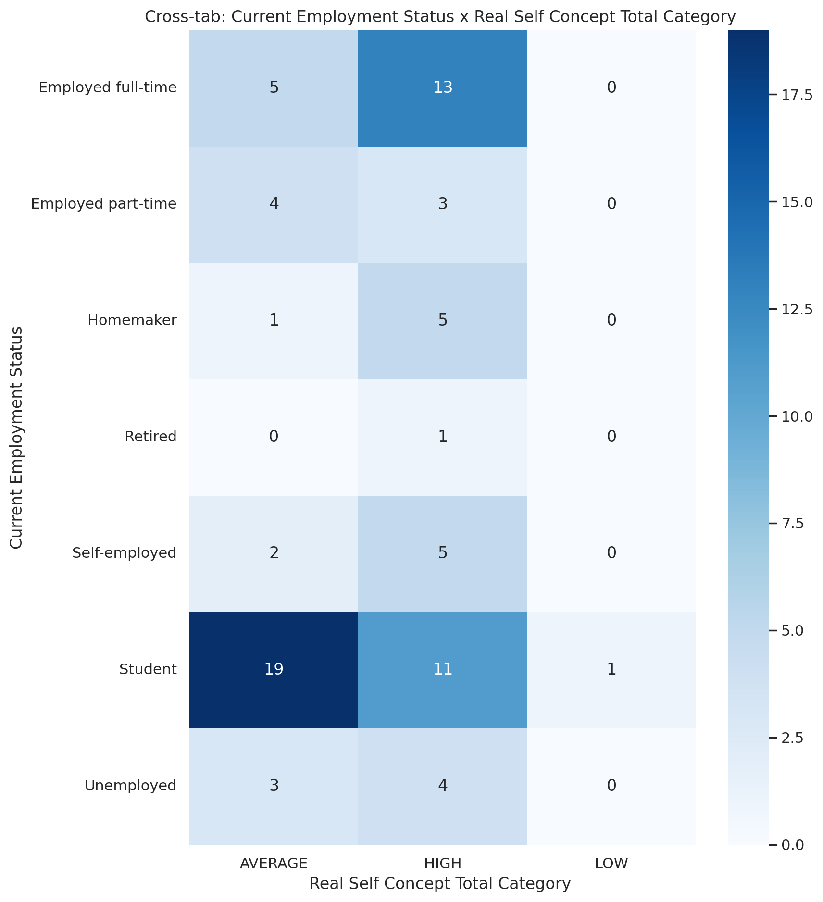

## Ideal Self Concept Total Category vs Current Employment Status

Test: chi2; statistic: 4.069841520837726; p-value: 0.6672253463237211;

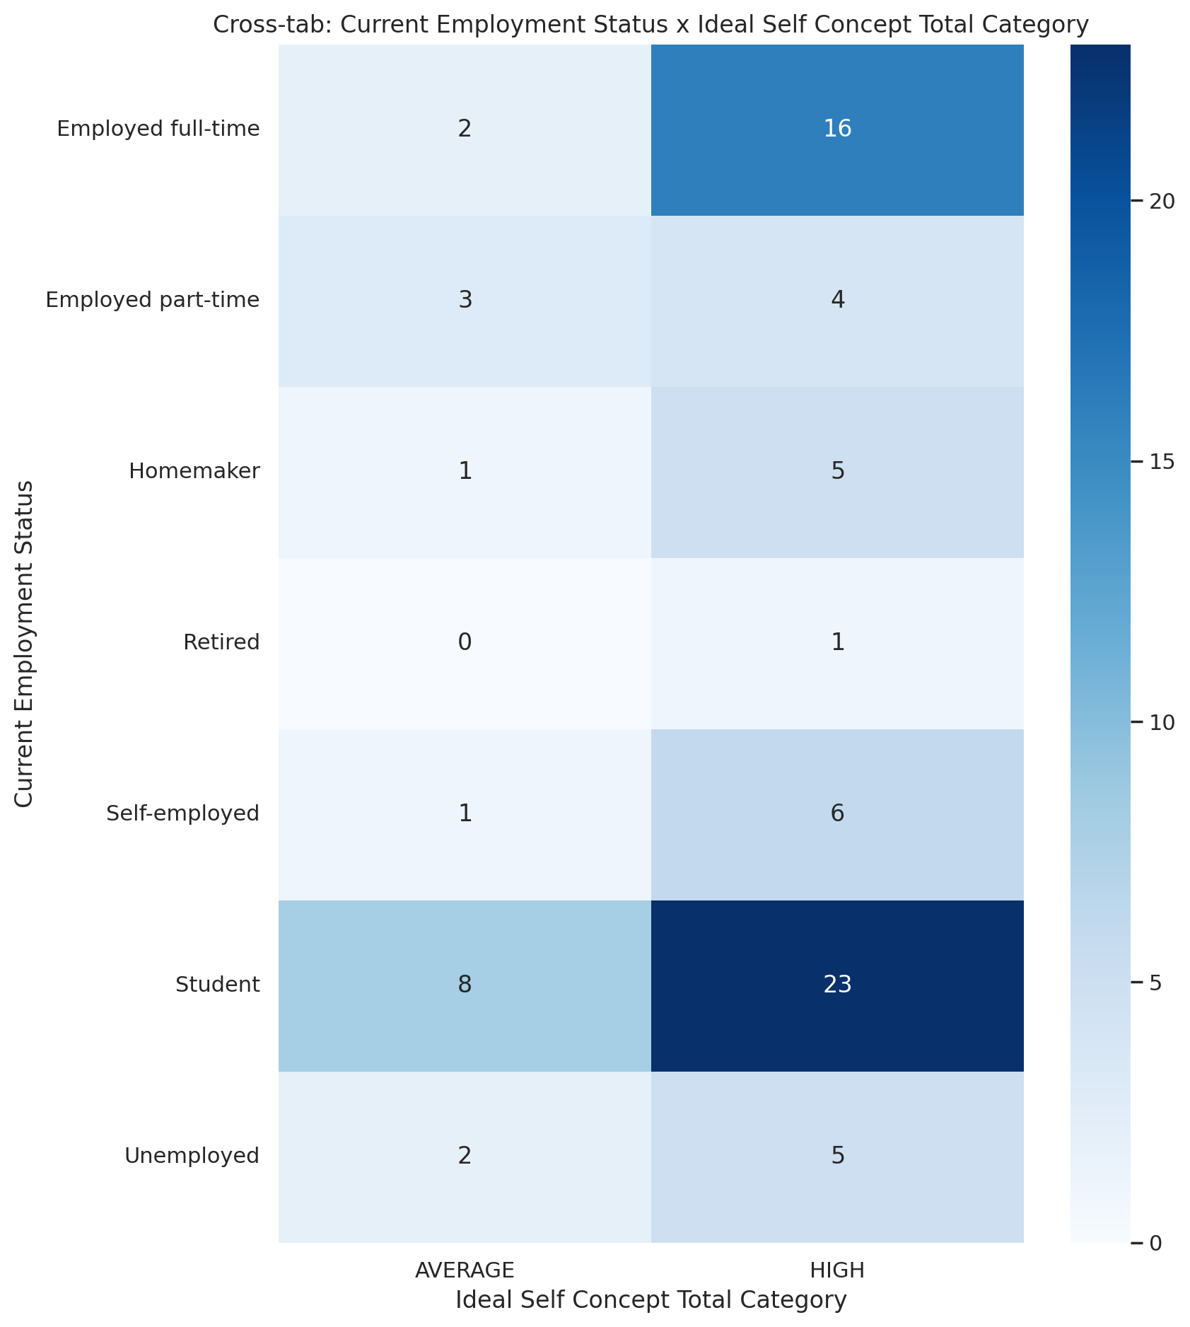

## Social Self Concept Total Category vs Current Employment Status

Test: chi2; statistic: 23.376045400238947; p-value: 0.024697874390347558;

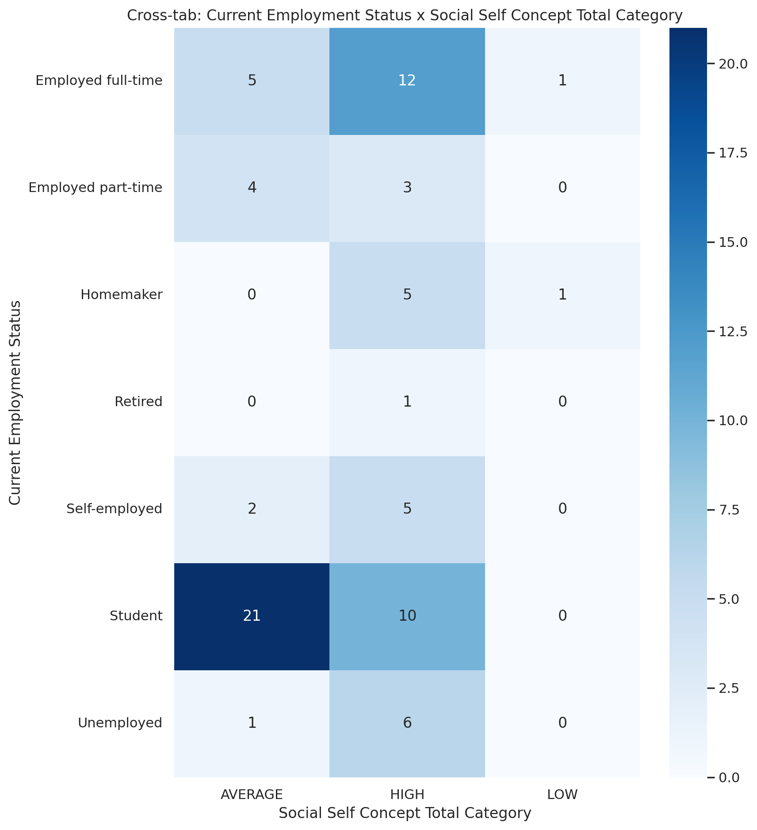

## Emotional Support - T Score vs Number of children

Test: ANOVA; statistic: 1.1168168267983134; p-value: 0.35779519501707985;

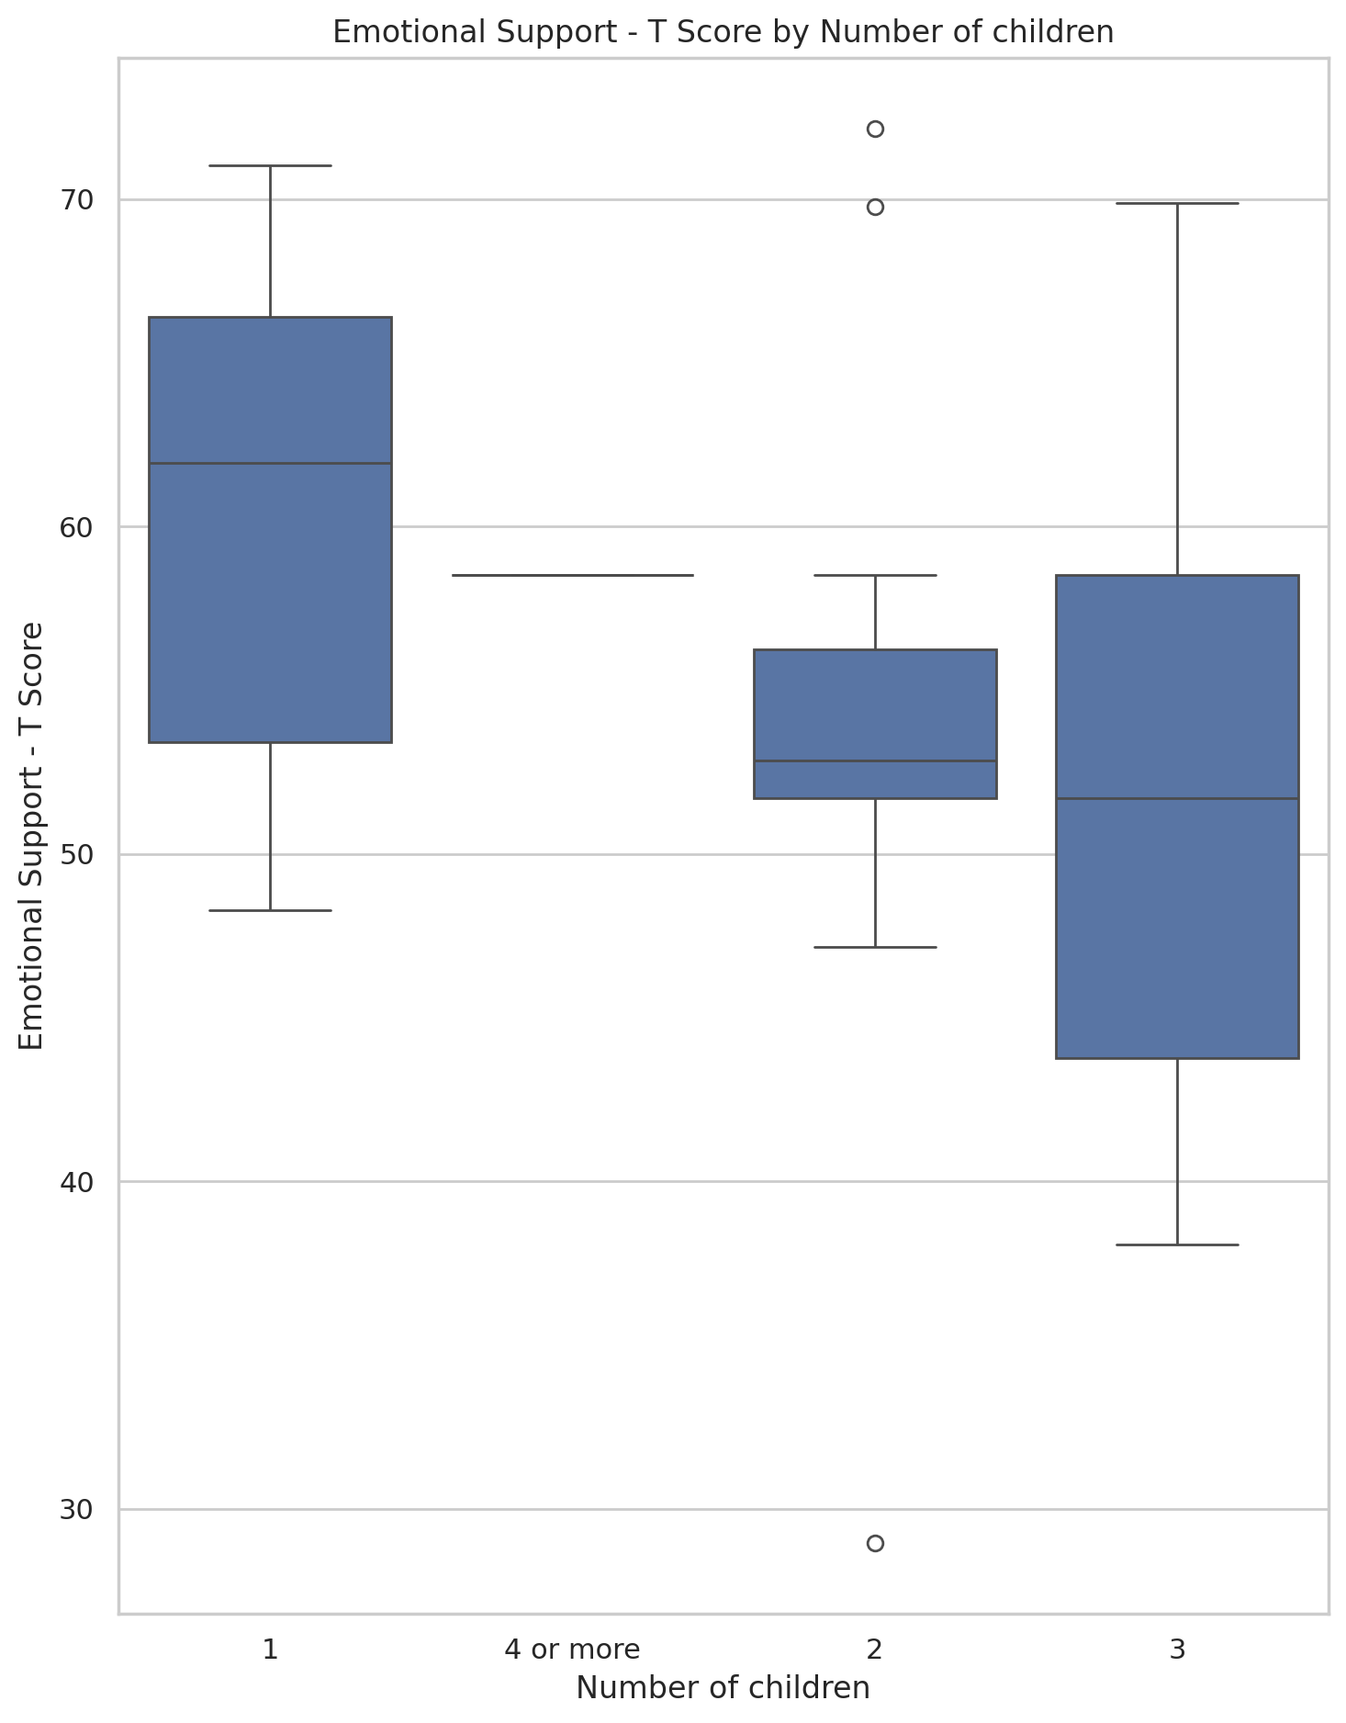

## Informational Support - T Score vs Number of children

Test: ANOVA; statistic: 1.263048144751329; p-value: 0.30474264676275975;

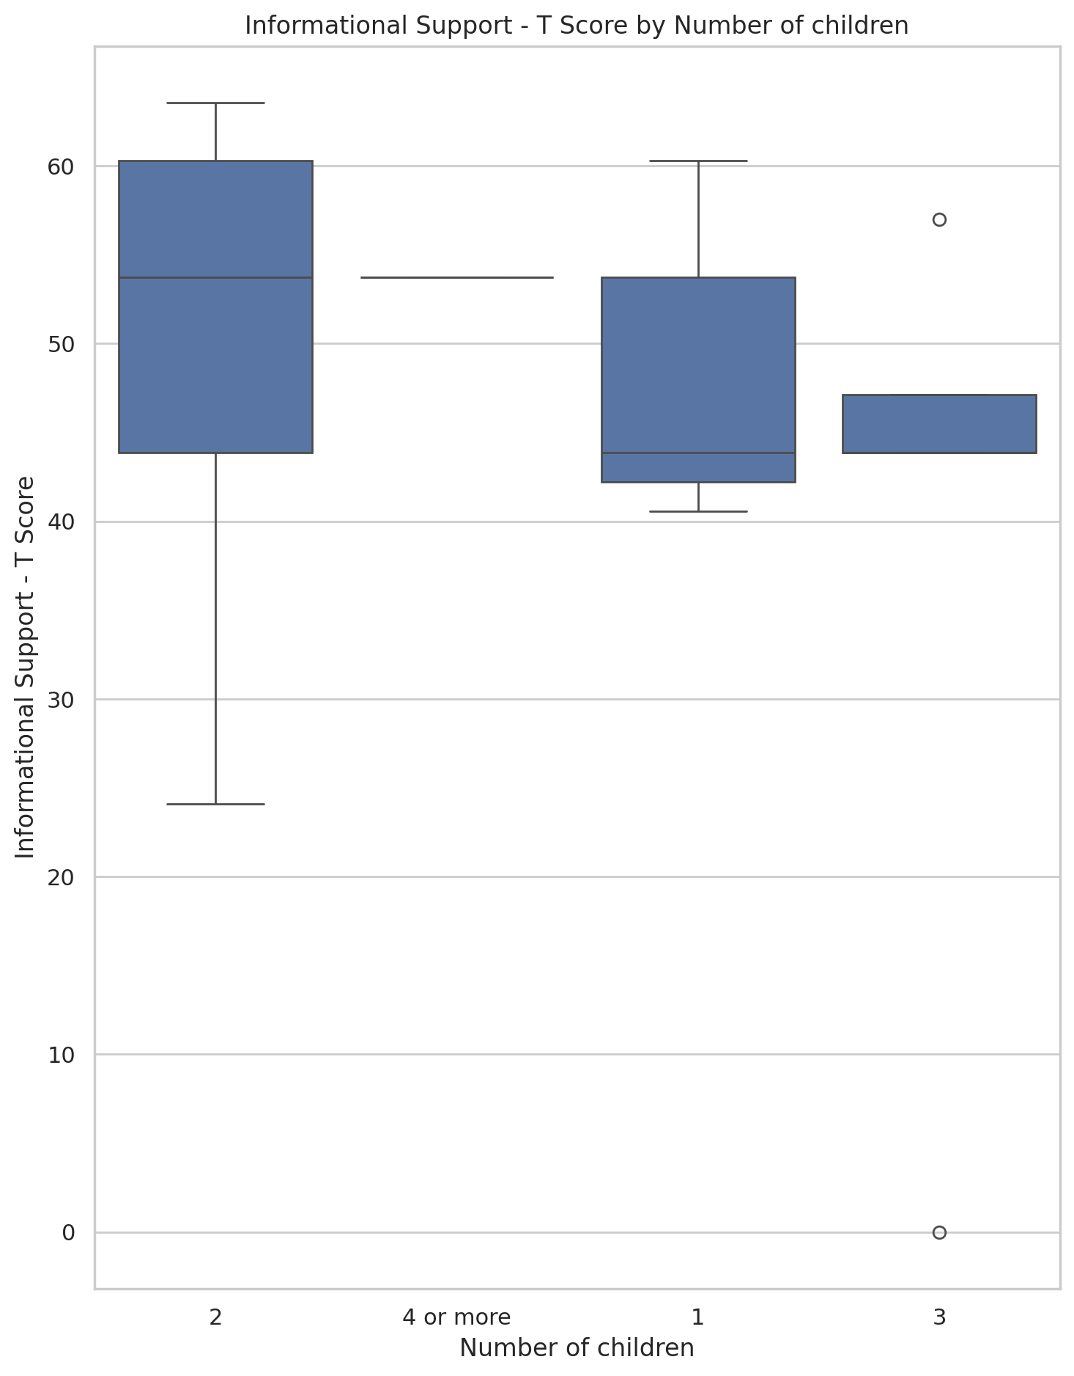

## Instrumental Support - T Score vs Number of children

Test: ANOVA; statistic: 1.267714035558983; p-value: 0.30318146881963;

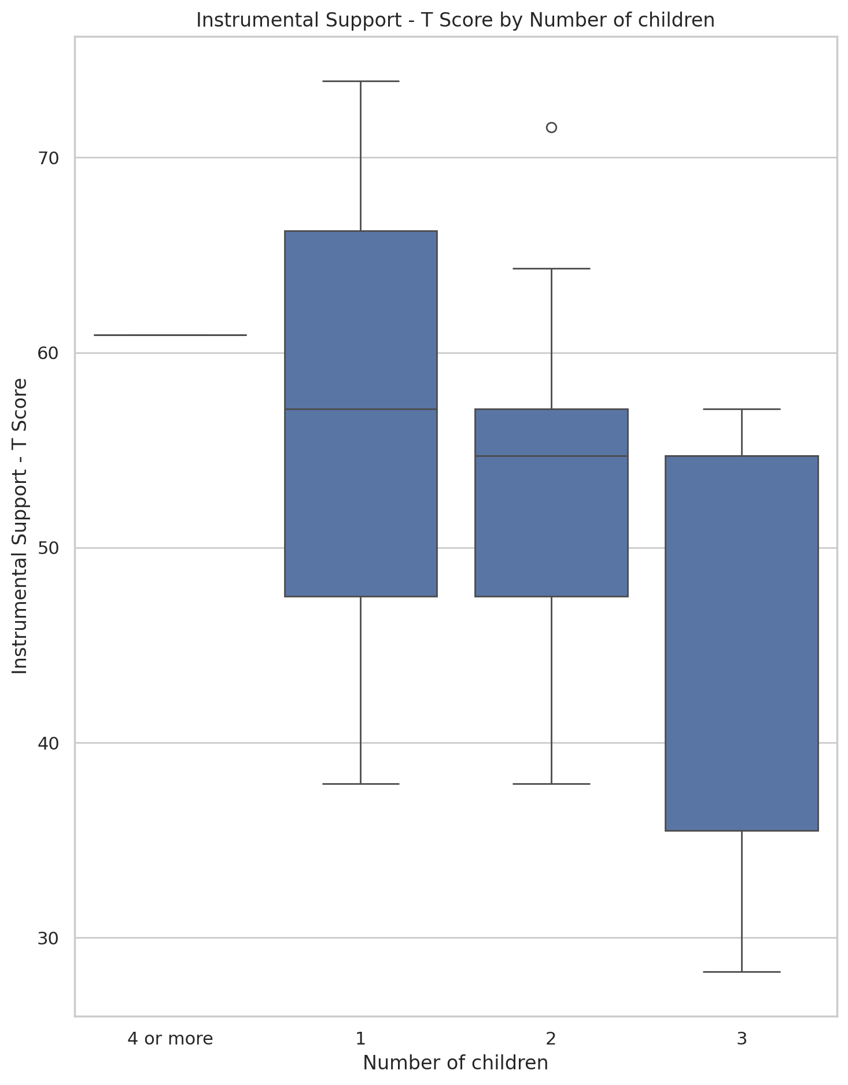

## Emotional Support - Rank vs Number of children

Test: chi2; statistic: 21.840952380952384; p-value: 0.03934150222281945;

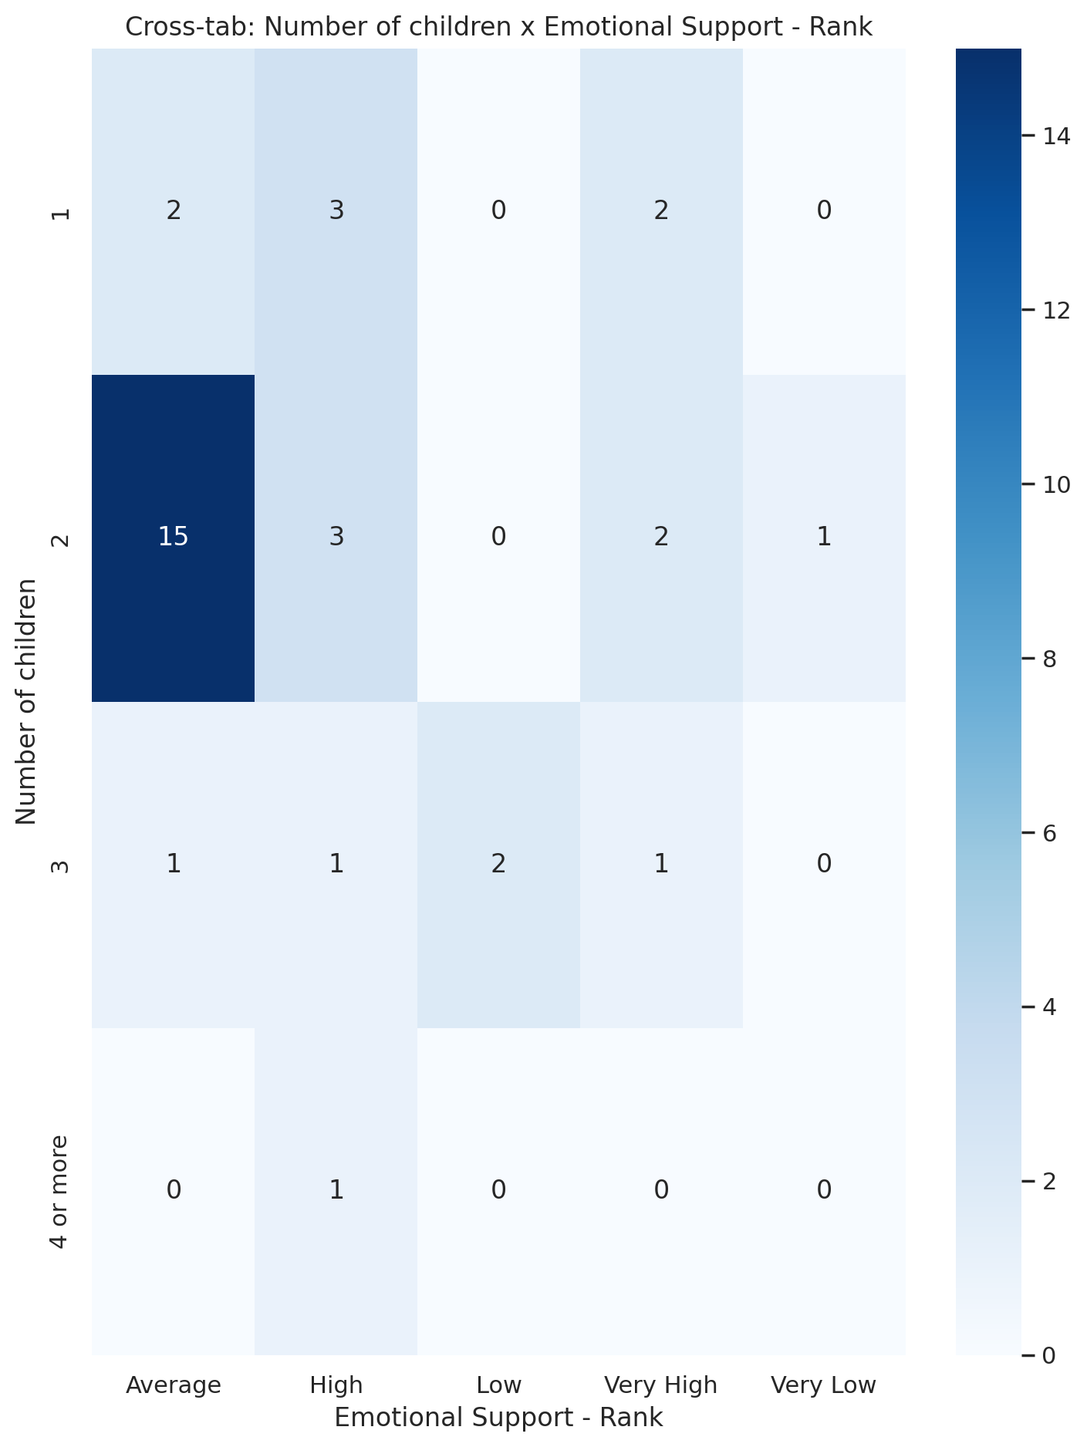

## Informational Support - Rank vs Number of children

Test: chi2; statistic: 6.996248196248196; p-value: 0.6375100440656836;

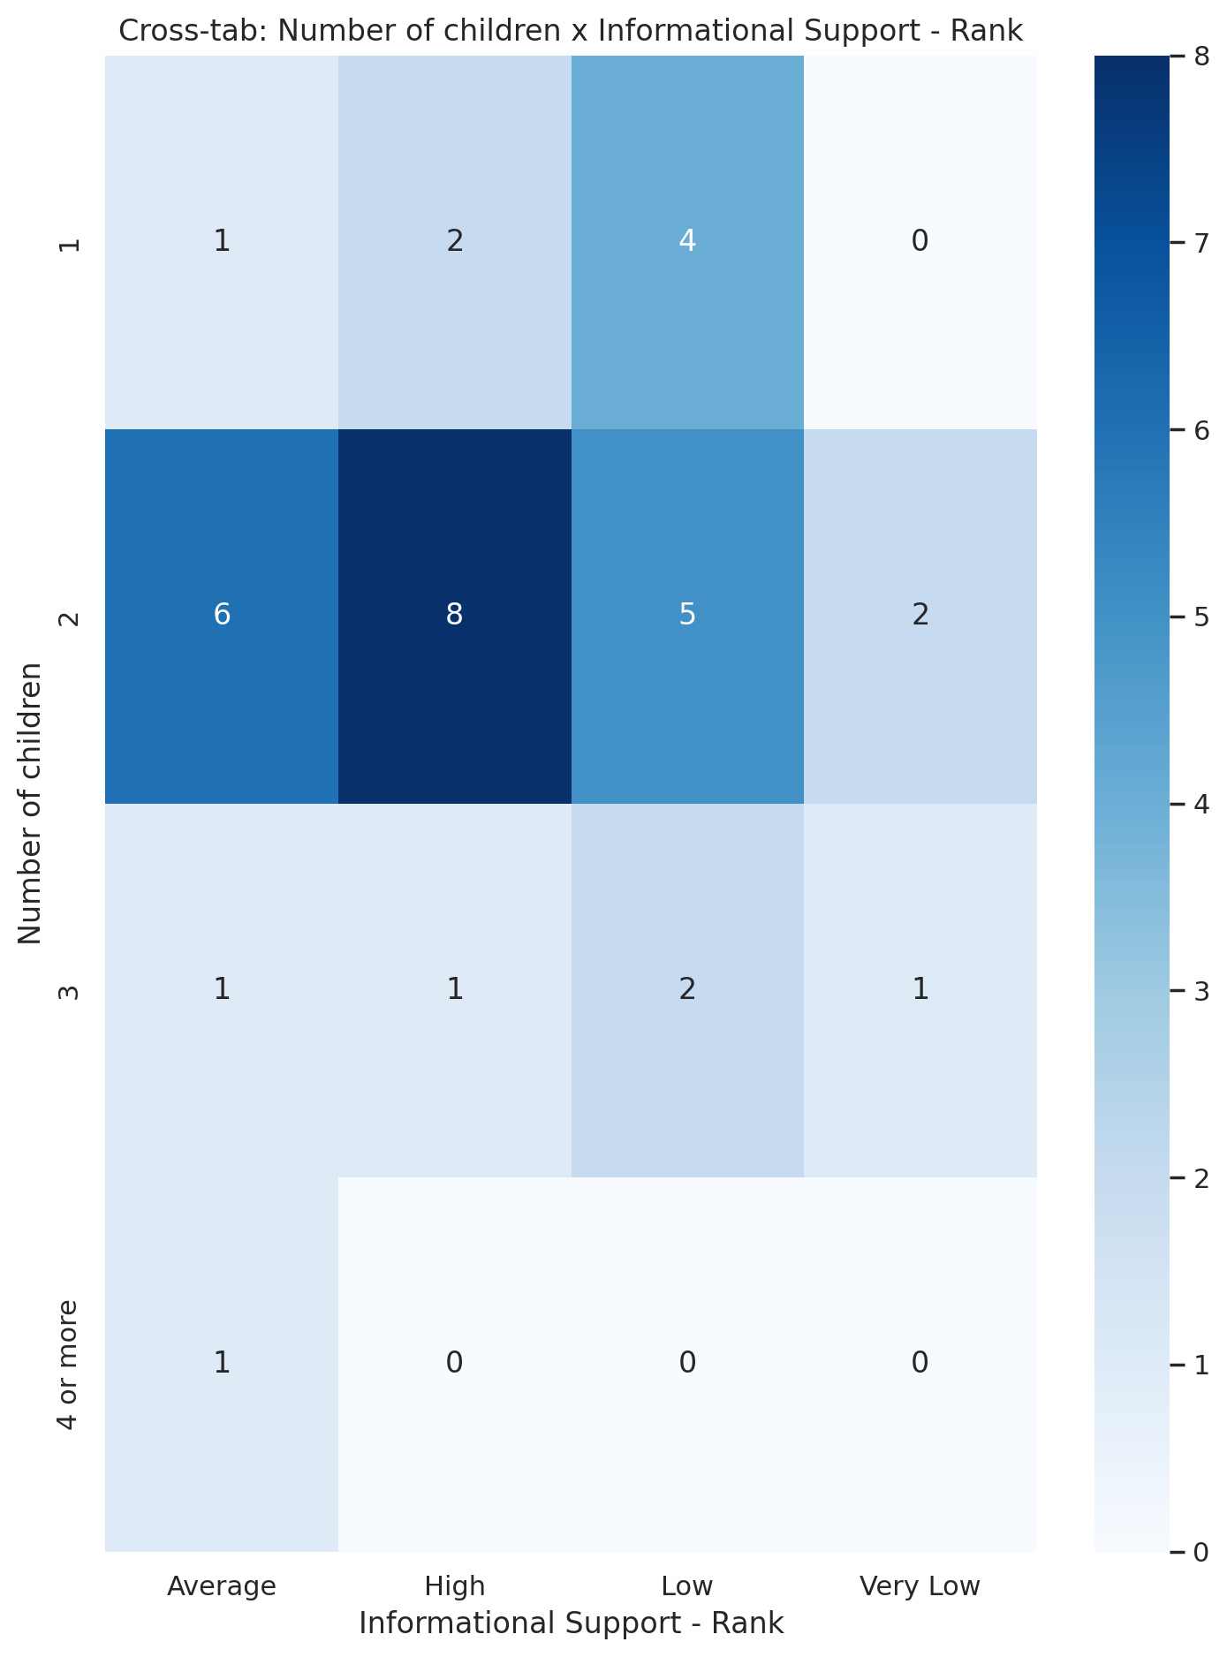

## Instrumental Support - Rank vs Number of children

Test: chi2; statistic: 12.303101343101341; p-value: 0.4216544872743611;

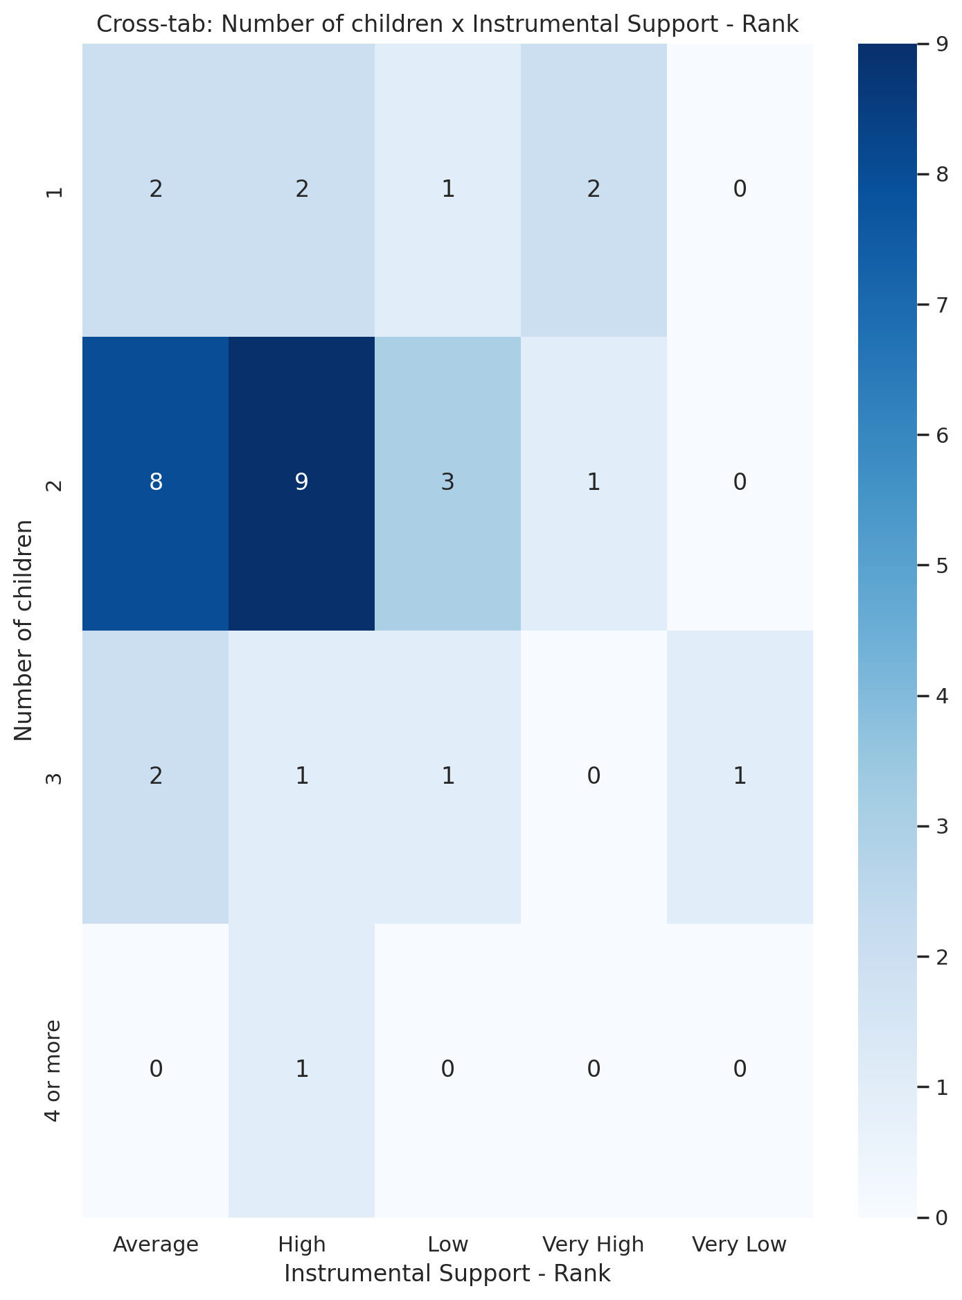

## Real Self Concept Total Category vs Number of children

Test: chi2; statistic: 3.8583703703703707; p-value: 0.2771692906038688;

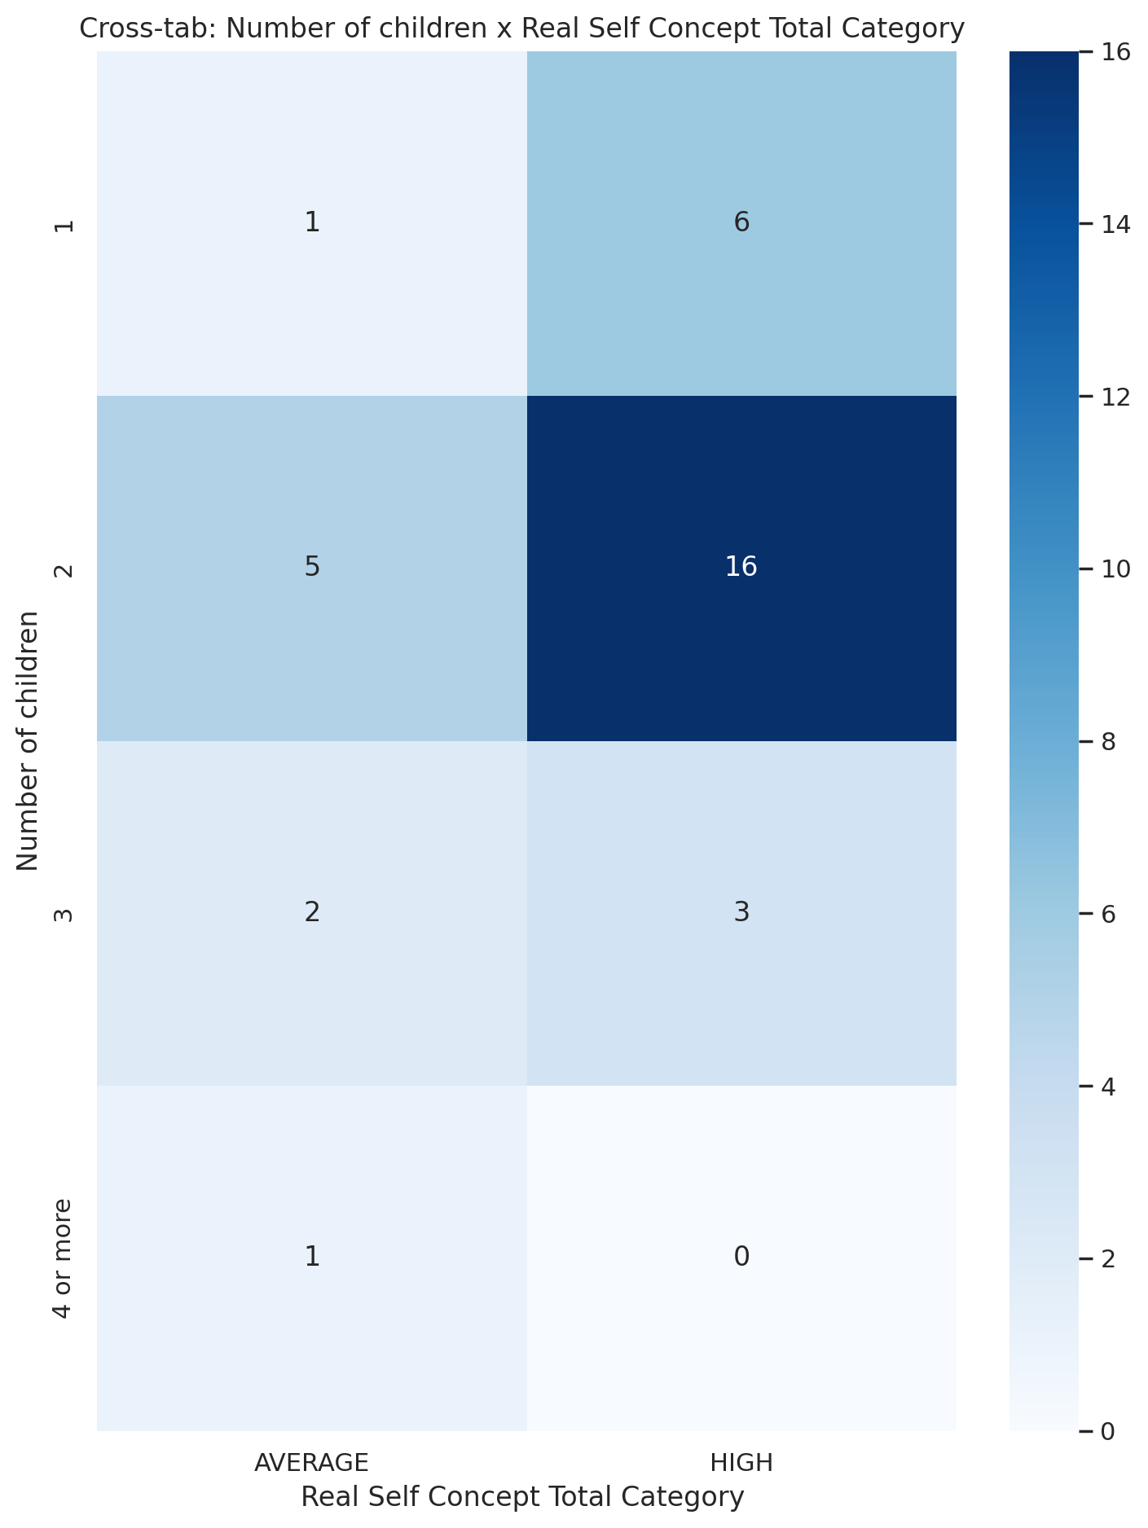

## Ideal Self Concept Total Category vs Number of children

Test: chi2; statistic: 0.9714285714285715; p-value: 0.808164929064211;

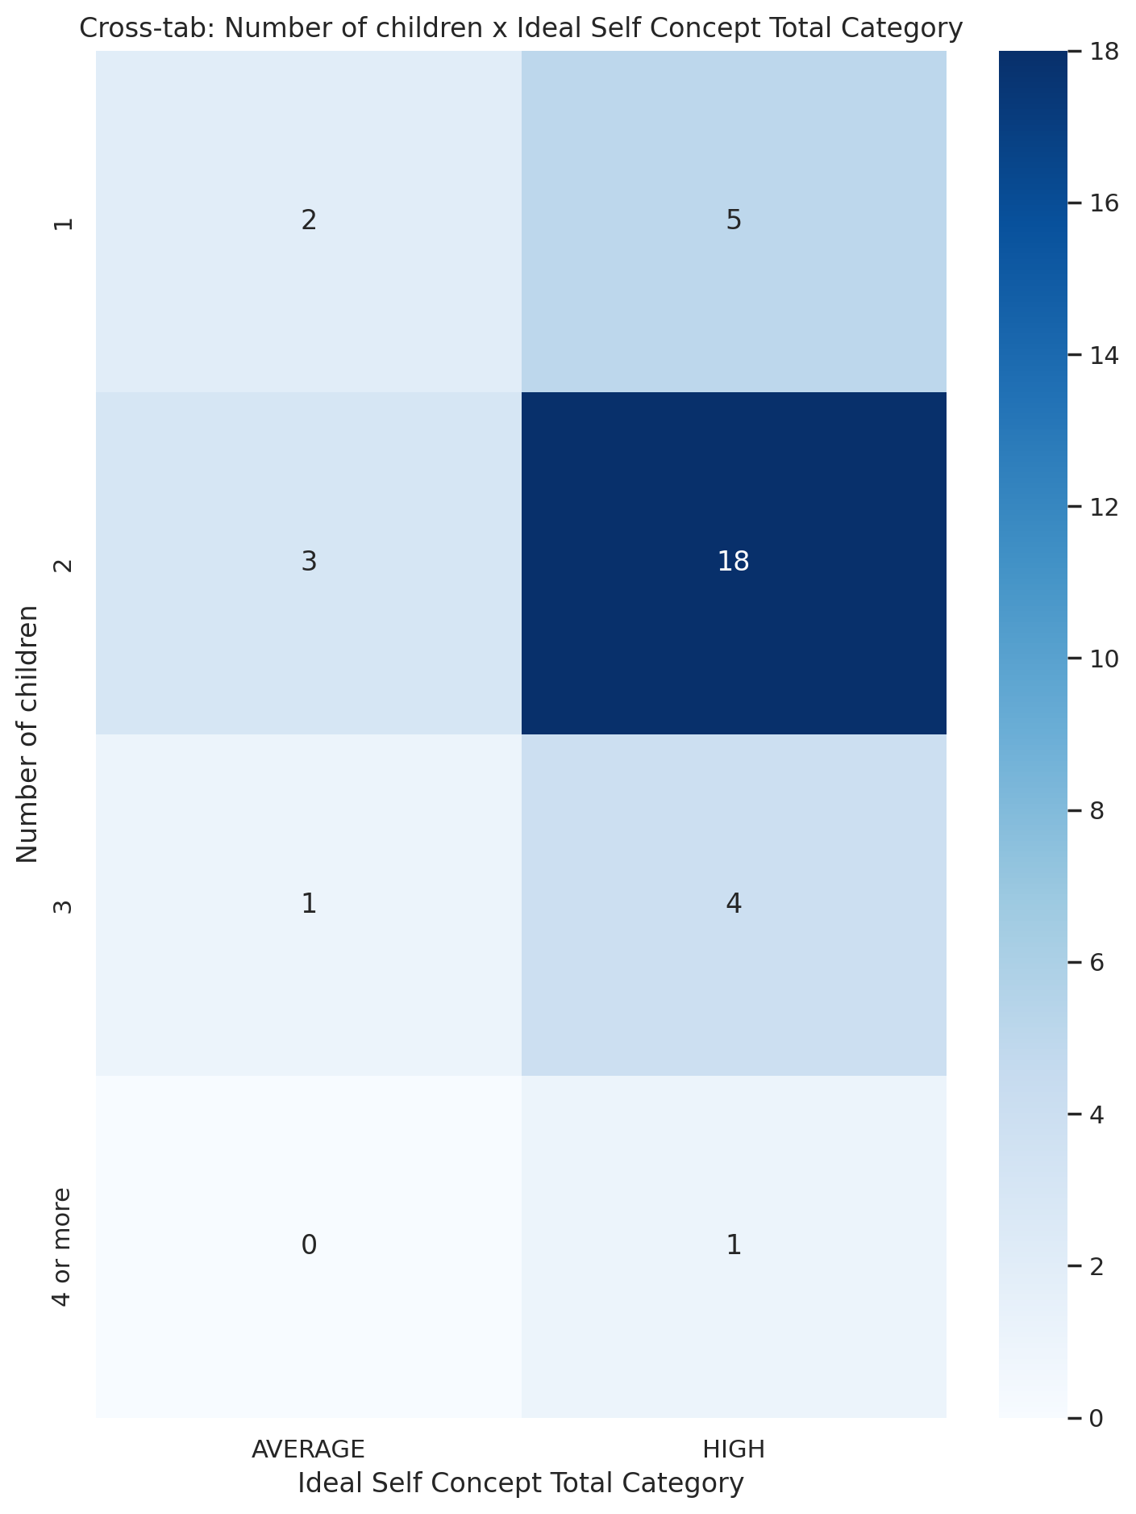

## Social Self Concept Total Category vs Number of children

Test: chi2; statistic: 2.059428571428571; p-value: 0.9141525718641634;

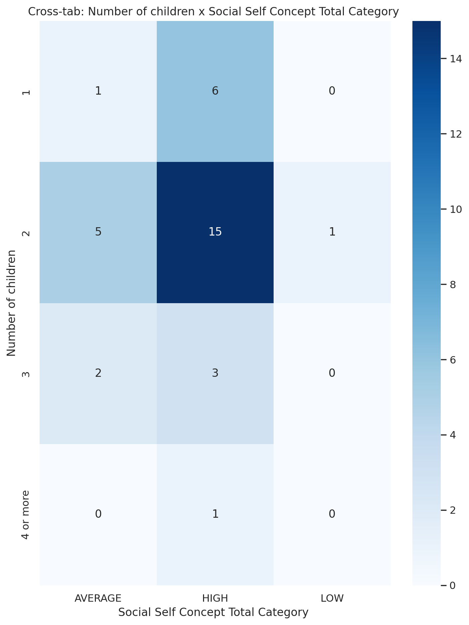

## Emotional Support - T Score vs Type of family structure

Test: ANOVA; statistic: 0.1150261690460669; p-value: 0.7354282656244804;

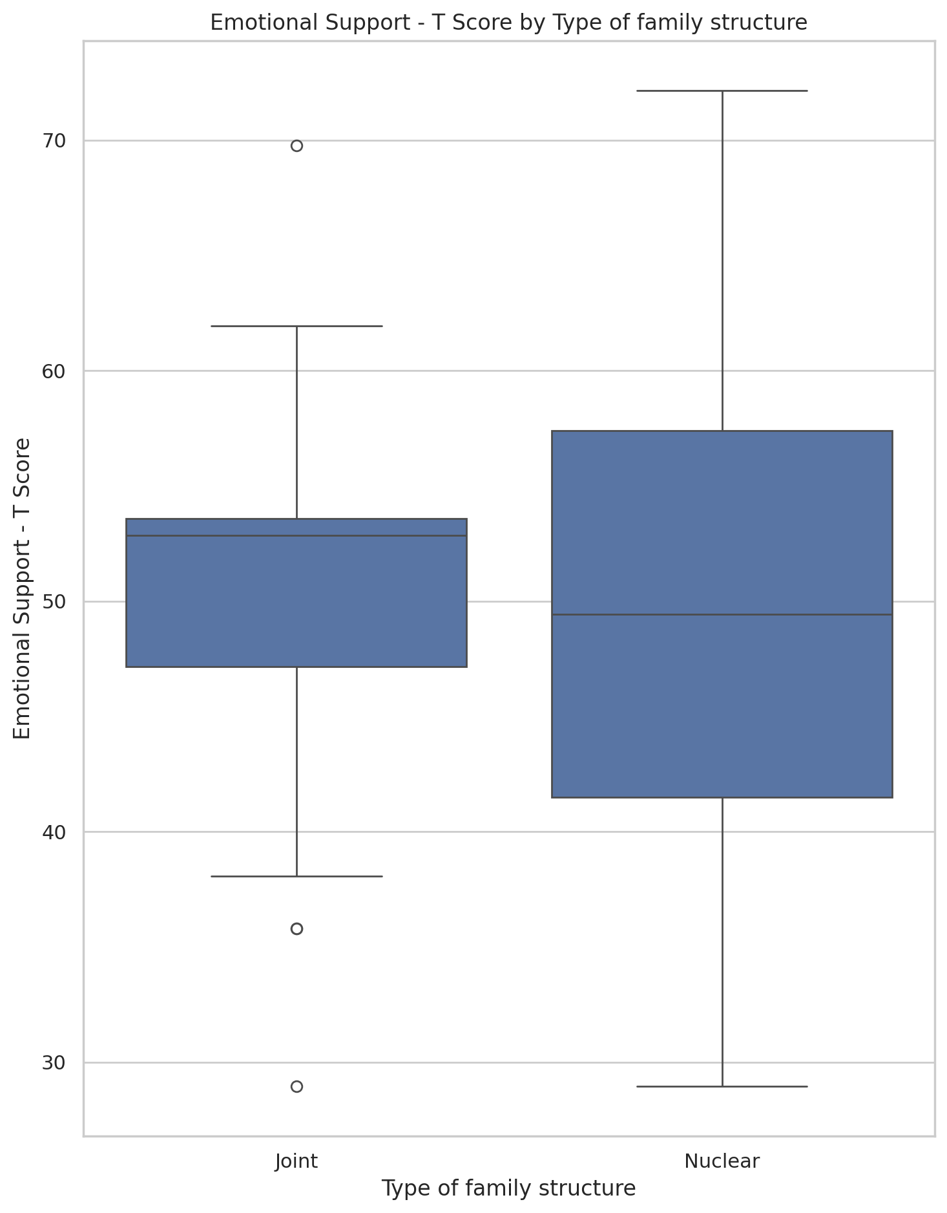

## Informational Support - T Score vs Type of family structure

Test: ANOVA; statistic: 0.04402853693570841; p-value: 0.8343620108078481;

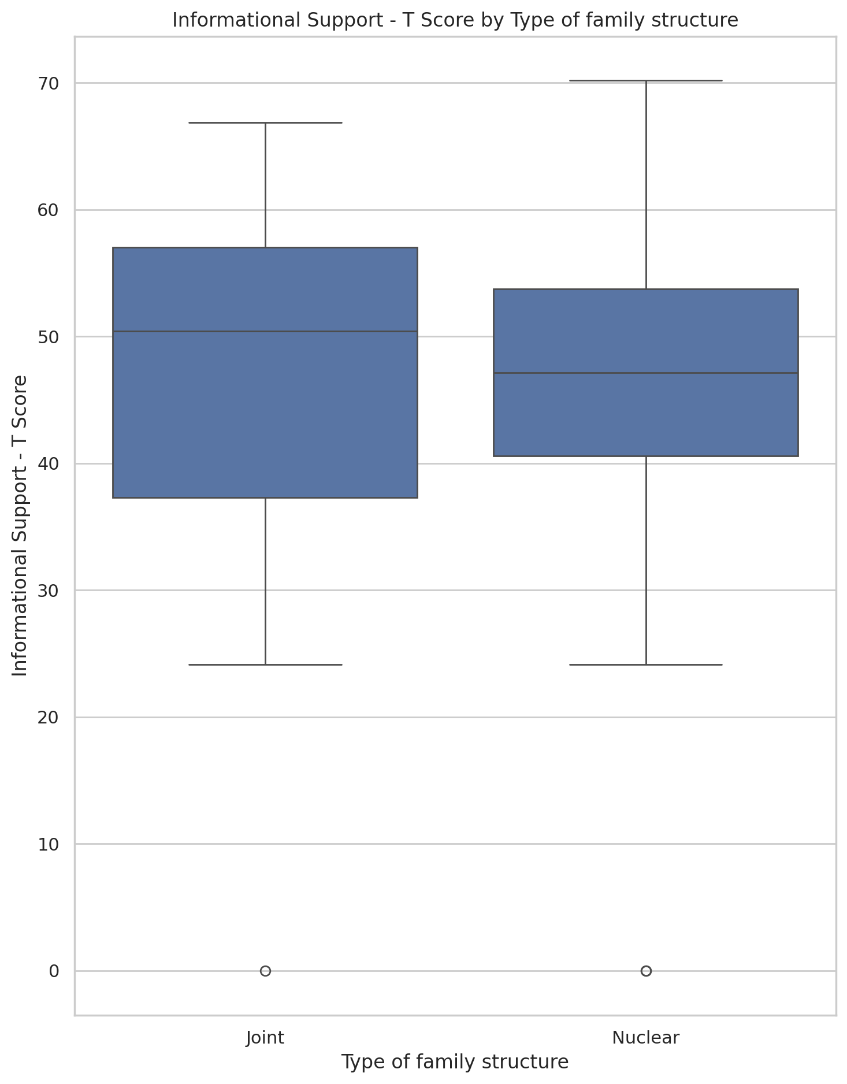

## Instrumental Support - T Score vs Type of family structure

Test: ANOVA; statistic: 0.015052715049545482; p-value: 0.9026768354891261;

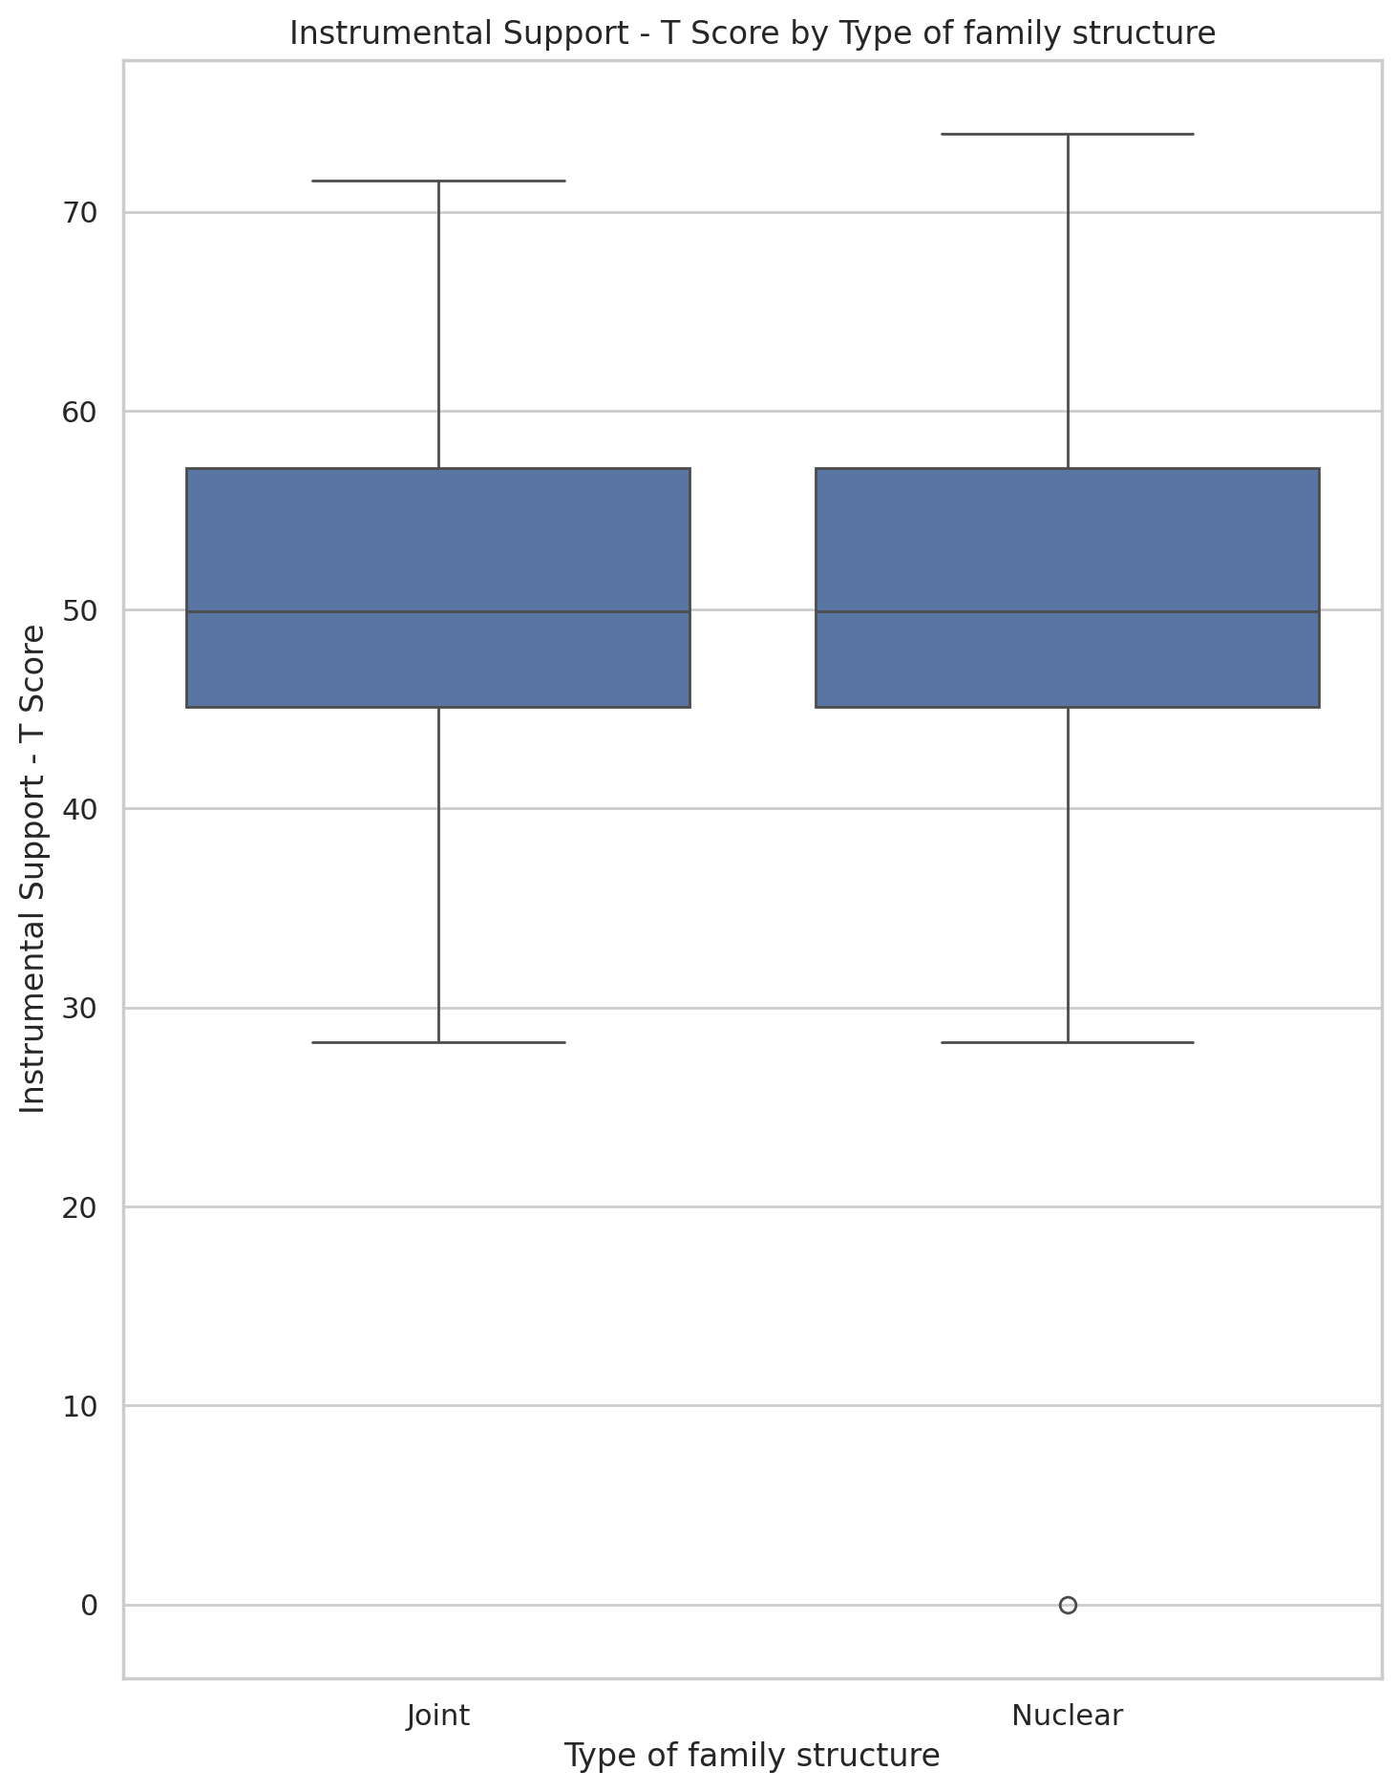

## Emotional Support - Rank vs Type of family structure

Test: chi2; statistic: 5.0978982810561755; p-value: 0.277399215926231;

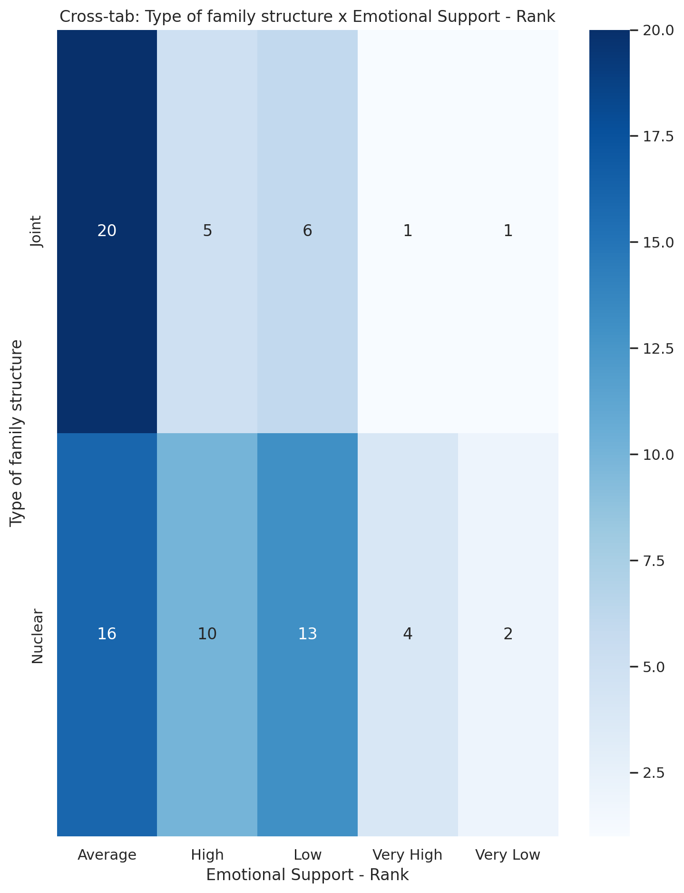

## Informational Support - Rank vs Type of family structure

Test: chi2; statistic: 2.3862514029180693; p-value: 0.6651132751510695;

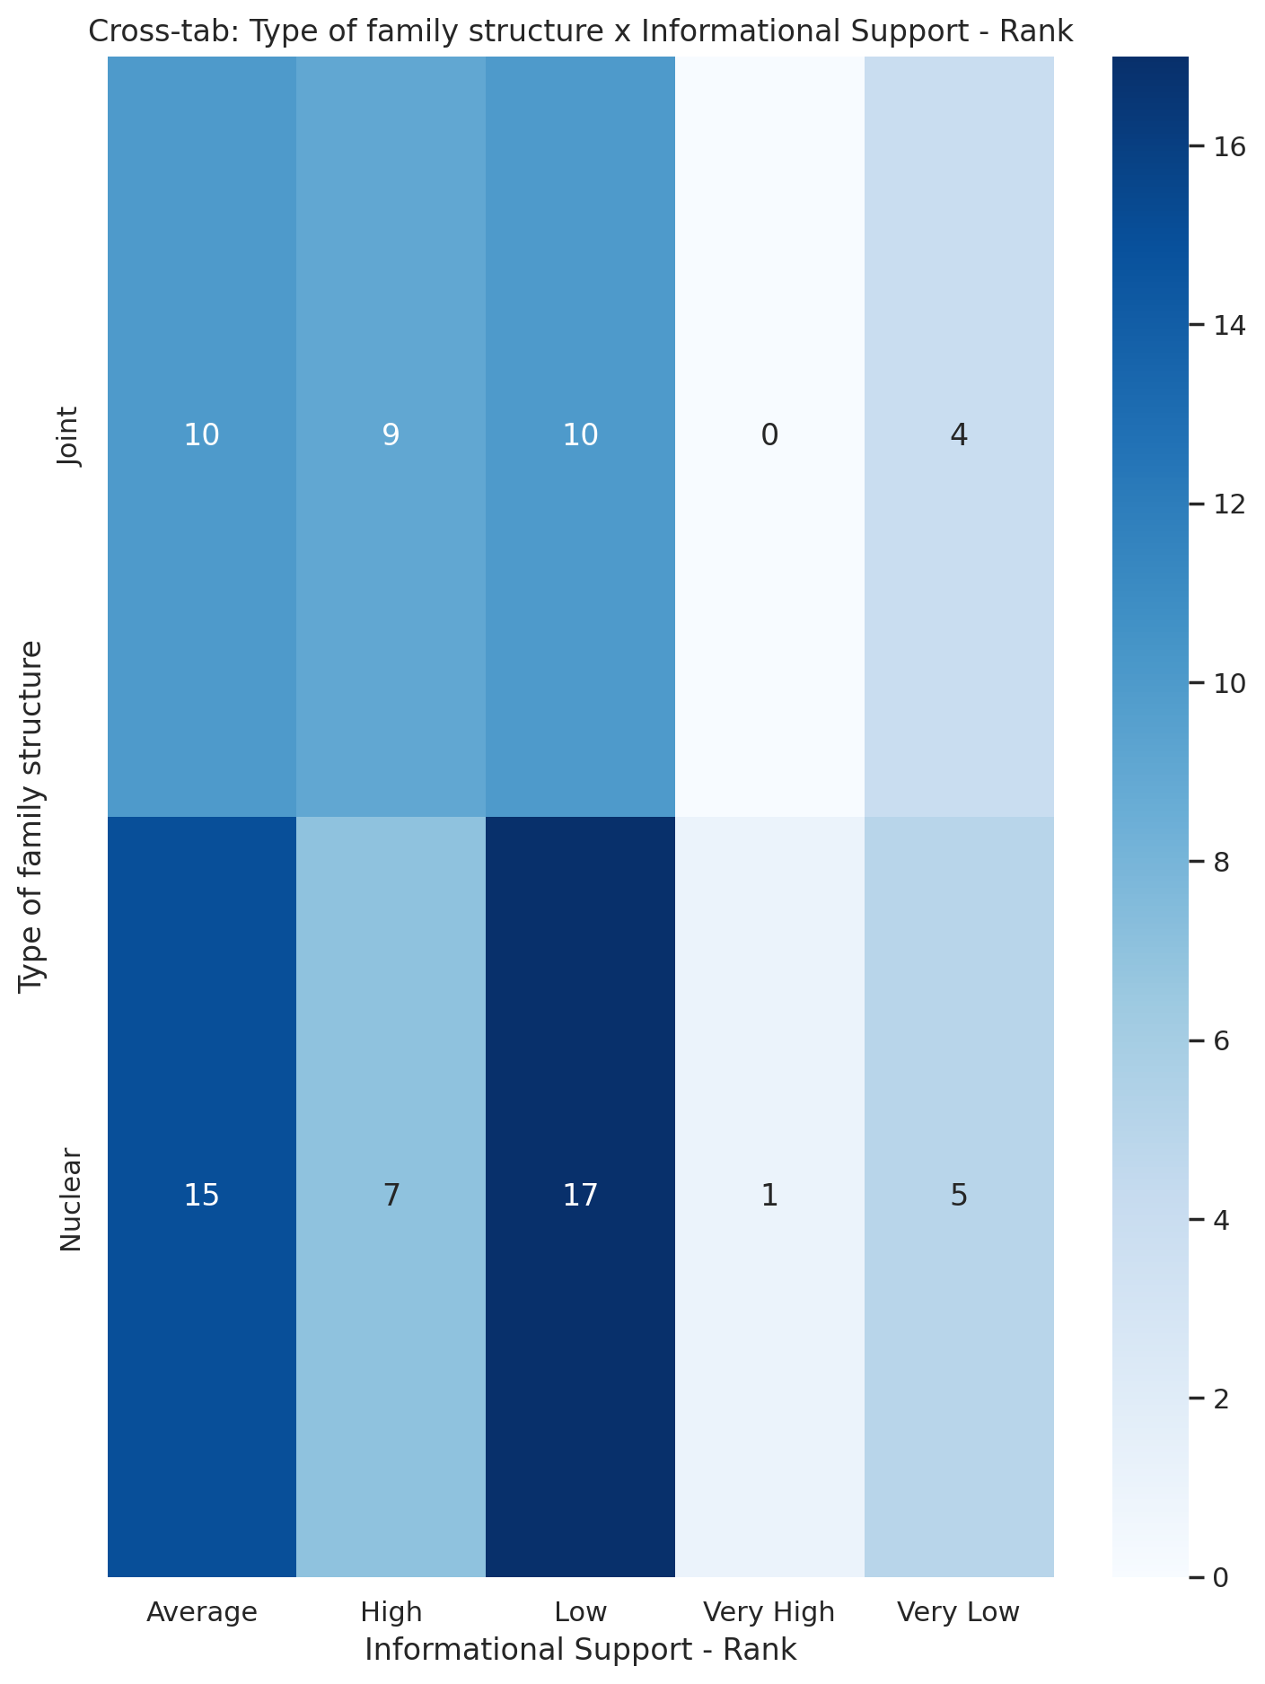

## Instrumental Support - Rank vs Type of family structure

Test: chi2; statistic: 1.2362529583582216; p-value: 0.872094496390385;

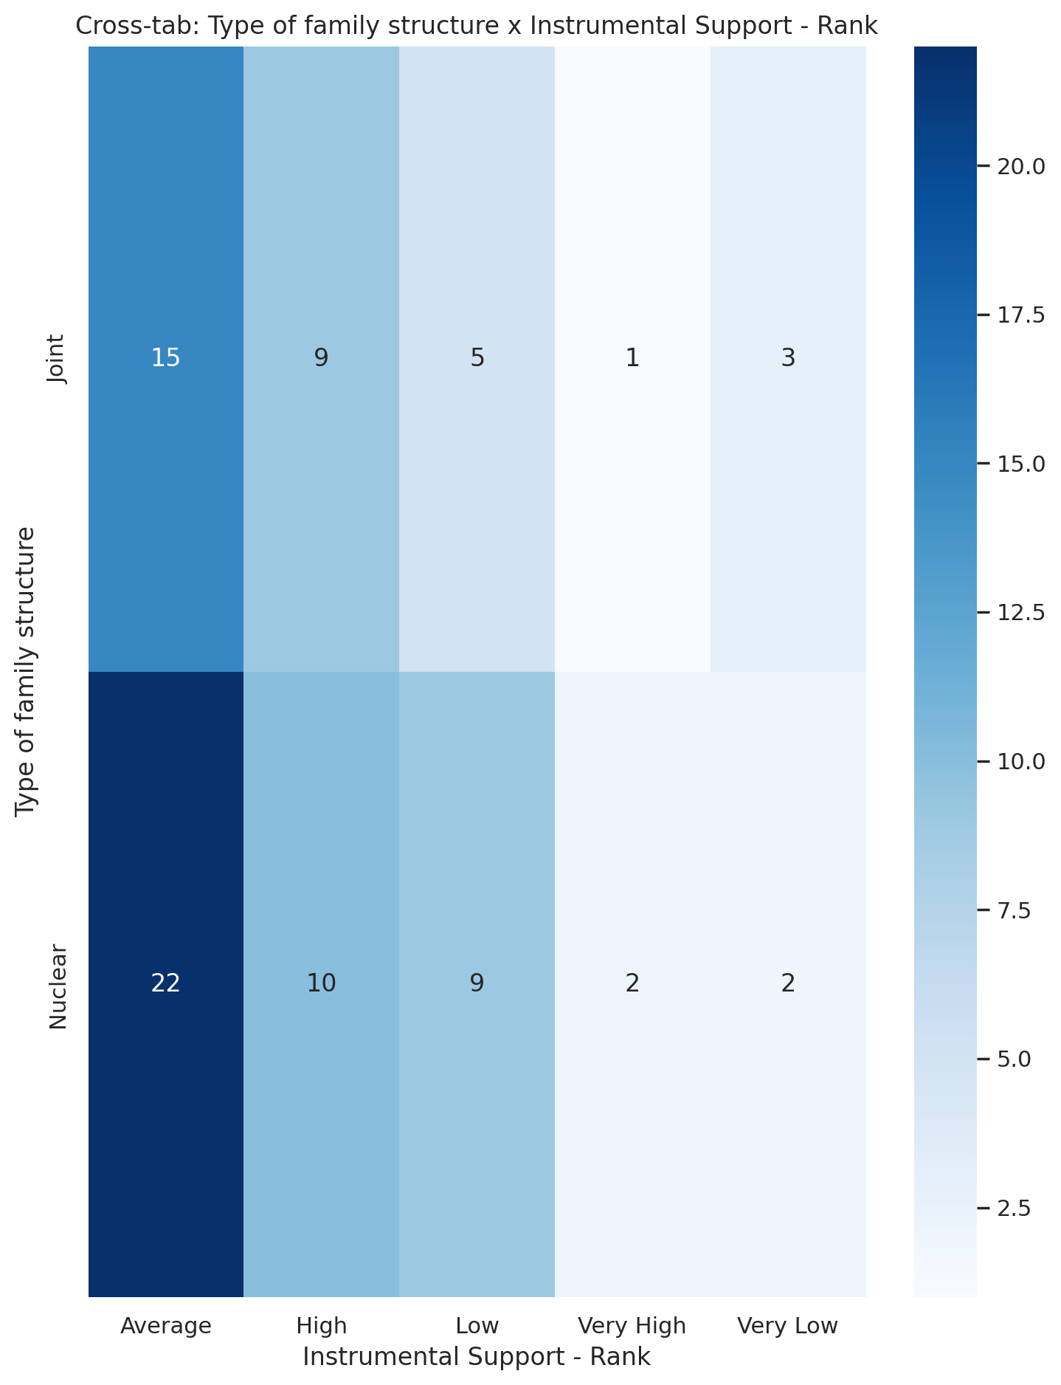

## Real Self Concept Total Category vs Type of family structure

Test: chi2; statistic: 5.815295815295815; p-value: 0.05460401262409126;

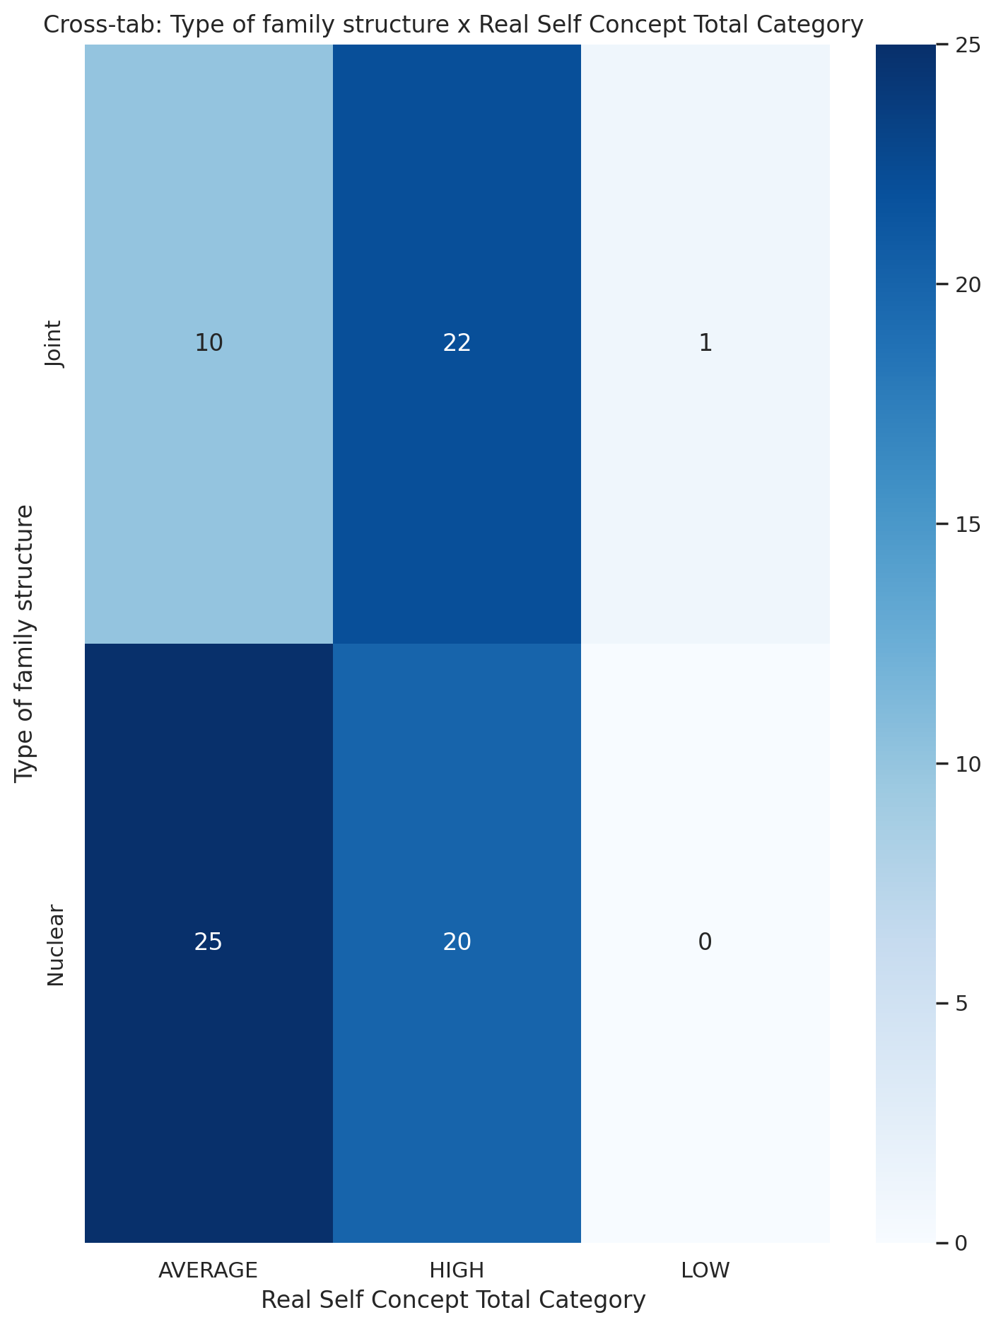

## Ideal Self Concept Total Category vs Type of family structure

Test: chi2; statistic: 0.0; p-value: 1.0;

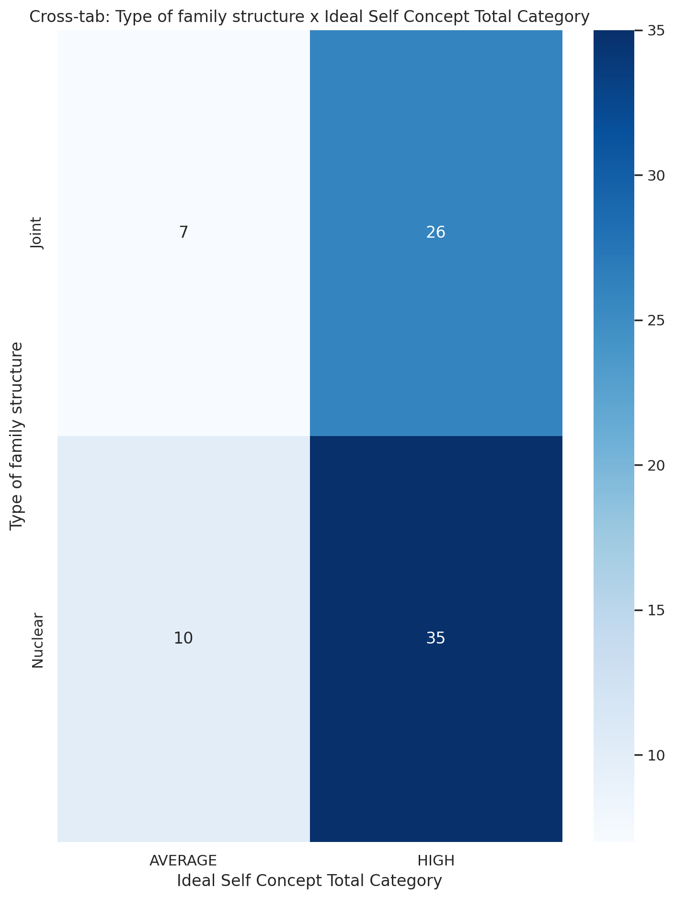

## Social Self Concept Total Category vs Type of family structure

Test: chi2; statistic: 4.111094134623545; p-value: 0.12802277933880163;

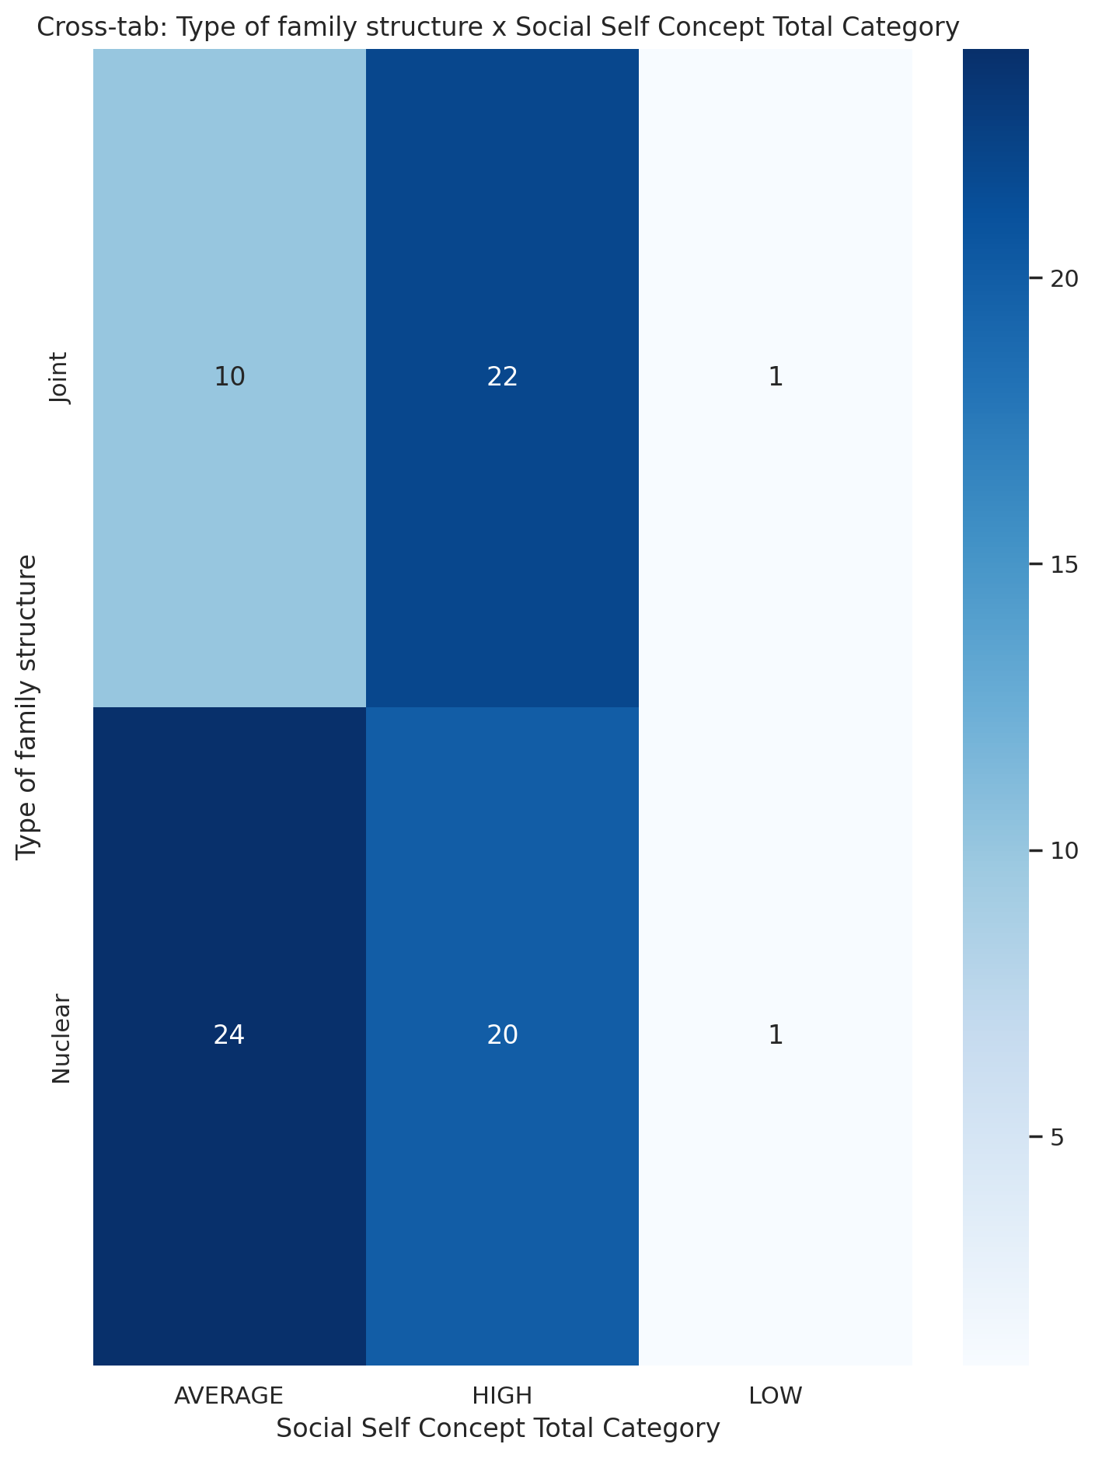

## Emotional Support - T Score vs Monthly household income

Test: ANOVA; statistic: 2.2046354009736433; p-value: 0.07744146894416237;

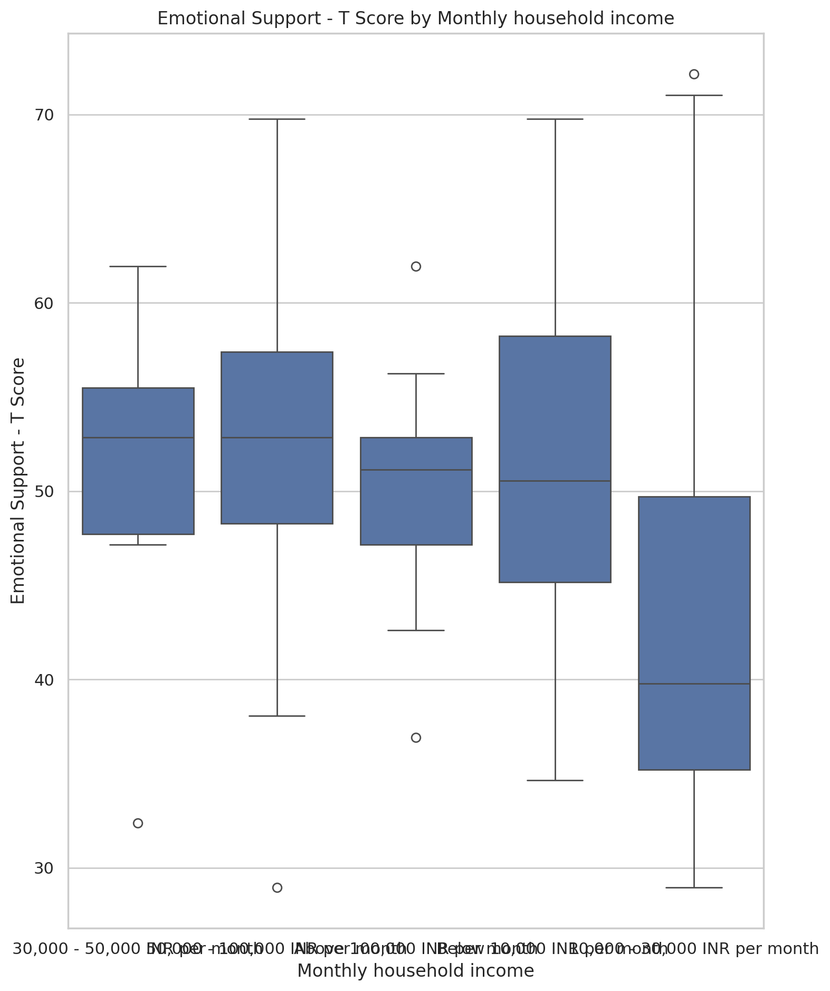

## Informational Support - T Score vs Monthly household income

Test: ANOVA; statistic: 1.6509251065274222; p-value: 0.17142562232042863;

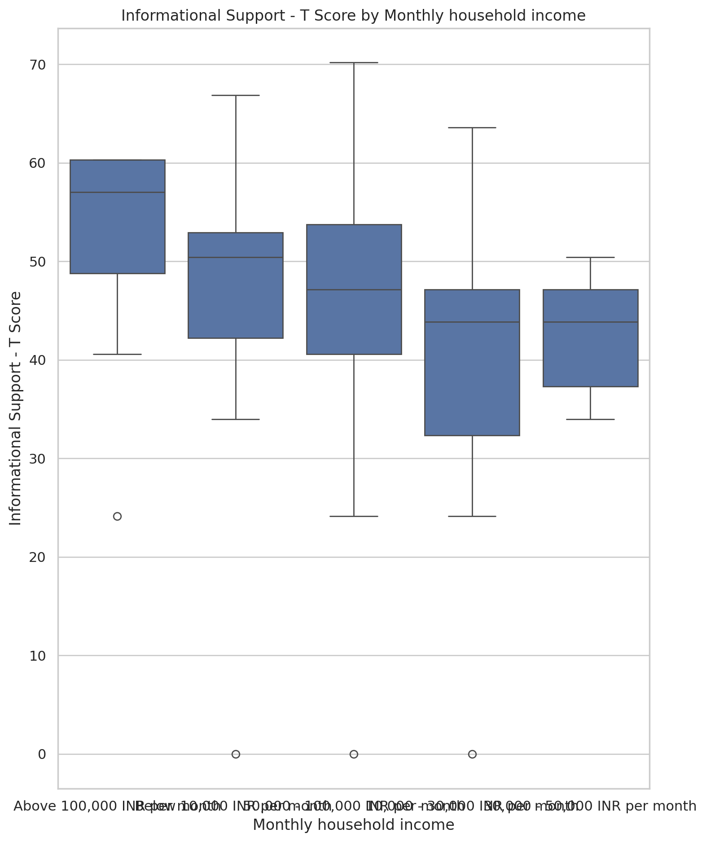

## Instrumental Support - T Score vs Monthly household income

Test: ANOVA; statistic: 0.511565139364433; p-value: 0.7273994794677159;

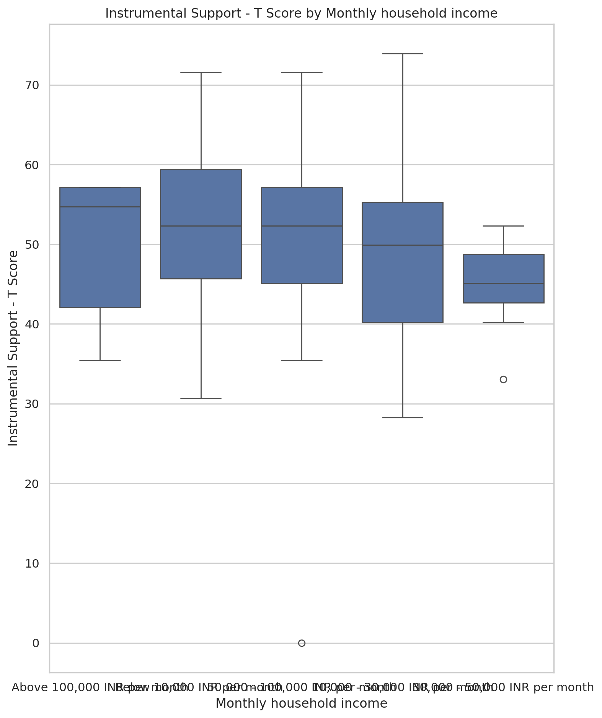

## Emotional Support - Rank vs Monthly household income

Test: chi2; statistic: 26.939081002771477; p-value: 0.0421652387760582;

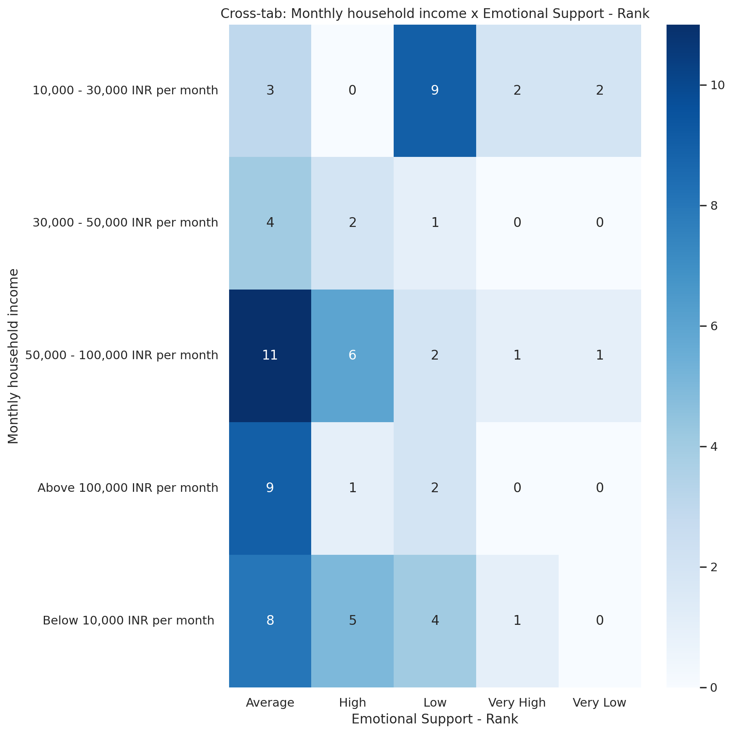

## Informational Support - Rank vs Monthly household income

Test: chi2; statistic: 26.561345563990493; p-value: 0.04662379587063722;

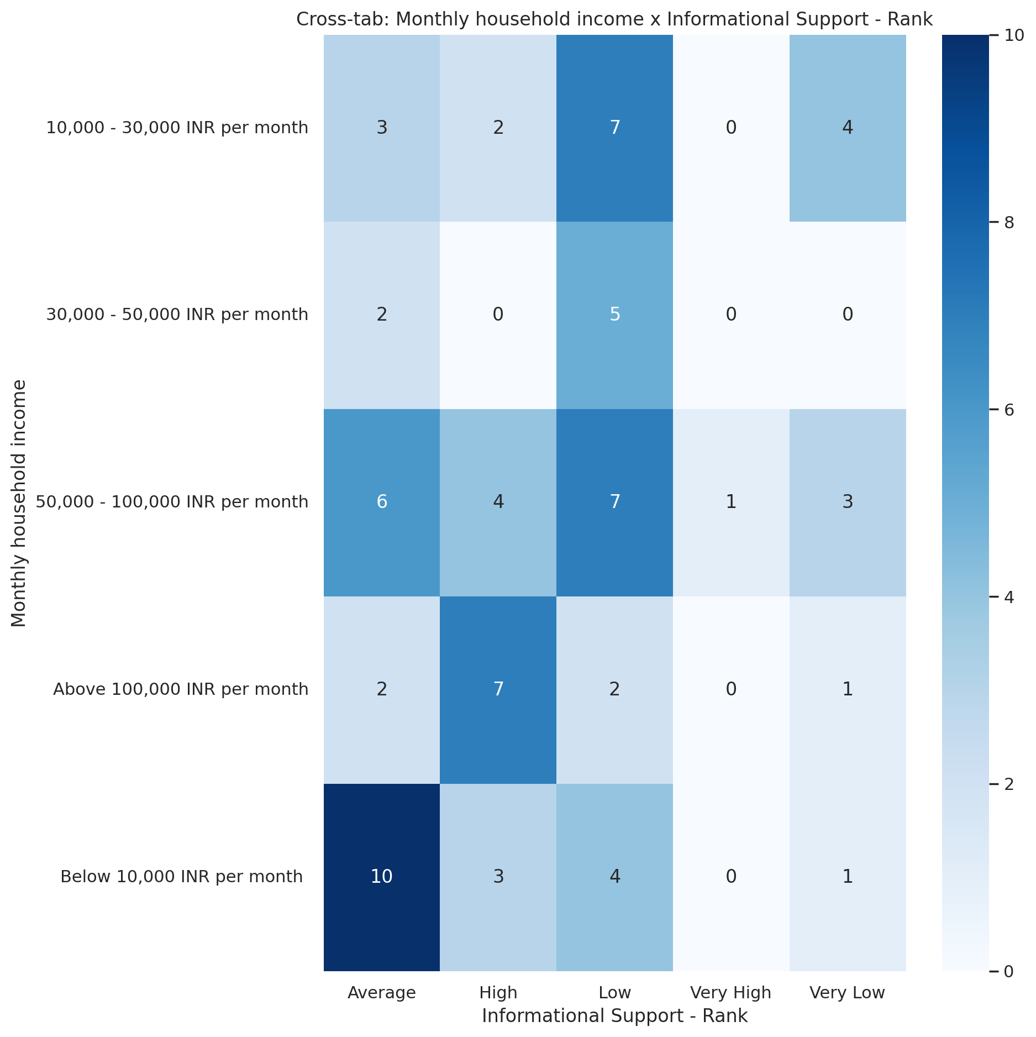

## Instrumental Support - Rank vs Monthly household income

Test: chi2; statistic: 14.044664902998237; p-value: 0.5953862776236917;

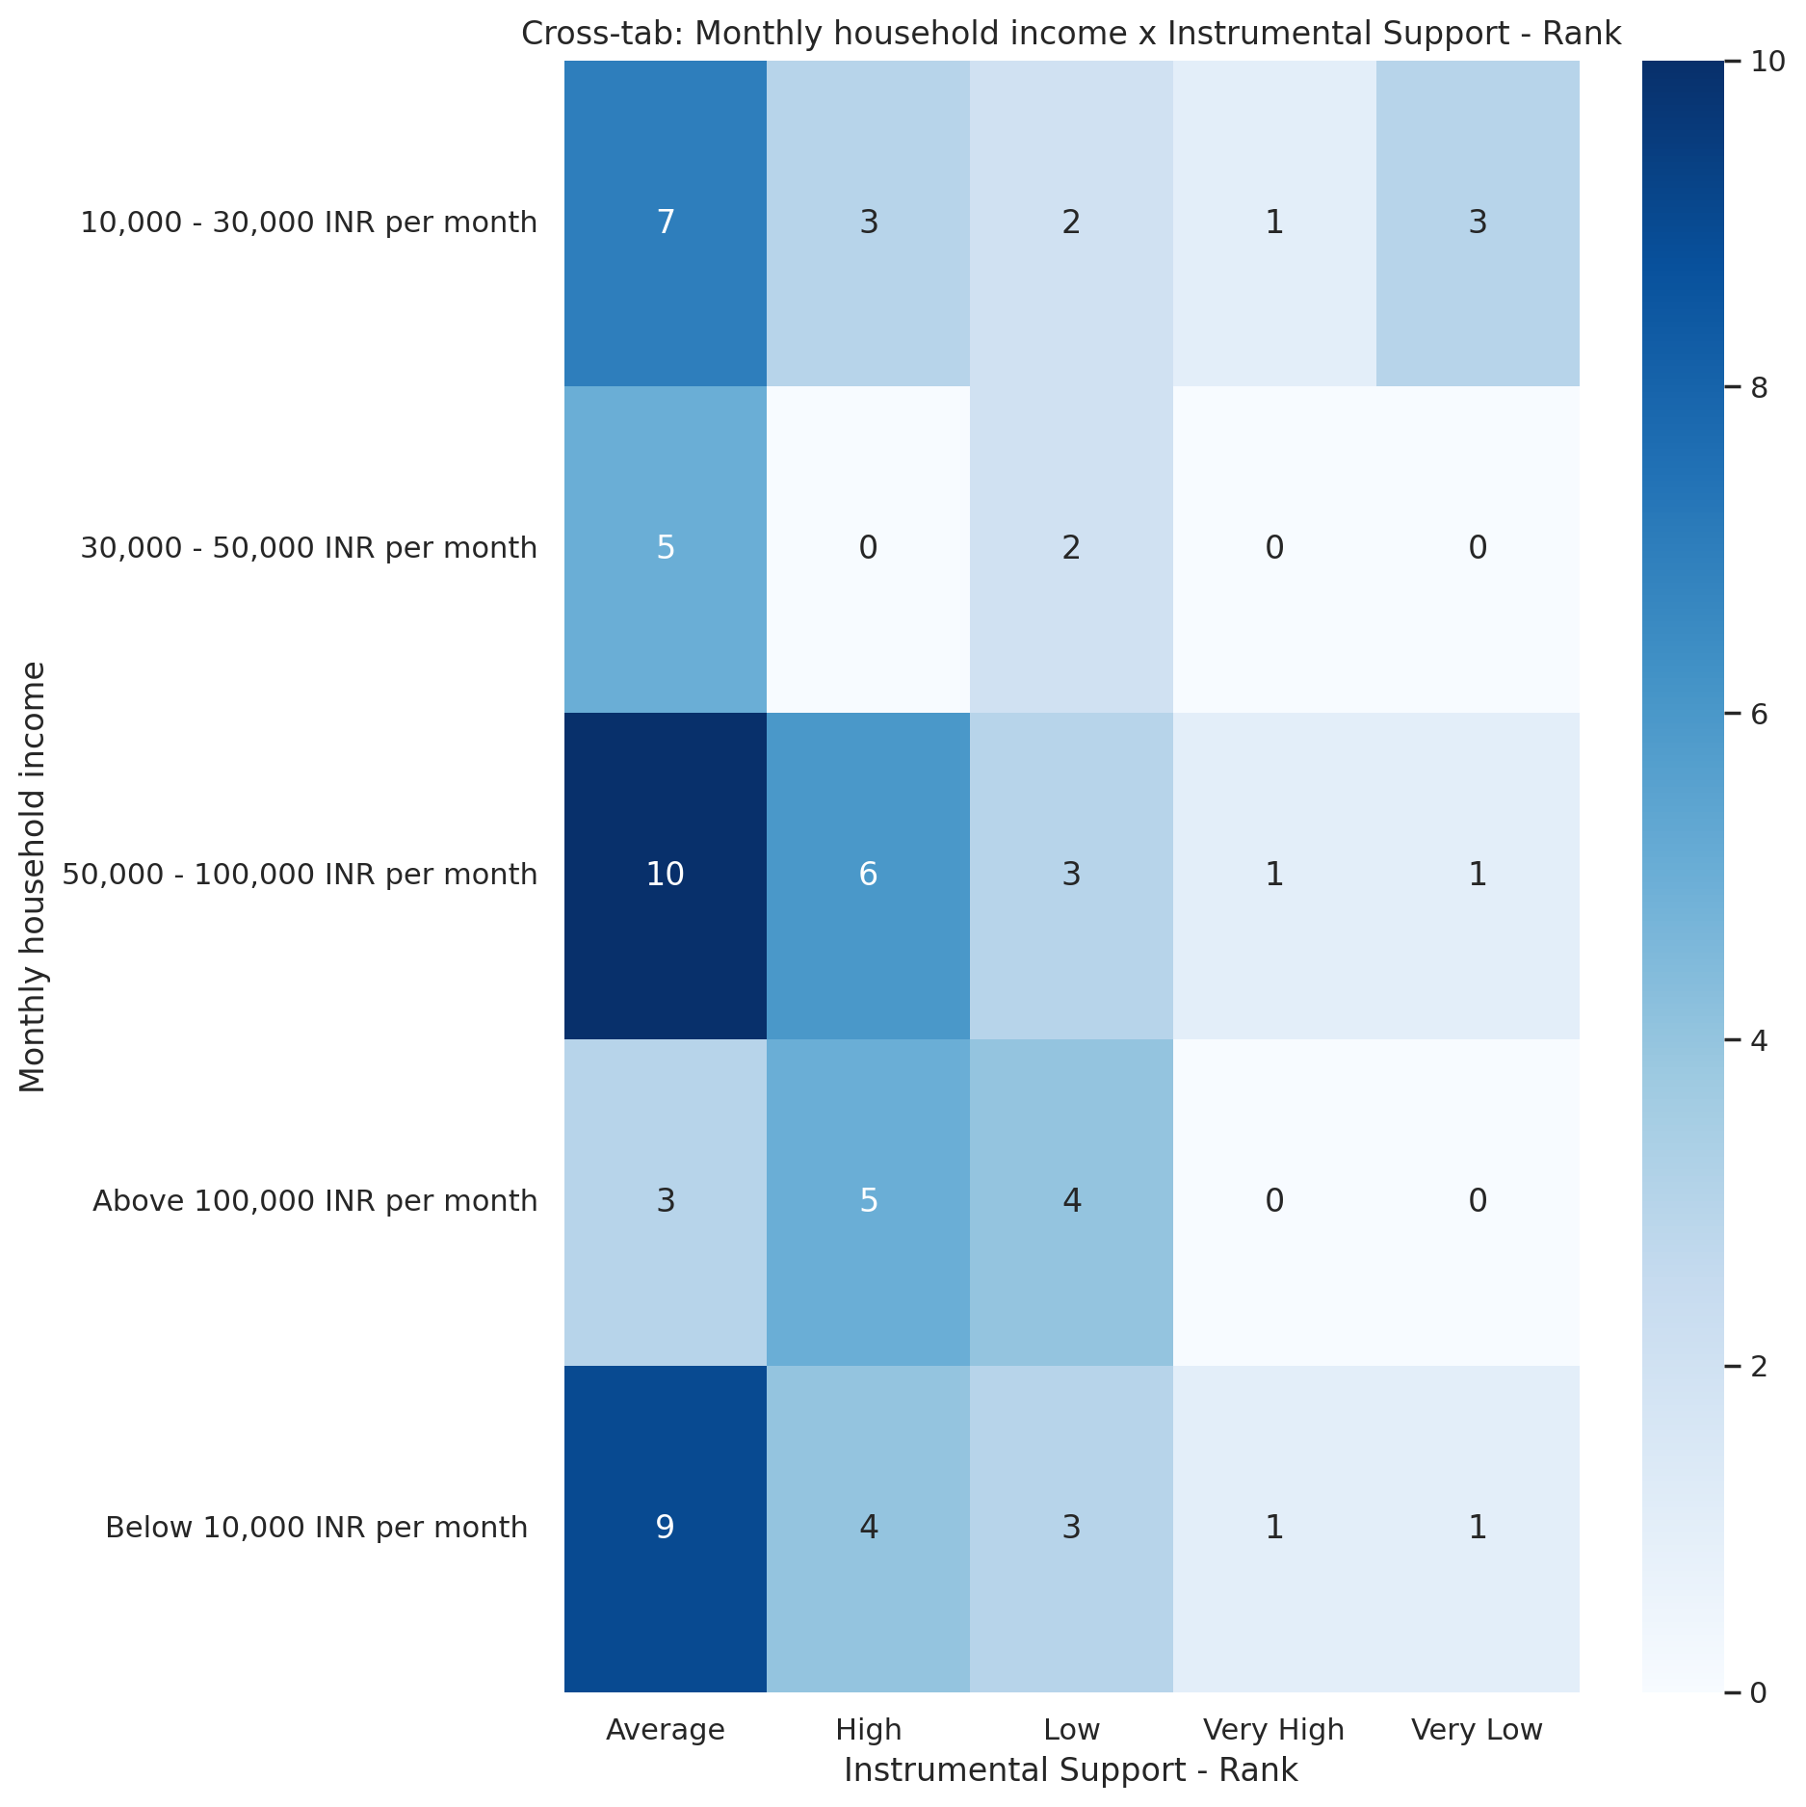

## Real Self Concept Total Category vs Monthly household income

Test: chi2; statistic: 8.700020264711576; p-value: 0.3682303755025514;

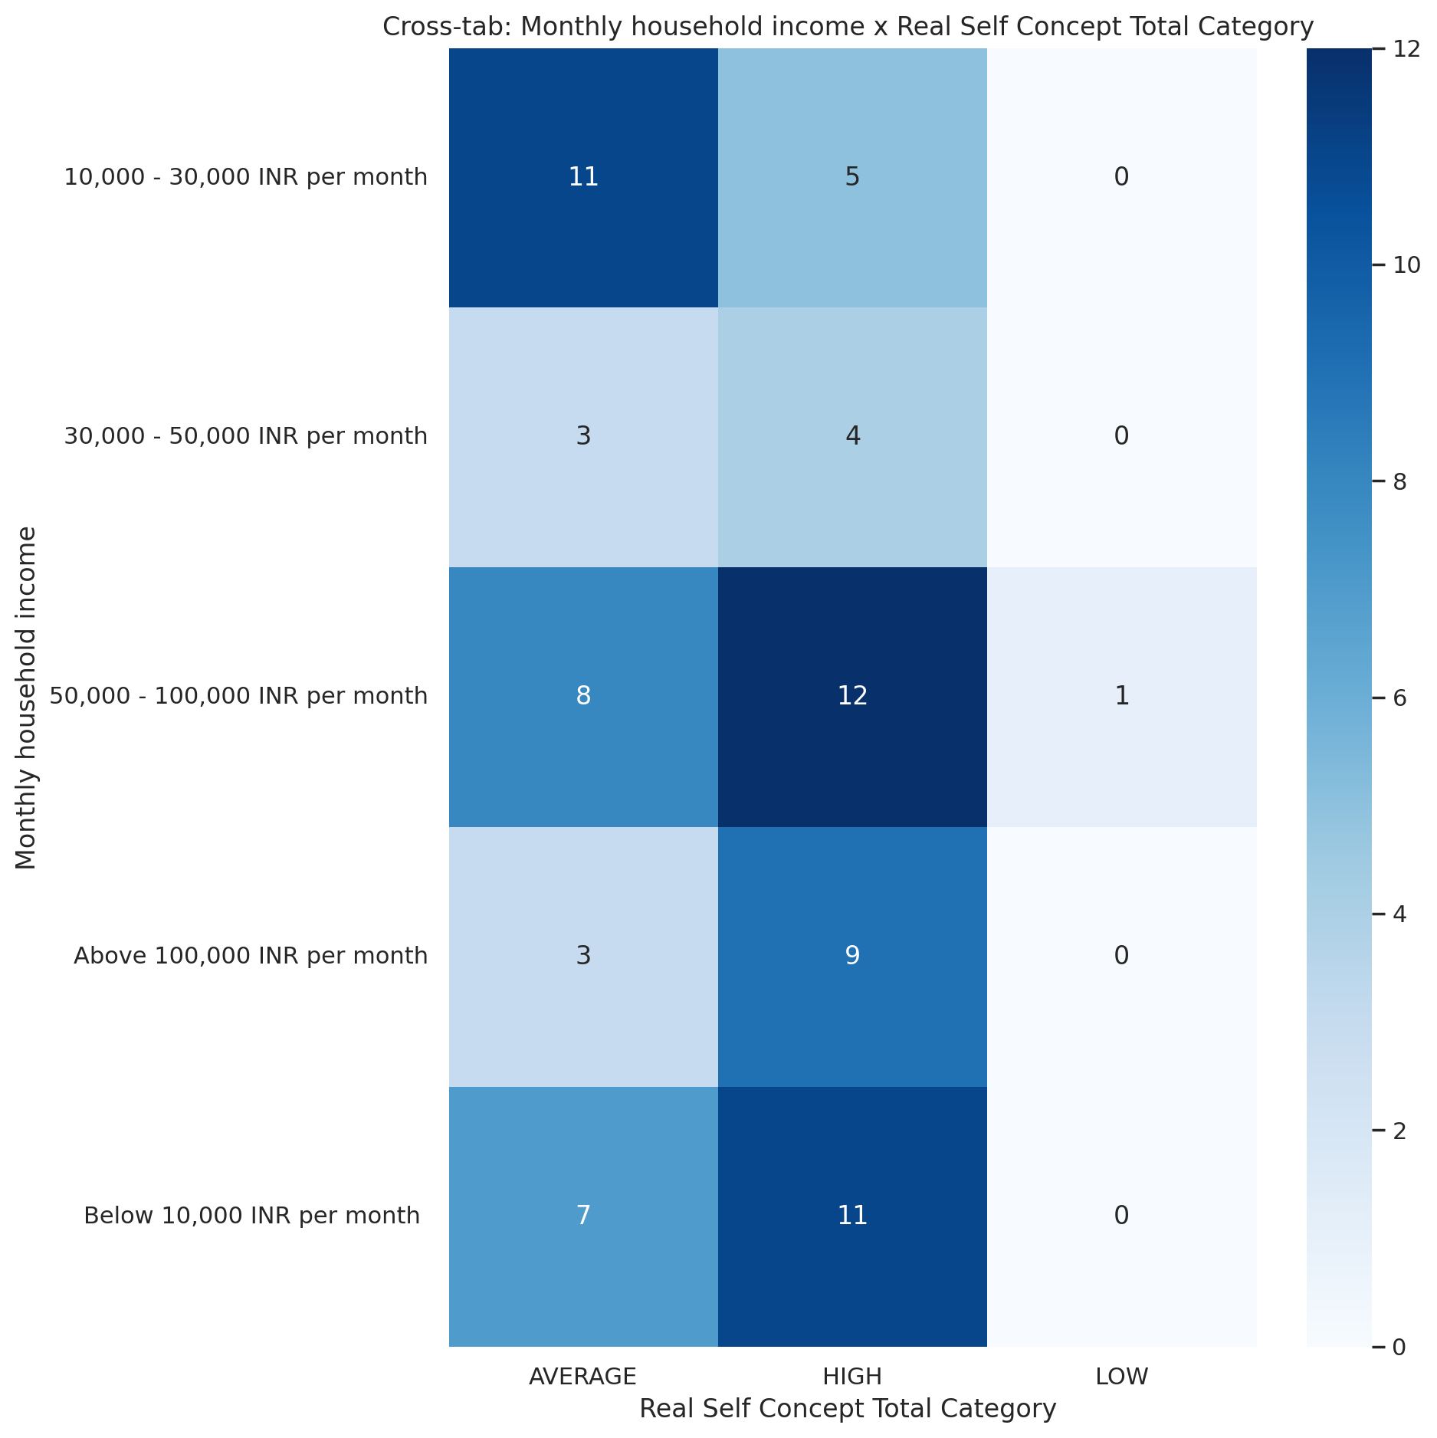

## Ideal Self Concept Total Category vs Monthly household income

Test: chi2; statistic: 5.343938149972633; p-value: 0.2537918022892582;

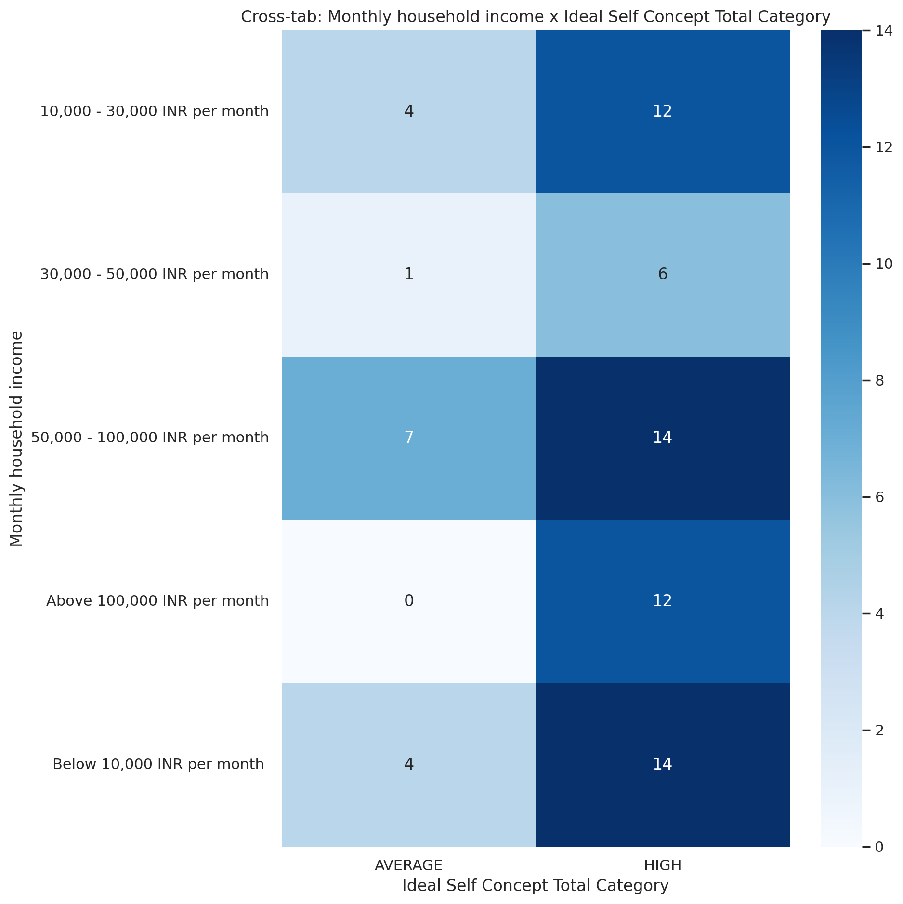

## Social Self Concept Total Category vs Monthly household income

Test: chi2; statistic: 9.61527293844367; p-value: 0.2930731936469939;

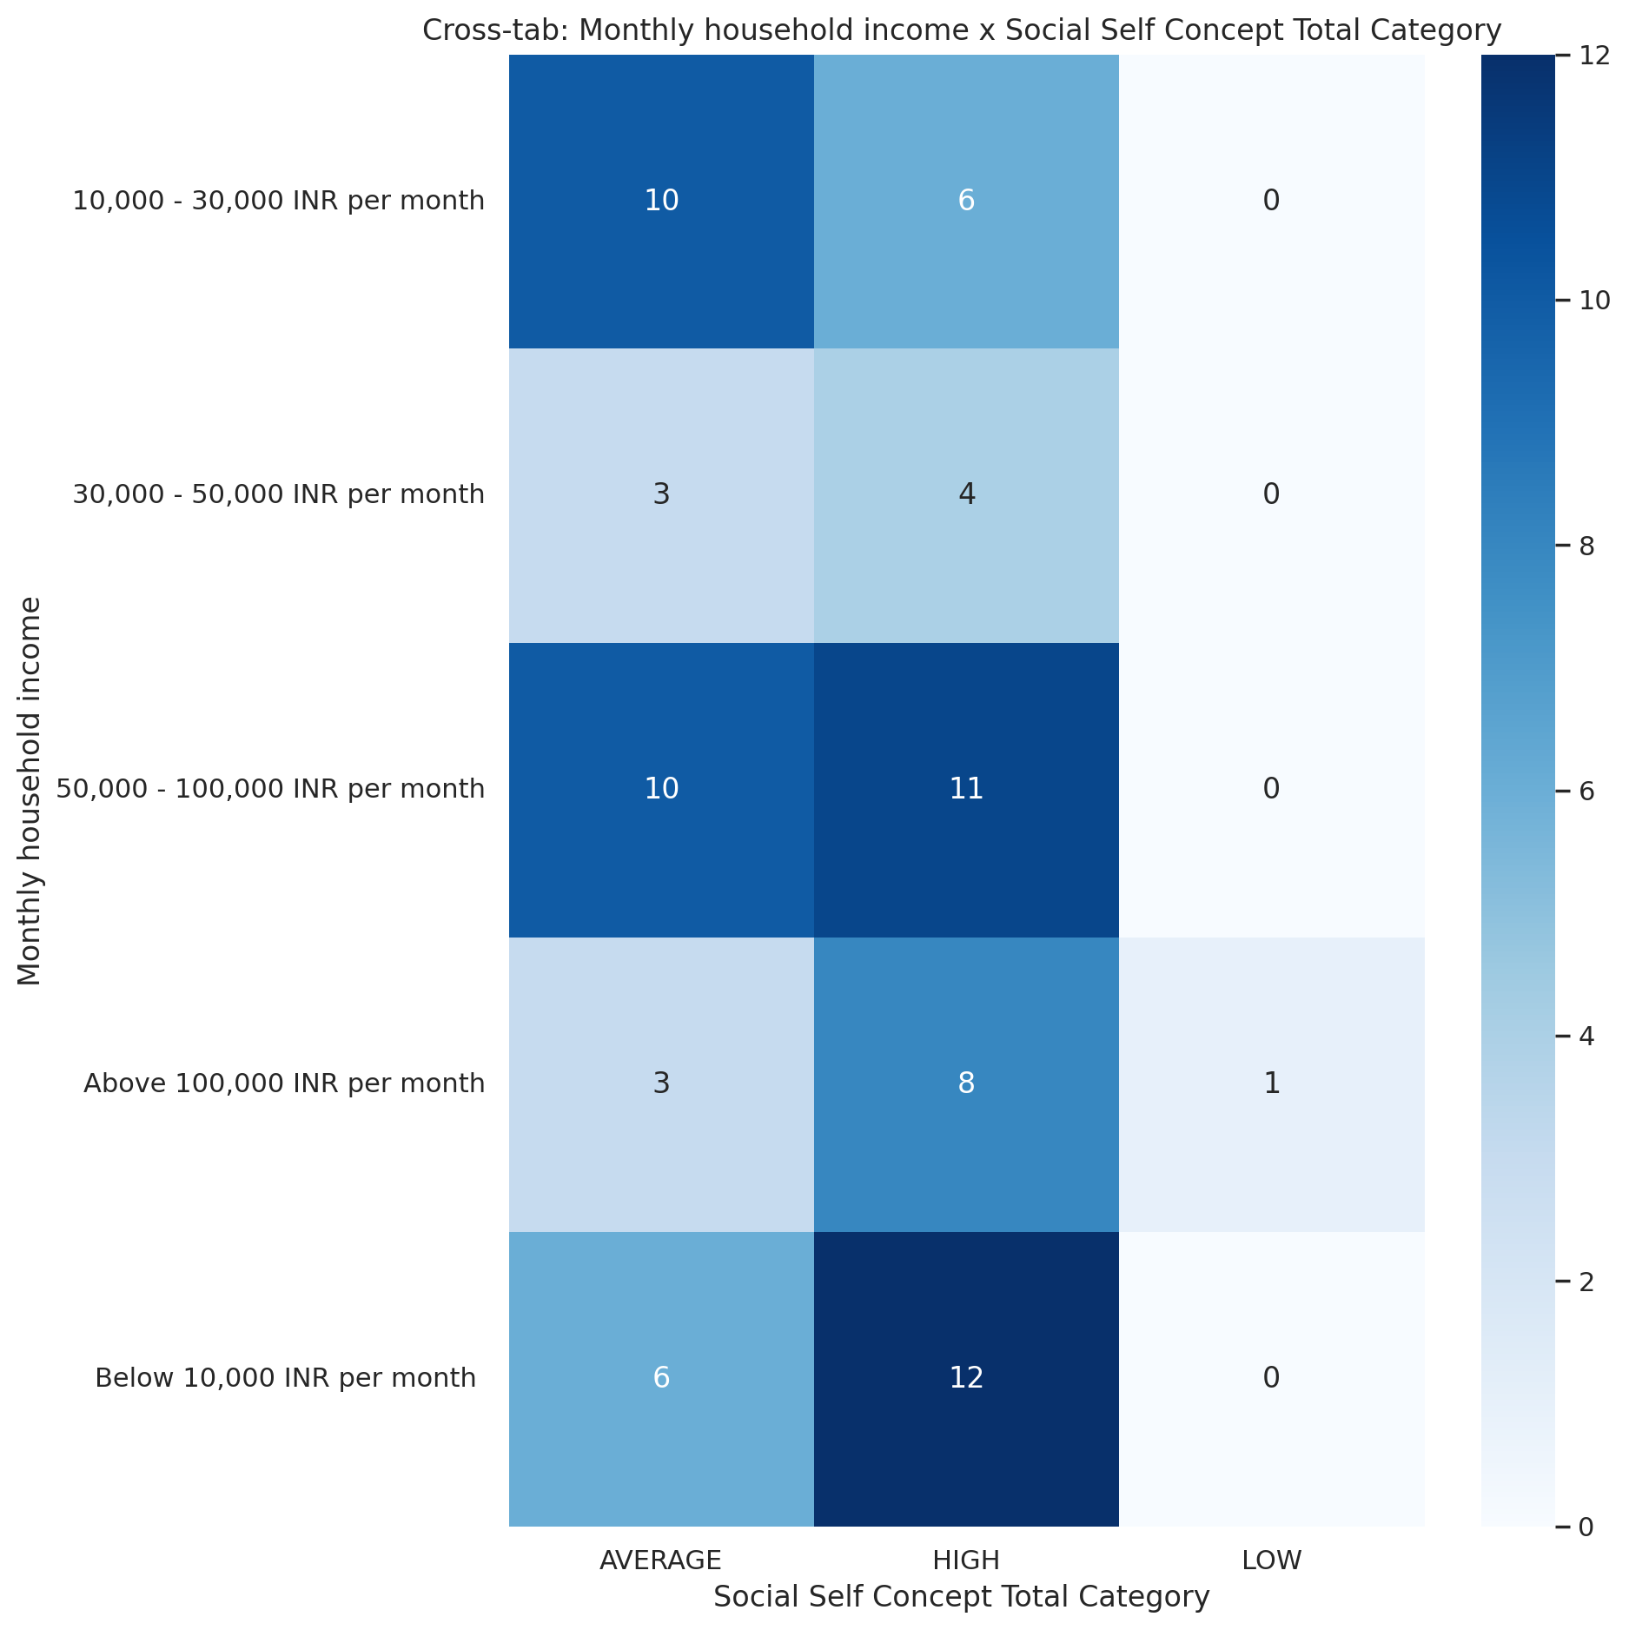

## Emotional Support - T Score vs Access to healthcare services

Test: ANOVA; statistic: 0.9974927278507926; p-value: 0.321357992560413;

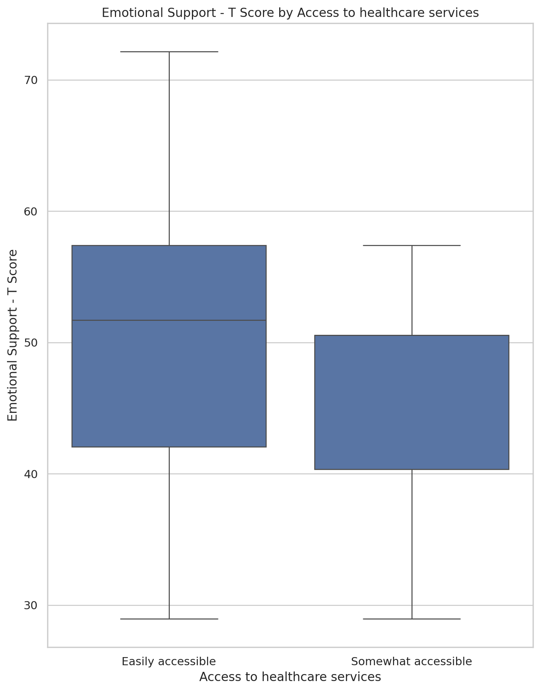

## Informational Support - T Score vs Access to healthcare services

Test: ANOVA; statistic: 1.6042953662235795; p-value: 0.20949398705947103;

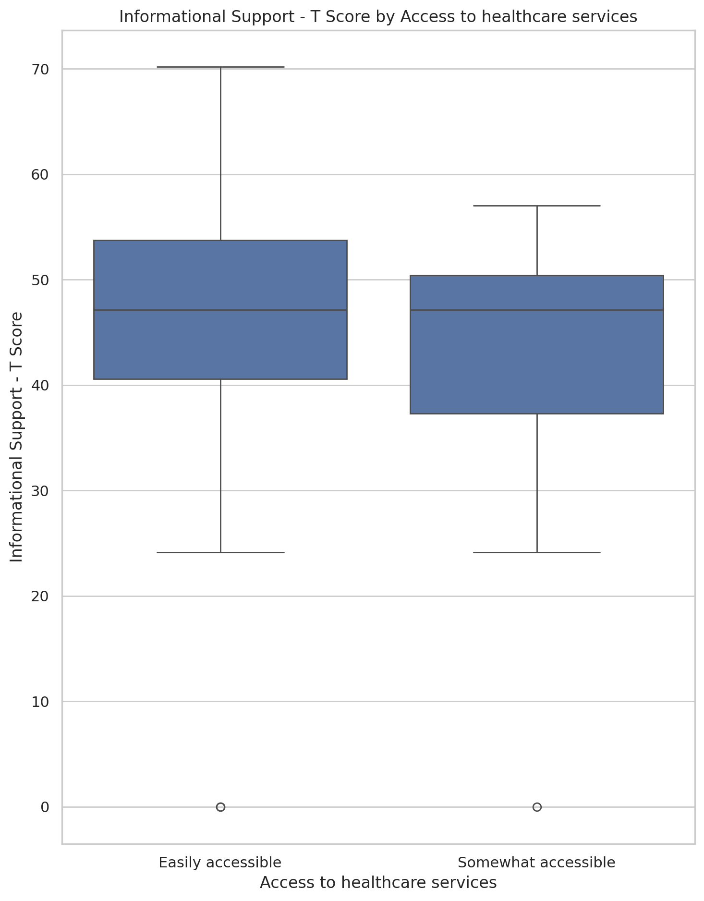

## Instrumental Support - T Score vs Access to healthcare services

Test: ANOVA; statistic: 1.1355120147421016; p-value: 0.29026441915010315;

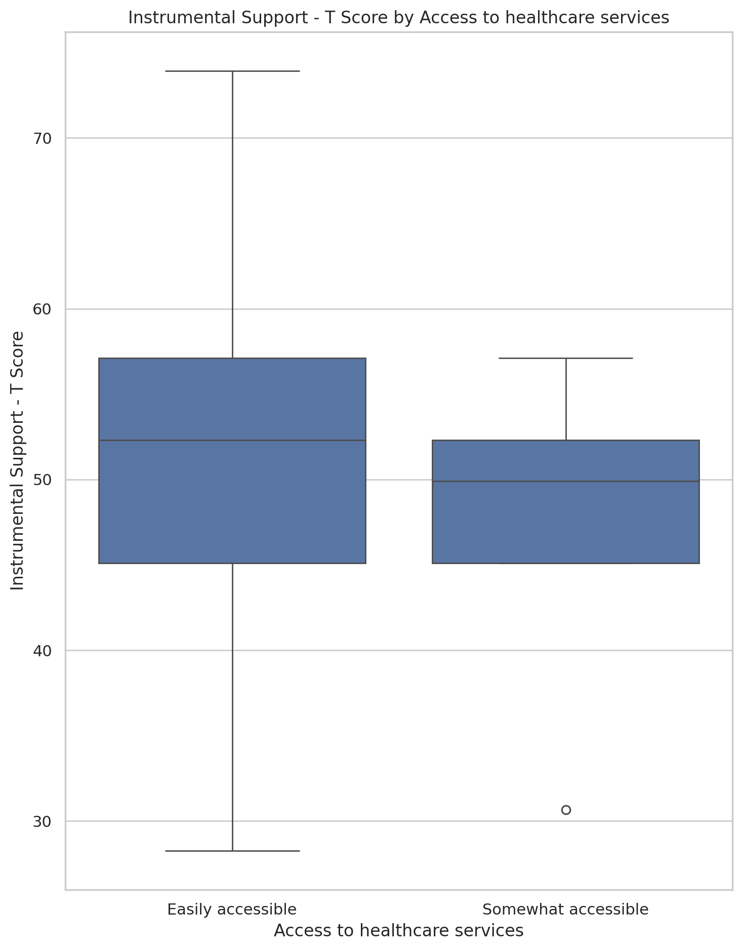

## Emotional Support - Rank vs Access to healthcare services

Test: chi2; statistic: 3.0536084055525725; p-value: 0.5488945900524431;

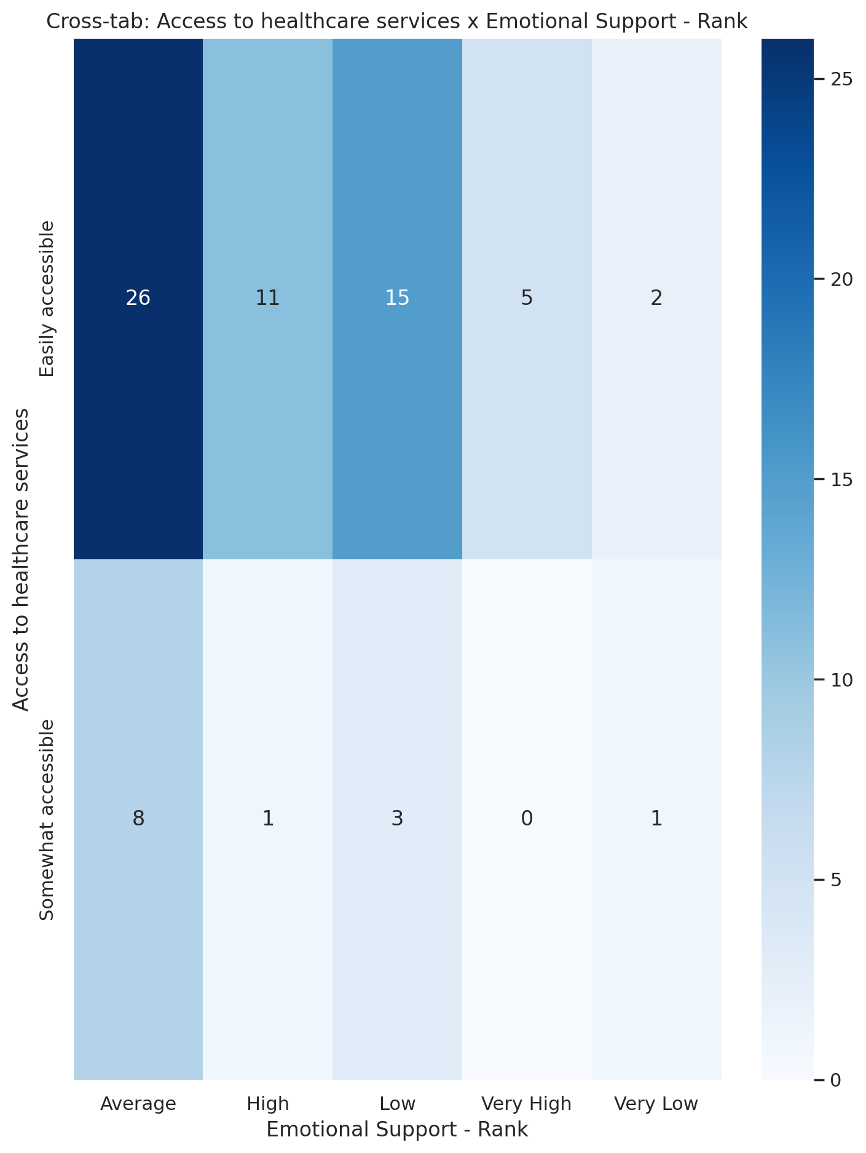

## Informational Support - Rank vs Access to healthcare services

Test: chi2; statistic: 2.056723055868229; p-value: 0.7253266383877355;

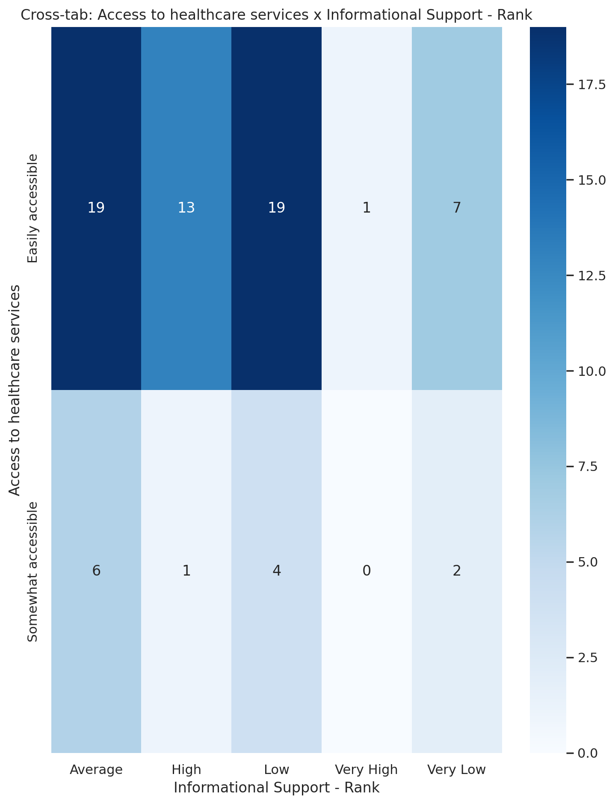

## Instrumental Support - Rank vs Access to healthcare services

Test: chi2; statistic: 10.066416136206763; p-value: 0.039323649175228056;

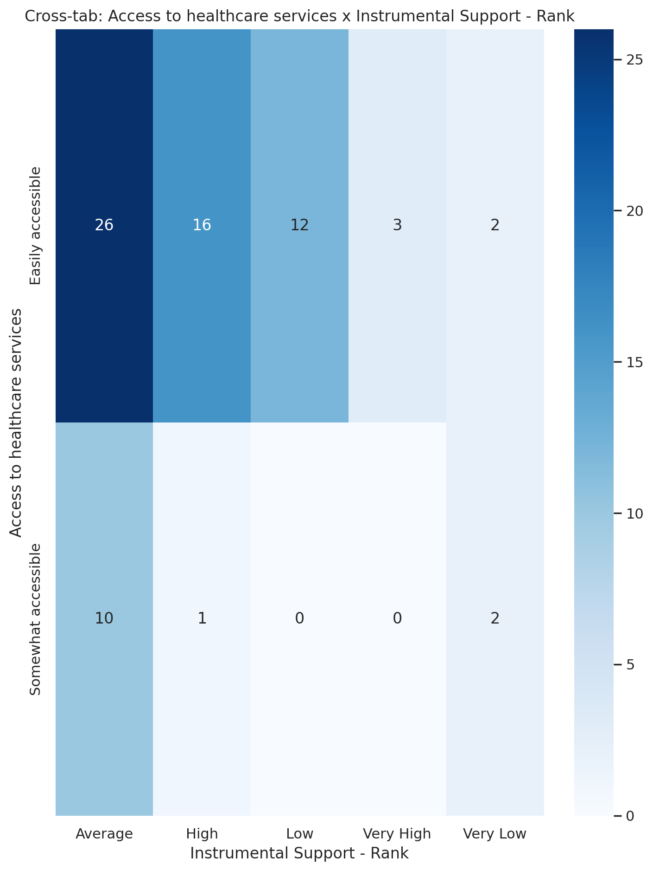

## Real Self Concept Total Category vs Access to healthcare services

Test: chi2; statistic: 1.6901492798013762; p-value: 0.42952529728870925;

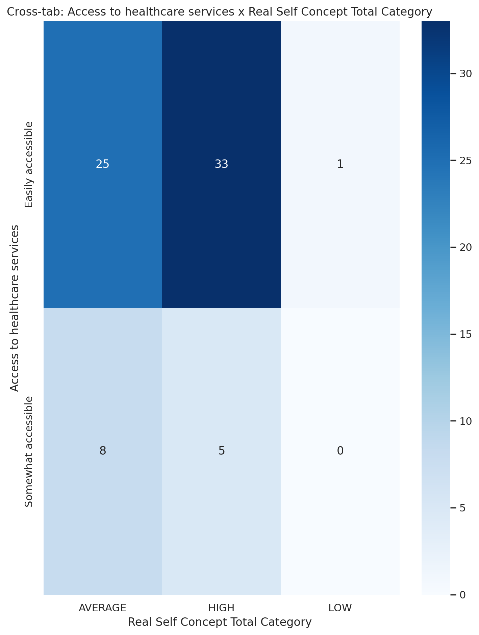

## Ideal Self Concept Total Category vs Access to healthcare services

Test: chi2; statistic: 0.35671447196870887; p-value: 0.550336620005309;

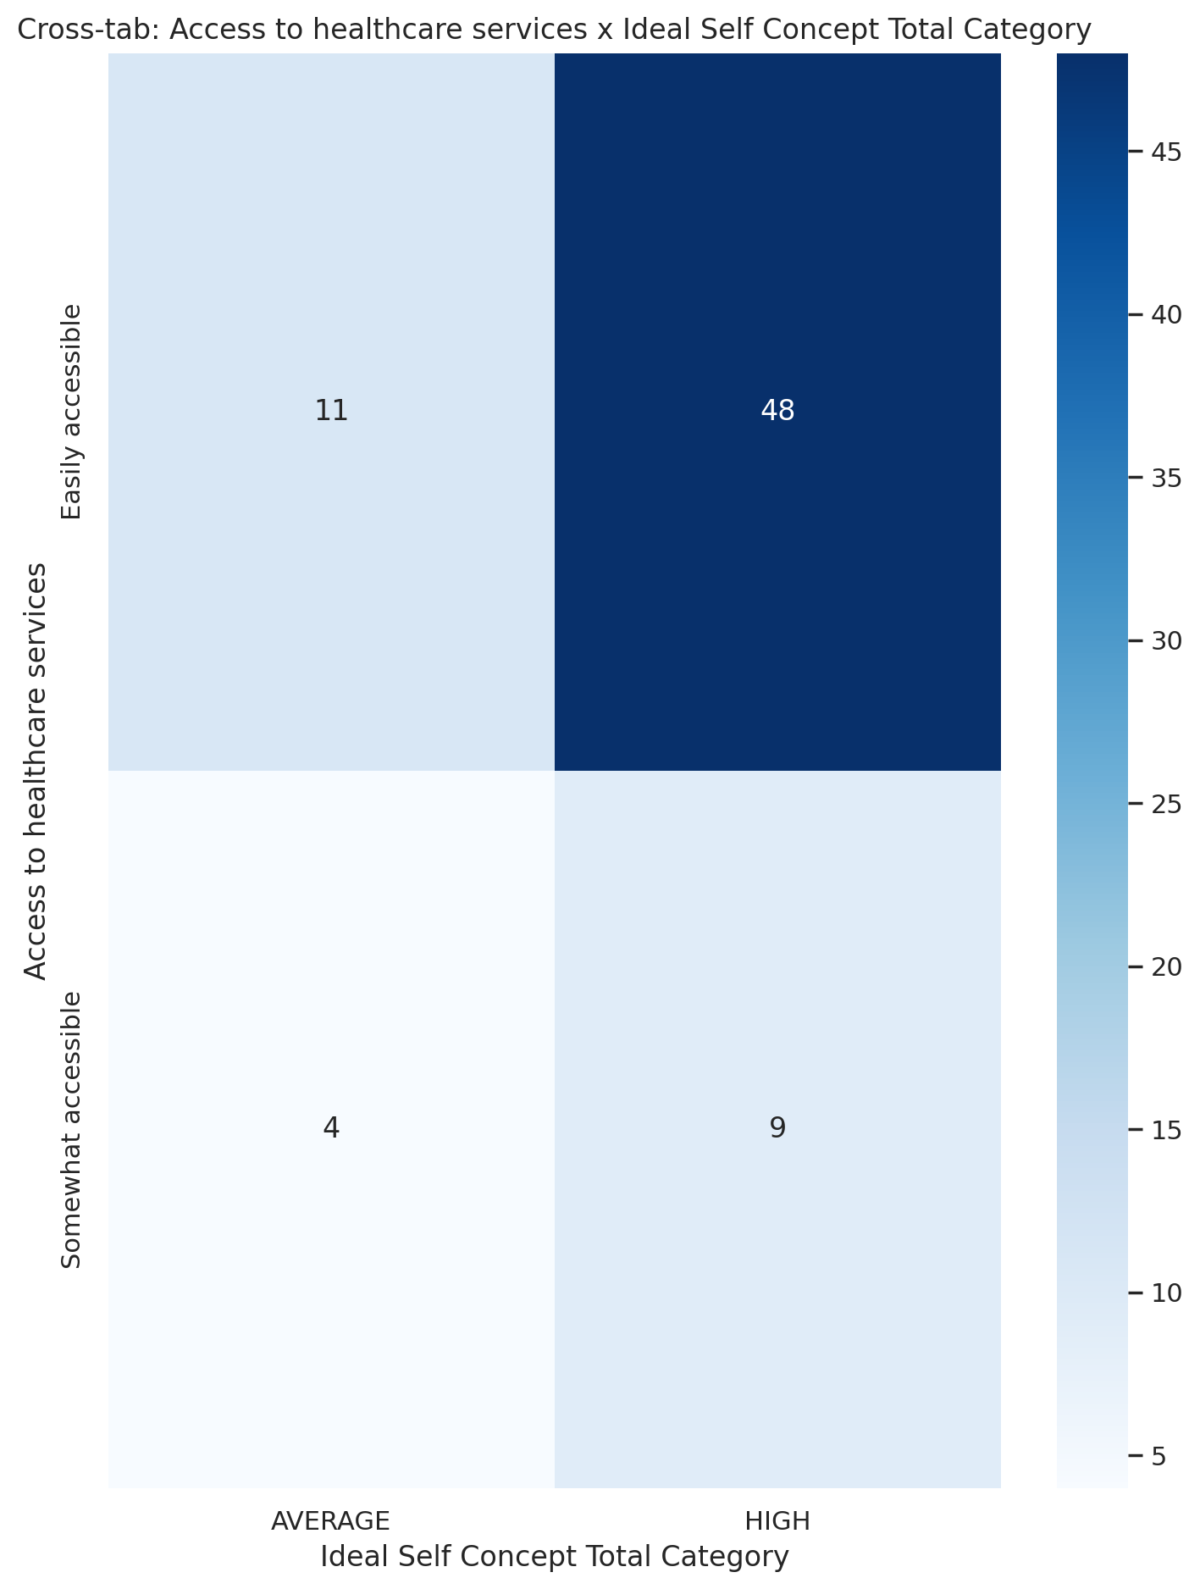

## Social Self Concept Total Category vs Access to healthcare services

Test: chi2; statistic: 3.8784052700198988; p-value: 0.1438185799711658;

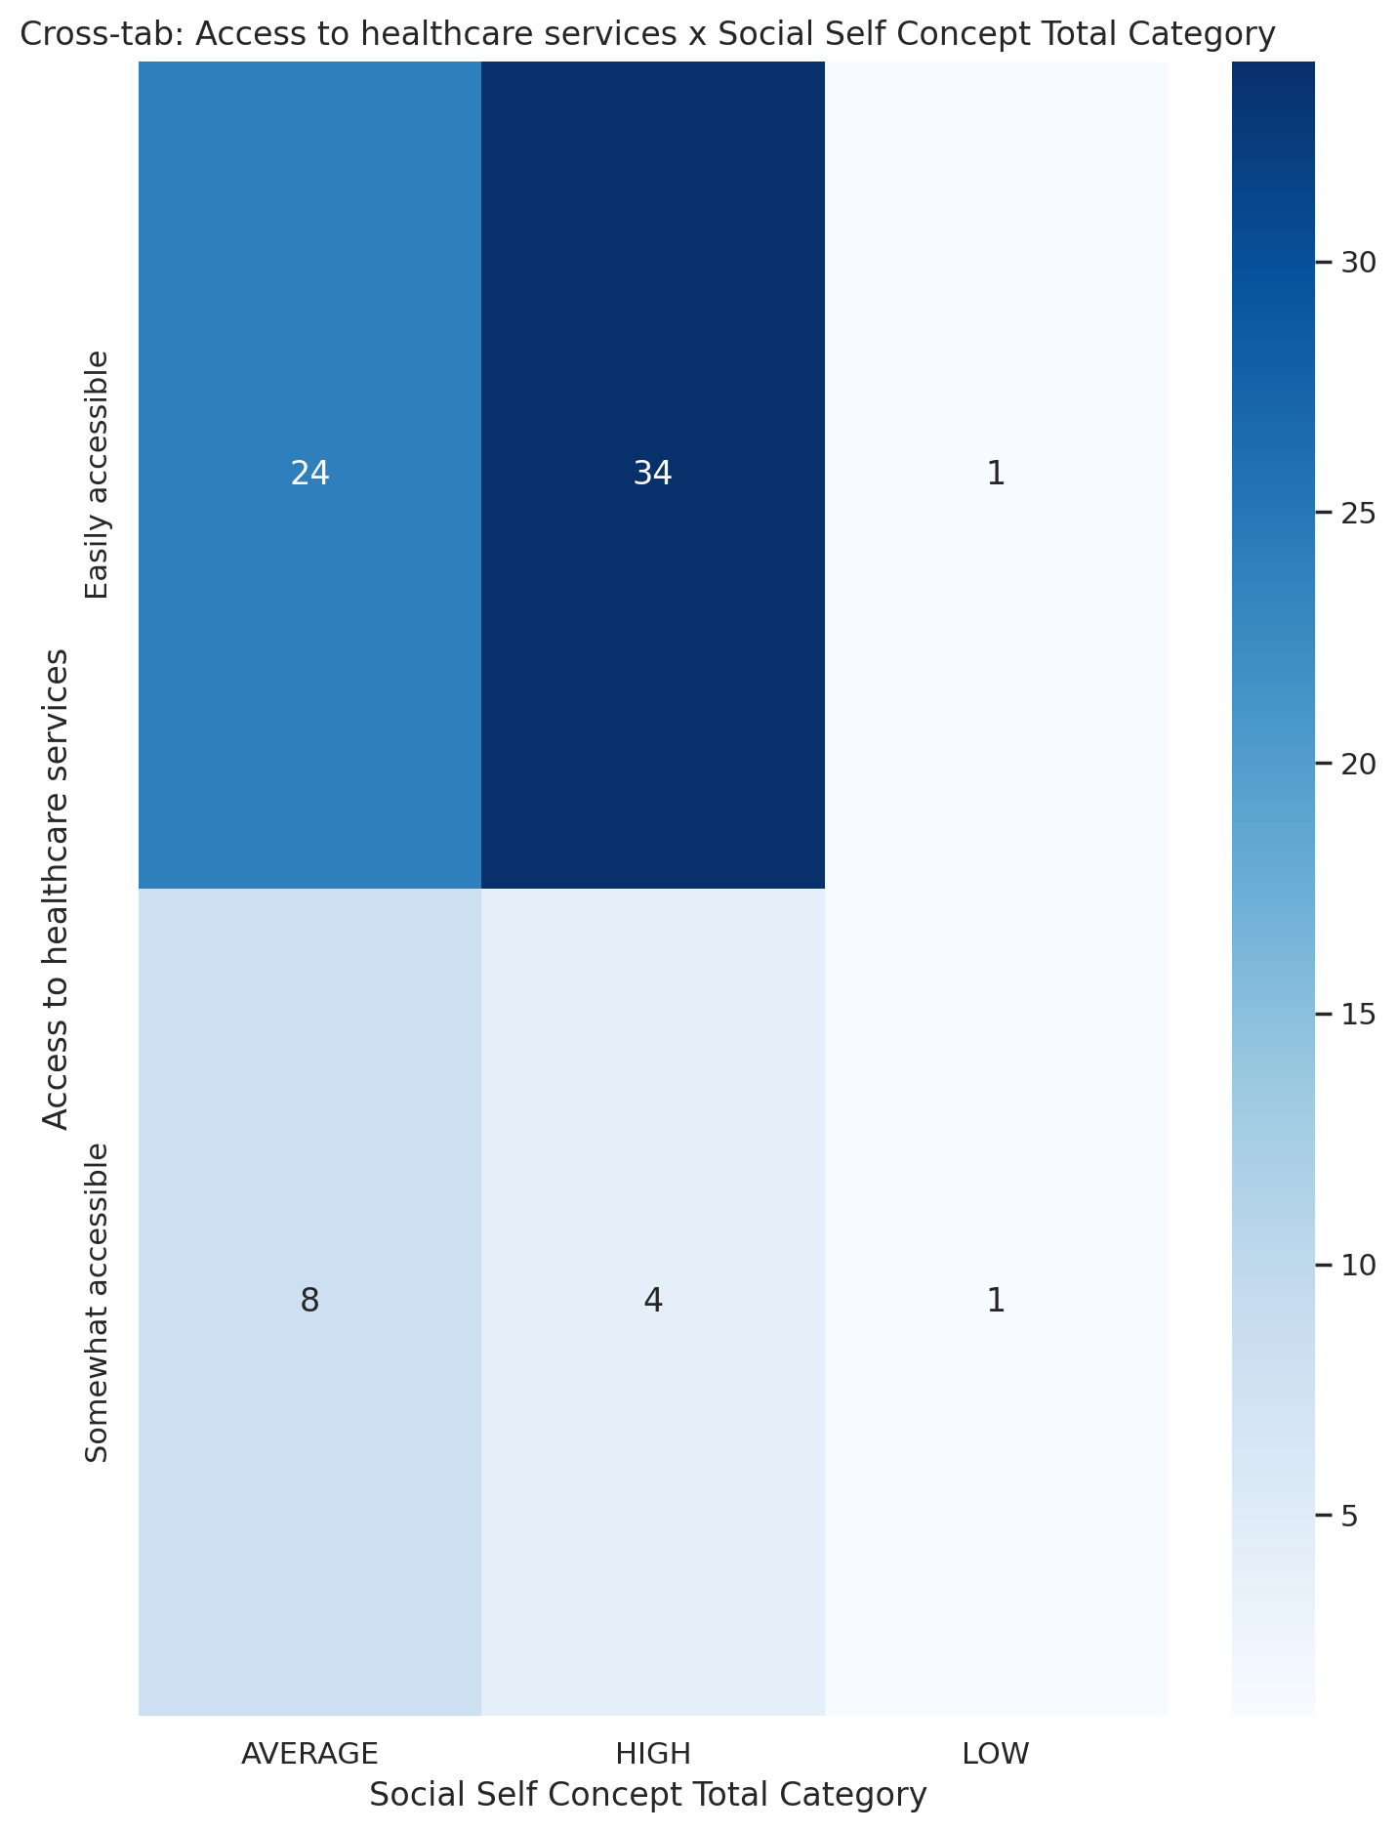

## Emotional Support - T Score vs Overall health status

Test: ANOVA; statistic: 0.5758666388616702; p-value: 0.6326749422744686;

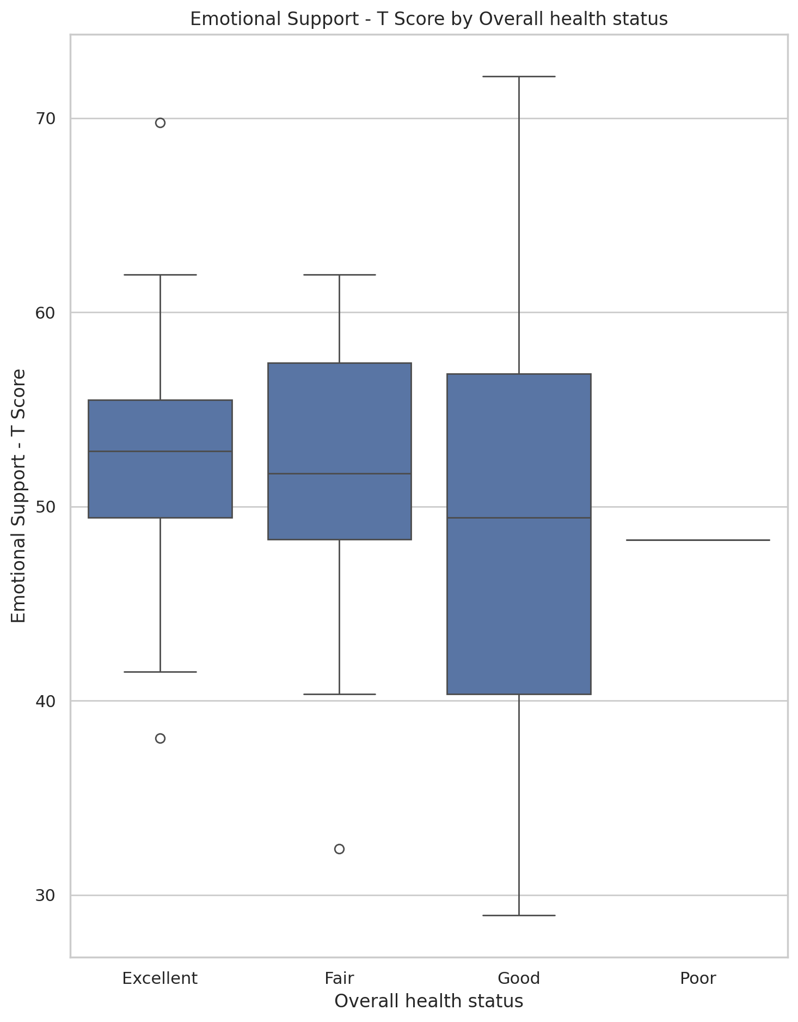

## Informational Support - T Score vs Overall health status

Test: ANOVA; statistic: 1.0661130329224533; p-value: 0.36876151883637925;

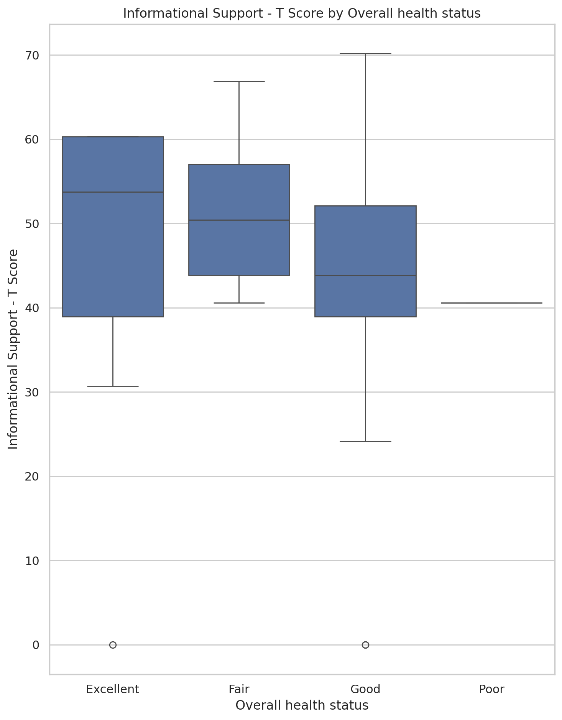

## Instrumental Support - T Score vs Overall health status

Test: ANOVA; statistic: 1.0343679090708175; p-value: 0.38244255750242756;

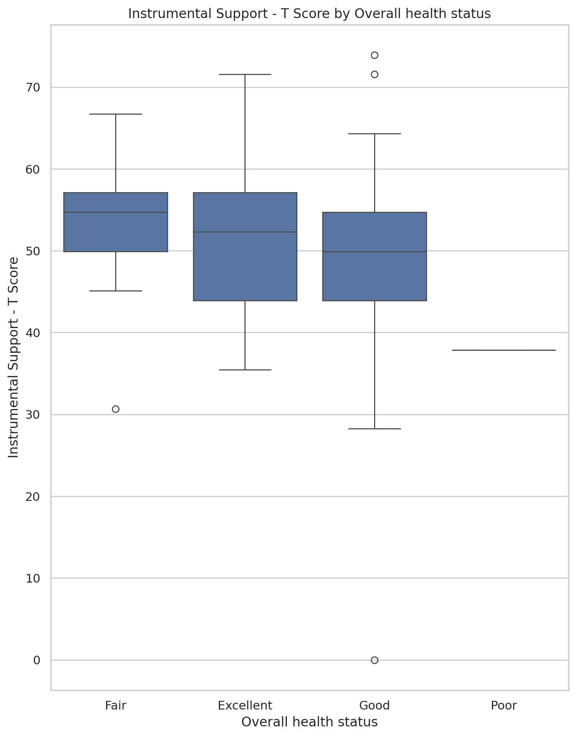

## Emotional Support - Rank vs Overall health status

Test: chi2; statistic: 6.805776651968603; p-value: 0.8701771509951076;

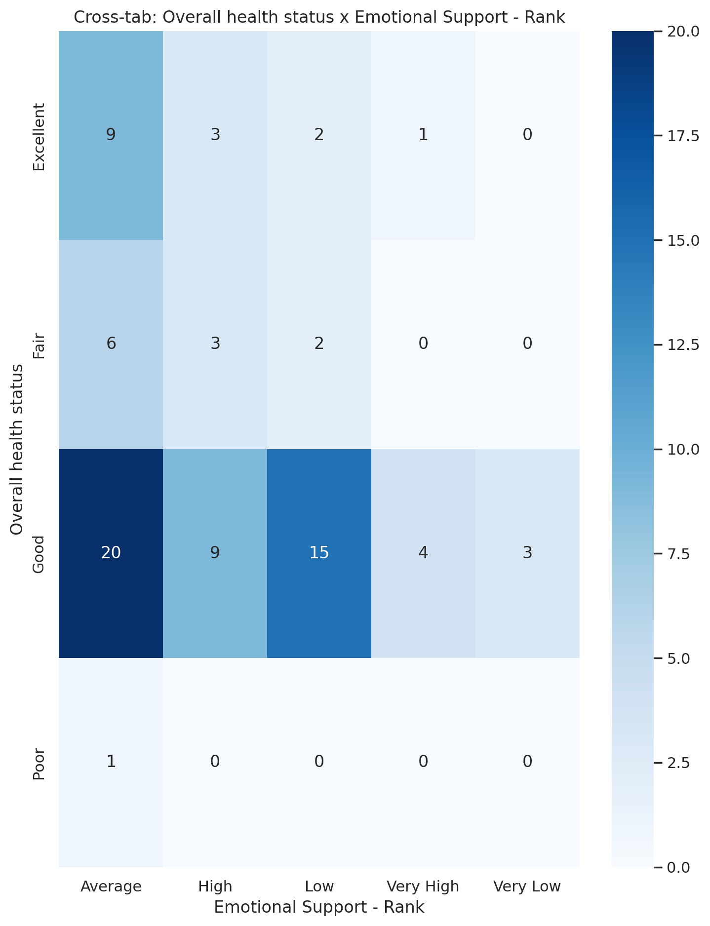

## Informational Support - Rank vs Overall health status

Test: chi2; statistic: 8.77282432164785; p-value: 0.7222020240992976;

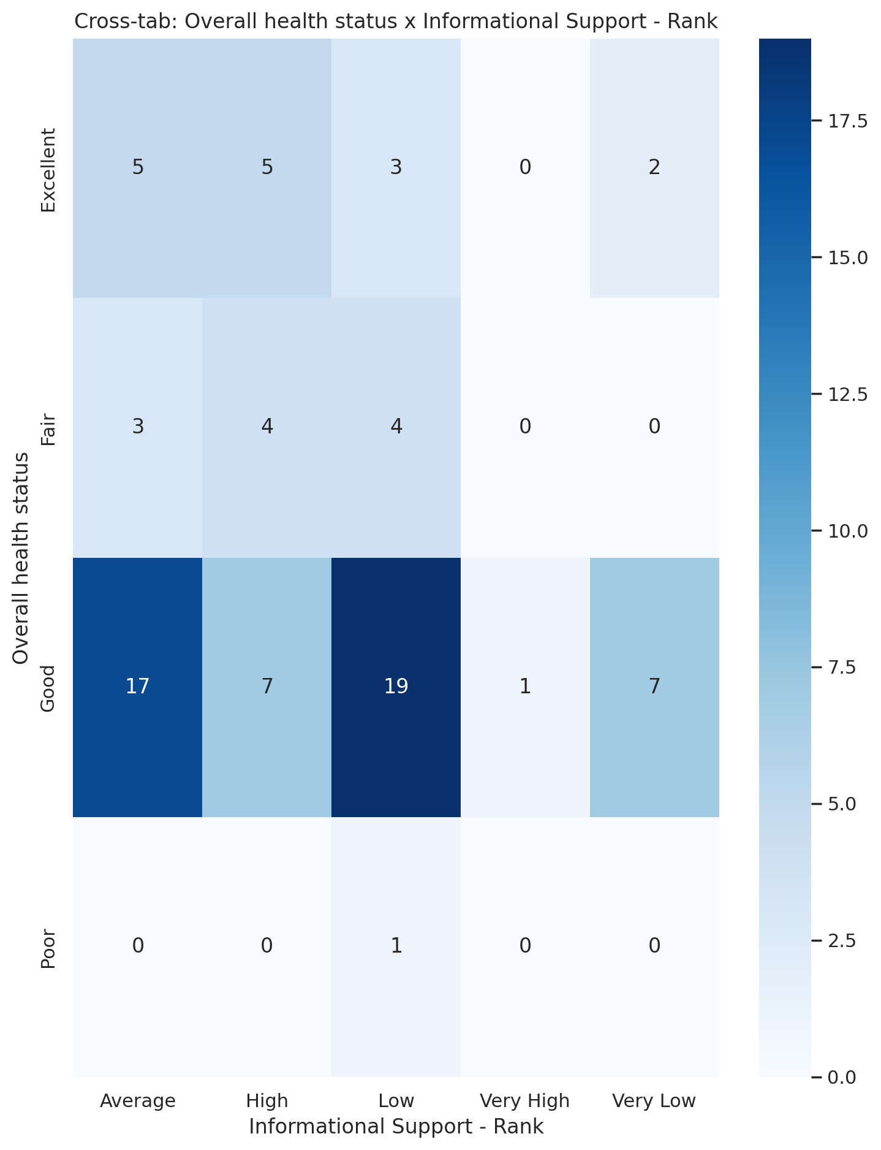

## Instrumental Support - Rank vs Overall health status

Test: chi2; statistic: 11.666349136318177; p-value: 0.47283379864470754;

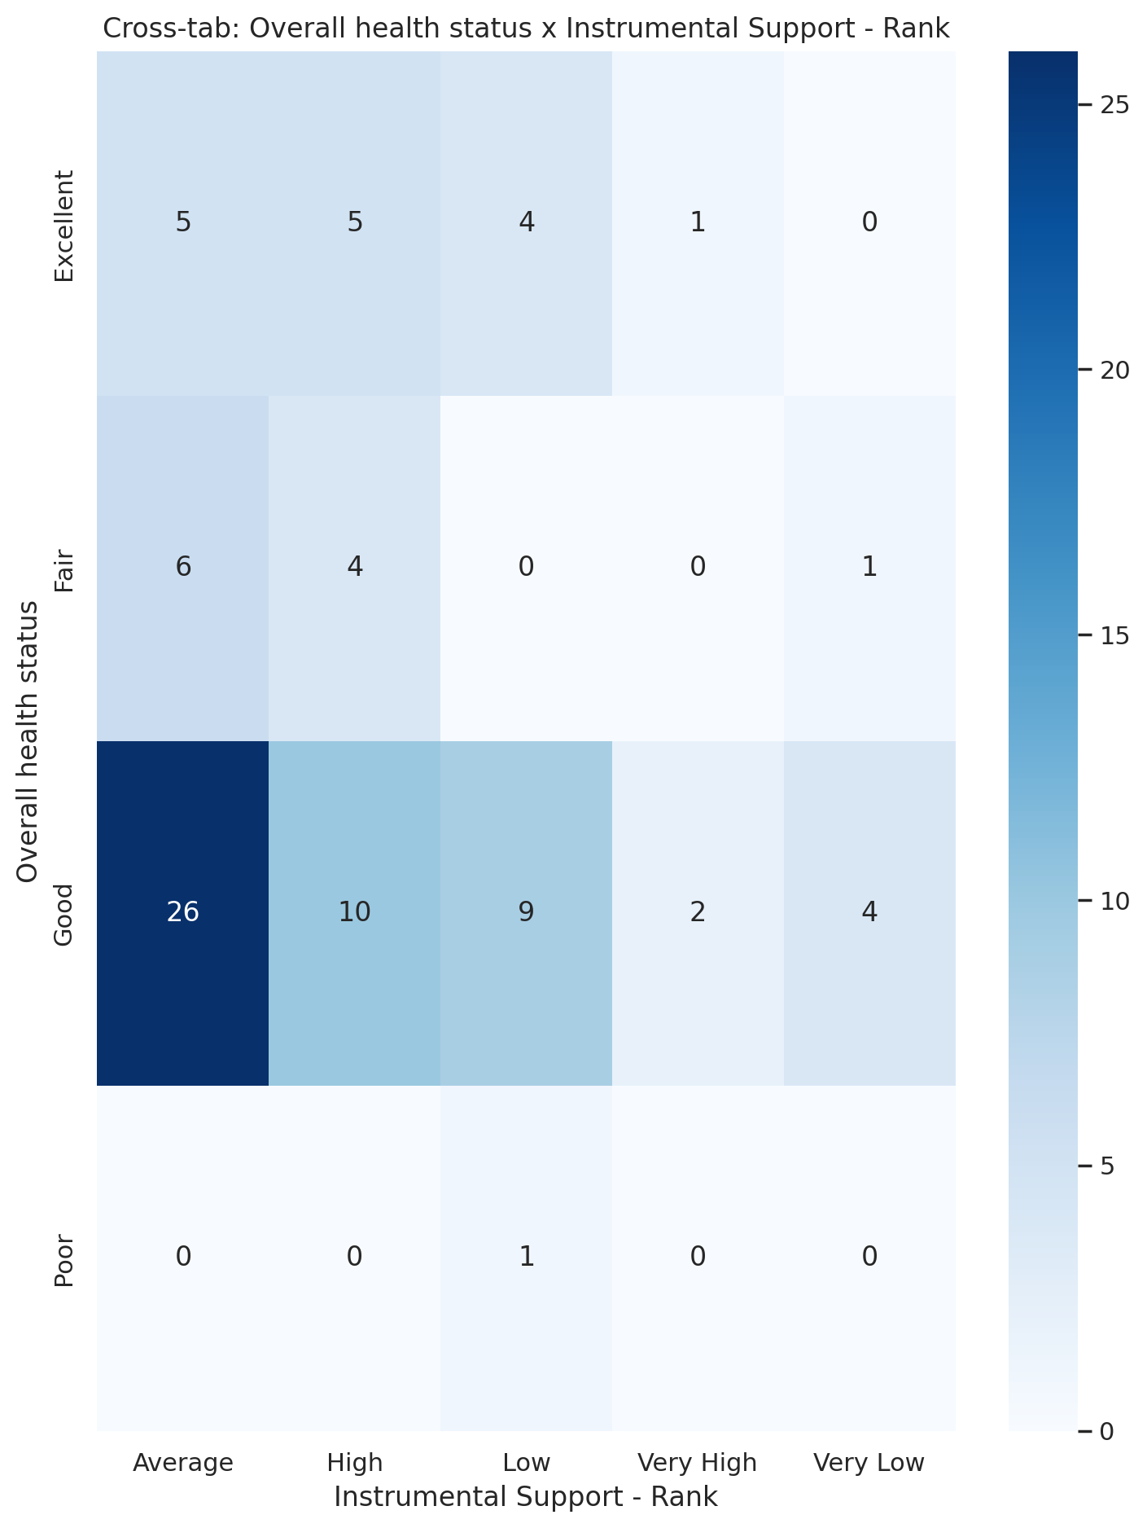

## Real Self Concept Total Category vs Overall health status

Test: chi2; statistic: 13.426778711484596; p-value: 0.03673765292607054;

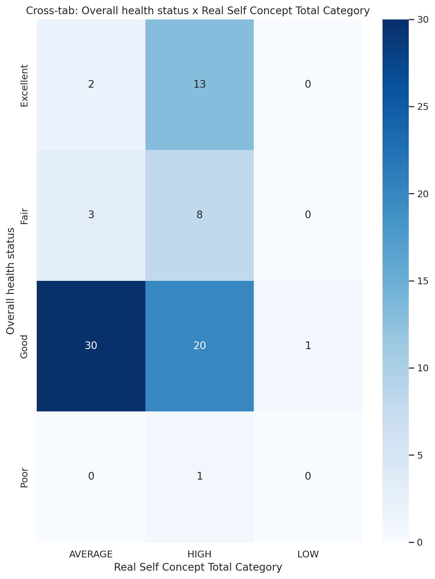

## Ideal Self Concept Total Category vs Overall health status

Test: chi2; statistic: 10.403834590731183; p-value: 0.015427635402034954;

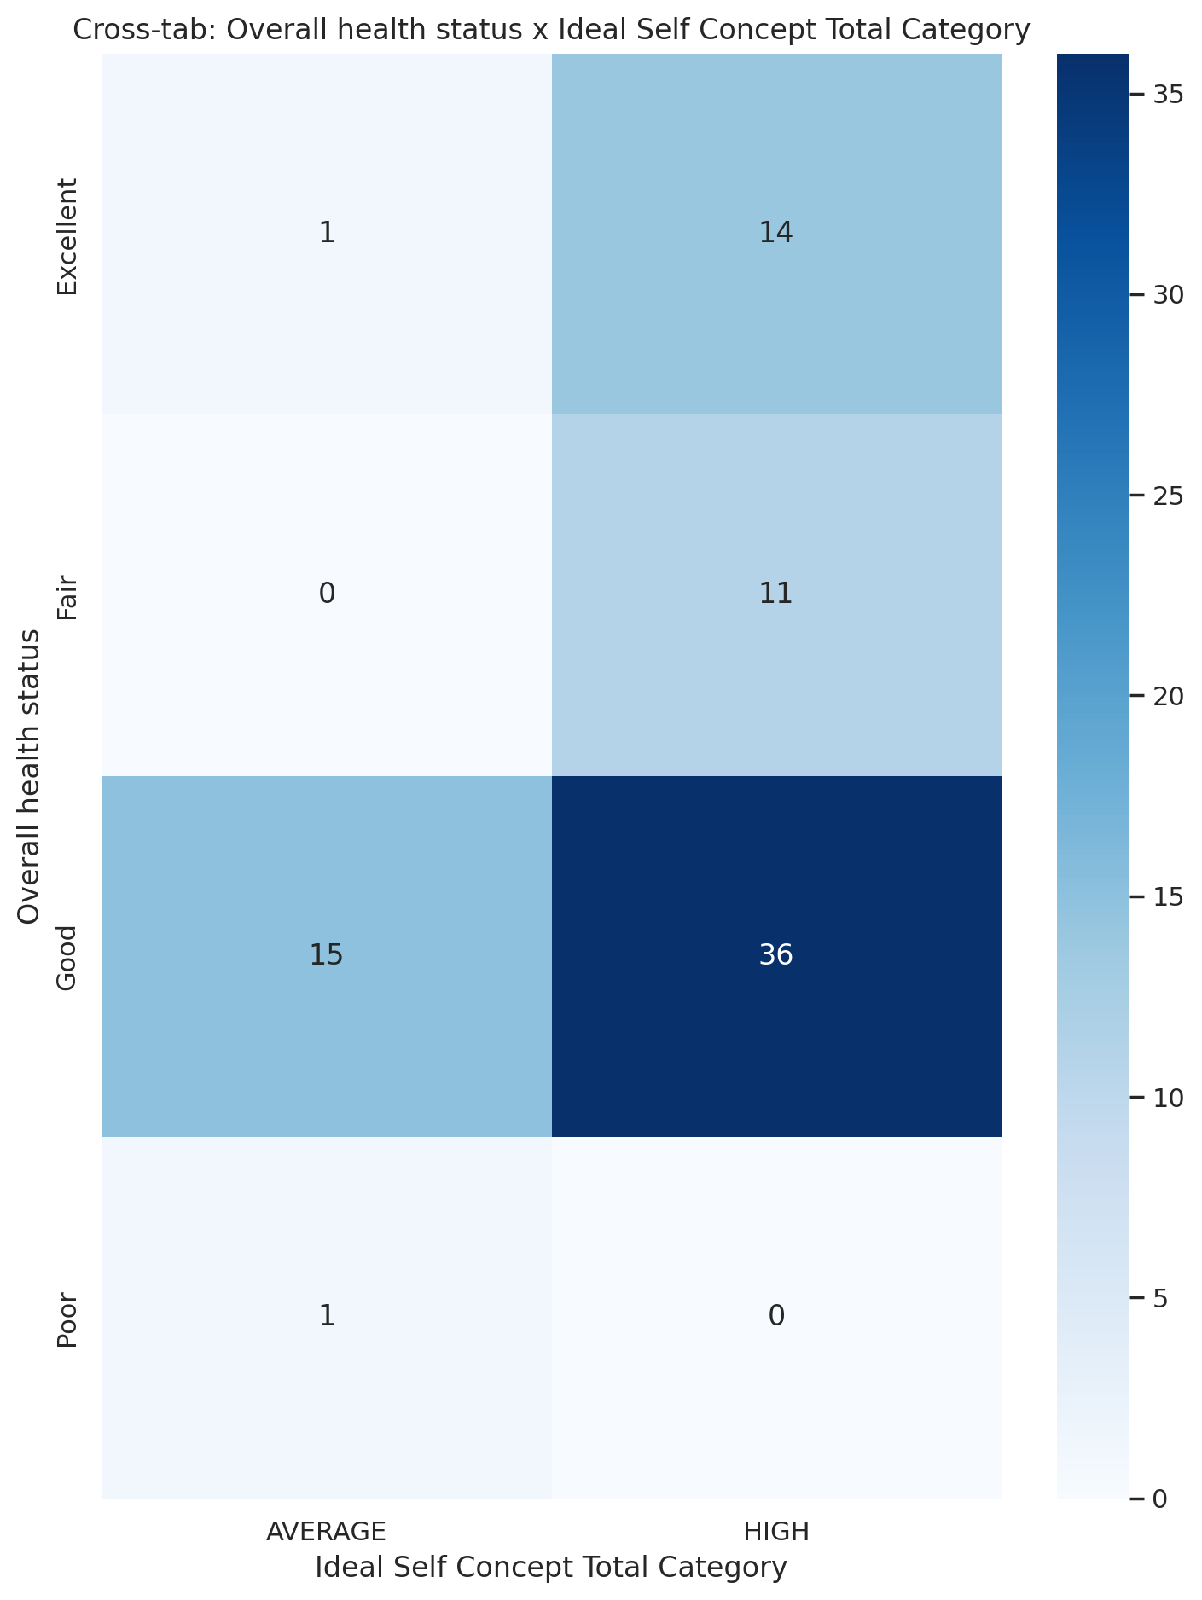

## Social Self Concept Total Category vs Overall health status

Test: chi2; statistic: 8.842858640782516; p-value: 0.18261037192275276;

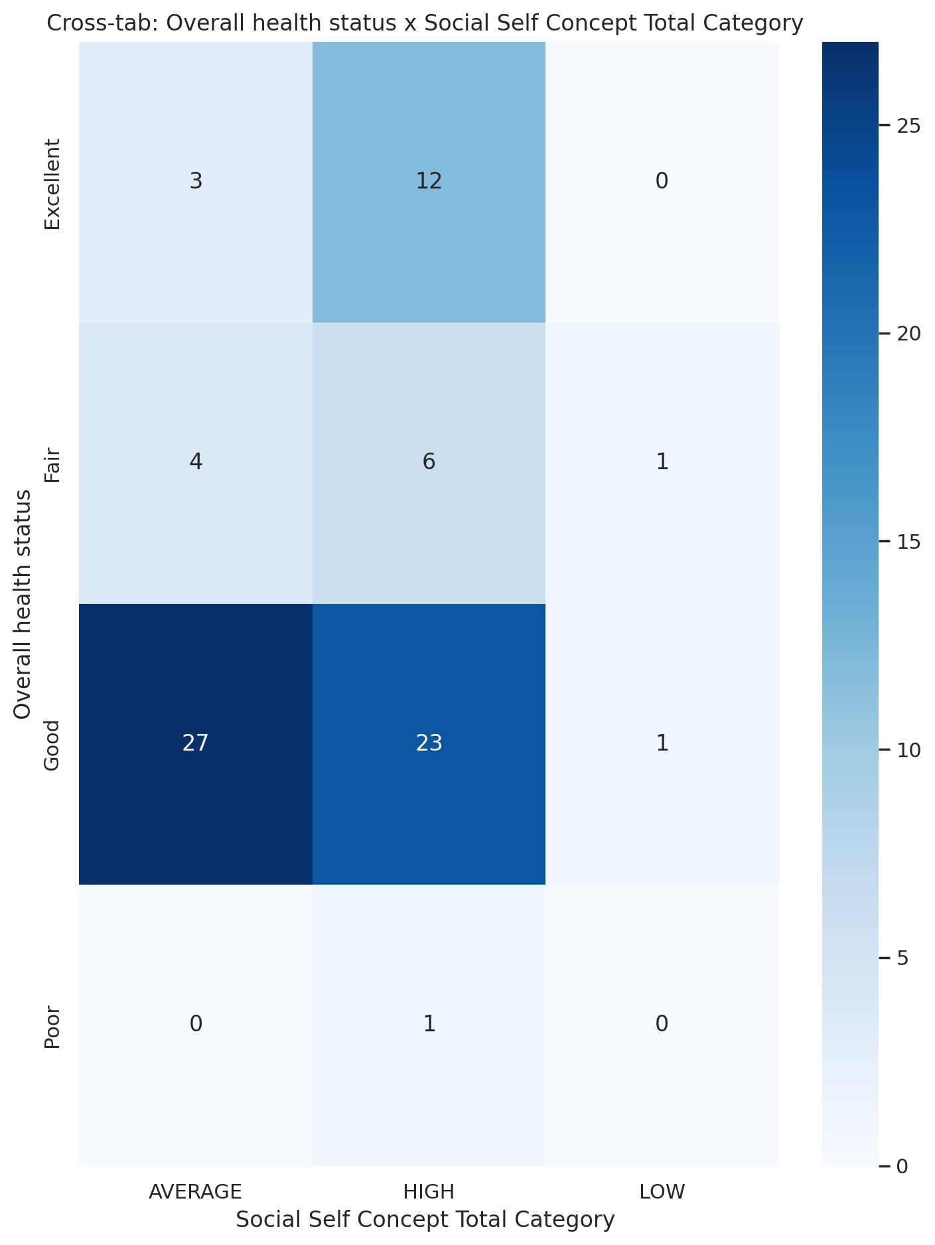

## Emotional Support - T Score vs Are you covered by health insurance?

Test: ANOVA; statistic: 10.663567993755139; p-value: 8.522391003476924e-05;

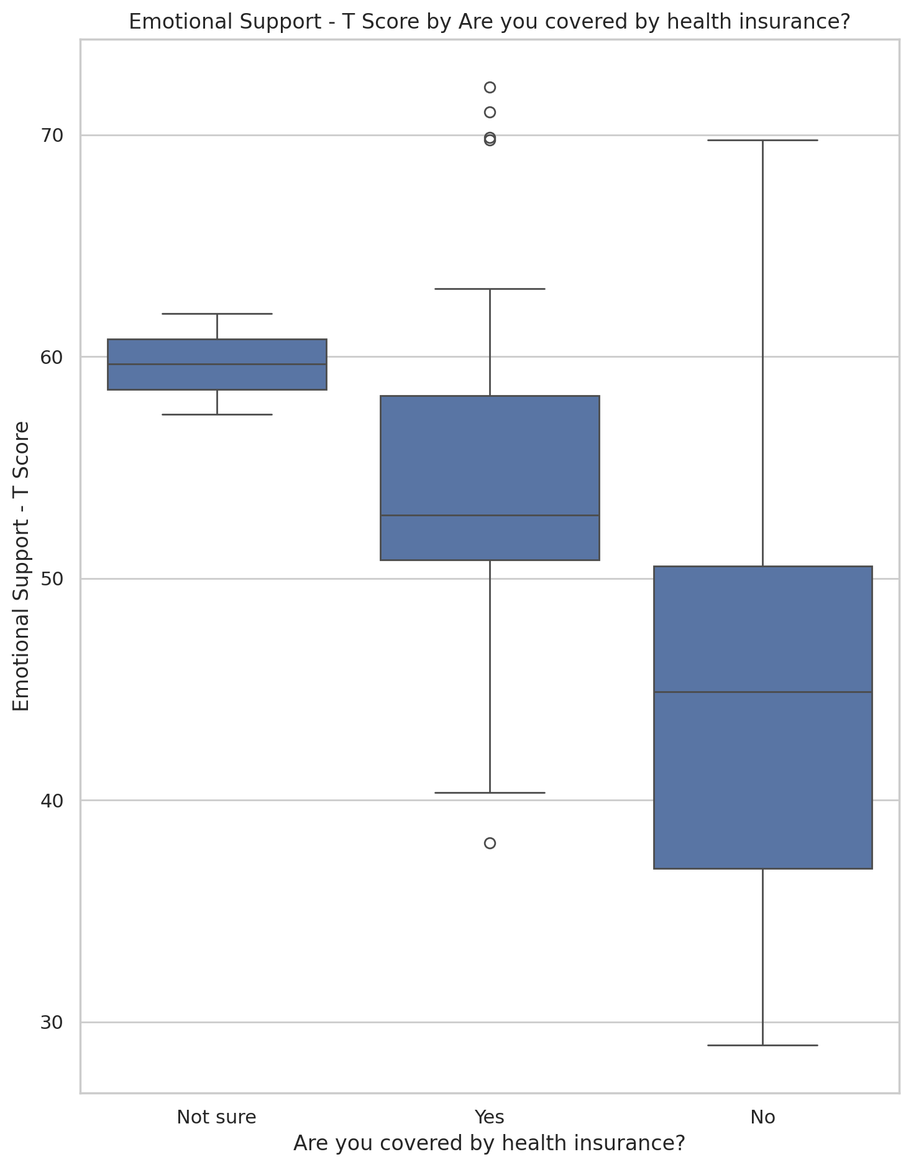

## Informational Support - T Score vs Are you covered by health insurance?

Test: ANOVA; statistic: 6.194991752952292; p-value: 0.003254079506871502;

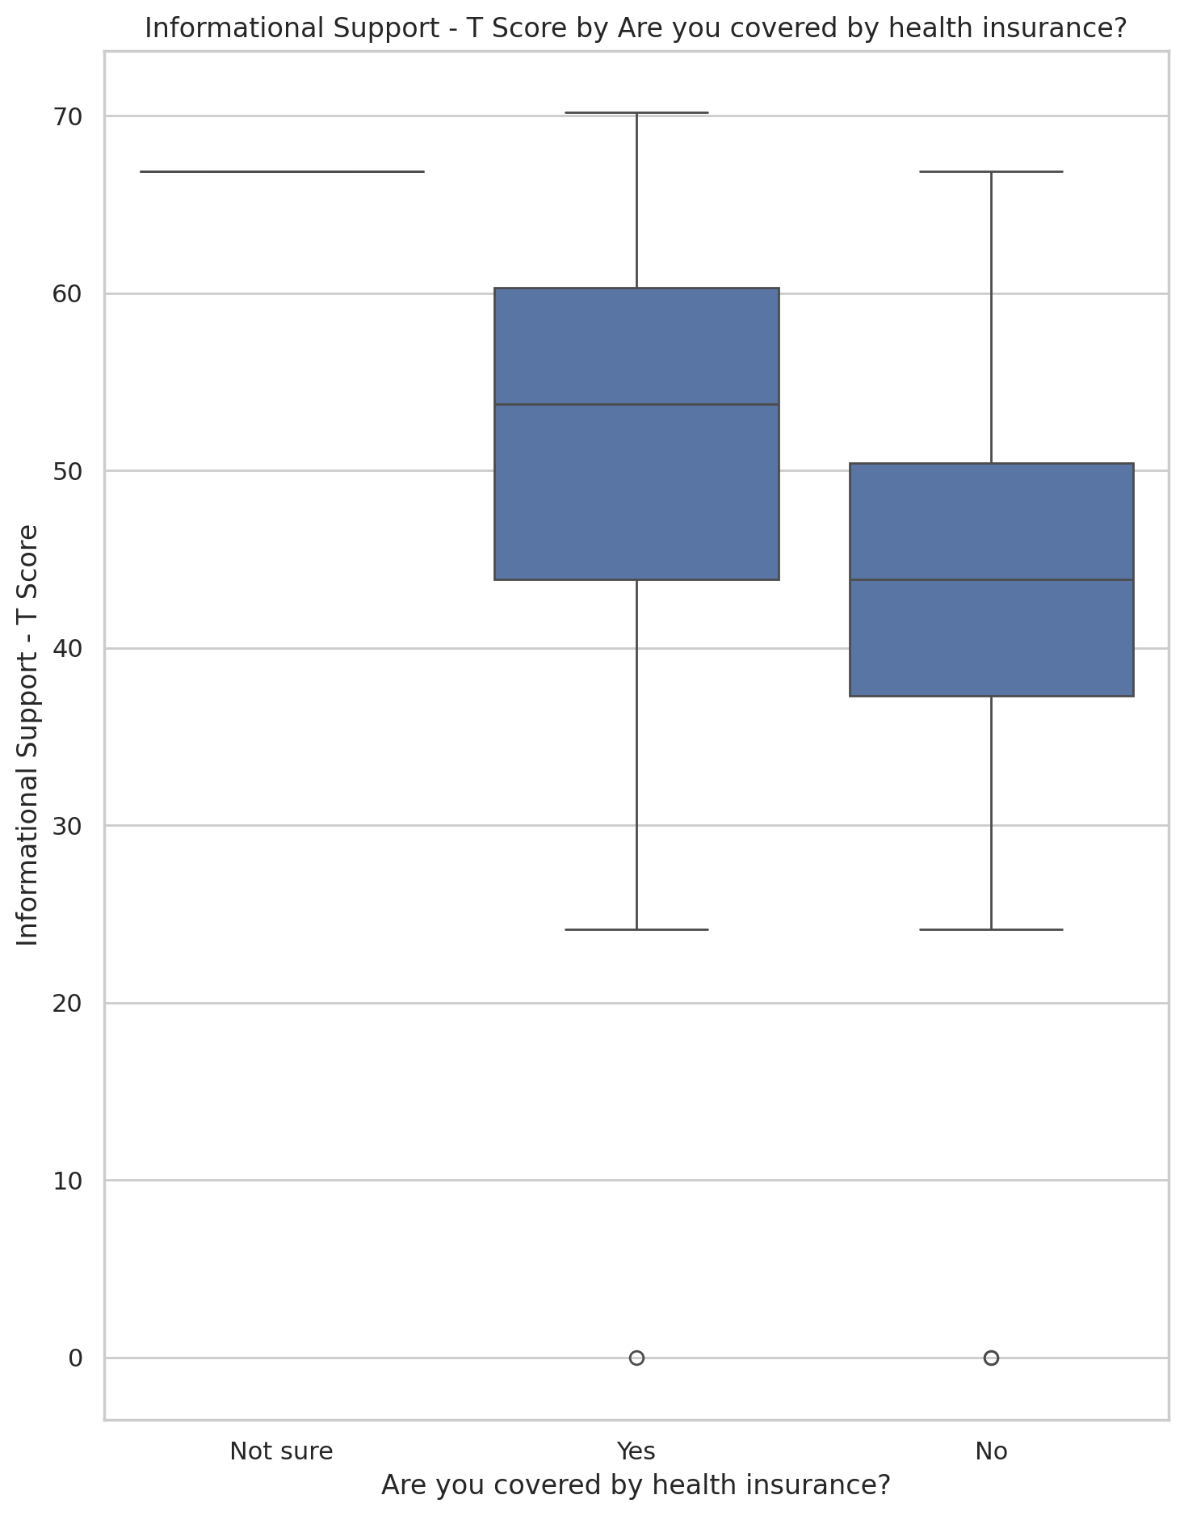

## Instrumental Support - T Score vs Are you covered by health insurance?

Test: ANOVA; statistic: 2.2480878896508623; p-value: 0.11276625688272181;

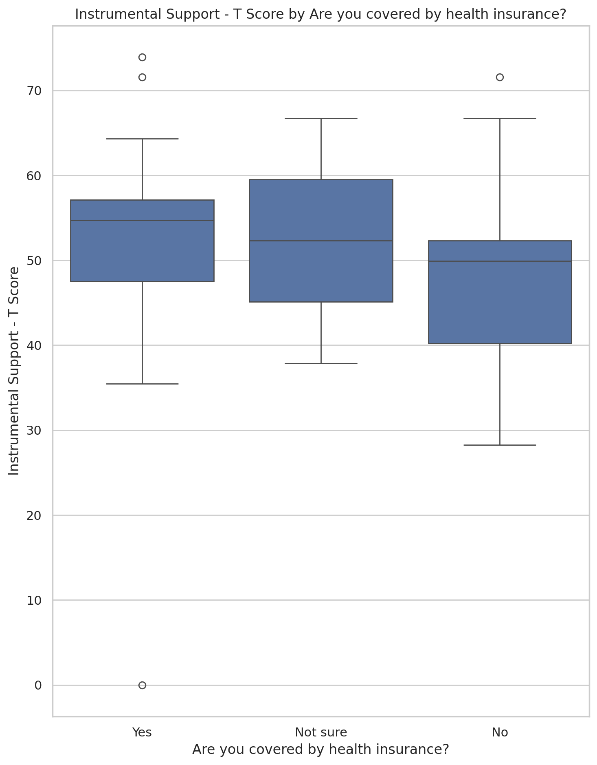

## Emotional Support - Rank vs Are you covered by health insurance?

Test: chi2; statistic: 22.7887085000881; p-value: 0.003646380325493732;

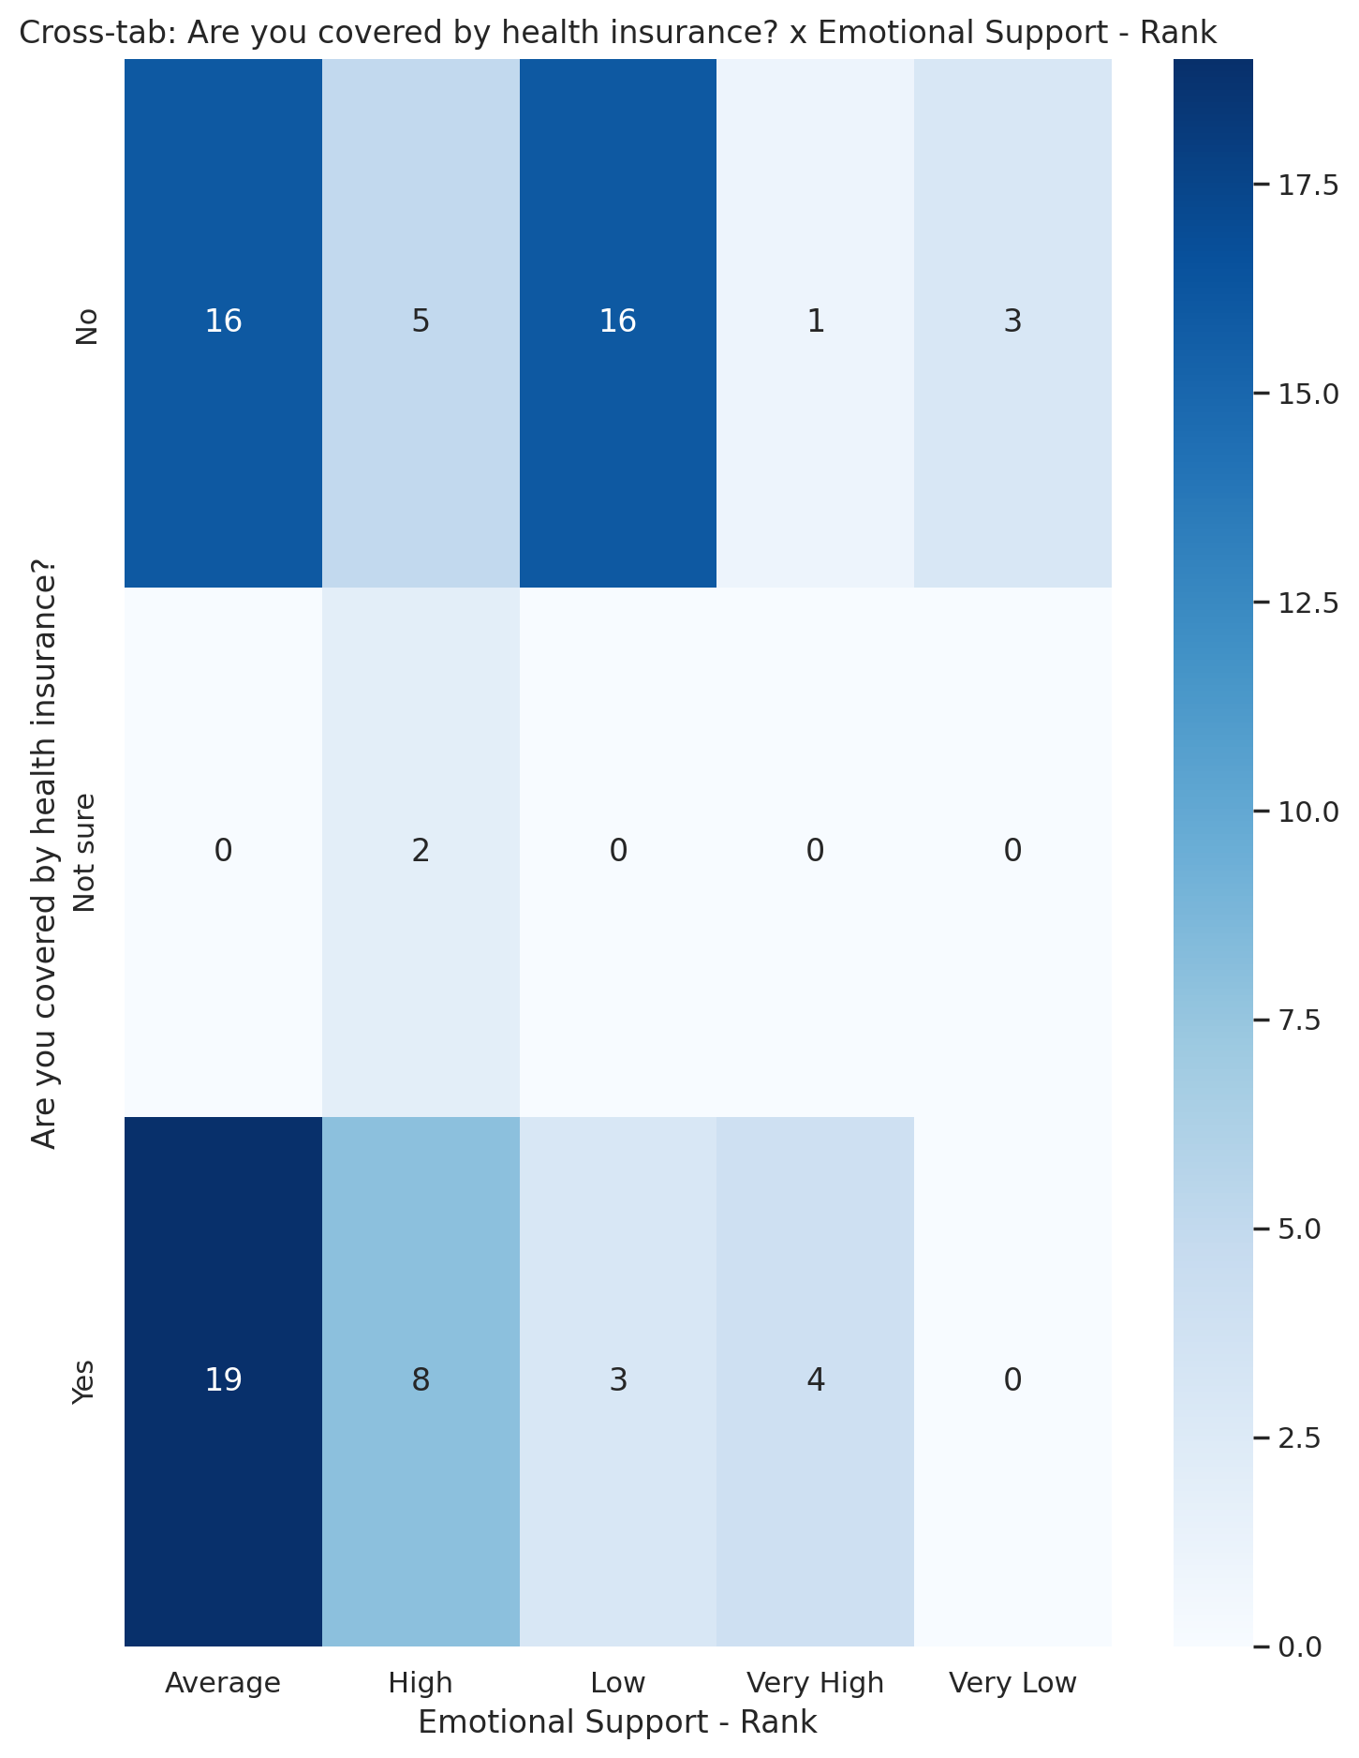

## Informational Support - Rank vs Are you covered by health insurance?

Test: chi2; statistic: 20.08008528614698; p-value: 0.010037271153601484;

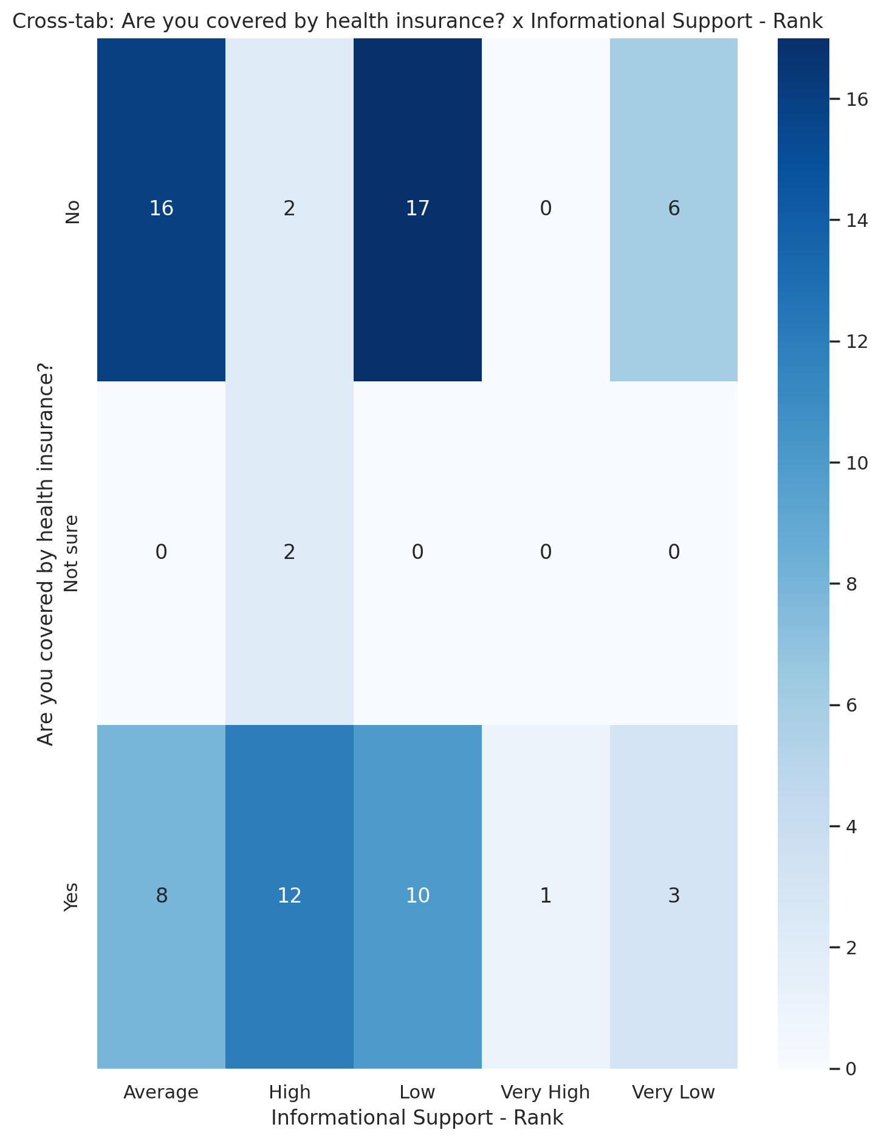

## Instrumental Support - Rank vs Are you covered by health insurance?

Test: chi2; statistic: 14.510889400689672; p-value: 0.06938333673485901;

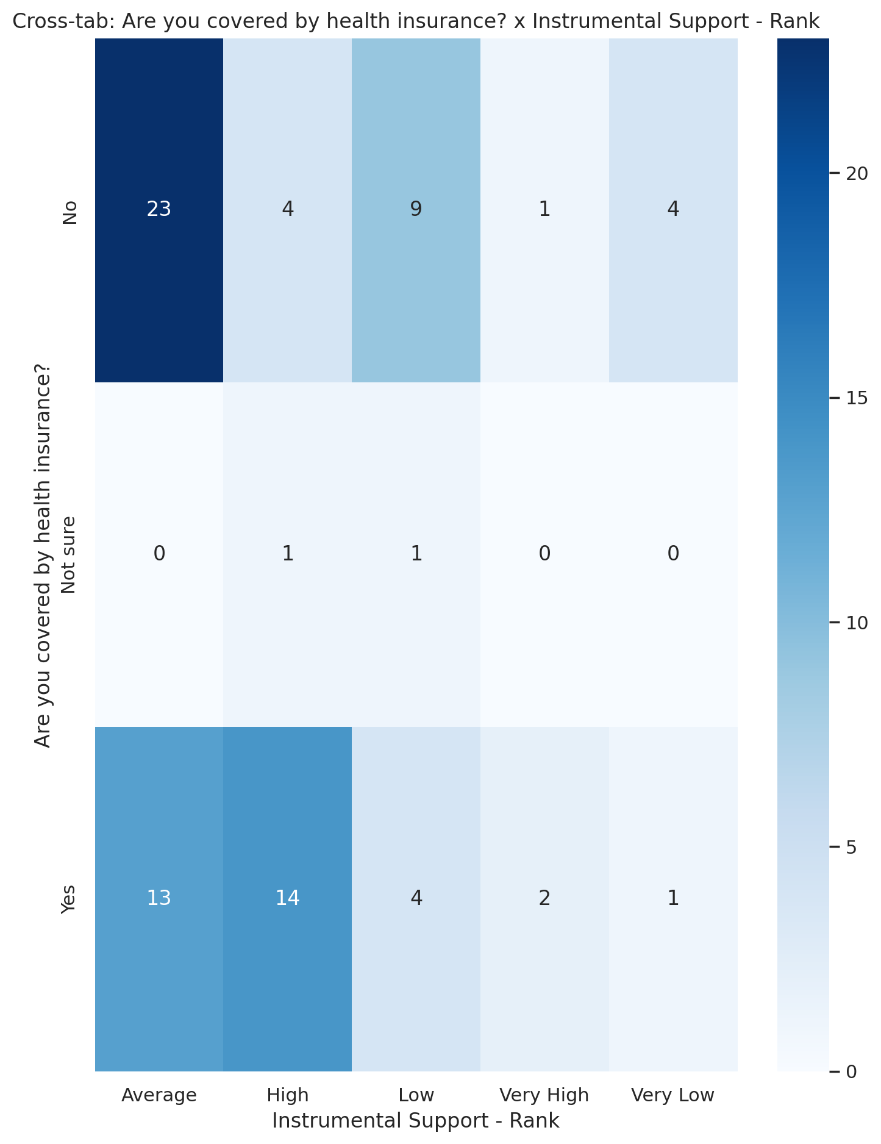

## Real Self Concept Total Category vs Are you covered by health insurance?

Test: chi2; statistic: 7.837687650908073; p-value: 0.0977081487681191;

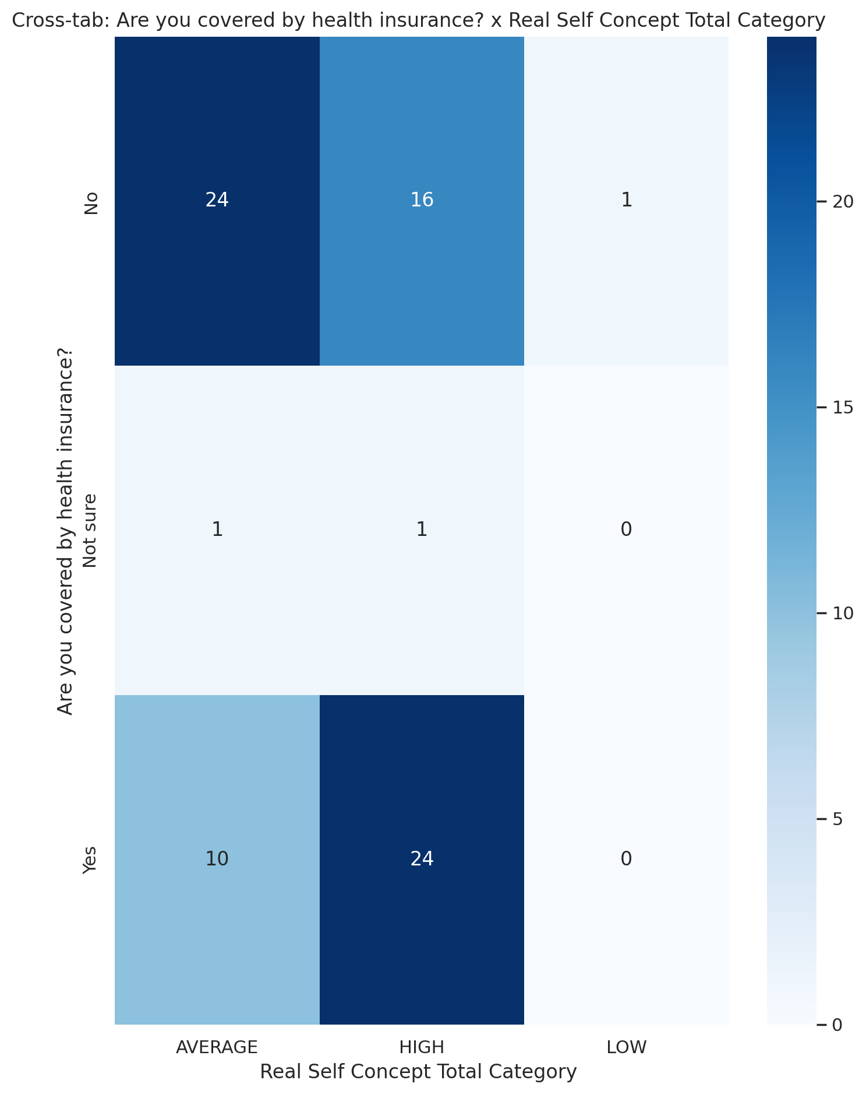

## Ideal Self Concept Total Category vs Are you covered by health insurance?

Test: chi2; statistic: 1.49269136636003; p-value: 0.4740958876242046;

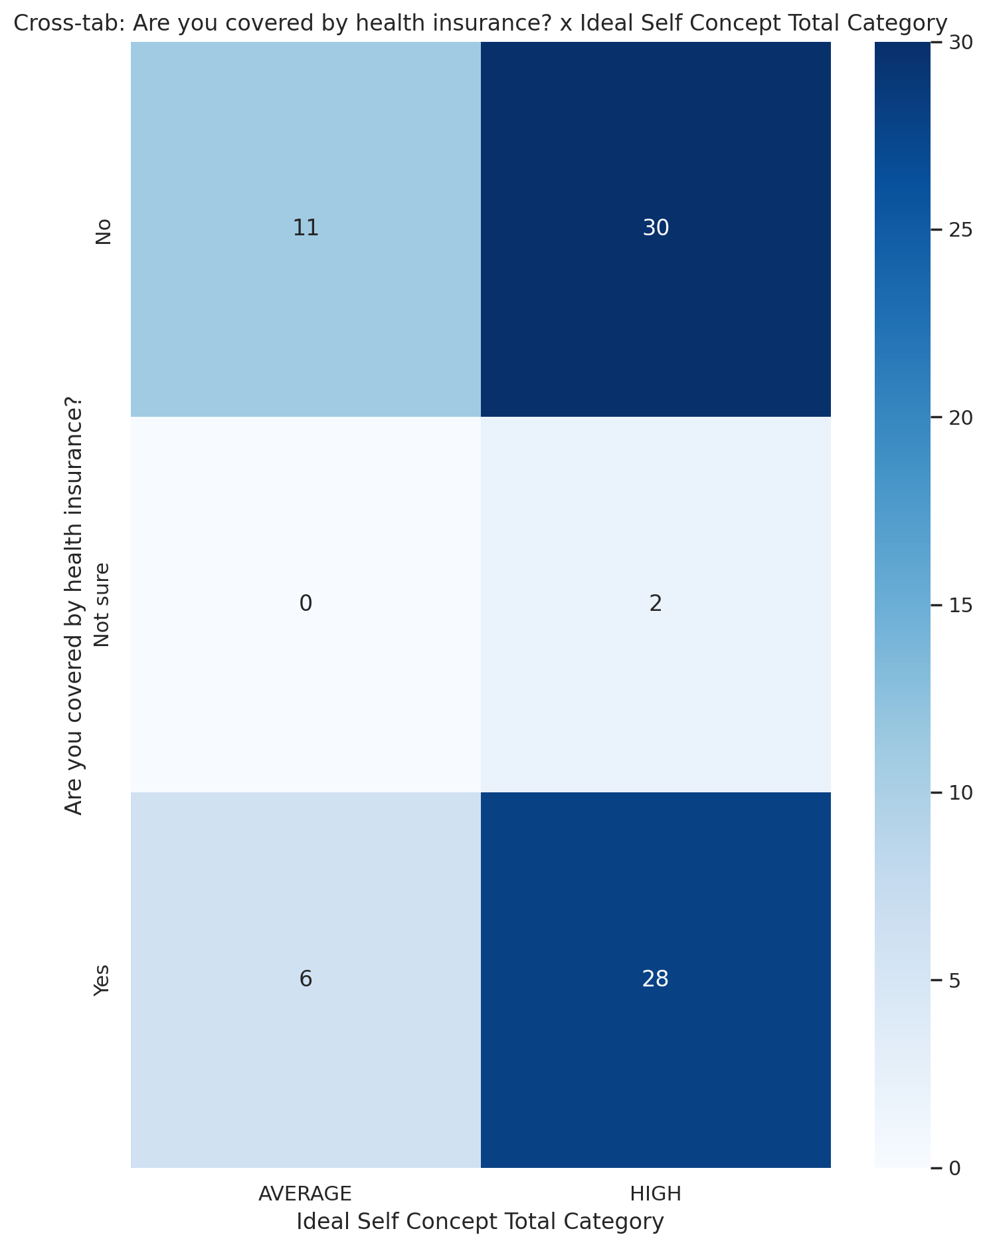

## Social Self Concept Total Category vs Are you covered by health insurance?

Test: chi2; statistic: 9.735295146858128; p-value: 0.04513064496331059;

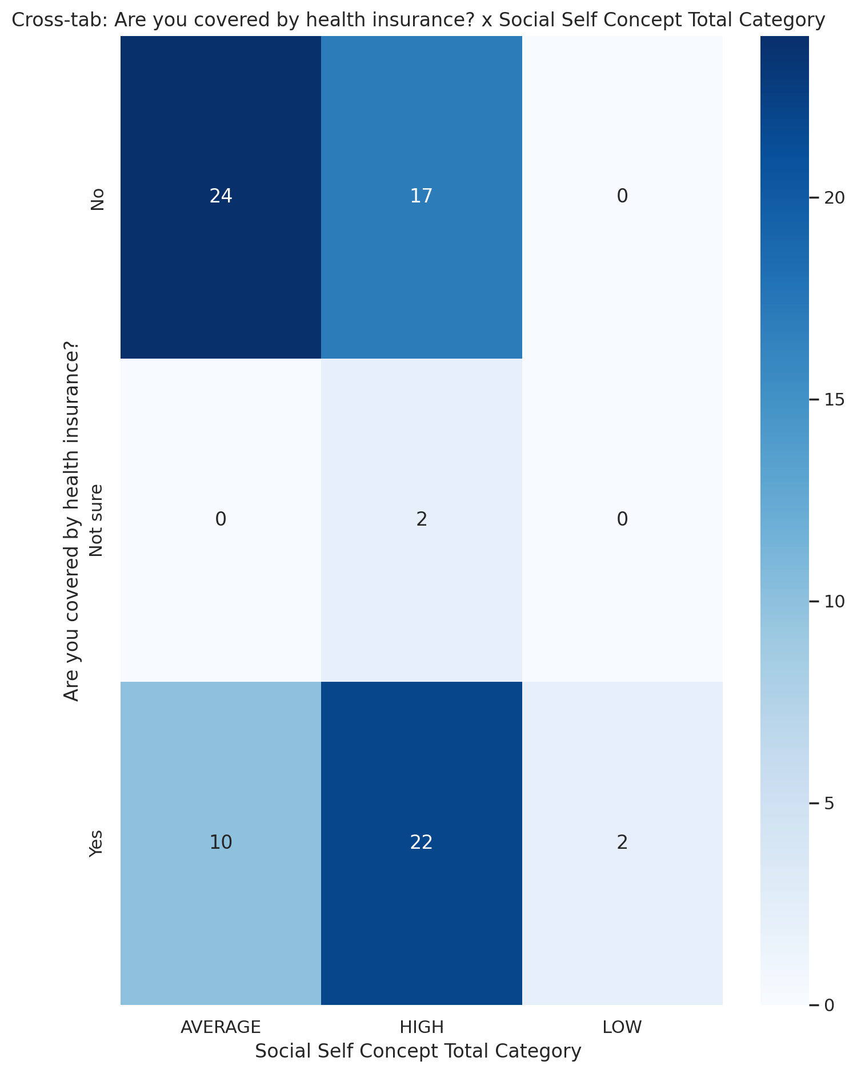

## Emotional Support - T Score vs Participation in community or social activities

Test: ANOVA; statistic: 1.309429432891522; p-value: 0.2761553681132624;

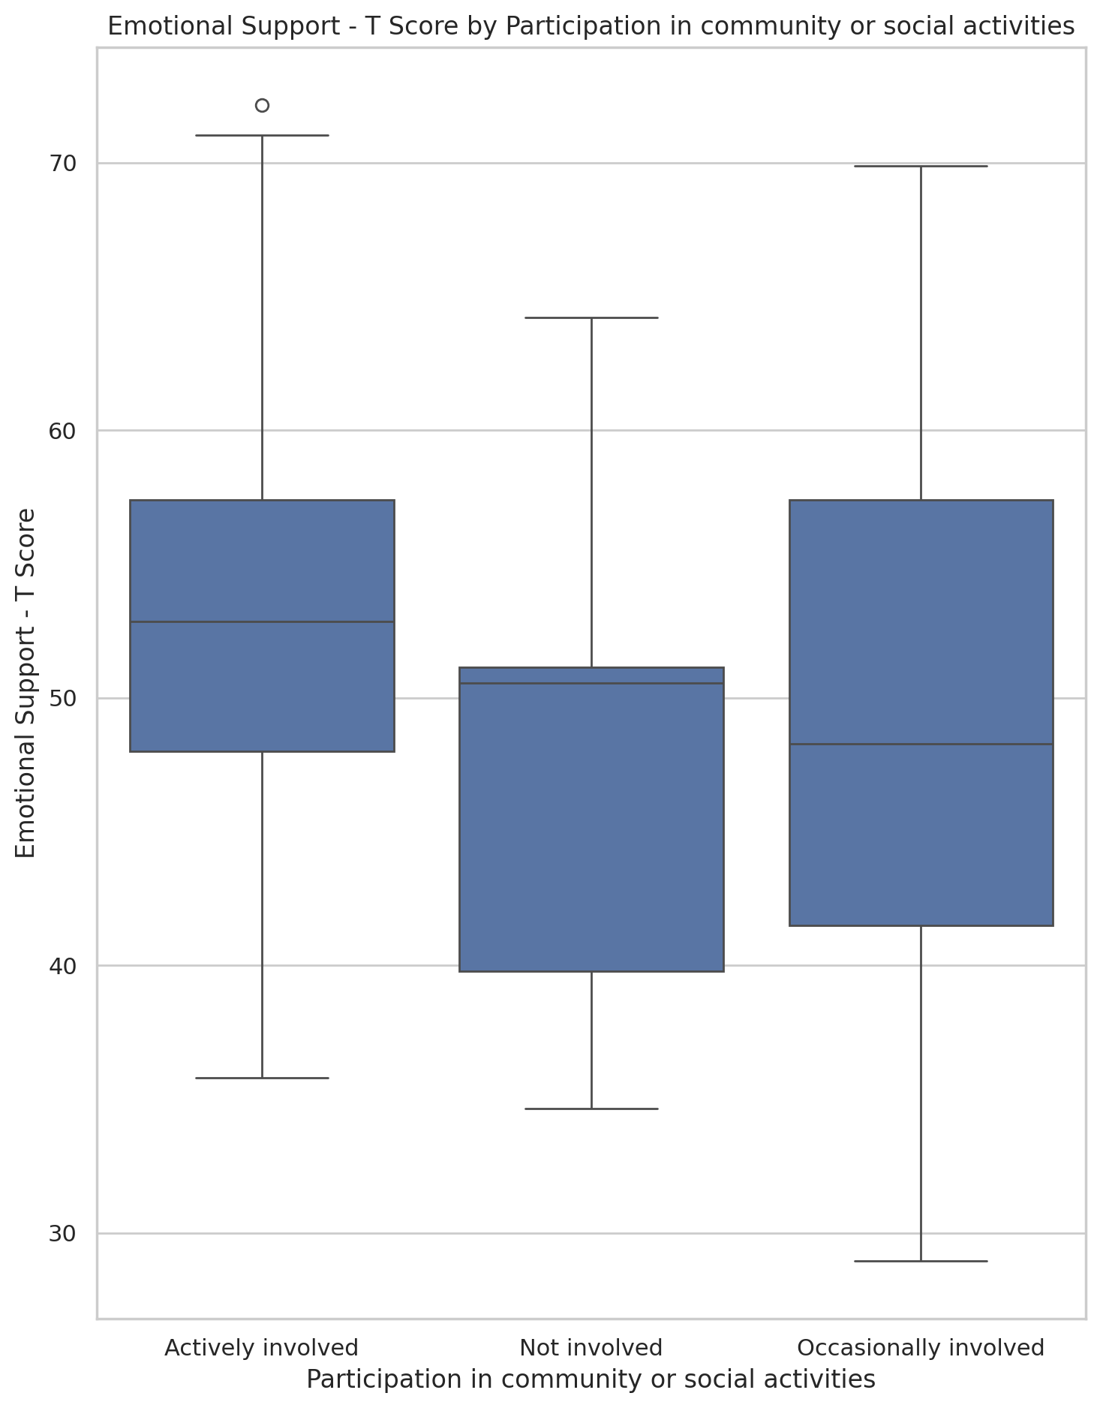

## Informational Support - T Score vs Participation in community or social activities

Test: ANOVA; statistic: 4.796710943293618; p-value: 0.010995267629328303;

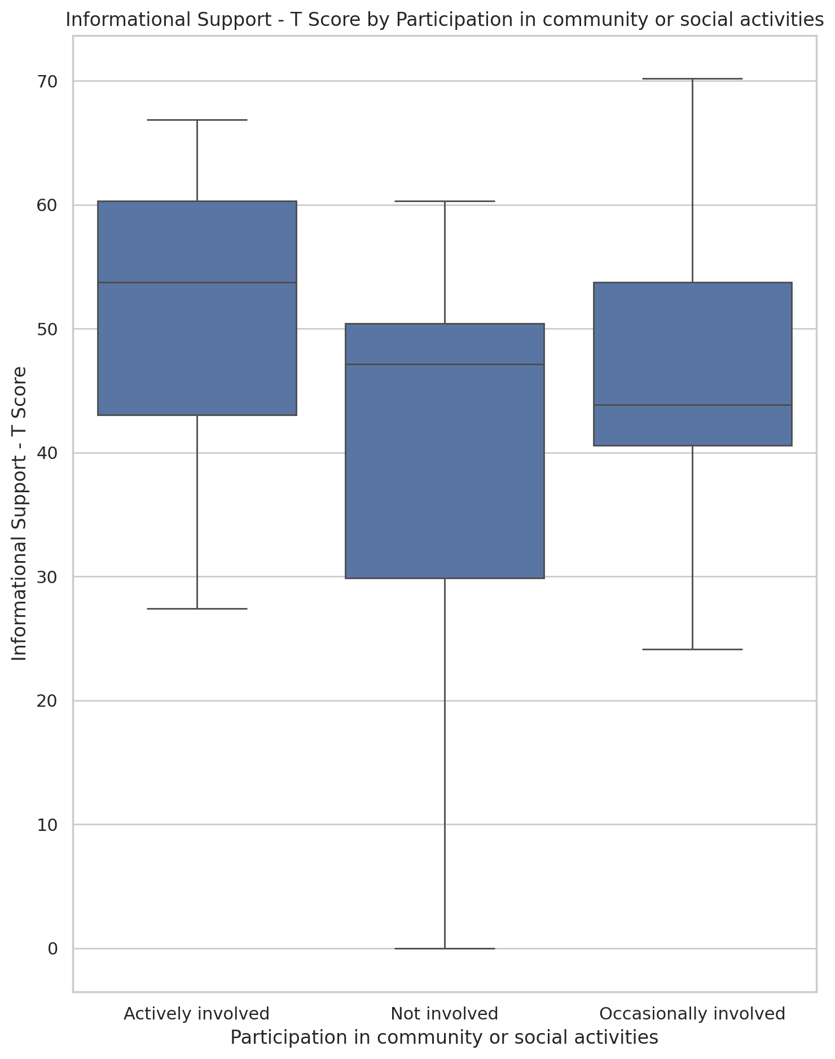

## Instrumental Support - T Score vs Participation in community or social activities

Test: ANOVA; statistic: 1.1677414673592252; p-value: 0.31673401266773415;

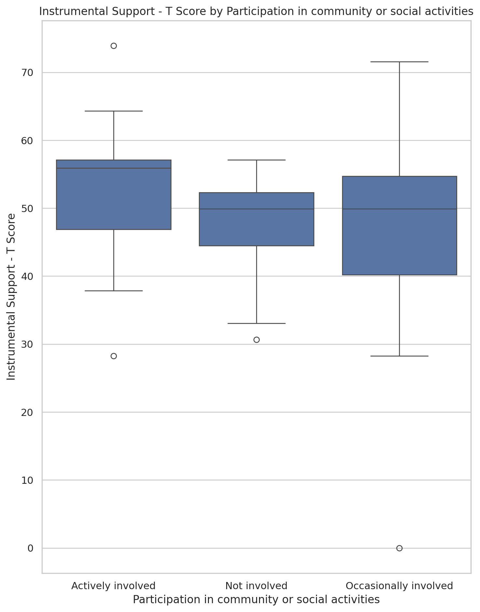

## Emotional Support - Rank vs Participation in community or social activities

Test: chi2; statistic: 6.853964127799173; p-value: 0.5524678499481361;

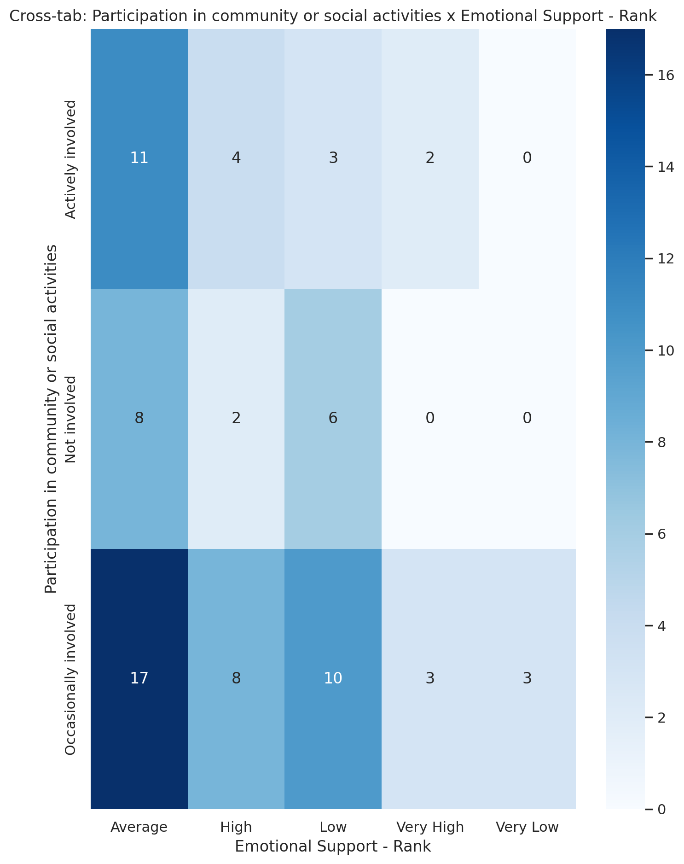

## Informational Support - Rank vs Participation in community or social activities

Test: chi2; statistic: 21.385084970641376; p-value: 0.006191866993017621;

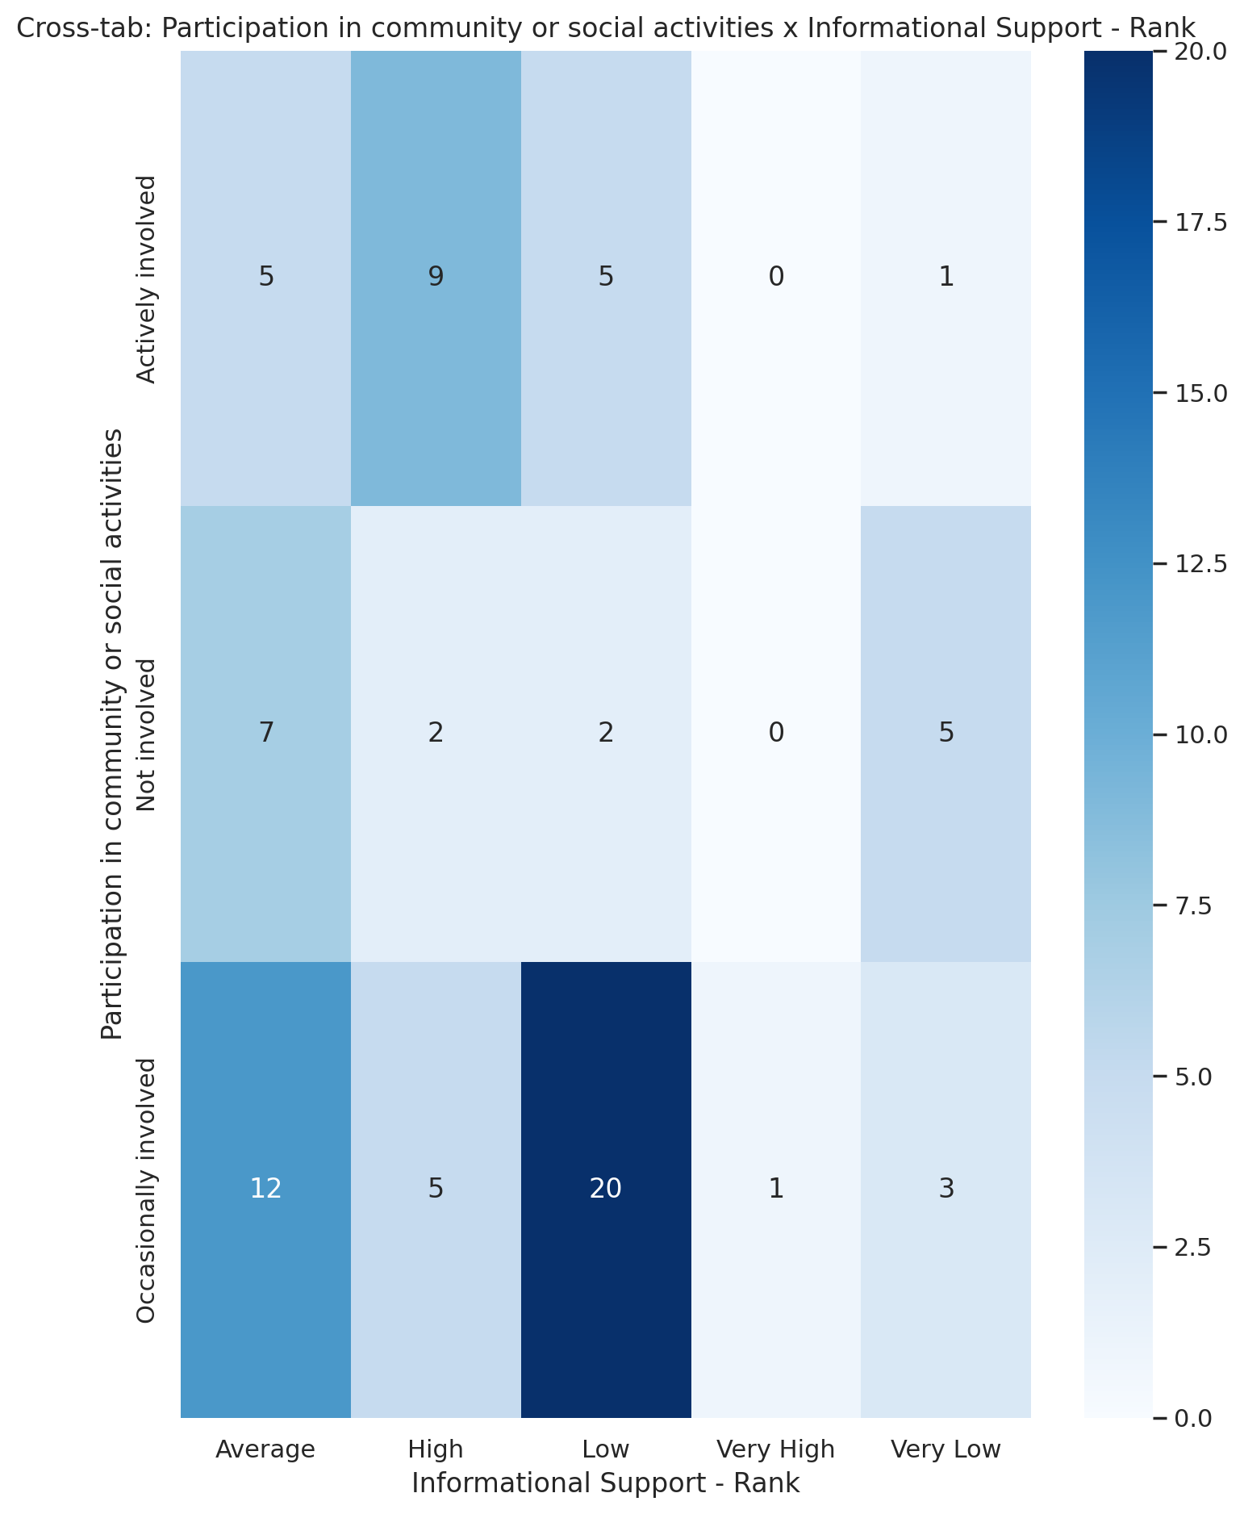

## Instrumental Support - Rank vs Participation in community or social activities

Test: chi2; statistic: 10.11172159964843; p-value: 0.25727195223956134;

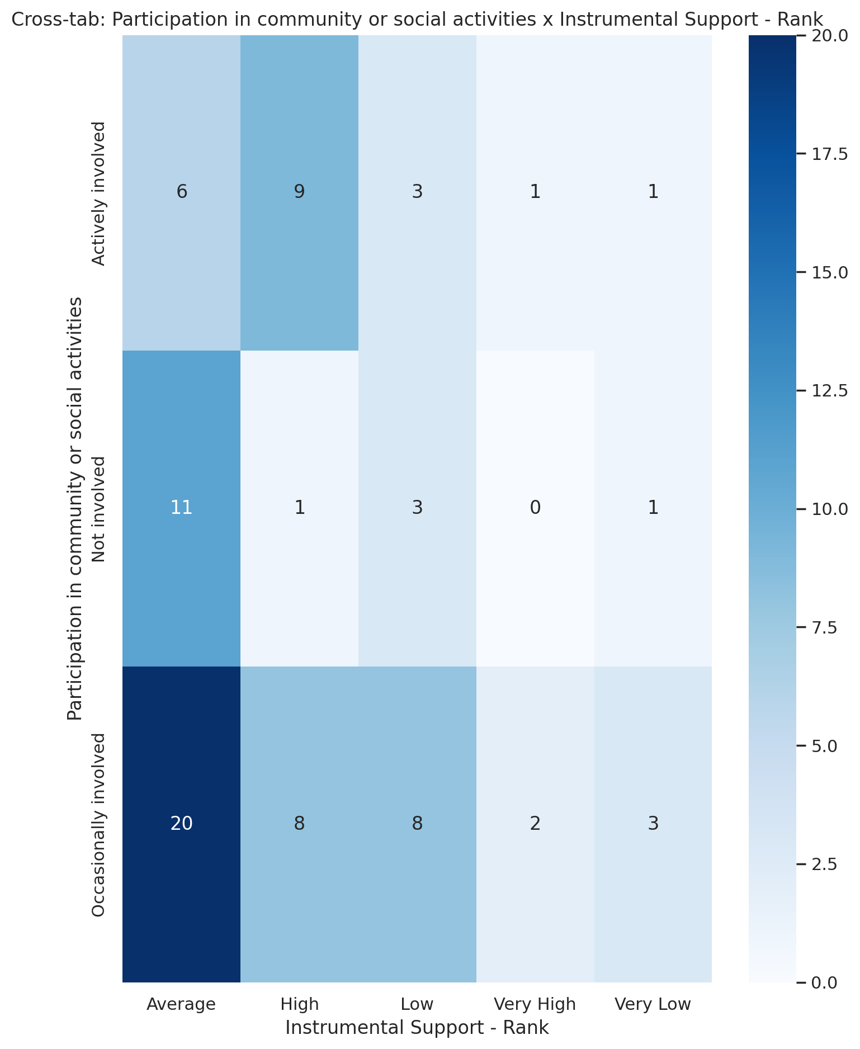

## Real Self Concept Total Category vs Participation in community or social activities

Test: chi2; statistic: 10.579806312769009; p-value: 0.03171525504241002;

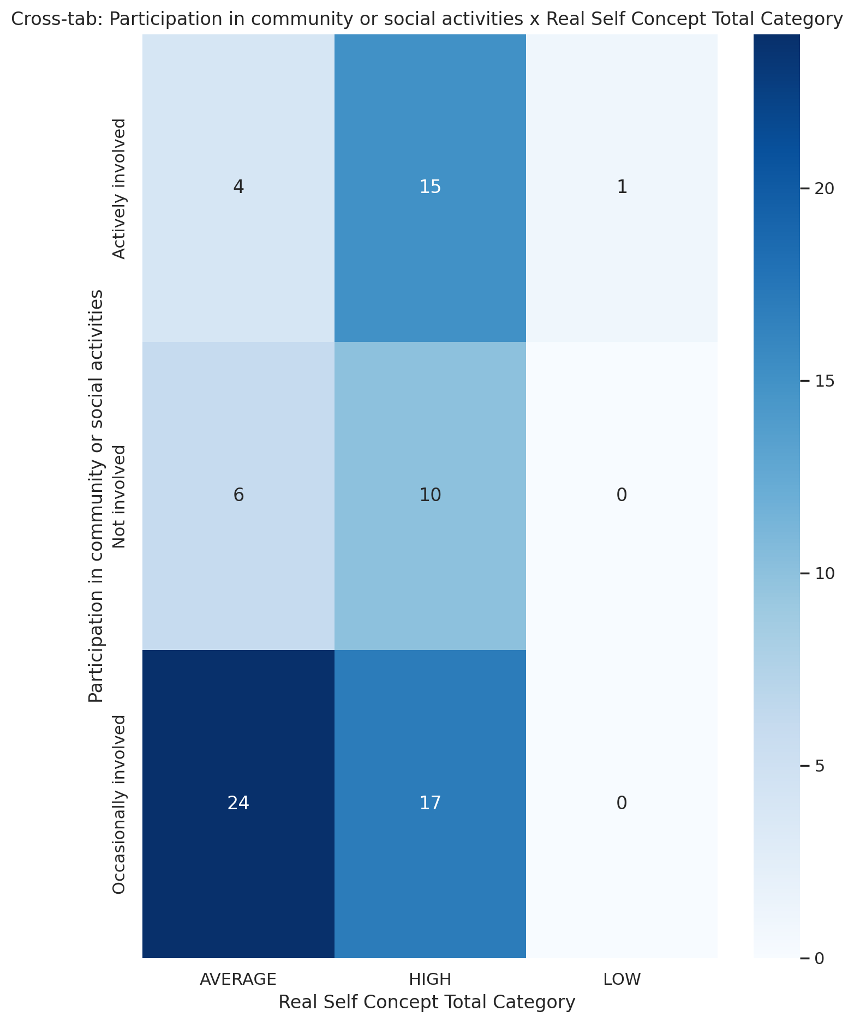

## Ideal Self Concept Total Category vs Participation in community or social activities

Test: chi2; statistic: 1.3651987685318032; p-value: 0.5053018101992461;

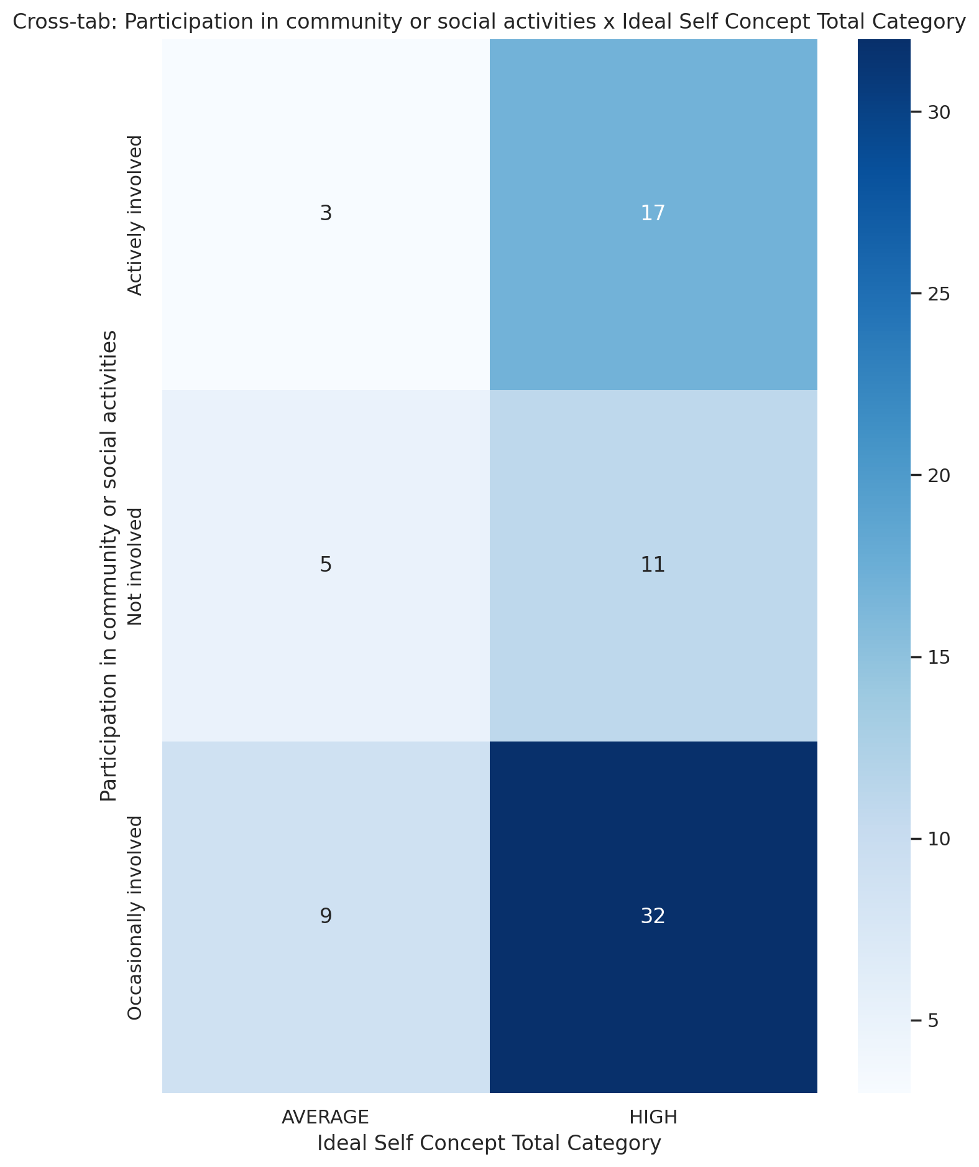

## Social Self Concept Total Category vs Participation in community or social activities

Test: chi2; statistic: 8.983993902439025; p-value: 0.06150080477732441;

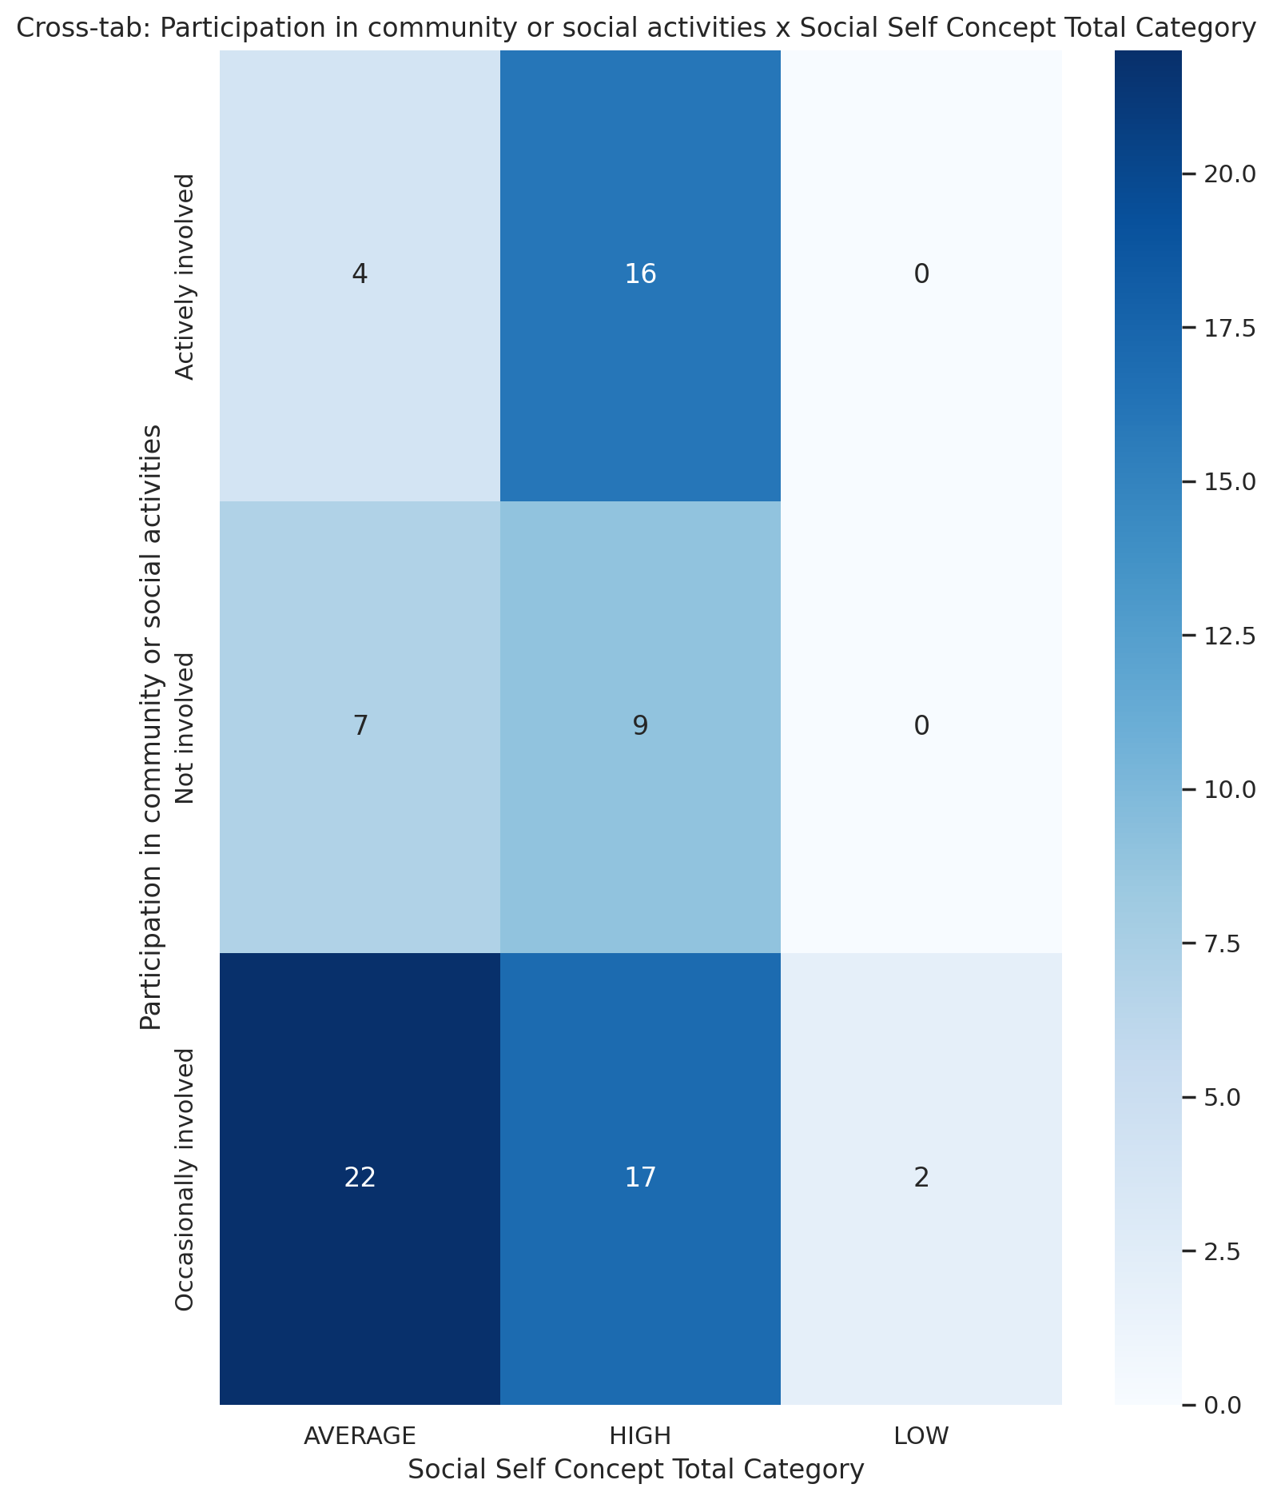

## Emotional Support - T Score vs Monthly household income_midpoint_INR

Test: pearson/spearman; statistic: 0.10461988872164257; p-value: 0.3750303143409348; spearman_r=0.098, spearman_p=0.406

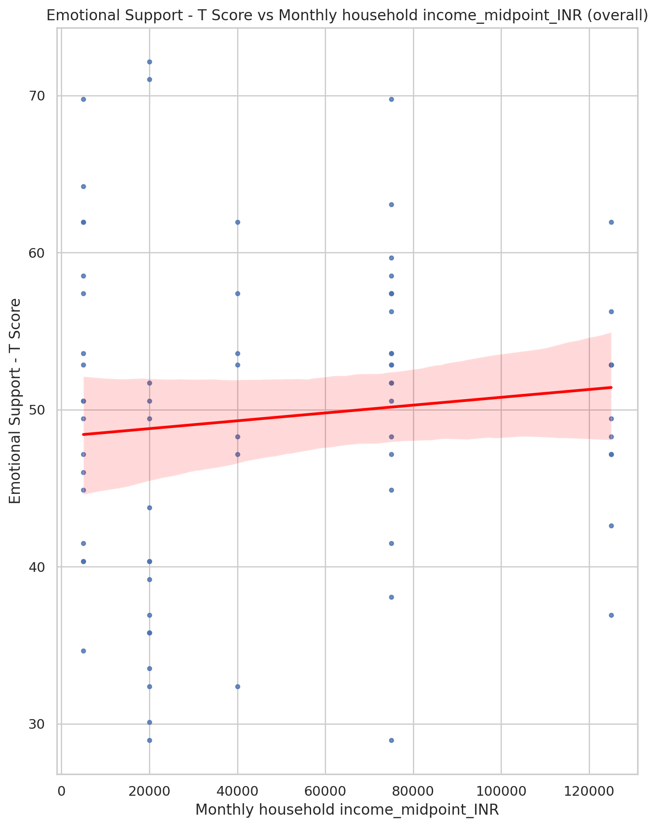

## Informational Support - T Score vs Monthly household income_midpoint_INR

Test: pearson/spearman; statistic: 0.17779274914039403; p-value: 0.12964704998038562; spearman_r=0.150, spearman_p=0.203

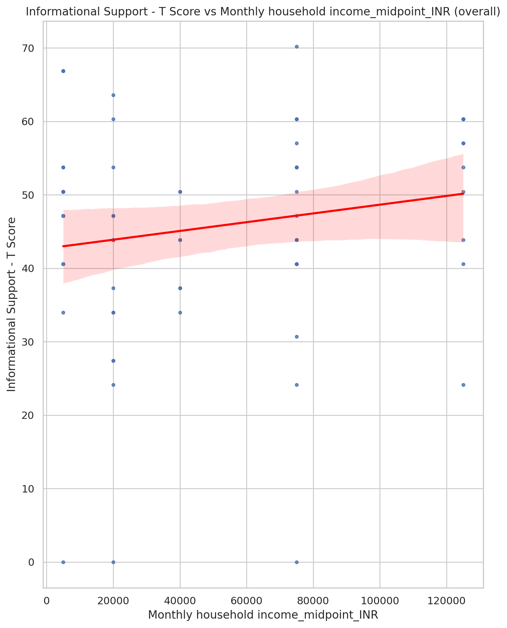

## Instrumental Support - T Score vs Monthly household income_midpoint_INR

Test: pearson/spearman; statistic: -0.012865752994508371; p-value: 0.9133645737596342; spearman_r=0.012, spearman_p=0.919

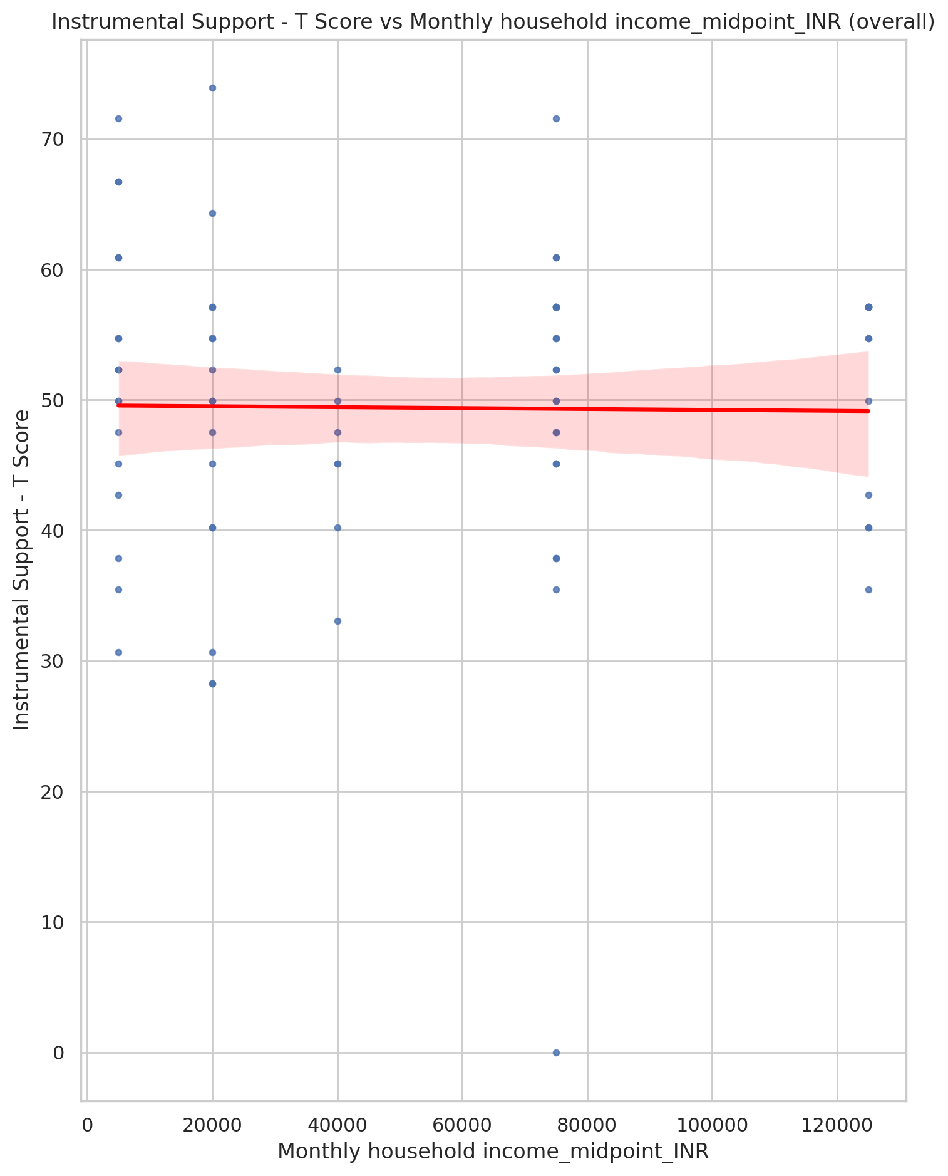

## Emotional Support - Rank vs Monthly household income_midpoint_INR

Test: ANOVA; statistic: 1.6887900231525164; p-value: 0.162498220506977;

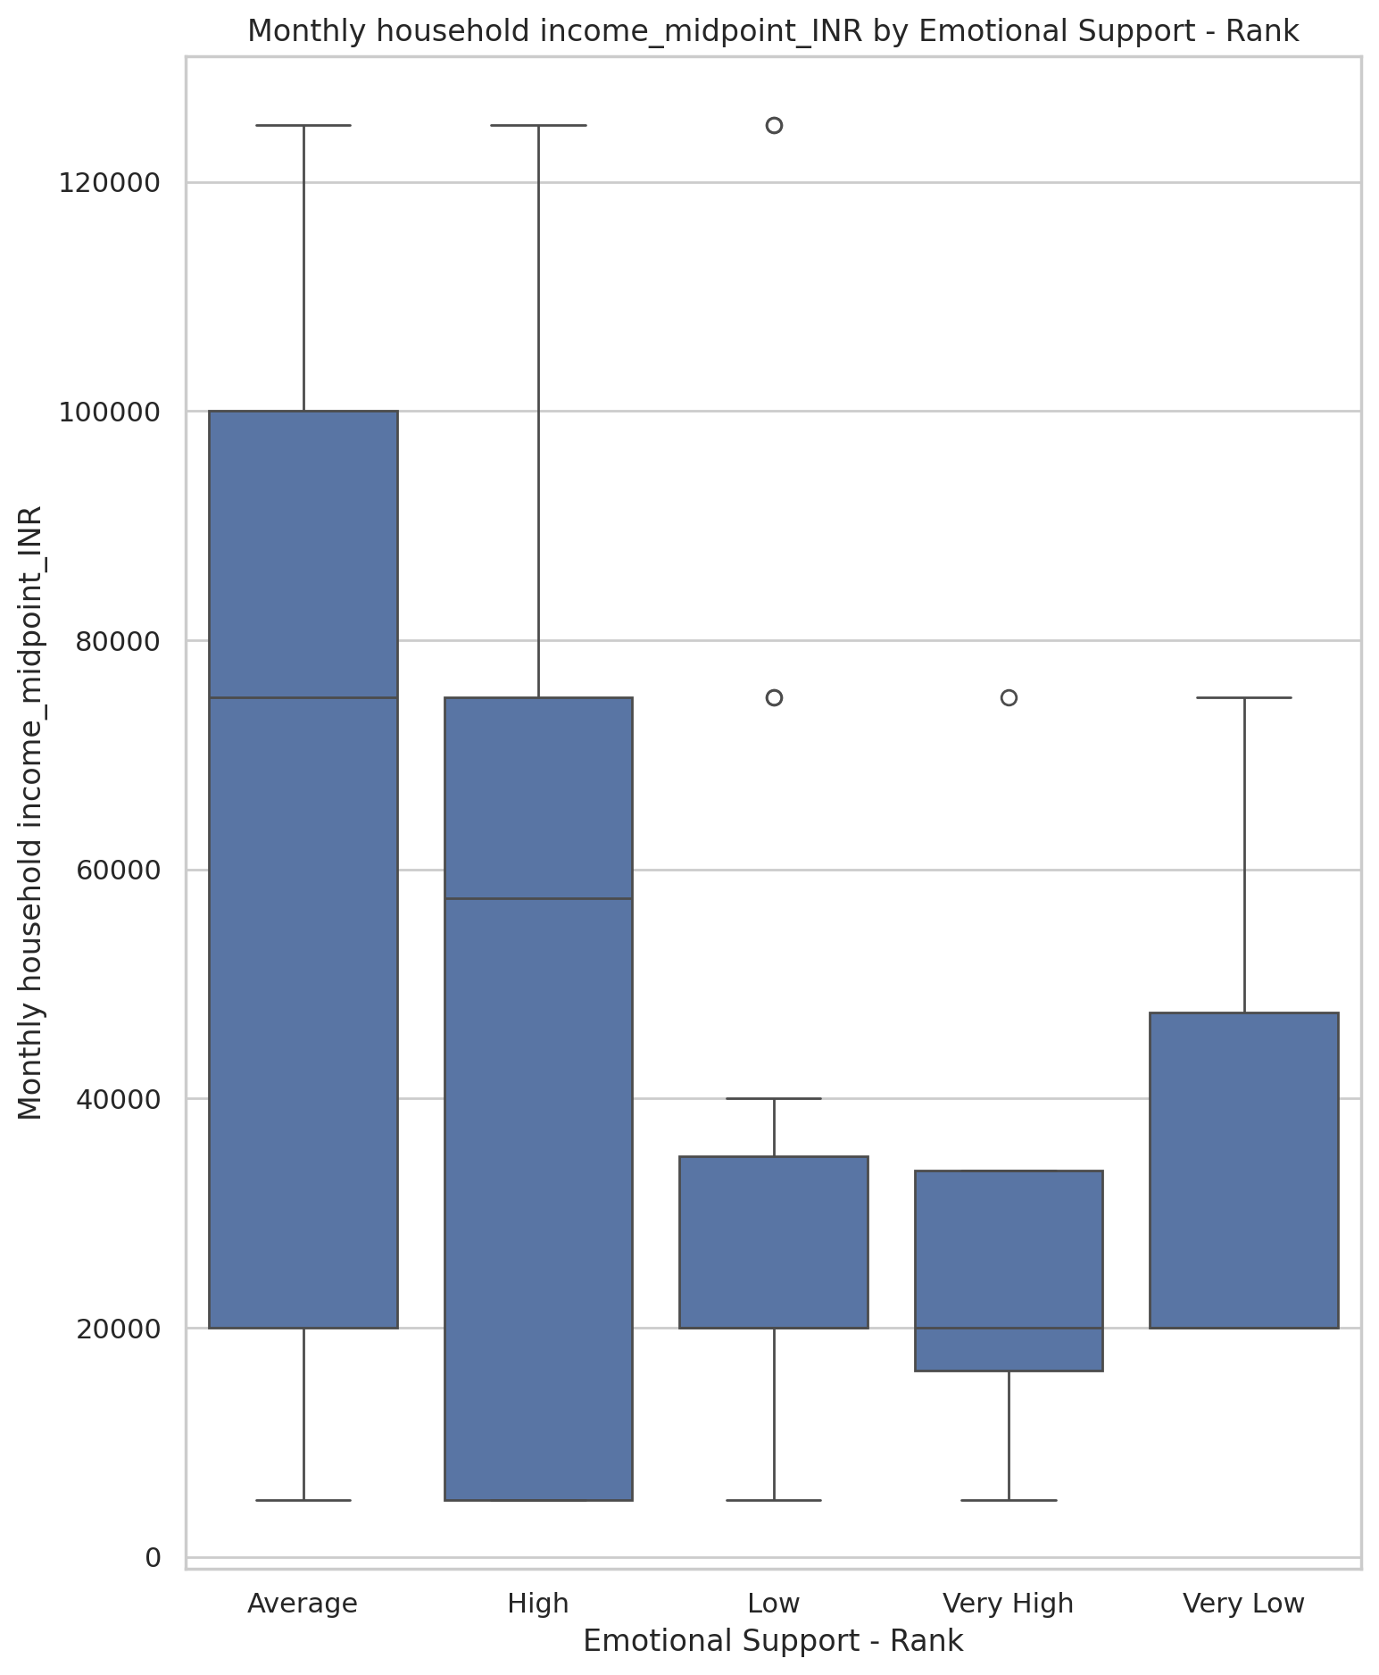

## Informational Support - Rank vs Monthly household income_midpoint_INR

Test: ANOVA; statistic: 2.3124184381906514; p-value: 0.06619901121491156;

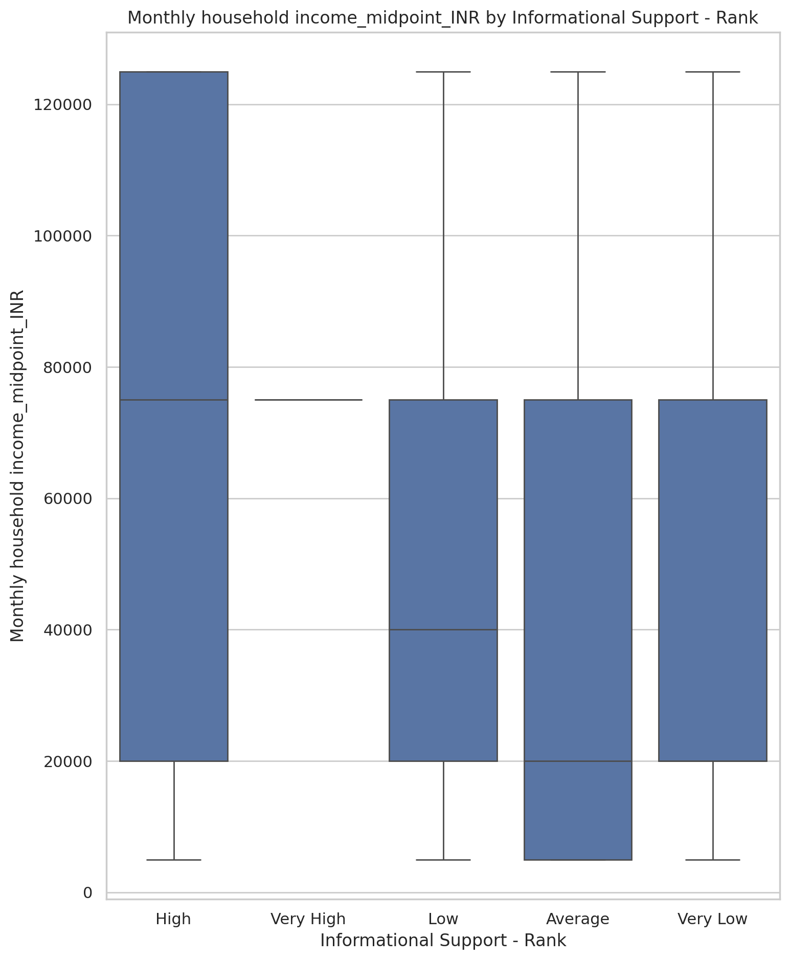

## Instrumental Support - Rank vs Monthly household income_midpoint_INR

Test: ANOVA; statistic: 1.366693676415622; p-value: 0.2545045006130292;

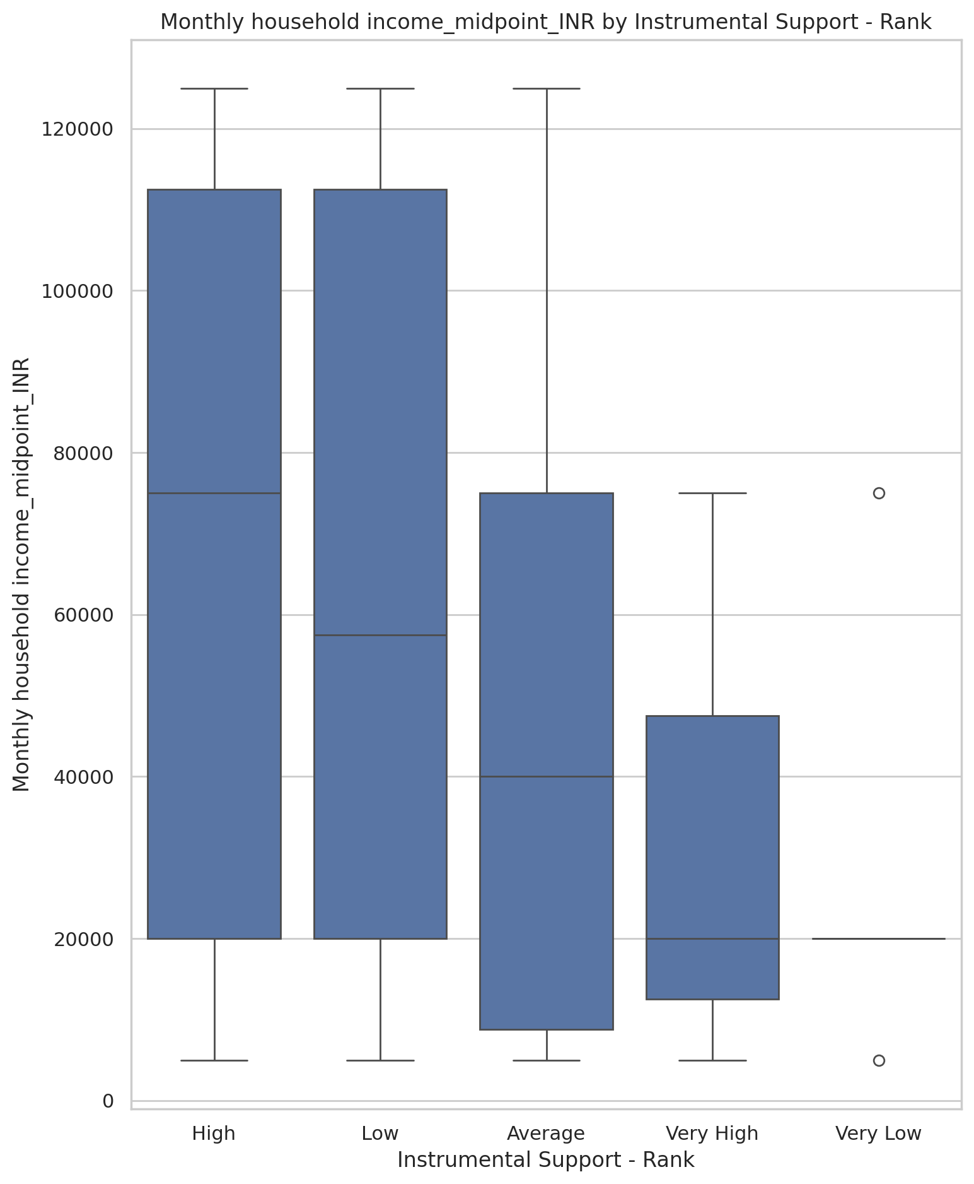

## Real Self Concept Total Category vs Monthly household income_midpoint_INR

Test: ANOVA; statistic: 1.2726021239534753; p-value: 0.2864122940209407;

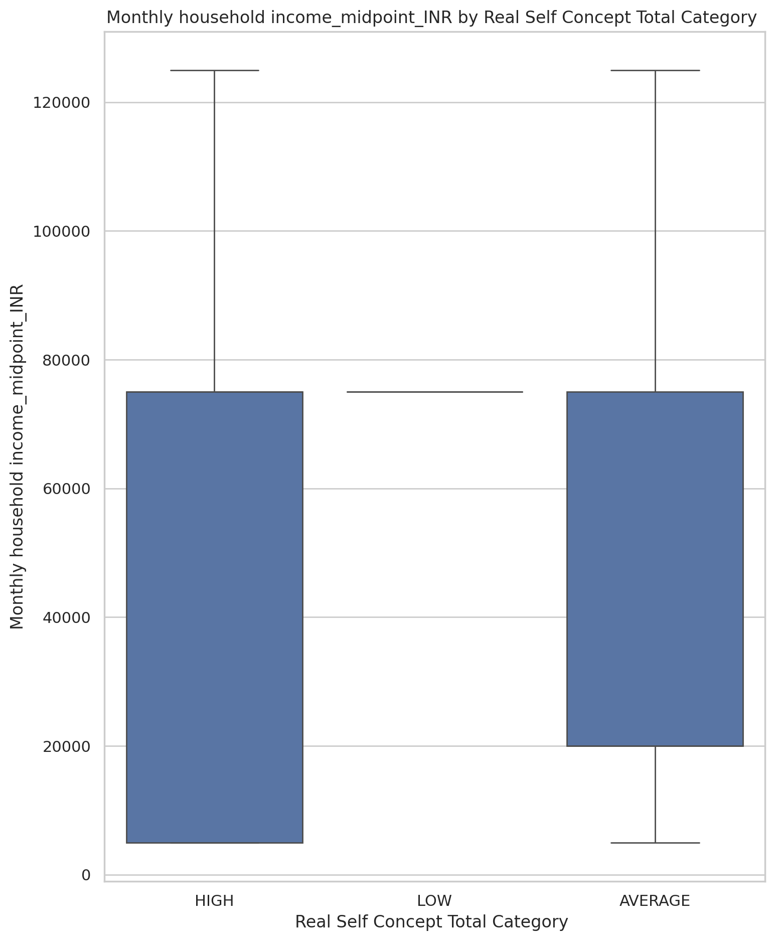

## Ideal Self Concept Total Category vs Monthly household income_midpoint_INR

Test: ANOVA; statistic: 0.9785999211117239; p-value: 0.32585757977586804;

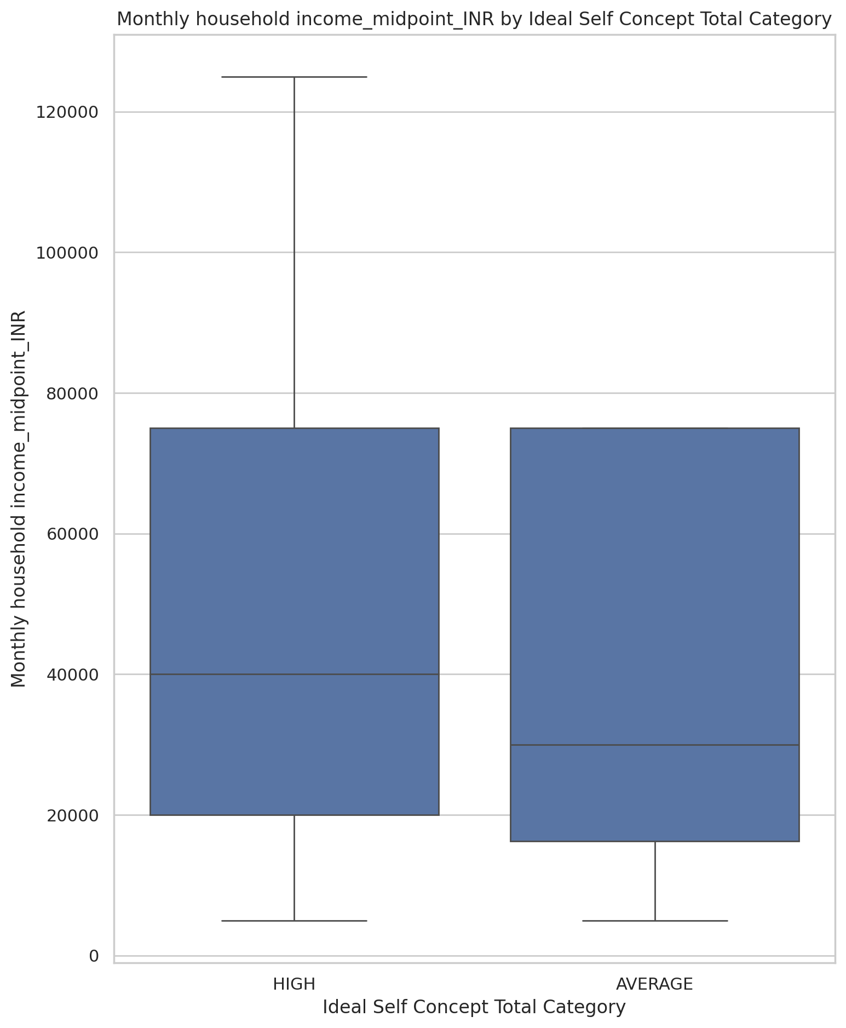

## Social Self Concept Total Category vs Monthly household income_midpoint_INR

Test: ANOVA; statistic: 1.8009150443598667; p-value: 0.17260953698539122;

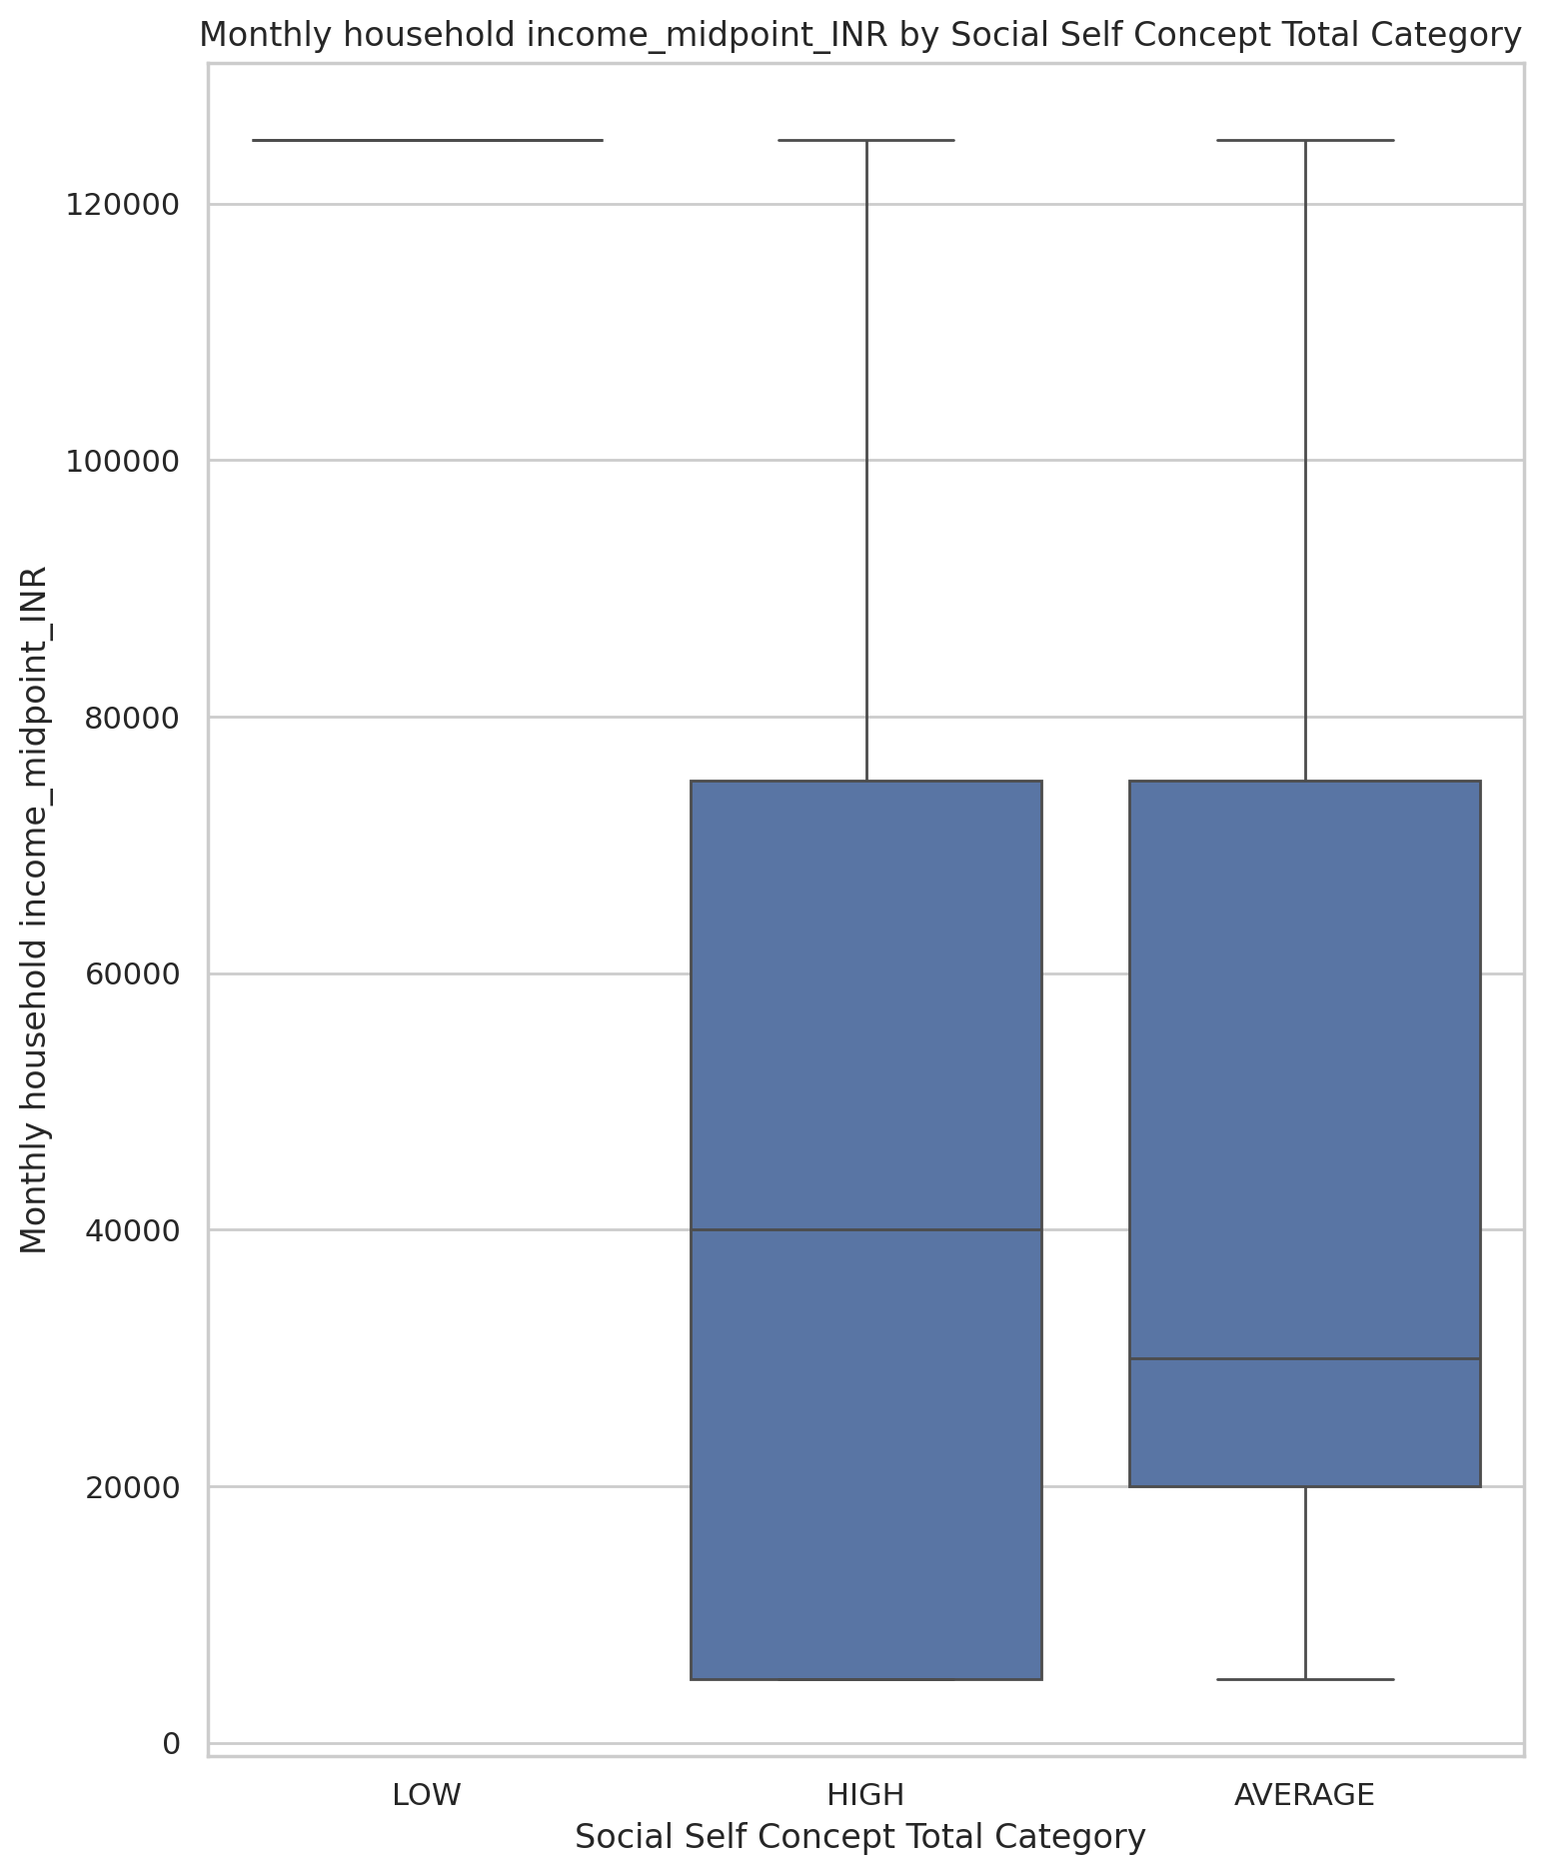

## Emotional Support - T Score vs Monthly household income_cat

Test: ANOVA; statistic: 1.870503532842662; p-value: 0.11014924117379869;

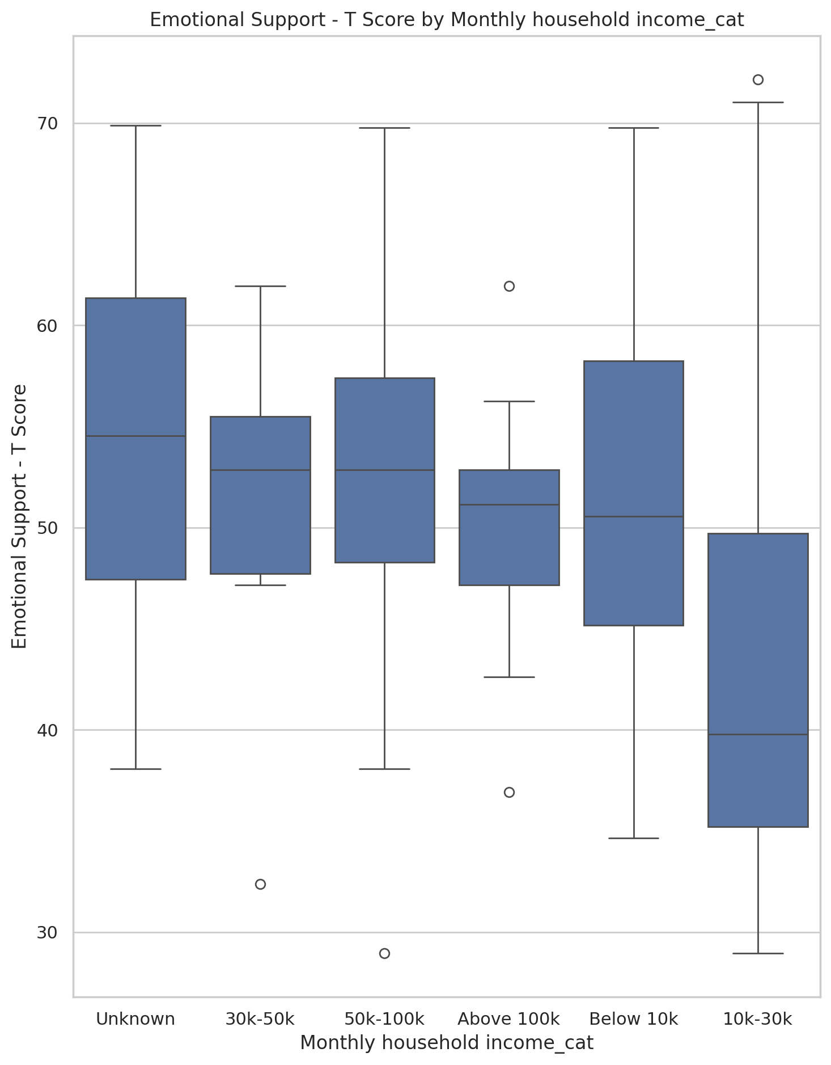

## Informational Support - T Score vs Monthly household income_cat

Test: ANOVA; statistic: 1.3855721516162829; p-value: 0.23989401165266294;

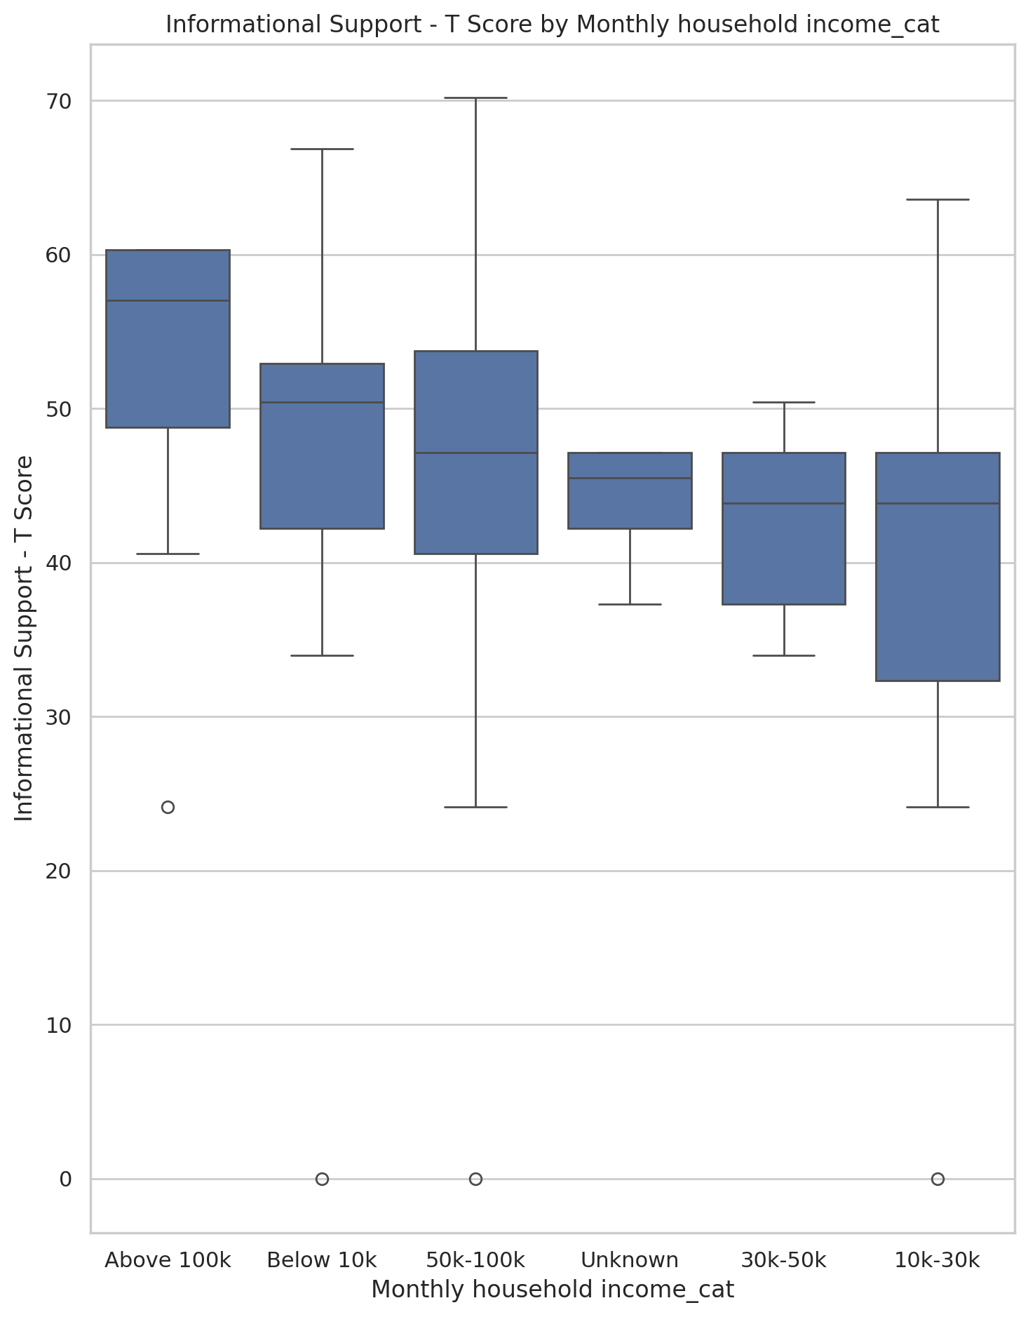

## Instrumental Support - T Score vs Monthly household income_cat

Test: ANOVA; statistic: 0.45360965645389295; p-value: 0.8093328617108376;

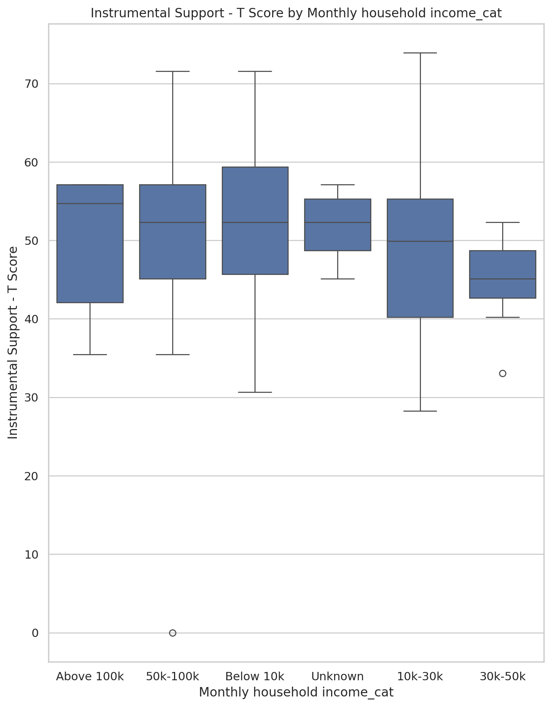

## Emotional Support - Rank vs Monthly household income_cat

Test: chi2; statistic: 29.70969263436369; p-value: 0.07469622984392471;

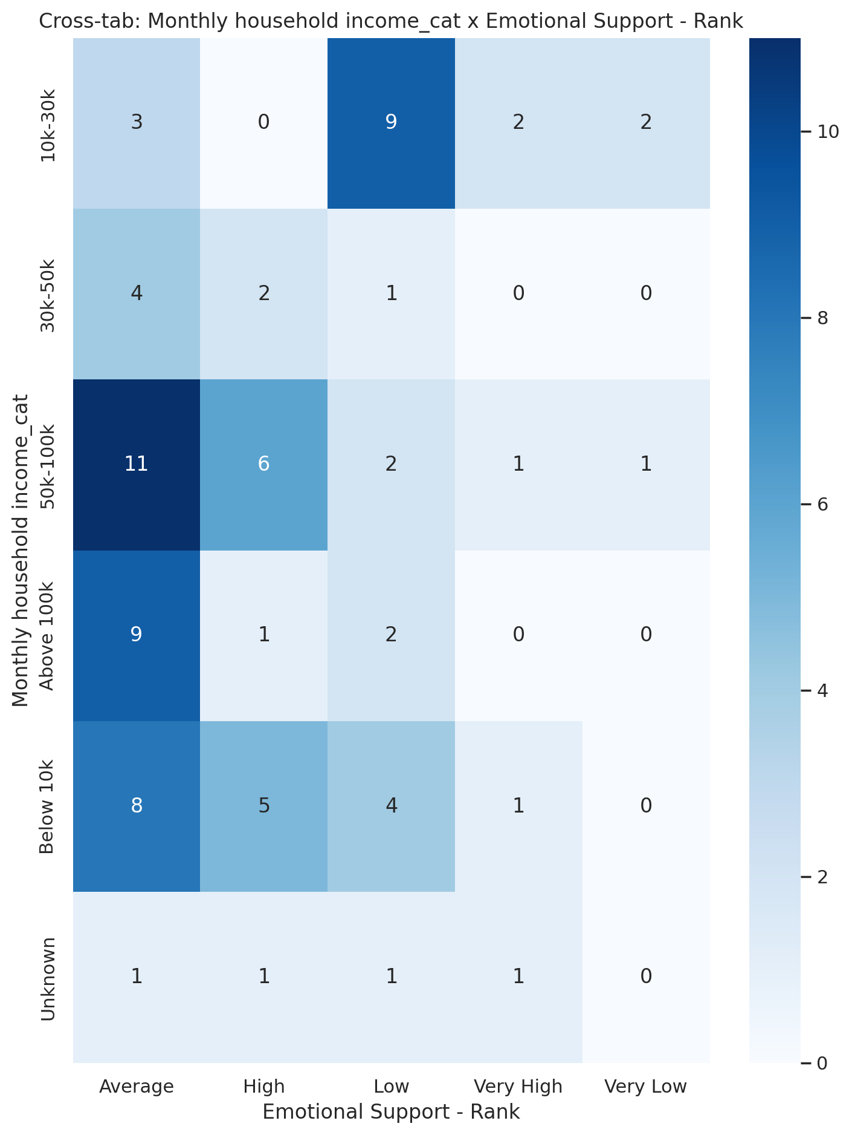

## Informational Support - Rank vs Monthly household income_cat

Test: chi2; statistic: 29.28066578483245; p-value: 0.0823782607429776;

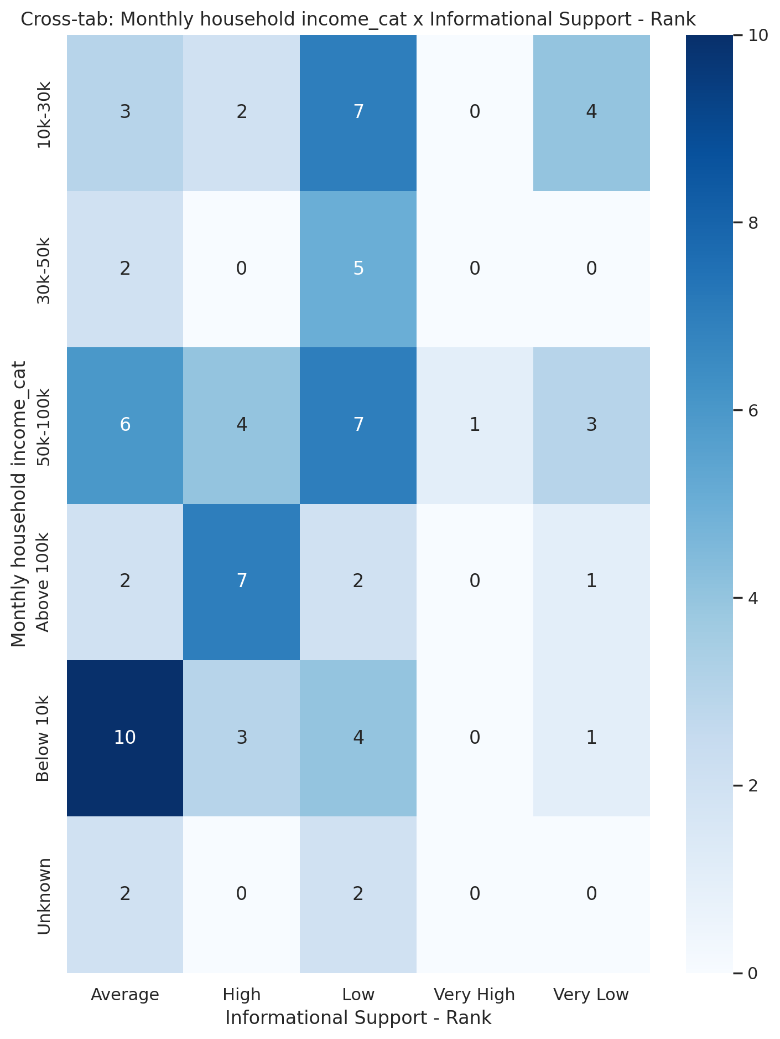

## Instrumental Support - Rank vs Monthly household income_cat

Test: chi2; statistic: 16.279969066811173; p-value: 0.6991105676361455;

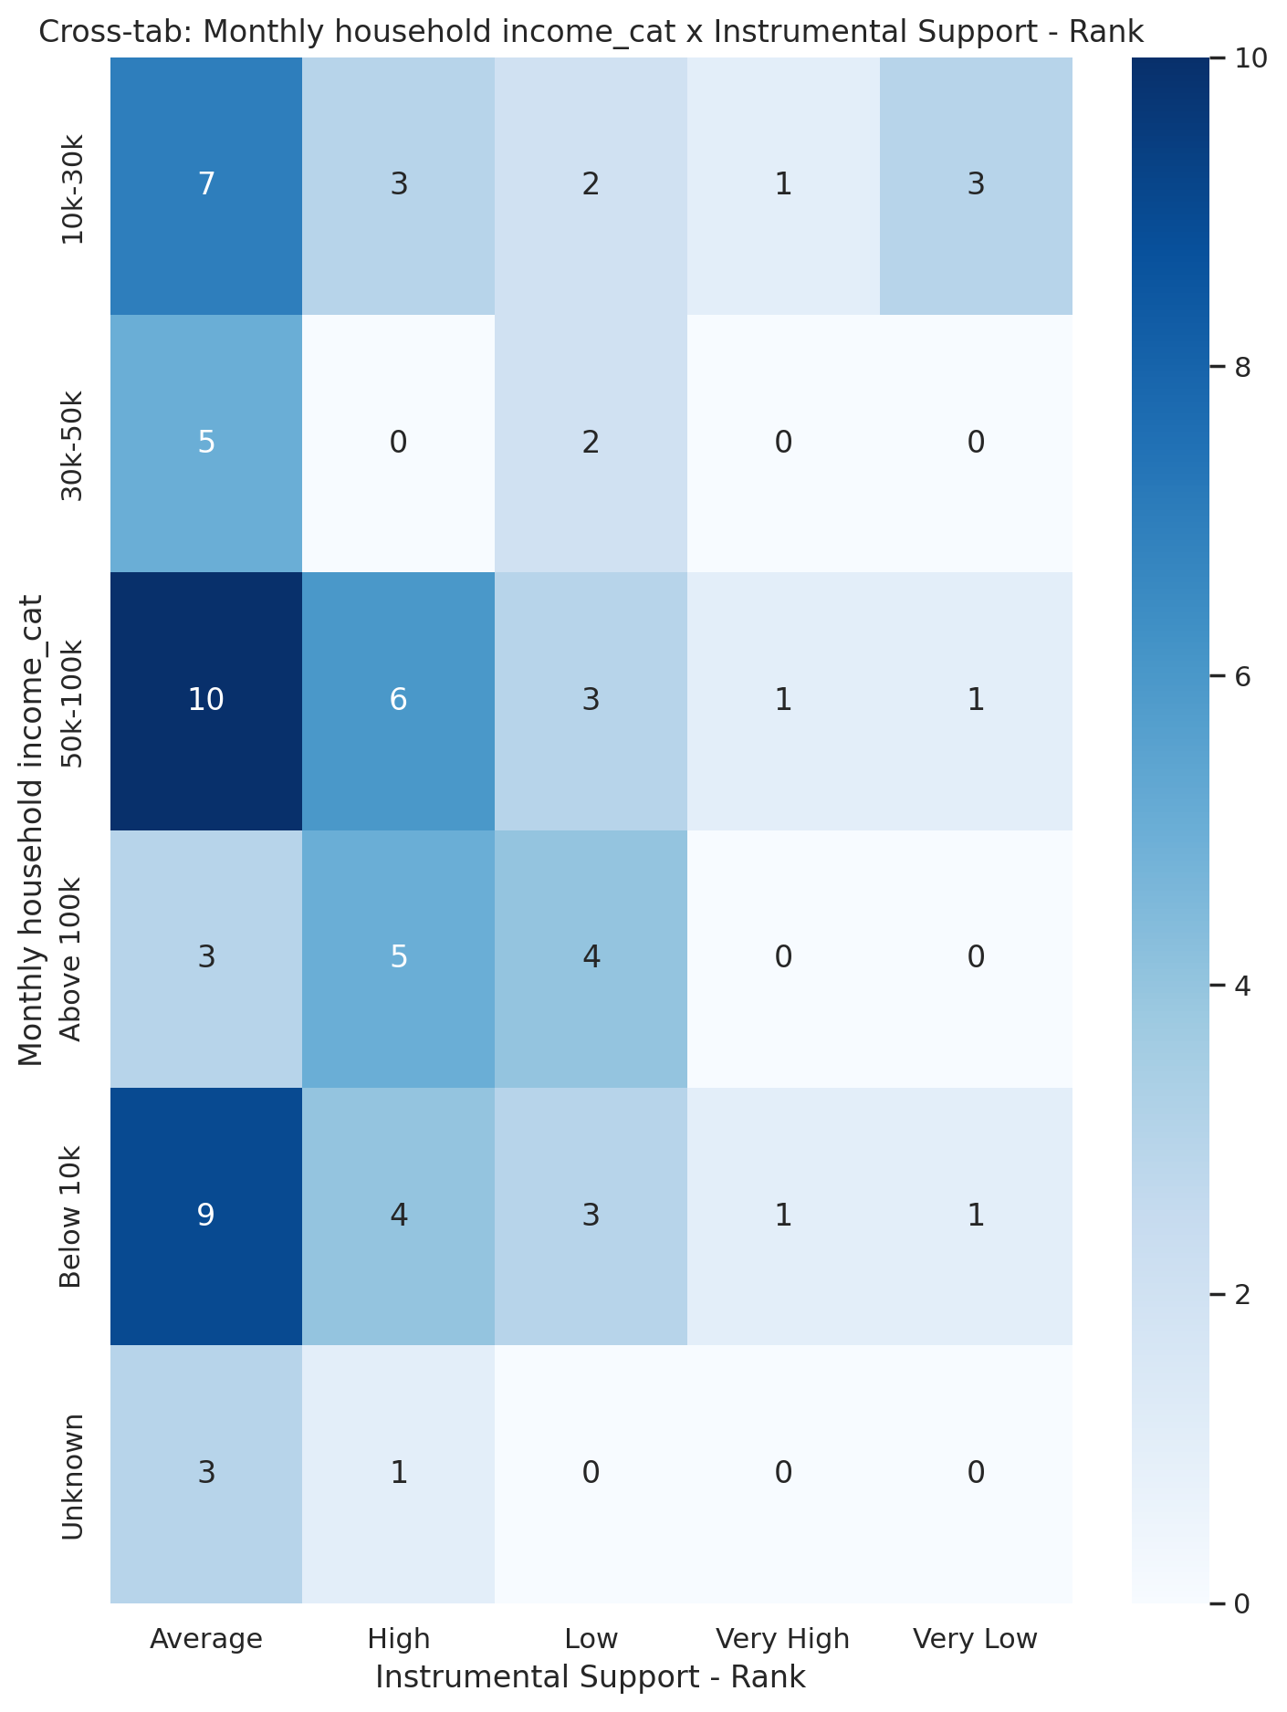

## Real Self Concept Total Category vs Monthly household income_cat

Test: chi2; statistic: 10.342885487528346; p-value: 0.4109431574469135;

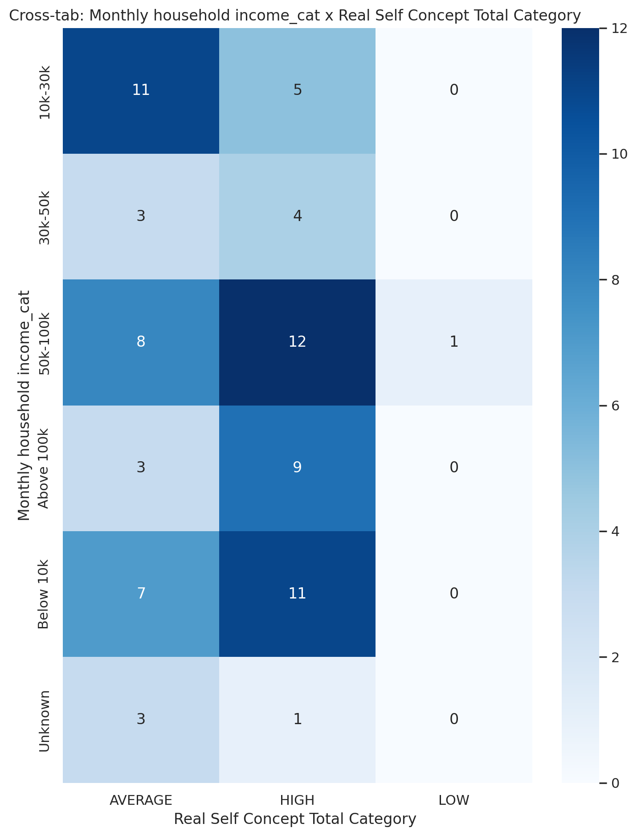

## Ideal Self Concept Total Category vs Monthly household income_cat

Test: chi2; statistic: 5.338614134178262; p-value: 0.3759670007015555;

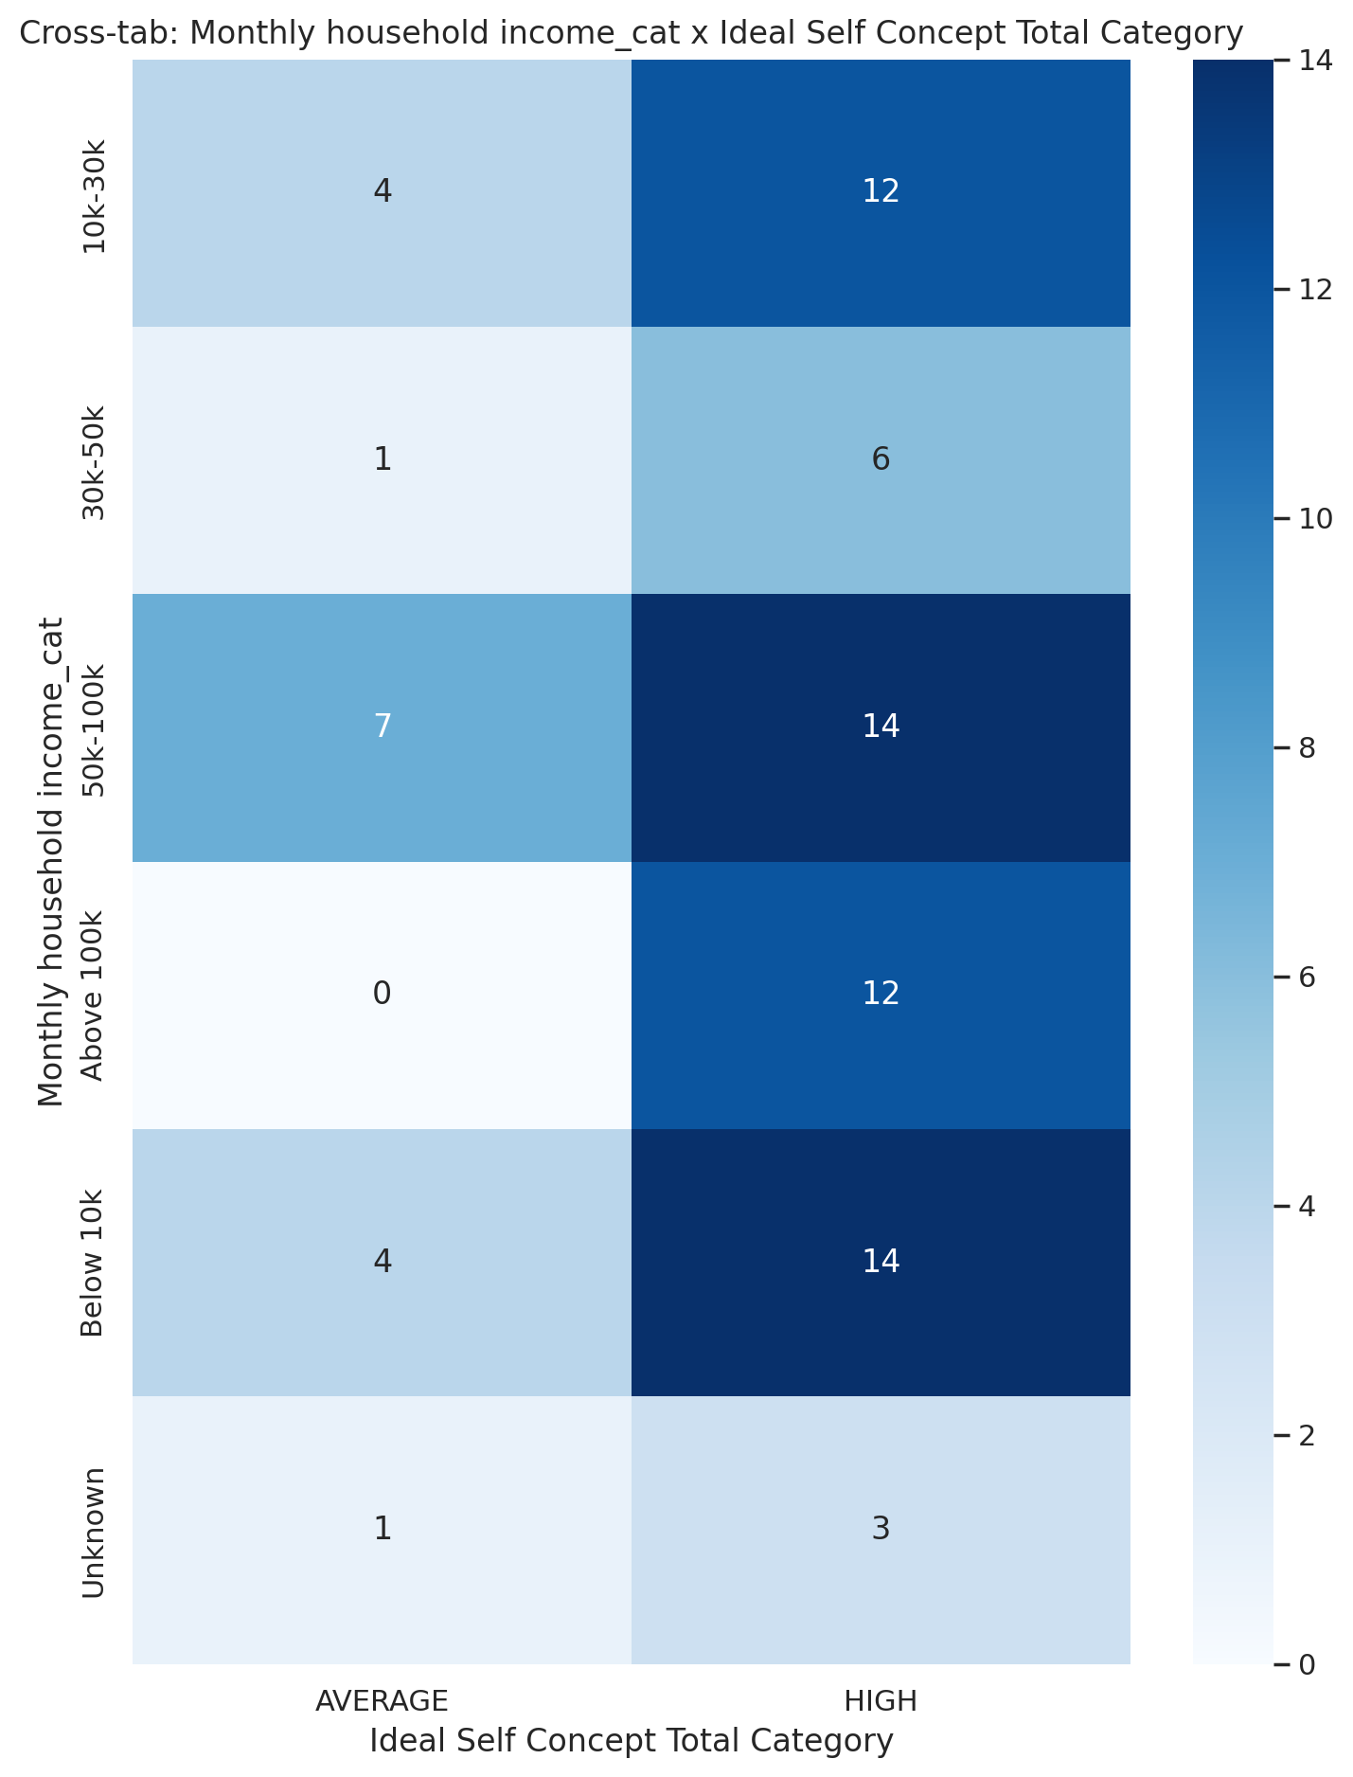

## Social Self Concept Total Category vs Monthly household income_cat

Test: chi2; statistic: 16.16546618647459; p-value: 0.09499269985926219;

